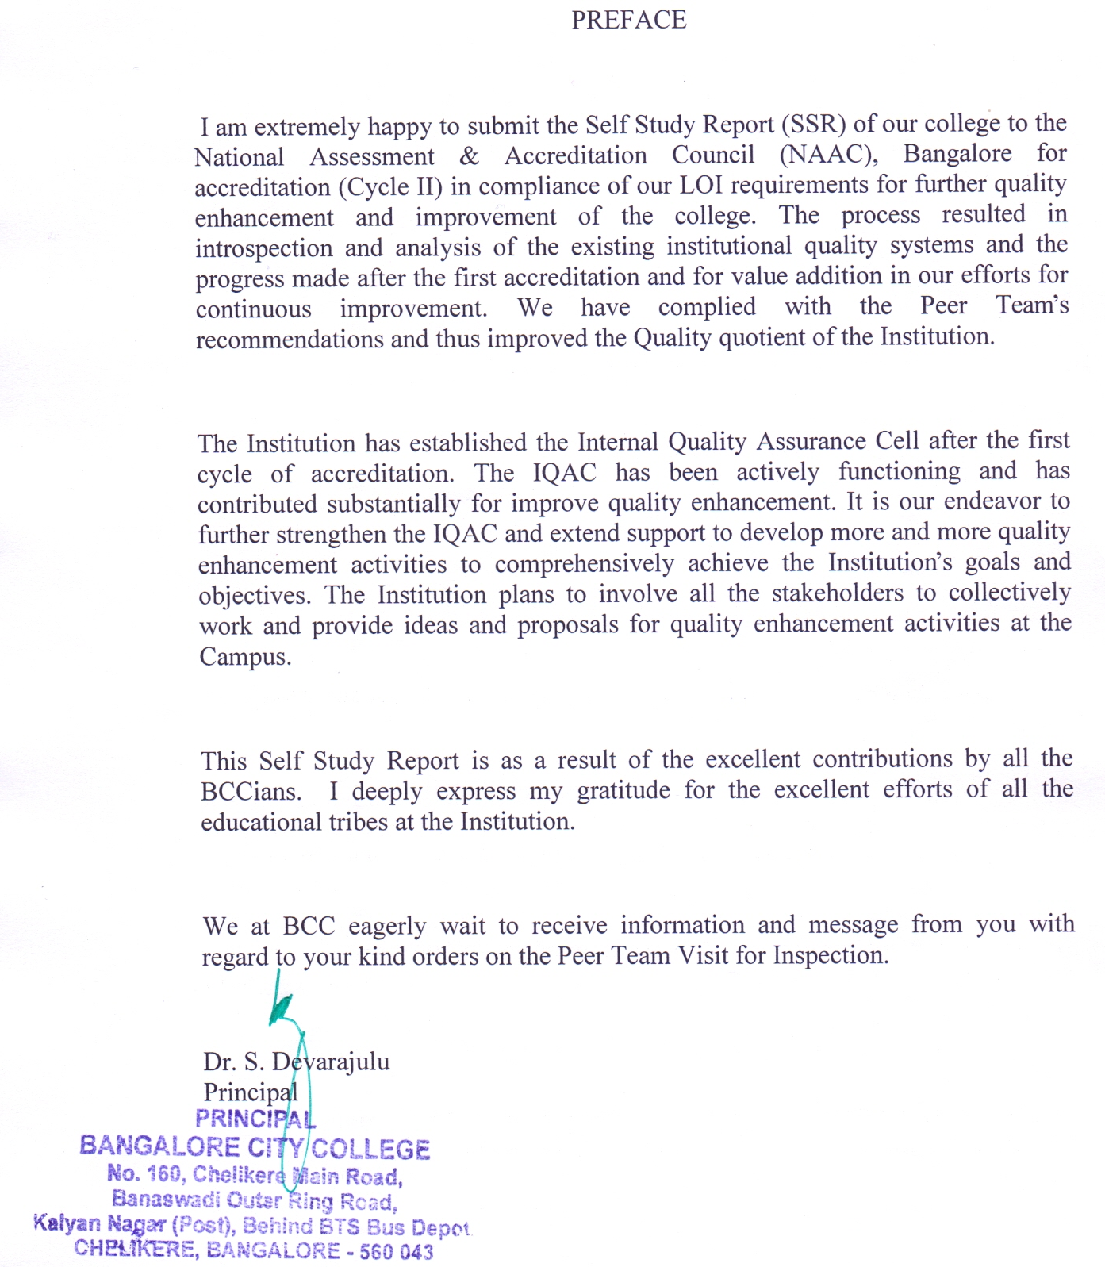
Profile of the Affiliated /Constituent College
- Name and address of the college:
Name : BANGALORE CITY COLLEGE
Address : #160, Chelikere Main Road, Banaswadi Outer Ring Road, Kalyan Nagar Post, Chelikere, Bangalor-560 043

City: Bangalore Pin: 560043 State: Karnataka

Website:

- For communication:
Designation | Name | Telephone with STD code | Mobile | Fax | E-mail
Principal | Dr. S. Devarajulu | O: 080-25459956  R: 9341788777 | 8088720711 | +91-80-25459958 | dr.devarajulu@yahoo.com
Vice Principal | Dr. C. Nagamani | O: 080-25439953  R:080-25290277 | 9448303885 | +91-80-25459958 | cnagamani@gmail.com
Steering Committee  Coordinators | Mr. K. Adisesha | O: 080-25439953  R: 080-25270133 | 9449081542 | +91-80-25459958 | adisesha.k@gmail.com
Steering Committee  Coordinators | Mr. Manjunath.S | O: 080-25439953 | 9916030046 | +91-80-25459958 | manju.msrit@gmail.com

- Status of the of Institution : Bangalore University

- Affiliated College | √
- Constituent College
- Any other (specify)
- Type of Institution:

  - By Gender
- Co-education | √
- For Men
- For Women

  - By shift

- Regular | √
- Day
- Evening

- Is it a recognized minority institution?
Yes
No | √
If yes specify the minority status (Religious/linguistic/ any other) and provide documentary evidence.
NA

- Source of funding:

Government
Grant-in-aid
Self-financing  Any other | √

- a. Date of establishment of the college: 05/08/2000 (dd/mm/yyyy)

b. University to which the college is affiliated /or which governs the college (If it is a constituent college)
BANGALORE UNIVERSITY

c. Details of UGC recognition:
Under Section | Date, Month & Year  (dd-mm-yyyy) | Remarks  (If any)
i. 2 (f) | Not Applied | Proposed
ii. 12 (B) | Not Applicable

(Enclose the Certificate of recognition u/s 2 (f) and 12 (B) of the UGC Act)

d. Details of recognition/approval by statutory/regulatory bodies other than UGC
(AICTE, NCTE, MCI, DCI, PCI, RCI etc.)

Under Section/clause | Recognition/Approval details Institution/Department/Program | Day, Month and Year (dd-mm-yyyy) | Validity | Remarks
(Enclose the recognition/approval letter)

- Does the affiliating university Act provide for conferment of autonomy (as recognized by the UGC), on its affiliated colleges?

Yes No
√

If yes, has the College applied for availing the autonomous status?
Yes No
√

- Is the college recognized
  - By UGC as a College with Potential for Excellence (CPE)?

Yes No
√

If yes, date of recognition: NA (dd/mm/yyyy)
  - For its performance by any other governmental agency?

Yes No
√

If yes, Name of the agency: NA and
Date of recognition: NA (dd/mm/yyyy)

- Location of the campus and area in sq.mts: Urban Area

Location * | Urban
Campus area in Sq. mts. | 8093.71 Sq. mts.
Built up area in Sq. mts. | 6503.21 Sq. mts.
(* Urban, Semi-urban, Rural, Tribal, Hilly Area, Any others specify)
- Facilities available on the campus (Tick the available facility and provide numbers or other details at appropriate places) or in case the institute has an agreement with other agencies in using any of the listed facilities provide information on the facilities covered under the agreement.

- Auditorium/seminar complex
with infrastructural facilities : YES

- Sports facilities
  - play ground : YES
  - swimming pool : NO
  - gymnasium : NO

- Hostel
  - Boys’ hostel : YES
    - Number of hostels : 01
    - Number of inmates : 80
    - Facilities (mention available facilities)
      - Furnished Bed Rooms with Attached Toilet/Bath and ceiling fan
      - Study table with Chair
      - Table lamp
      - Wi-Fi Facility
      - Catering Facility

  - Girls’ hostel : YES
    - Number of hostels : 01
    - Number of inmates : 60
    - Facilities (mention available facilities)
      - Furnished Bed Rooms with Attached Toilet/Bath and ceiling fan
      - Study table with Chair
      - Table lamp
      - Wi-Fi Facility
      - Catering Facility

  - Working women’s hostel : NO

    - Number of inmates : Nil
    - Facilities (mention available facilities)

- Residential facilities for teaching and non-teaching staff (give numbers available -- cadre wise) : NO

- Cafeteria -- : YES

- Health center – : YES
First aid, Inpatient, Outpatient, Emergency care facility, Ambulance…….
Health center staff –
√

Qualified doctor Full time Part-time

√
Qualified Nurse Full time Part-time

- Facilities like banking, post office, book shops :

  - Banking Facility: About 5 Branches of Nationalized and private banks are functioning in the vicinity.
  - Post Office: The Chelekere Post office is situated about 500mtrs from the campus.
  - Book Shops & Utility center: Is located very proximate to the campus.

- Transport facilities to cater to the needs of students and staff : YES
- Animal house : NO

- Biological waste disposal :YES

- Generator or other facility for management/
regulation of electricity and voltage : YES

- Solid waste management facility : Generation of solid waste is minimal which is segregated and disposed.

- Waste water management : YES

- Water harvesting : NO

- Details of programs offered by the college (Give data for current academic year)

Programme Level | Sl. No | Name of the Program  Course | Duration | Entry Qualification | Medium of Instruction | Sanctioned  Student  Strength | Number of students  admitted
Under Graduate | 1 | B.Sc., Bio-Technology | 3 Years | Pass in 10+2 | English | 60 | 15
Under Graduate | 2 | B.Sc., Microbiology | 3 Years | Pass in 10+2 | English | 30 | NIL
Under Graduate | 3 | B.Sc.,(FAD) | 3 Years | Pass in 10+2 | English | 60 | 05
Under Graduate | 4 | B.Sc.,(C.Sc) | 3 Years | Pass in 10+2 | English | 60 | 07
Under Graduate | 5 | BA (Journalism) | 3 Years | Pass in 10+2 | English | 60 | 06
Under Graduate | 6 | B.Com | 3 Years | Pass in 10+2 | English | 160 | 32
Under Graduate | 7 | BCA | 3 Years | Pass in 10+2 | English | 140 | 45
Under Graduate | 8 | BBM | 3 Years | Pass in 10+2 | English | 180 | 23

Programme Level | Sl. No | Name of the Program  Course | Duration | Entry Qualification | Medium of Instruction | Sanctioned  Student  Strength | Number of students  admitted
Post Graduate | 1 | M.Sc., Biotechnology | 2 Years | Pass in B.Sc. Bio Tech with 50% & above | English | 60 | 18
Post Graduate | 2 | M.Sc., Bio Chemistry | 2 Years | Pass in B.Sc. Bio Chem. with 50% & above | English | 30 | 04
Post Graduate | 3 | M.Sc., Chemistry | 2 Years | Pass in B.Sc. Bio Chem. with 50% & above | English | 90 | 37
Post Graduate | 4 | M.Sc., Physics | 2 Years | Pass in B.Sc. Physics with 50% & above | English | 60 | 60
Post Graduate | 5 | M.Sc., Microbiology | 2 Years | Pass in B.Sc., M.B. with 50% & above | English | 60 | 15
Post Graduate | 6 | M.Sc., | 2 Years | Pass in B.Sc. Bio Chem. with 50% & above | English | 30 | 00
Post Graduate | 7 | M.Sc., Electronics Science | 2 Years | Pass in B.Sc. Physics with 50% & above | English | 60 | 08
Post Graduate | 8 | M.Sc., Computer Science | 2 Years | Pass in B.Sc. Mathematics with 50% & above | English | 60 | 07
Post Graduate | 9 | M.S.W | 2 Years | Pass in UG with 50% and above | English | 60 | 29
Post Graduate | 10 | MFA | 2 Years | Pass in UG with 50% and above | English | 60 | 08
Post Graduate | 11 | MIB | 2 Years | Pass in UG with 50% and above | English | 60 | 00
Post Graduate | 12 | M.Sc., Mathematics | 2 Years | Pass in B.Sc. Maths with 50% & above | English | 30 | 12
Post Graduate | 13 | MA., English | 2 Years | Pass in UG with 50% and above | English | 30 | 06

- Does the college offer self-financed Programs?

√
Yes No
21
If yes, how many?

- New programs introduced in the college during the last five years if any?

Yes | √ | No |  | Number | 06

- List the departments: (respond if applicable only and do not list facilities like Library, Physical Education as departments, unless they are also offering academic degree awarding programs. Similarly, do not list the departments offering common compulsory subjects for all the programs like English, regional languages etc.)

Particulars | UG | PG | Research
Science | 05 | 09 | NA
Arts | 01 | 02 | NA
Commerce | 02 | 02 | NA
Any Other not covered above | NIL | NIL | NA

- Number of Programs offered under (Program means a degree course like BA, BSc,MA,M.Com…)
00
  - Annual system
23
  - Semester system
00
  - Trimester system

- Number of Programs with
Nil
  - Choice Based Credit System

  - Inter/Multidisciplinary Approach
Nil

  - Any other ( specify and provide details)
Nil

- Does the college offer UG and/or PG programs in Teacher Education?
√

Yes No
If yes,
  - Year of Introduction of the program(s)………………. (dd/mm/yyyy)
And number of batches that completed the program
  - NCTE recognition details (if applicable)
Notification No.: ……………………………………
Date: …………………………… (dd/mm/yyyy)
Validity:………………………..
  - Is the institution opting for assessment and accreditation of Teacher Education Program separately?

Yes No
√

Does the college offer UG or PG program in Physical Education?
√
Yes No
If yes,
  - Year of Introduction of the program(s)………………. (dd/mm/yyyy)
and number of batches that completed the program
  - NCTE recognition details (if applicable) :Not Applicable
Notification No.: ……………………………………
Date: …………………………… (dd/mm/yyyy)
Validity:……………………
  - Is the institution opting for assessment and accreditation of Physical Education Program separately? Not Applicable

Yes No
- Number of teaching and non-teaching positions in the Institution

Positions | Teaching faculty |  |  |  |  |  | Non-teaching staff |  | Technical staff
Positions | Professor |  | Associate Professor |  | Assistant Professor
 | *M | *F | *M | *F | *M | *F | *M | *F | *M | *F
Sanctioned by the UGC / University / State Government  Recruited | 00 | 00 | 00 | 00 | 00 | 00 | 00 | 00 | 00 | 00
Yet to recruit | - | - | - | - | - | - | - | - | - | -
Sanctioned by the Management/society or other authorized bodies Recruited | 10 | 10 | 06 | 04 | 13 | 43 | 11 | 29 | 05 | 00
Yet to recruit | - | - | - | - | - | - | - | - | - | -

*M-Male *F-Female
- Qualifications of the teaching staff:

Highest qualification | Professor |  | Associate Professor |  | Assistant Professor |  | Total
Highest qualification | *M | *F | *M | *F | *M | *F | Total
Permanent teachers: 86
D.Sc./D.Litt. | - | - | - | - | - | - | -
Ph.D. | 07 | 07 | 00 | 00 | 00 | 03 | 17
M.Phil. | 01 | 01 | 01 | 02 | 02 | 06 | 13
PG | 02 | 02 | 05 | 02 | 11 | 34 | 56
Temporary teachers: 00
Ph.D. | - | - | - | - | - | - | -
M.Phil. | - | - | - | - | - | - | -
PG | - | - | - | - | - | - | -
Part-time teachers: 01
Ph.D. | 1 | - | - | - | - | - | 01
M.Phil. | - | - | - | - | - | - | -
PG | - | - | - | - | - | - | -

*M: Male *F: Female

- Number of Visiting Faculty /Guest Faculty engaged with the College.
13

- Furnish the number of students admitted to the college during the last four academic years.

Under Graduatation:
Categories | Year 1 |  | Year 2 |  | Year 3 |  | Year 4
Categories | 2013-14 |  | 2012-13 |  | 2011-12 |  | 2010-11
Categories | *M | *F | *M | *F | *M | *F | *M | *F
SC | 13 | 09 | 12 | 05 | 09 | 04 | 13 | 05
ST | 02 | 02 | 05 | 03 | 04 | 02 | 02 | 03
OBC | 25 | 20 | 26 | 15 | 12 | 07 | 48 | 29
General | 40 | 30 | 107 | 84 | 87 | 57 | 130 | 97
Others | 0 | 0 | 0 | 0 | 0 | 0 | 0 | 0

*M: Male *F: Female
Post Graduatation:
Categories | Year 1 |  | Year 2 |  | Year 3 |  | Year 4
Categories | 2013-14 |  | 2012-13 |  | 2011-12 |  | 2010-11
Categories | *M | *F | *M | *F | *M | *F | *M | *F
SC | 14 | 09 | 09 | 11 | 21 | 05 | 13 | 05
ST | 07 | 04 | 03 | 05 | 06 | 01 | 02 | 03
OBC | 39 | 38 | 66 | 71 | 21 | 25 | 48 | 29
General | 43 | 50 | 65 | 34 | 84 | 89 | 130 | 97
Others | 0 | 0 | 0 | 0 | 0 | 0 | 0 | 0

*M: Male *F: Female

- Details on students enrollment in the college during the current academic year:

Type of students | UG | PG | Total
Students from the same state where the college is located | 73 | 155 | 228
Students from other states of India | 39 | 44 | 83
NRI students | 05 | 0 | 05
Foreign students | 22 | 04 | 26
Total | 139 | 203 | 342

          - Dropout rate in UG and PG (average of the last two batches)

Year | UG |  | PG
Year | Total Students | Dropout | Total Students | Dropout
2010-11 | 327 | 10 | 327 | 10
2011-12 | 182 | 07 | 252 | 09
2012-13 | 257 | 59 | 264 | 10
2013-14 | 139 | 10 | 203 | 08

          - Unit Cost of Education

(Unit cost = total annual recurring expenditure (actual) divided by total number of
students enrolled)
Rs. 52766.12/-
- Including the salary component:
Rs. 37281.27/-
(b) Excluding the salary component:

27. Does the college offer any program/s in distance education mode (DEP)?
Yes No
√
If yes,
a) Is it a registered center for offering distance education programs of
another University:
√

Yes No
Name of the University which has granted such registration.

    - Number of programs offered

    - Programs carry the recognition of the Distance Education Council.
Yes No

      - Provide Teacher-student ratio for each of the program/course offered:
Under Graduatation
Sl. No | Name of the Program  Course | Teacher  Strength | Student  Strength | Teacher-Student Ratio
1 | B.Sc., Bio-Technology | 3 | 54 | 1:18
2 | B.Sc., Microbiology | 2 | 25 | 1:12
3 | B.Sc.(FAD) | 3 | 27 | 1:09
4 | B.Sc.(Cs) | 2 | 36 | 1:18
5 | BA (Journalism) | 2 | 25 | 1:08
6 | B.Com | 4 | 102 | 1:25
7 | BCA | 4 | 118 | 1:29
8 | BBM | 4 | 125 | 1:31

Post Graduate
Sl. No | Name of the Program  Course | Teacher  Strength | Student  Strength | Teacher-Student Ratio
1 | M.Sc., Biotechnology | 3 | 29 | 1:10
2 | M.Sc., Bio Chemistry | 4 | 20 | 1:05
3 | M.Sc., Chemistry | 7 | 100 | 1:14
4 | M.Sc., Physics | 6 | 120 | 1:20
5 | M.Sc., Microbiology | 2 | 29 | 1:14
6 | M.Sc., Electronics Science | 4 | 32 | 1:05
7 | M.Sc., Computer Science | 6 | 39 | 1:13
8 | M.S.W | 5 | 55 | 1:11
9 | MFA | 3 | 24 | 1:08
10 | MIB | 0 | 0 | 0
11 | M.Sc., Mathematics | 3 | 12 | 1:03
12 | MA., English | 3 | 06 | 1:02

      - Is the college applying for
√
Accréditation : Cycle 1 Cycle 2 Cycle 3 Cycle 4

Re-Assessment:
(Cycle 1refers to first accreditation and Cycle 2, Cycle 3 and Cycle 4 refers to re-accreditation)

      - Date of accreditation* (applicable for Cycle 2, Cycle 3, Cycle 4 and re-assessment only)

Cycle 1: 15/06/2009 (dd/mm/yyyy) Accreditation Outcome/Result: B-Grade
Cycle 2: Not Applicable(dd/mm/yyyy) Accreditation Outcome/Result: NA
Cycle 3: Not Applicable(dd/mm/yyyy) Accreditation Outcome/Result:NA
* Kindly enclose copy of accreditation certificate(s) and peer team report(s) as an annexure.

      - Number of working days during the last academic year.
251 days

      - Number of teaching days during the last academic year.
(Teaching days means days on which lectures were engaged excluding the examination days)
182 days

      - Date of establishment of Internal Quality Assurance Cell (IQAC)
IQAC : 22/05/2009 (dd/mm/yyyy)

      - Details regarding submission of Annual Quality Assurance Reports (AQAR) to NAAC.

AQAR (i) 04/ 07/ 2013 (dd/mm/yyyy)
AQAR (ii) 06/08/2012 (dd/mm/yyyy)
AQAR (iii) 26/ 09/ 2011 (dd/mm/yyyy)
AQAR (iv) 07/ 03/ 2011 (dd/mm/yyyy)

      - Any other relevant data (not covered above) the college would like to include. (Do not include explanatory/descriptive information)

: Nil

Executive Summary
The brainchild of Ramakrishna Education Trust (R), Bangalore City College (BCC) was founded with the sole aim to serve the youth community by imparting quality education to enable them to take up useful vocation and serve the society. Ramakrishna Education Trust was founded in the year 1999 and envisages to provide quality management education along with information technology and biological sciences to further their intellectual and social growth in the society.
Situated in a pristine location, at the centre of Bangalore and providing atmosphere for academics, Bangalore City College aims at imparting value based education to the students. The objectives of the Trust are achieved with the professional support of a very distinguished team of academicians under the guidance of the trustees. BCC sincerely follows the Mission and objectives of the Institution to enhance attitude, knowledge and skills of the youth to contribute effectively for the growth of industry and business for a bright future of the country. The Institute’s practices in the various fields of academics are given hereunder:

- Curricular Aspects

The college has multiple programs in UG and PG to enable the students to choose and join the programs as per their desire. In all there are 08 and 13 UG and PG programs respectively. All the programs are self financed. BCC being one of the affiliated colleges to the Bangalore University, it shall adhere to the curriculum designed by the Universities Board of Studies (BOS). All the departments prepare a Department Annual Academic plan which is program-wise and semester-wise. The Plan is prepared and submitted to the Principal three months before the commencement of the academic year. The plans provide the details of Curricular, Co-curricular and Extra-curricular activities. The academic plan contains subject allotment to the Faculties, time table, lesson plans, syllabus plan, etc.,

To effectively translate the curriculum and to improve teaching practices, Faculties undergo training at workshops, seminars, Orientation Programs and in- service training. The recharging strategies are properly planned and faculties are deputed to attend workshops, seminars, conferences etc. conducted by internal and external agencies. Whenever the curriculum is amended/ revised by the University, faculties are given necessary incite and inputs through training programs. The institution provides the necessary infrastructure for effective teaching learning practice through ICT facilities, internet, Wi-Fi etc. to impart knowledge through advanced technology. Internal tests are regularly conducted and corrective actions are initiated. Students are guided on the books to be referred, websites to be browsed on the net, online journals for reference, scientific journals, current articles etc. Frequent updating of books is done whenever there is a syllabus change every year. Field trips, Educational tours, case studies, etc., are also implemented. The institution has developed enrichment and enhancement courses such as Computer Application and Software Development, Personality Development programs etc. For these programs, the curriculum and course materials are developed by the faculties.
The Institute obtains feedback from stakeholders and analyzes them to identify corrective actions required for the improvement. The feedbacks from the stakeholders are analyzed and a few improvements have been made. The faculties discuss on various academic issues with the respective BOE’s with regard to department issues and identify the solutions. The faculties also participate in valuation of answer booklets and acquire certain additional inputs to their curriculum aspects. They also attend seminars and workshops organized by the university and other external organizations. The valuable information acquired are shared in the general meetings which creates general awareness and to improve the curriculum.
The new programs introduced in the Institution in the last four years are Master of International Business, Master of Financial Accounting, Master of English, Master of Science in Mathematics and Electronics and B.Sc in Microbiology. The institute undertook survey and feed back from the stakeholders. After a detailed study of data obtained, a pilot study was under taken. When all the outcomes were positive and encouraging the institute took necessary permission from the affiliating University and launched the new programs.
- Teaching-Learning and Evaluation
The institution has absolute transparency in the admission process. An admission desk is established with the team of personnel to counsel the candidates and parents who wish to seek admission to the various programs conducted by the institution. The admission desk comprehensively provides multiple solutions to all the queries and enquiries regarding the admission. The admission notification is advertised in leading regional/national newspapers and on the college websites. Prospectus of the college with comprehensive details of programs is printed every year and is distributed at all educational fairs. The team visits various cities in different states where common entrance tests are conducted and institutions which are providing pre university education. The prospective students are guided to see and understand the various infrastructural facilities available at the campus. Large hoardings are displayed at vantage points for the information of the public and students.
An induction program and a bridge course are conducted to all the students who joined the college. During these programs, the student’s current level of knowledge and skills are assessed. Certain participatory exercises such as group discussions on some current topics, simple quiz contest, etc., are conducted and students’ knowledge and skills are assessed. Students are grouped based on the needs that are required to enable them to effectively perform academically. To bridge the knowledge and skill gap, foundation lectures are delivered before commencement of the regular classes. Further, the students’ class performance and the internal test are assessed. On the basis of all these factors, students are categorized as advanced learners, average learners and slow learners. The slow learners are provided special coaching through remedial classes to academically rehabilitate them. Depending upon the students’ knowledge gap, add on/enrichment programs are also conducted.
The institution has initiated several actions to sensitize students on gender, inclusion and environment. The HODs/Principal monitors and guides to resolve students’ problems and grievances. Special care is also taken in respect of students with weakness in communication skills (spoken English classes are conducted regularly) to ensure that the barrier in communication is eliminated.
The advanced learners are identified in the same manner by which slow learners are identified. Some of the activities to recognize the positive performance of the advanced learners are by nominating them as class representatives, sponsoring them to the external quiz competitions, poster presentations, seminars etc. The faculties also ensure certain special efforts are made to guide these students to acquire knowledge and skills beyond the curriculum through special classes. Special tutorials are organized to enable these students to participate in national level competitive examinations and any high level research activities.
Teaching plan: All the courses taught in the college are through lecture method. Apart from classroom interactions, tutorials, assignments, project-writing and seminars are provided to the students in most of the Departments. Some departments adopt other practices such as group discussion, laboratory work, field-work, industrial visits etc. Individual faculties from all departments have to maintain work diaries where details of all lesson plans are made and sincerely followed.
Portion Completion Certificate: In the beginning of the academic year itself the total number of lectures available during the semester is calculated on the basis of academic calendar and examination schedule. Accordingly teaching plans are prepared and portion completion dates are announced and intimated to the H.O.D’s. In case a teacher needs additional lectures, special lectures are allotted.
Examination schedules: Semester examination schedules are notified through the academic calendar issued before the beginning of the semester. Class tests topics and dates are notified through the notice board.
IQAC help to improve the overall teaching – learning process by introducing self appraisal of faculty, student assessment of faculty performance getting continuous feedback. The faculties evince interest to introduce and adopt best practices in the college that would improve the teaching learning system. The IQAC has been regularly organizing several quality enrichment programs. Especially from the previous academic years many programs are focused on teaching-learning enhancement. Even for current academic year 2013-14, a detailed annual IQAC plan has been formulated and programs are organized as per the plan.
Students are encouraged to participate in debate competitions or make presentations at the seminars. The college arranges for field trips to good institutions to enable them to inculcate the finer aspects of higher studies and research activities. Orientation visits are undertaken to expose them to understand the actual working conditions, work culture and various other vocation related norms, procedures etc,. They are encouraged to take hands – on projects at some industries where they can have the glimpse of the future of the particular subject they are interested for. They participate in lectures of eminent scientists or resource person in house or outside to have a glimpse of the current research topics on all fields. Students are given ideas of research methodologies to develop the scientific temper among them.
For effective teaching by the faculties facilities are provided such as sufficient number of class rooms with multimedia projectors and, desktop with internet facility to prepare lesson plans, power point presentations, web assignments and to browse various important websites to keep them updated with the emerging trends and recent technologies in the respective fields.
The institution has subscribed for online access to Journals through INFLIBNET as a part of library. The institute has a large computer lab with Wi-Fi and internet facilities. The lab is extensively used by the faculties and students. Computers are upgraded from time to time
The mentor-mentee system is to identify and provide support to the slow learners. Students are grouped in small numbers to the individual faculties who undertake case work on students independently and counsel them to provide personal and psycho social support to enable the slow learners to improve their academic performance. Remedial classes are conducted to academically rehabilitate them.
The college has a well-equipped computerized library with adequate books including text books, reference books, advanced books, journals and periodicals on various subjects. The Library provides various support services such as computer facility, online access to Journals, assist faculty and students on information on selected topics, information on new arrivals, display of interesting articles, question papers of previous years are maintained for students’ reference and to prepare for the examinations.
The comprehensive information and details of the evaluation process is printed in the prospectus and are available on the institution’s website. It is also covered during the induction program. Major evaluation reforms introduced by the University have been adopted by the institute. The implementation of evaluative reforms is ensured by adopting the following process:
The academic committee at the beginning of the academic year receives communication from the parent university in respect of reforms to the evaluation if any. The procedure to be adopted is discussed and circulars, notices and communications are sent to all the stake holders about the change in the procedure. The principal with the able support of HODs and nonteaching staff ensures that a quality systems which are operational for evaluation process is suitably amended for effective implementation. Constant monitoring and follow up results in successful implementation of the evaluation reforms.
The institution has been practicing both formative and summative process of assessment and evaluation. In the formative assessment the goal is to monitor the students learning and provide feedback to the students. Parallely the students’ feedback on faculty is obtained on the teaching learning methodology. Appropriate changes and amendment are made in the teaching learning practice by the faculty suiting to their requirements of the students. The process helps students to identify their strengths and weaknesses and target areas that need additional efforts. The goal of the summative assessment is evaluate student learning at the end of an instructional unit and comparing the same with the standard practice or practices which are bench marked. Some of the summative assessments includes midterm examination, the final project etc.,
The institution has defined the program objectives and learning outcomes for each program. The whole process of teaching learning evaluation process are although as per the norms of the parent university, the co-curricular activities are planned to specifically address on program objectives. The outgoing students on completion of each program are required to undergo a test which clearly indicates the level of the learning outcomes achieved. In case of major mismatch between the program objectives and learning outcomes the reasons for such a scenario is studied in detail and corrective action are initiated.
- Research, Extension and Collaboration
A research committee is functioning in the Institution. The main objectives of the Research Committee are to plan and design the annual research activities, to conduct science related symposiums for post graduates, developing the research projects (Internal and External) to give exposure to the new areas of research, to promote faculty to attend national and international conferences and to encourage faculty and students to publish their research work. The Institution has implemented the recommendations given by the Research Committee such as to provide computer with internet facility to the teachers, official leave to attend national and international conferences, encourage staff to help to publish the research work carried out in the labs, conducting inter college science fest in the college and to expose students to current developments by inviting experts.
The Research Committee has been planning to promote research Activities in the campus by forming several clusters for the faculties, UG and PG Students’. One cluster is totally devoted to take up minor and major research projects either individually or through collaboration. Currently faculties are guiding the PG students and few UG students to complete the research dissertation projects. The institute has been organizing training programs and sensitization programs regularly for the students to imbibe research culture.
The details are:
- Orientation training programs on research dissertation work are organized during the third semester for the PG students to enable them to take up the research work which is a part fulfillment of the PG program.
- Programs providing detailed information on career opportunities in research and development are conducted for the benefit of the PG students during the fourth semester.

Many Faculties have made significant contribution in Research Publications and have won many awards. They have served many professional and research bodies in distinguished positions.
The institution is committed to develop quality students and as a responsible citizens of the nation. Our faculty from various departments organizes programs in association with NSS in various inspiring activities which includes the following:
- Conducted awareness programs on Alcohol abuse , Drugs abuse ,etc
- The college has established a woman empowerment cell to provide awareness about women’s rights and their protection, comprehensively handling violence against women.
- The students have come forward to donate their blood and organs to ensure that the needy patients are saved.
- The students create awareness among the members of the community to come forward and register for blood and organ donation by organizing regular camps.
- Our students are involved in theprogram of Green environment.
- Visit and counseling at orphanages, Pulse polio campaign, developing HIV awareness, Shramadan- Awareness to a healthy life by maintaining cleanliness and Literacy development programs

- Infrastructure and Learning Resources

Good infrastructural facilities shall alone contribute for the effective implementation academic programs. The Institution has two independent blocks with adequate infrastructure facilities. One block is exclusively for UG studies and the second is for the PG studies. The Institution has sufficient number of well equipped classrooms with necessary facilities including ICT equipments such as OHPs, LCDs, Wi-Fi, etc., All the Science departments are equipped with labs with the most modern amenities. The Computer lab has sufficient desktops with internet facilities.

Both the blocks have independent digital Libraries with computer for library office and separate Computers with internet facility for the students to access internet and online journals.
The Institution has two independent hostels, one for boys and one for girls with 80 and 60 inmates respectively. The hostels are equipped with Wi-Fi access, medical room with necessary equipments to provide treatment in case of emergency with a qualified visiting medical officer and facility for indoor games.

The Institution has provided independent recreational facilities for boys and girls with audio visual equipments. More over the instution has medicial room with necessary equipements to provide first aid and also has a tieup with a high end hospital where regular visits by qualified doctors are made.
The security personnel are available in the college and hostel round the clock and the campus has been installed with Closed Circuit Cameras for safety purposes

- Student Support and Progression

The Institute has in place a good Student and Support system in place. The Prospectus with comprehensive information is published every year. Induction programs are conducted every year for the benefit of fresher’s. Bridge Programs are also conducted. The objectives of the Induction and Bridge program are to create sufficient awareness among the fresher’s on the various norms, procedures and practices applicable to higher education.

Individual Students are assigned to a mentor who monitor the progress of the student and provides guidance in academics, project, further studies and job placement. In case of any problem the student can approach his/her mentor. The institution has a Placement and Training Centre which offers a wealth of experience and advice. The Placement and Training Centre helps the students to realize their potential to find a career which will match their skill and talents. The Placement and Training Centre runs comprehensive career programs with seminars and workshops to help students to identify their skills, understand the employer requirement.
The college has a Grievance Handling Committee. The students can either directly approach the committee members or drop their grievances in the box meant for grievances. The cell actively responds to the students’ grievances and initiates required action. The college has constituted an Anti-sexual harassment Committee to resolve issues pertaining to sexual harassment. To ensure the campus is totally free from sexual harassment, the college is equipped with CCTV cameras. Till date no cases of sexual harassment has neither happened nor reported in the institute. Ragging is strictly banned in Bangalore City College. The students receive sufficient awareness of the evils of ragging and the punitive measures which are initiated. This has ensured that the student do not indulge in ragging. As per the college rules if any student is found indulging in such kind of activities, strict action will be taken as per the college norms. For this purpose an Anti-ragging committee has been formed.
An Alumni Association has been constituted. Every year college conducts an Annual meet which is scheduled in the last week of December. Alumni members are invited to share their experience and give vocational guidance to students.
The Institution takes keen interest in supporting the students who have difficulty to handle the academic pressure. The institution has successfully implemented the mentorship program through which slow learners who are at the risk of failure or drop out are provided sufficient academic and other needy facilities to be academically successful. The institute strongly believes that every UG student before the completion of 4th semester will have sufficient inputs to formally decide on the career that he/she may opt on completion of the program or the value addition to his/her UG education which shall facilitate him/her to a superior career option. All the departments of the institution regularly organize sessions where in students are provided the details of the various options available on completion.

The college has defined mechanism for obtaining feedback from outgoing students on the institution. HODs are responsible to take feedback from students. The Feedback obtained are analyzed. The institution considers the feedback and analysis to be valuable as it helps the college to initiate action for continuous development.
The Institution is publishing every year a student magazine which is published. The complete responsibility of the magazine is handled by the Magazine Committee consisting of a group of students and teachers. The objectives of the Magazine are:
- To bring out the talents and skills of the students.
- To make known to the stakeholders the activities and other important events that takes place in the college every year.
- The photographs published in the magazine are one of the records of the events that had taken place in the course of the academic year.
- It’s a form of motivation not only to the student community but also to the staff for exhibiting their writing skills in the form of poems, articles, and their experiences in the institution.
- It forms as a platform for the business community to advertise their products and to enhance their business.
- The magazine is an avenue to make known to the students, the staff and the stakeholders the strides they are making every year in the form of development in academic excellence, infra-structure, curricular activities, sports and games etc.
- The magazine is an excellent platform to update information of the institution to the past students who may be interested in the growth and development of their alma mater.
- It’s a great medium in the memory lane of the students to recapture the nostalgic events of their days in the institution.

- Governance and Leadership
The Institution believes in its vision and mission statement which can transform their objectives to achieve excellence. The Institutions distinctive characteristics are imparting good education to students, providing inputs to opt for suitable career, education for all and education for a bright future of the youth and the country. The institution’s distinctive characteristics enables the students a free hand to meet their goals and desires.
The college focuses on promotion of quality teaching, learning to acquire knowledge, skills and attitude. It also promotes research and self evaluation. This is achieved through:
- There are more than 90 qualified and experienced faculties.
- Enhancement of skill is achieved through practical sessions, co-curricular activities etc.
- Students are guided to adopt the right attitude and life skills through personality development programs and extension activities.

The campus has created an atmosphere for excellence in education by utilizing the latest technology to enable the students’ friendly teaching-learning process. Remedial classes for the slow learners are conducted and various co-curricular activities such as workshops, seminars, etc to motivate students to take up research projects to improve their scholarly activities. The college concentrates on all round development of the youth of today to make them powerful and respectable citizens of tomorrow. Creative writing contests, career oriented trainings,, analytical thinking test, extempore speech etc are conducted to prepare the students for their future endeavors and other special activities which are beyond the syllabus. As the students of this college are from diverse background (both rural and urban) and many are from foreign countries, the college fosters the global competencies among students and also encourages the spirit of extension service for developing a better nation. Community orientation projects such as social counseling, blood donation and organ donation camps, visit and service to orphanages and blind schools, organizing camps in rural areas for creating public awareness on social, ethical, medical and marital issues etc. provides a holistic development of the students. The NSS camp helps to integrate issues like human rights, environmental Education etc., to provide awareness to students and to the community. All important festivals are celebrated in the college for generating cultural and traditional awareness and to create moral and ethical values among all the students and especially among the foreign students. The importance of celebrating these special days and its ethical values are shared by conducting speech, competition, essay writing, skit, cultural activities etc.
The Institution is committed to provide quality education to the students enabling them to excel in the fields of Science, Arts and Management to cater to the changing and challenging needs of society and industry by:
- Contributing to the academic standing and overall knowledge development of the students.
- Maintaining and continuously improving the state-of-the art infrastructure and congenial learning environment.
- Enhancing the competency of the faculty to a very high standards and to enable them to adopt to the most modern and innovative methods in teaching-learning process.
- Inculcating moral and ethical values among students and staff.
- Collaborating with Institutions and Industries to understand the emerging changes and development and to suitably adopt to continue provide effective services.
- Promoting research and development programs for the growth of economy.
- Disseminating technical knowledge in the region by continuing educational programs.
- Ensuring continual improvement of Quality Management Systems through IQAC and other entities in the institution.
The Governing council meets at the beginning of the academic year to discuss the plans and policies for the forth coming year and to resolute any issues that came up during the previous years. The Principal of the college conveys the council decisions and the action plans to be initiated by the HODs of the respective departments. The HODs are responsible for accurate execution of the action plan. Thereafter the Faculty members of each department are informed about their duties and responsibilities. They follow the instructions given by the Principal of the college and interact with him or HODs for any clarification or feedback.
The Management regularly interacts with the Principal and staff at formal and informal meetings and obtains feedback from the staff irrespective of transactions of teaching – learning process. Whenever there are any bottlenecks, the management discusses the same at length with the Principal and necessary corrective measures like arranging meetings with senior faculty members for guidance of junior members.
Structured and regular meetings of Managing Committee, IQAC and Heads of Departments provide opportunities to discuss the perspective plans and decide future plans.

Autonomy is given to the faculty to decide various polices for the Teaching-Learning process. These are then monitored during the Principal- Faculty and Principal to H.O.D meetings during the semester.
Departments are given the freedom to invite academic experts of their choice for their specific subjects. The equipment and books to be purchased are decided by the respective departments though the college allots money for these. Every department does a frequent updating of both when there is a syllabus change and every year new updated publication of books are recommended to be purchased and maintained in the library. The teacher is given the freedom to evaluate the students for giving the internal marks which constitutes 20% of the total marks. For proper evaluation of the students class tests, seminar, assignments and internal tests are regularly conducted. Evaluation is completely done by the course teacher for college exams but it is monitored by the Head of the department. Students are given the opportunity to review their evaluated answer scripts and seek clarifications if any. Student and the faculty feedback mechanism ensure accountability. Heads of Departments are given the twofold responsibility of monitoring faculty performance and attending to communications sent from various offices of the college.
The participatory management approach is practiced at different levels in the college and stakeholders are involved in the process of decision making based on shared insight. The IQAC is constituted as per the norms of UGC. This ensures the involvement of Teaching and Non-teaching staff, students, Industrialist and the Management Board member in the decision making process. The heads of all departments and the senior faculty are actively involved in the decision making process ensuring a role for each of the departments. For college functions on campus, members of the nonteaching staff and students are included in different working committees with the faculty members. Parent teacher meeting are conducted every semester to allow the parents to know about their wards performance as well as to get any feedback on the institution from the student representatives (one girl and one boy for each department) are selected from all departments, both UG and PG to represent the whole class. They communicate the decision taken by the management and the opinion of the Principal to the entire student body. The representatives are also included in several committees of the institution who are able to present student problems to the particular committees and also can give suggestions to resolve a particular problem. They function in close association with the students and the management. Feedback from alumni and present students are also collected on a regular basis and all the feedbacks suggestions are analyzed and any corrective action is incorporated in the next semester planning or policy making.
BCC has a formally stated quality policy. In line with the quality policy of the institution the entire academic plan which includes curricular, co-curricular and extra- curricular activities are planned every year. The IQAC which is constantly monitoring the entire activities of the institution ensures that the quality policy is properly deployed in all the spheres of the academic activities. The feedback received from the stake holders on the various academic aspects and on the institution provides a clear picture of the institutional adherence to the quality policies. In case of any deviations, immediate corrective actions are initiated. The institute has a perspective plan for development. The institution takes effort in developing plans for continuous improvement. The details are:
  - The institute interacts with the stake-holders; other similar educational institutions etc. and indentify the various best practices in different aspects of academics. In addition to the above, it monitors the changing scenario and the global development which requires enhancing the institutions systems and procedure and the need for introducing better practices. The inputs received through these sources are analyzed and refined systems are developed.
  - The institute maintains a harmonious relationship with the industry and business representatives who are involved in the institutes’ co-curricular activities. These representatives provides valuable inputs about the current changing scenario and forth coming professional and technological changes and the different needs which are required to cope with the developments.
  - The data received are analyzed and the changes required to carry out are analyzed and classified as systems required to be implemented immediately and to be implemented in the next five years.
  - A suitable and an effective action plan is drawn for smooth implementation of the plan and to effectively introduce revised and best practices.

The institute initiates actions to enhance and enrich the teaching and non-teaching staff for their professional development. The details are:
1. The members of the faculty are deputed/nominated to attend training programs (FDP) organized either in-house or by other external institutions.
2. Faculties are deputed to attend conferences/ seminars/workshops, paper presentation.
3. The institute has subscribed for online journals which are made available to each stream of program.
4. The library is regularly improving the collection of books in various streams and has been subscribing to reputed journals and magazines which are effectively used by the faculty.
5. Non teaching staff are provided both basic and advanced training in computers and related areas for improving computer skills, training programs on the emerging academic trends and programs to update and enhance their soft skills.
To ensure effective and efficient use of financial resources, the institute initiates the following action:
- The institute ensures that all the HODs submit the departmental budget to the principal well in-advance.
- The budget provides details quarter wise for all the four quarters of the year.
- The budget for the institute is finalized by the principal and forwarded to the trust for approval.
- The approved budget is maintained by the finance department who monitors purchase and expenses incurred by the various departments.
- Any deviation in the budget approvals is required to be approved by the trustees before purchasing/incurring expenditure.
- On completion of the accounting year, a qualified accounting organization conducts an external audit and provides the audited balance sheet to the trustees which is deliberated in the trust meeting and approved.
The institution has appointed M/s Chinappa and Associates headed by a qualified Charted Accountant- Mr. Chinappa. He along with his team of qualified accountants conducts the external audit of the entire institutes’ accounts. On completion of the audit the Charted Accountant Company issues the receipts and payments statements along with the audited account for every financial year. The last statutory audit was conducted on 28th September 2013 and the audit report dated 20-12-2013 for the year 2012-13 is available with the institute. The audit reports have not noticed any types of anomalies in the audit so far and the reports have certified that the books of accounts are maintained by the institute in the proper manner.
The institution’s main source of receipts is by way of fees payable by the students. The institute has the budgetary system in place and ensures that the income and expenditure is as per the budgetary plans.
Institution has established an IQAC on 22/05/2009.
The aim of the institution is to provide quality education for the empowerment of youth from all strata of society by promoting academic brilliance, employability and leadership with social obligation. The quality policy has been formulated based on the vision and mission of the college and is the guiding force that help departments to plan their activities.
The chairman and the IQAC team members ensure that this policy is embodied in the quality objectives are well communicated to all the departments of the College for better enrichment and accomplishment in academic excellence. The IQAC ensures that all its programs and activities are in-line with the quality policy which are reviewed by the IQAC team at its regular meeting. An external member who is a very senior academician and Head of Academics of a large Institution has been invited who attends the IQAC meetings.
The IQAC cell analyses the feedback forms on faculty/ curriculum/ academic by the stakeholders, analyses the feedbacks and necessary recommendations are made by the committee to improve the quality of education.
The major recommendations have been approved by the management and many of them were implemented and are in practice like:-
- Implementation of ICT facilities.
- Wi-Fi facility in the college which can be accessed by both faculty and students
- Digital Library
- Organizing guest lectures , seminars, bridge courses, etc.,
- To form committees like women’s cell and anti-sexual harassment committee, library advisory committee, etc.,
- Organizing cultural events like ethnic day, celebration of national festivals.
- Blood donation camps.
.
The institution has formed IQAC with members who are senior faculties with high academic expertise. All the HODs are the constituent members of the IQAC in addition to principal as the chairman with the vice-principal and a coordinator. The IQAC constituting such senior members of the faculty decide and formulate methodologies, systems and procedures for the growth and development of the institution and to provide the best.

- Innovations and Best Practices
Innovation the best practices chiefly contributes for any organization to excel in all its services and activities. The Institution adheres to various practices which are innovative and best. The practices followed by the Institutions are:
To create awareness among the stakeholders and to establish eco-friendly atmosphere on the Environmental conditions regular programs are organized with the help of NSS in the campus and hostel. The campus has sufficient greenery and various kinds of trees are grown. To ensure that the campus is a plastic free zone, the students and staff are educated on the hazards caused by abusing plastic materials and minimize the use of plastic.
A number of awareness programs are conducted for the benefit of stakeholders for preservation and conservation of natural resources such as power, water and air. Display boards are kept seeking stakeholders participation in conserving electricity and water when it is not used.
- Energy conservation
- The ordinary bulbs and tube lights are replaced with CFL bulbs throughout the campus.
- The faculty members are advised to consume energy economically in the Staff rooms, class rooms and the laboratories by maximizing the use of natural light and turning off all non – essential lights, turning off exterior lighting during daytimes, minimizing the usage of fans and air conditioners.
- Turning off the powered equipments when not in use like computers and other electronic devices at the end of the day.
- Normal CRT monitors are upgraded to LCD monitors in the labs to consume less energy.
- Elevator is used only for essential purpose and for persons who are differently abled.
- The overflow of water is checked and the leaking points are identified and repaired immediately. Suitable measures are undertaken to prevent wastage of water.

- Minimizing wastage:
- Plastics Bottles, cans and papers are sent for recycling.
- Waste fabric from Fashion & Apparel Design is used for making accessories for children and other fabrics.
- The water heaters in the hostels are operated with solar power.
- Efforts for Carbon neutrality
- Students are motivated to use public transportation rather than individual transportation.
- Awareness programs on global warming are conducted by NSS.
- Plantation of trees in campus has been increased to absorb carbon-di-oxide emitted.

- Plantation
NSS Volunteers and members of institution take keen interest in tree plantation and organizing programs for plantation of trees within the campus.
- Hazardous waste management
- The college avoids the usage of severe corrosive and toxic chemicals in the practical classes and sees that minimum quantity of chemicals is purchased to save expiry and disposal.
- Adequate number of exhaust fans and fume hoods are also provided to make sure that all unwanted fumes generated during organic or in-organic synthetic procedures are got rid off while conducting practical classes. Solid waste in the chemistry lab is collected separately and disposed off carefully without causing any harm to the inmates.
- Special drainages are constructed to dispose off the chemical waste from the labs.
- e-waste management
The electronic components are maintained to the extent possible and on expiry date the components are disposed to the authorized vendors as per the central government rules.
The Institution has adopted several innovations in its practices. A few of the innovative practices are:
Innovations in teaching and learning:
- Web assignments, seminars organized by students, innovative quiz programs etc.
- Add-on courses are conducted to fulfill the demands of the current job market.
- Faculty Development programs are conducted on regular basis where in a special session is held to analyze and discuss on innovation in teaching around the world.
- To improve the performance of the faculty, the feedbacks from the students are analyzed and the faculties are appropriately counseled by the HODs/Principal to overcome their short coming and weakness. The good performers are recognized with several honors as a part of motivation.
- Remedial coaching for slow-learners
- Students are taken to Industrial visits for real time experience to related companies and places.
- ICT-enabled teaching and learning are in practice
- Motivating and recommending the students for Internship training in the industries.
Innovations in student support services
- Various committees such as Students’ Council Cell, Grievance, and Anti-ragging Committee are in existence to ensure students’ welfare.
- Alumni association is in existence and functional to maintain the link and relationship between the college and the alumni’s.
- The Placement Cell facilitates the students in getting placed in to their desired and dream companies.
- Students have a wide option to select to join the Add-on courses of their choice which shall provide a better leverage for placement.
Innovative Infrastructure
- ICT, Wi-Fi and internet facility is made available to students and faculty members.
- The institution has well- stacked and maintained central library.
- A Well equipped and upgraded computer lab for the exclusively use of students and faculties.
- Automated administration.

The Institution has introduced several best practices in line with the Vision and Mission to serve community more effectively.

The Best Practices are:
Mentoring Slow Learners
Those students who have personal, financial or academic problem are provided an opportunity for counseling to help the students with their specific problems to overcome them and to bring them into the normal stream of studies.
The first reason to establish a structured student mentoring initiative is that to utilize the talents the institution is having. A structured mentoring initiative can save costs in talent, energy and time for students. Any information that saves their time and energy directly affects their satisfaction with their work and improves both the quality of their performance and their commitment to their studies, thus enhancing our chances for retaining and improving them.
Student mentoring is an arena for problem solving, and an opportunity for encouragement. Mentors should be as friend-philosopher – guide who are able to spend valuable time with needy students to hear their concerns, successes, and grievances and proper reasons that make them slow learners. It should be only one is to one interaction between a teacher and student.
Being in contact with our student on a personal basis is beneficial to the fact that it creates trust in the student teacher relationship. When a student feels there is a shared trust in the relationship, the student is less likely to cheat or miss classes.
Stakeholders’ Relationship
The Stakeholders are Students, Parents, Staff, Alumni and Society. The Objectives of the Practice is to standardization of system and infrastructure, efficient professional management, enhancing teaching quality, maintenance of discipline, attendance, performance, etc.
The Practice: Students’ union and allied association represent student population. Students can communicate their problems to their respective faculty advisors and HOD. Parents have access to meet them with the prior permission of the Principal. Information regarding GO from DCE/RJD, any changes in the schedule given in the college calendar are informed to the students and the faculty members. Decisions are taken after consultation with the faculty. Old students’ association is active with a senior faculty in-charge. Suggestions from alumni are acknowledged. Suggestions of the parents are also considered. Career counseling is extended. Good library with internet facility and wide range of books serves as a knowledge resource. Faculty members participate in research and administrative activities. Guest lectures by eminent scholars are arranged.

Proficiency to become skilled on a skill
The meaning “to become skilled on a skill” is a method of increasing the knowledge and skill of a person for doing the job in their field of interest. Training helps to acquire latest skills, thus increase versatility for qualification for busting carrier. It provides better safety, remuneration and security. It also enables to drive greater satisfaction and utilize the full skills and capacity. Proper training teaches skilled operation and directs the student in a right manner. Since Biotechnology is an application oriented program, we prefer students to attend training courses in techniques related to various concepts in Molecular biology, recombinant DNA technology, Bioinformatics, Tissue culture, microbiology and gene therapy. Thus as an outgoing alumnae, our students are highly skilled enough to compete the growing technology. These innovative practices will improve the performance and morale of students and they acquire new skills, increasing their contribution to their self-esteem so, they’re up skilled to do new and different tasks, which keep them motivated and fresh.
The purpose of the learning environment is to support evidence-based practices that improve their skills in procedure of research and biotechnological service organizations. Best Practices in Biotechnology education is directed at faculty seeking to start or expand biotechnology education programs; policy-makers and economic developers seeking to help meet workforce needs; and, students, scientists, and business professionals looking to enter the industry or upgrade their existing skills. These best practices provide a framework upon which to understand critical issues in biotechnology business development. Experts from a wide range of disciplines will share their experiences and expertise, by giving hands on training and creating a vital toolbox covering a broad spectrum of topics. These best practices will enable to develop a better understanding of the key elements in these operations and empower to better manage their implementation. Our aim at good skills training is that all learners should enjoy their training Skills and practice course and thereby the end of their course all learners should be confident trainer.

SWOT ANALYSIS
Strength:

- Multiple student-centered programs comprising of modern and emerging global practices in academics for holistic growth.

- ICT enabled and automated campus with excellent infrastructure for the most innovative programs

- Highly Qualified and efficient faculty on regular rolls as well as Visiting Professors.

- MoUs with industries to reinforce confidence and creativity among students and augment career prospects.

- Outreach Programs with skill-development programs and Counseling session for their academic and general well-being

- Strong mentoring and student support system taking care of all students

- Importance to personality & soft skill development through development of positive attitude, leadership qualities and self-awareness

Weakness:

- To establish a Research Center

Opportunities:

- Ever-growing global opportunities for multi skilled jobs
- Optimum utilization of ICT
- Opportunities for more programs

Challenges:

- Mushrooming Educational Institutions
- Develop Collaborative Research work
Future Plans:
- Develop E –Learning
- Increase Publications
- Develop Faculty Exchange Program
Criterion- I: Curricular Aspects

  - Curriculum Planning and Implementation

1.1.1 State the vision, mission and objectives of the institution, and describe how these are communicated to the students, teachers, staff and other stakeholders.
Vision:
To set high standards in imparting knowledge in higher education and inculcating superior value systems among students for the nation development to comprehensively meet the global competencies and challenges with a quest for excellence ably guided by technology.
Mission:
The college transforms the curriculum through systematic teaching, learning and evaluation process to create valuable citizens. Our endeavor is to ensure exemplary infrastructural facility with optimum student support activities coupled with good governance, leadership and innovation.
Bangalore City College [BCC] has been started with the vision of enabling the youth of this country to have a purposeful mission and to secure a niche in higher education for job oriented courses approved by the Bangalore University. The college aims at giving the students a free hand to meet their goals and desires.
Objective:
The main objective is to define the elements of higher education in India through a combination of self and external quality evaluation, promotion and sustenance initiatives. The college focuses on promotion of quality of teaching, learning and research promotion of self evaluation, accountability and innovation in higher education and encouraging the students in research studies. An atmosphere for excellence in studies and the use of the latest technology in delivering knowledge is one of the hallmarks of the college.
The college concentrates on all round development of the youth of today to make them powerful and respectable citizens of tomorrow.
The college through its curriculum fosters the global competencies among students and also encourages them on the spirit of social service for developing a better nation.
The vision, mission, goals and objectives of the college are made known to all the stakeholders through the College Prospectus and through the Website. The posters and banners are displayed near the main gate. Arrangements have been made to notify the details of the college and the programs at various vantage points of Bangalore City and in all such notifications, the college vision and mission statements are exhibited. Advertisements are regularly published in newspapers and magazines about the details of the programs. Advertisements through brochures, hoardings on BMTC buses, etc., are also carried out. The college vision statement is also included in all these advertisement materials. The vision and mission statements are displayed in the office of Chairman, Director, Principal, Reception and various departments.
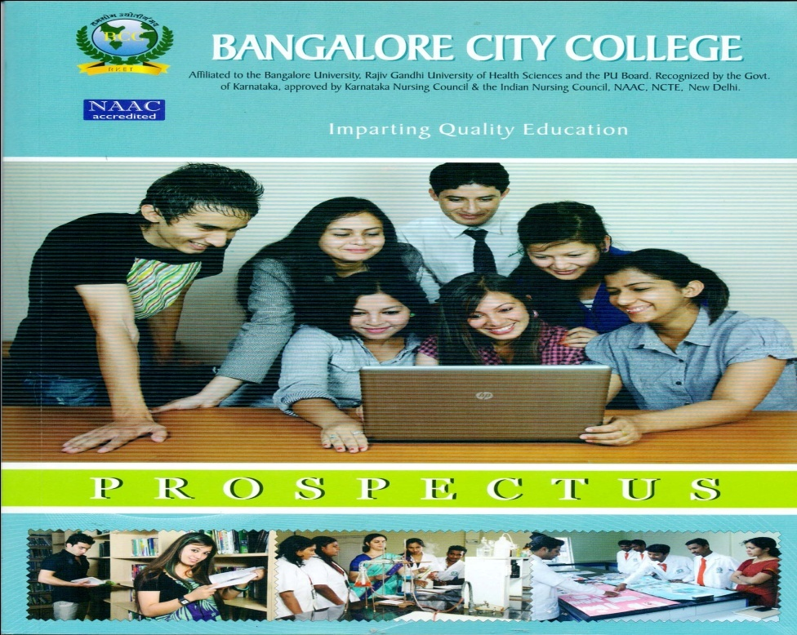
The vision and mission statement are read out at the commencement of all the official functions of the college. The mission of the college and vision of each department is communicated to the students in the orientation programs.
1.1.2 How does the institution develop and deploy action plans for effective implementation of the curriculum? Give details of the process and substantiate through specific example(s)
The College is affiliated and follows the syllabus and the curriculum prescribed by the Bangalore University.
Bangalore City College follows semester wise plan. At the beginning of the semester, an academic calendar is planned department wise. Secondly the curriculum is allotted to various department faculties based on individual’s specialization by HOD’s. Thereafter, the timetables are drawn for various programs. For example the dates of important events like Sports day, Fresher’s day, Graduation day etc. The academic calendar includes Government holidays, summer and winter vacations, internal exams etc. The department’s plan and interdepartmental activities are also listed in the academic plan. According to the academic plans, faculties will prepare lesson plans. The lesson plans are implemented and documented in work diaries. Every faculty is provided with work diaries at the beginning of the academic year. The work diaries provide the details of time table, syllabus plan – month wise/date wise which are recorded in the work diaries.
The implementation of the entire process is regularly monitored by the HOD and Principal and timely collective actions are initiated to ensure proper implementation of curriculum for all programs.
Implementation of The Curriculum:-
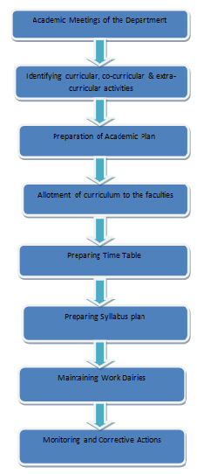
1.1.3 What type of support (procedural and practical) do the teachers receive (from the University and/or institution) for effectively translating the curriculum and improving teaching practices?
Bangalore City College has to follow the curriculum designed by the Bangalore University as it is affiliated to the same. For effectively translating the curriculum and improving the teaching practices, the faculties of respective departments conducts workshops, seminars, orientation Programs and in-service training programs. The recharging strategies are properly planned and faculties are deputed to attend workshops, seminars, conferences etc. conducted by internal and external agencies. Whenever the curriculum is amended/ revised by the University, faculties are given necessary incite and inputs through training programs.
The institution provides the necessary infrastructure for effective teaching learning practice through ICT facilities, OHP, internet, Wi-Fi etc. to impart knowledge through advanced technology.
1.1.4 Specify the initiatives taken up or contribution made by the institution for effective curriculum delivery and transaction on the Curriculum provided by the affiliating University or other statutory agency.
All the departments prepare an academic plan and implement the same. The implementation adequately ensures the entire curriculum is covered as per academic plan and sufficient time is provided for revision classes. To ensure the curriculum is properly transformed to the students. Internal tests are regularly conducted and corrective actions are initiated. The HODs of the concerned departments guide the faculties and the faculties guide the students with regard to the books to be referred, websites to be browsed on the net, online journals for reference, scientific journals, current articles etc. Every department does a frequent updating of books when there is a syllabus change and every year, updated books to be referred are recommended to be purchased and maintained in the library.
Apart from the above, field trips, Educational tours, case studies, Personality development programs etc., are also implemented for the effective curriculum delivery and transaction on the curriculum provided by the affiliating university.
1.1.5 How does the institution network and interact with beneficiaries such as industry, research bodies and the university in effective operationalization of the curriculum?
Bangalore City College has tie- ups with many industries and research institutes. Individual departments of the college have entered into network with various academic institutions, research centers etc., for interaction for quality enhancement.
Industry: Orientation visit to various industries are regularly organized by various Departments. The concern HOD’s initiates action to coordinate and organize the visits to different industries and industrial tour outside the state. This provides quality exposure to the students to gain and explore different work situations in various industries. Industries also participate in campus interviews to select and place students in their organization.
Research Bodies: - Students are exposed to research to instill scientific temper. Scientists, research fellows and academic professionals are regularly invited to deliver guest lectures on research, as resource persons for seminars, workshops, etc., all these activities enables students to complete their projects which are a part of their curriculum. Students also visit renowned research institutes like IIHR, GKVK etc.
Alumni Association provides details about the placement and research opportunities and the alumni students who are well placed in their vocation are invited to deliver guest lecture to facilitate the students to receive valuable inputs about the research opportunities, requirements to be employed
University: All the departments of Bangalore City College keep in touch with the Chairman/ Chairperson of BOEs of their respective departments in the university. The head of the departments makes a visit in person to the university and their concerned department in the university to get the latest updates and guidelines and implement the same. The HODs also arrange seminars and guest lecture through their Chairman, Board of Education.
1.1.6 What are the contributions of the institution and/or its staff members to the development of the curriculum by the University?(number of staff members/departments represented on the Board of Studies, student feedback, teacher feedback, stakeholder feedback provided, specific suggestions etc.
Renowned and eminent senior academicians are employed in various departments. They have held higher responsibilities and have served in various academic bodies in the previous assignments. Most of them are serving in various national and regional professional associations in various capacities. However currently, college has no representation on university board of studies. Most of the faculty members are regularly assigned by the university very important responsibilities evaluation process as external examiners, valuators, reviewers etc.,

1.1.7 Does the institution develop curriculum for any of the courses offered (other than those under the purview of the affiliating university) by it? If ‘yes’, give details on the process (‘Needs Assessment’, design, development and planning) and the courses for which the curriculum has been developed.
As per Bangalore University rules, affiliated colleges are not permitted to design and develop curriculum for courses offered by the University. However the institution has developed certain enrichment and enhancement courses such as Computer Application and Software Development, Personality Development programs etc., for these programs the curriculum and course materials are developed by the faculties.
1.1.8 How does institution analyze/ensure that the stated objectives of curriculum are achieved in the course of implementation?

The students’ academic performance is monitored through periodic assignments and internal tests. It comprises of class test, internal exams conducted twice every semester for both UG and PG courses. Other than the academics the students’ attendance is also monitored by maintaining hourly attendance sheet and subject wise attendance. As per the college requirement every student is expected to attend a minimum of seventy five percent of the classes conducted. Students whose academic performance and attendance percentage are below the average are identified and corrective actions are initiated.
To ensure that the stated objectives of curriculum are achieved, the head of the department monitors that the faculties follow the lesson plans and complete the syllabus in time and the revision classes are adequately conducted. Student’s assignments are evaluated. The performance in the seminars and guest lectures, Industrial visits are also monitored.
By closely monitoring the student’s performance in the above manner, the objectives of the programs are fairly achieved and the outcomes match with the objectives.
1.2 Academic Flexibility
1.2.1 Specifying the goals and objectives give details of the certificate/diploma/ skill development courses etc., offered by the institution.
Bangalore City College does not provide any certificate/diploma/skill development courses to the students. However as already mentioned in the fore going paragraphs, certain enrichment and enhancement programs are conducted.
1.2.2 Does the institution offer program’s that facilitate twinning /dual degree? If ‘yes', give details.

The Bangalore University has no provision for the affiliated colleges to offer twinning/dual degree programs.
1.2.3 Give details on the various institutional provisions with reference to academic flexibility and how it has been helpful to students in terms of skills development, academic mobility, progression to higher studies and improved potential for employability
- Range of Core /Elective options offered by the University and those opted by the college
- Choice Based Credit System and range of subject options
- Courses offered in modular form
- Credit transfer and accumulation facility
- Lateral and vertical mobility within and across programs and courses
- Enrichment courses

Range of Core /Elective options offered by the University and those opted by the college:

Bangalore City College being an affiliated college, has no provision to formulate an institutional policy on academic flexibility. Based on the norms and regulations of the University the following practices are followed.Certain UG and PG programs provide elective options which are followed by the institution.
Choice Based Credit System and range of subject options and Courses offered in modular form.

The Bangalore University has no provision for choice Based Credit System and range of subject options and offering courses in modular form. Affiliated colleges are not permitted to give credit transfer and accumulation facility. Hence no credit transfer and accumulation facility is available in the institution.

Credit transfer and accumulation facility

The Bangalore University do not practice credit transfer system.

Lateral and vertical mobility within and across programs and courses

Lateral entries are admitted for the same course under Bangalore University from other colleges as well as from our college to other affiliated to Bangalore University. After admission of students to a particular program, no vertical mobility within the program and across the program is permissible.
Enrichment courses

Certain enrichment and enhancement courses such as Computer Application and Software Development, Personality Development programs etc., for these programs the curriculum and course materials are developed by the faculties.
1.2.4 Does the institution offer self-financed program? If ‘yes’, list them and indicate how they differ from other programs, with reference to admission, curriculum, fee structure, teacher qualification, salary etc

All the programs offered by the institution are self-financed programs.
1.2.5 Does the college provide additional skill oriented programs, relevant to regional and global employment markets? If ‘yes’ provide details of such program and the beneficiaries.

Bangalore City College provides additional Skill oriented Programs relevant to regional and global employment markets that provide beneficiaries to the students in different perspectives.
Spoken English and Verbal skill: International Students who are not very proficient in English are trained and given special attention to increase their language skills both written and spoken. This academic Year the College is approved with the Master of English course which will help the students to get trained by the professionals.
Computer Fundamentals: When students are admitted for the UG and PG programs special classes on basic computer is conducted by the computer department faculties. They teach them the basics and give an outline of using Information and Communication technologies to instill the students in getting basic ideas of computer and how to make use of it in their academics and to be a eminent personality in the modern IT world.
Soft Skills: Soft skills for personality development, business communication and other skill oriented programs are arranged by our college to improve the external quality evaluation of students when they step out of our college.
Guest Lectures/ seminars: Eminent resource persons from different industries will be called to give hands on training and lectures to train the students for global environment.
1.2.6 Does the University provide for the flexibility of combining the conventional face-to-face and Distance Mode of Education for students to choose the courses/combination of their choice” If ‘yes’, how does the institution take advantage of such provision for the benefit of students?
The institution does not offer any distance mode education programs.
1.3 Curriculum Enrichment
1.3.1 Describe the efforts made by the institution to supplement the University’s Curriculum to ensure that the academic programs and Institution’s goals and objectives are integrated?

The institution initiates the following actions to ensure that the academic programs integrate with the institutional goals:

- To effectively transform the curriculum designed by the university a structured teaching practices are designed for the students to successfully complete external quality evaluation and for the promotion and sustenance of academic initiatives.

- The institute believes in focusing through promotion of quality teaching and learning. Sufficient opportunities are provided to the students for self-evaluation and improvements.

- The institute has created an academic atmosphere for excellence in studies through use of the latest technologies in delivering the knowledge, to acquire competitive skills and possess the right attitude.

- The college through co-curricular activities fosters a comprehensive development of the youth of today to make them the most powerful and highly respected citizens of tomorrow.

1.3.2 What are the efforts made by the institution to modify, enrich and organize the curriculum to explicitly reflect the experiences of the students and cater to needs of the dynamic employment market?

Our College entirely depends on the curriculum provided by the Bangalore University for both UG and PG programs. The efforts made by our college to enrich curriculum to cater the needs of the dynamic employment market is by following practices mentioned hereunder:
- The teaching learning practices emphasize on innovative learning practices which provides the valuable insight to the students on the work environment beyond the theory sessions.
- The annual academic plan ensures that as part of the co-curricular activities, the students participate in programs such as workshops, seminars, guest lecture etc. Primarily the objectives of these activities are to expose and interact with the expert from the industry and business houses. Valuable inputs on the practical work situations are shared in these sessions. The dynamic and challenging demands in the employment market are also made known to them.
- As a part of enrichment programs the students undergo personality development program which ensures developing life skills among the students besides preparing them for on the job assignments.
- The feedback system which is regularly under taken by the institution ensures that the students provide feedbacks on the curriculum, teaching learning practices, co-curricular activities and about the infrastructure and the institution. The analysis on all these feedbacks provides valuable inputs for the institution to review the various practices for the betterment of the quality systems.
1.3.3 Enumerate the efforts made by the institution to integrate the cross cutting issues such as Gender, Climate Change, Environmental Education, Human Rights, ICT etc., into the curriculum

The institution is aware that there are various cross cutting issues which needs to be integrated into the curriculum. Some of the major issues are examined hereunder:
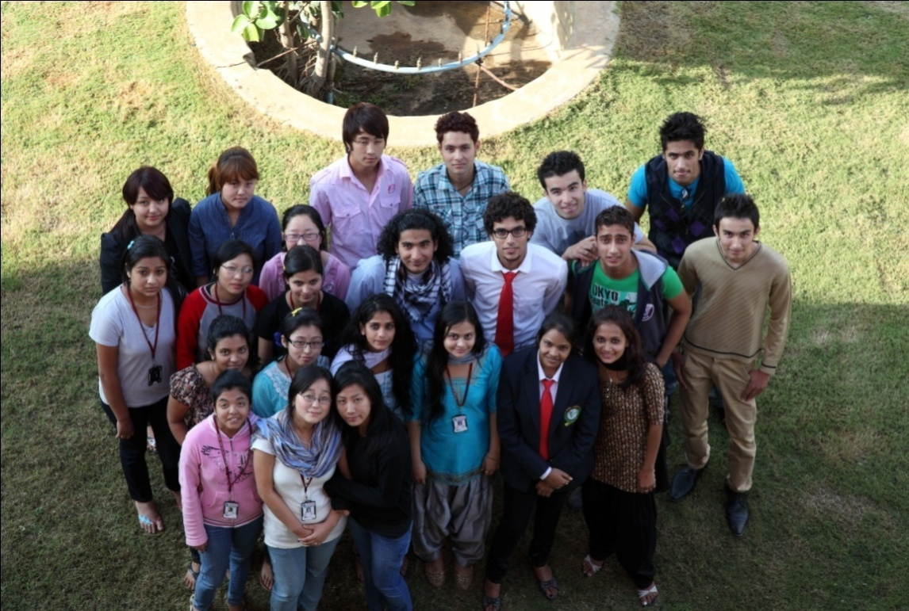
- Gender and gender sensitivity; in a country like ours have primary importance for education and employment.Sensitizing the youngsters is a very important duty of every institution. Hence, during induction program for the fresher’s every year, a special session is held on gender sensitivity.
- In addition to the induction program which briefly covers the climate and environment education, the institution on a continuous process inculcates and develops the students to be of environmental friendly and to be instrumental in eco development in all the approaches. This is achieved through day to day practices which every student is required to practice and through special programs such as observation of World Environment day etc.
- The institute has created an environment in the campus which promotes a culture which is free, fair and the most disciplined. This environment by itself promotes every individual to play a role which is independent but within its parameters required for the organization. Furthermore guest lecture on the subjects promotes and facilitates the students to develop the right qualities.
- ICT: The institution has realized the growing impact of information communication technology globally within the country. It has become very evident that pursuing any branch of education without active aid of ICT will only result in producing semi-literate citizens. Hence, the institution has given the optimum importance for ICT in all the spheres of academic activities. Class rooms in fair numbers are ICT enabled, exclusive seminar hall with state-of-the- art technology, computerized central library, WI-FI enabled campus etc. are some of the significant facility available on the campus to the students and the faculty.
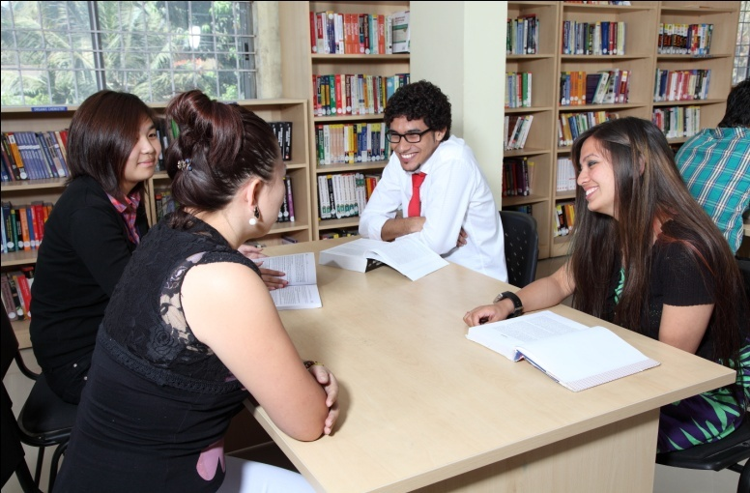 | 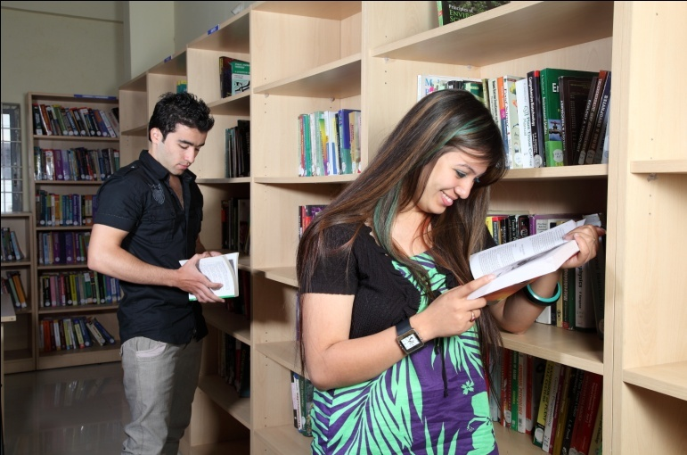
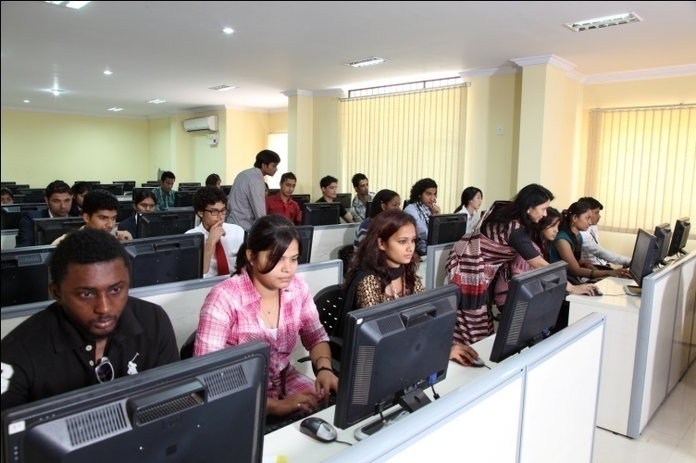 | 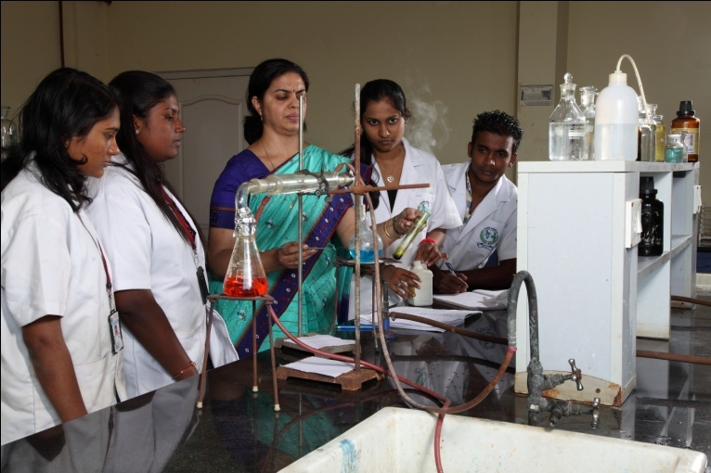

1.3.4 What are the various value-added courses/enrichment programmes offered to ensure holistic development of students?
    - moral and ethical values
    - employable and life skills
    - better career options
    - community orientation

Creative writing contests, Employable and life skills Moral and ethical values, career oriented options; Community orientation provides a holistic development of students.
Moral and ethical values:-
The induction program conducted for the fresher are designed to elaborately include lecture sessions and activities sessions which generates moral and ethical values among the students. Further, the code of conduct which students are required to follow imbibes these values among the students.
To implement the importance of these values, programs are conducted to promote and practice the values. Even speech competition, essay writing, skit, cultural activities etc. are organized to imbibe moral and ethical values.
Employable and Lifestyles:-
The college has a placement cell which is responsible for conducting campus interviews and placing the students in suitable jobs. As a preliminary and preparatory activity of the program, a cell organizes personality development programs to develop soft skills of the students. These preparatory activities mould the students to the current industry needs and also help them to build a skilled personality to face the various complex work situations in the competitive world.
Better career options:-
The institution is currently conducting eight UG programs and Thirteen PG programs. This enables the candidates who seek admission to both UG and PG programs,a wide variety of options to select the program of his/her choice as per the career option decided by the individual student.
Community orientation:-
The college with the active participation of students from all the programs in general and students of Master of Social Work department in particular, a number of community orientation projects like social counseling, blood donation and organ donation camps, visit and service to orphanages and blind schools, organizing camps in rural areas for creating public awareness on social, ethical, medical and marital issues etc. are being regularly carried out.
The NSS camp helps to integrate issues like human rights awareness/ program, environmental Education etc., to provide awareness to students and to the community.
1.3.5 Citing a few examples enumerate on the extent of use of the feedback from stakeholders in enriching the curriculum?

The College is practicing to obtain feedback from stakeholders, analyzing them to identify corrective actions required for the improvement. Majority of the actions are for the improvement of co curricular and extracurricular activities only. This is the view of the reason that as an affiliated college, it is bound to follow and implement the curriculum designed by the BOS of the Bangalore University.
The feedback from the stakeholders is analyzed and a few improvements made in the curriculum are given below.
  - Each program’s academic calendar plans for a day in a week for organizing co curricular activities and planning the activity and including the same in the annual academic calendar.
  - The faculties regularly plan theory and practical classes which are far more than the University norms and requirements. This facilitates the faculties to complete the portion in a fairly shorter period of time, to spent useful time in revision and classroom activities which help the students to achieve excellence in academics.
  - All the department plan and organizes educational trips and industrial visits which enriches the quality of education.
  - The faculties discuss on various academic issues with the respective BOE’s with regard to departments’ issues and identify the solutions. The faculties also participate in valuation of answer booklets and acquire certain additional inputs to their curriculum aspects. They also attend seminars and workshops organized by the university and other external organizations. The valuable information acquired is shared in the general meetings which creates general awareness and to improve the curriculum.
1.3.6 How does the institution monitor and evaluate the quality of its enrichment programmes?
The institution evaluates the quality of the enrichment programs by following feedback systems. The analysis are tabulated, analyzed and corrective actions are initiated.

1.4 Feedback System
1.4.1 What are the contributions of the institution in the design and development of the curriculum prepared by the University?
The curriculum is designed by the Bangalore University and hence the College besides providing feedback on the curriculum has an interaction with BOE’s when ever required.

1.4.2 Is there a formal mechanism to obtain feedback from students and stakeholders on Curriculum? If ‘yes’, how is it communicated to the University and made use internally for curriculum enrichment and introducing changes/new programmes?
Feedback is obtained from students and stake holders. After feedback analysis, changes in co-curricular and extra-curricular activities are made by the college. Suggestions and feedback are provided to the Bangalore University in respect to the curriculum.
1.4.3 How many new programs/courses were introduced by the institution during the last four years? What was the rationale for introducing new courses/programs?

The new programs introduced in the College in the last four years are:
Master of International Business, Master of Financial Accounting, Master of English, Master of Science in Mathematics and Electronics and B. Sc Microbiology.
The institute undertook survey and feedback from the stakeholders. After a detailed study of data obtained a pilot study was under taken. When all the outcomes were positive and encouraging the institute took necessary permission from the affiliating University and launched the new programs.
Any other relevant information regarding curricular aspects which the college would like to include:
Nil

Criterion- II: Teaching-Learning and Evaluation
2.1 Student Enrolment and Profile
2.1.1 How does the college ensure publicity and transparency in the admission process?
The institution has absolute transparency in the admission process. An admission desk is established with the team of personnel to counsel the candidates and parents who wish to seek admission to the various programs conducted by the institution. The admission desk comprehensively provides multiple solutions to all the queries and enquiries regarding the admission. The admission notification is advertised in leading regional/national newspapers and on the college websites www.bangalorecitycollege.org. Prospectuses of the college are printed every year and are distributed at all educational fairs. The prospectus provide complete details and information about the UG and PG courses, eligibility criteria and the facilities provided by the college management.
The team regularly undertakes visits to various cities in different states where common entrance tests are conducted. The participants are provided with pamphlets and information about the programs at the college and the candidates’ personal information are collected. This enables the candidates to contact the college for admission and for the college to follow up with the candidates.
The team visits institutions which are providing pre university education. Interested students are invited to visit the college wherein they are counseled on the relevant academic or other relevant details available at the institution. The students are guided to see and understand the various infrastructural facilities available at the campus.
Large hoardings are displayed at the vantage points for the information of the public and students which provides details of the various programs conducted by the institution.
2.1.2 Explain in detail the criteria adopted and process of admission (Ex. (i) merit (ii) common admission test conducted by state agencies and national agencies (iii) combination of merit and entrance test or merit, entrance test and interview (iv) any other) to various programs of the Institution.
The programs conducted by the college do not require any preliminary qualifying examination /tests. Admission to UG programs is based on the marks in the qualifying examination, followed by an interview and the procedure as per the norms of Bangalore University. The affiliating university has prescribed the procedure to share the admissions for the PG programs. The institution independently initiates action for admitting the students under the institution quota. The final selection for admission is after an interview. In respect of the seats to be offered under the university share, the university initiates action for the admission process and sends a list of candidates to be admitted and the college complies with the instructions.
    - Give the minimum and maximum percentage of marks for admission at entry level for each of the programs offered by the college and provide a comparison with other colleges of the affiliating university within the city/district.

The minimum percentage of marks for PG and UG programs are as per the university norms for different categories of students. However neither the university nor the college has fixed any maximum percentage of marks for admission.
Generally all the affiliated colleges of the university follow the above procedure for admission to UG and PG programs.
    - Is there a mechanism in the institution to review the admission process and student profiles annually? If ‘yes’ what is the outcome of such an effort and how has it contributed to the improvement of the process?

Yes. The college admission desk conducts regular meetings after the admission is complete. The students’ profile and minimum maximum percentage marks for admission for all the programs are analyzed. In case of decrease on demand for admissions for any programs if any are analyzed and corrective actions are initiated.

2.1.5 Reflecting on the strategies adopted to increase/improve access for following categories of students, enumerate on how the admission policy of the institution and its student profiles demonstrate/reflect the National commitment to diversity and inclusion
- SC/ST
- OBC
- Women
- Differently abled
- Economically weaker sections
- Minority community
- Any other

The college is required to follow and adhere to the norms of the Bangalore University in respect of admission of students from various categories. Hence the admission policies are in line with the university’s guidelines and admissions are carried out accordingly.

2.1.6 Provide the following details for various programs offered by the institution during the last four years and comment on the trends. i.e. reasons for increase / decrease and actions initiated for improvement.
Details of Existing UG Courses (Combination wise) With Intake:-
Sl  No | Existing  Course | Combination | Year of Affiliation | Admission made
 |  |  |  | 2009-10 | 2010-11 | 2011-12 | 2012-13 | 2013-14
01 | B.Sc(CS) | Computer Science,Mathematics, Statistics | 2001-02 | 15 | 0 | 0 | 15 | 07
02 | B.Sc(BT) | Biotech,Biochemistry, Genetics | 2001-02 | 17 | 12 | 17 | 17 | 16
03 | B.Sc(MB) | Microbiology, Biotech, Chemistry | 2003-04 | 0 | 0 | 06 | 25 | 0
04 | B.Sc(FAD) | Fashion & Apparel Design | 2006-07 | 13 | 09 | 09 | 10 | 11
05 | B.Sc(ELE) | Electronics, Physics, Maths | 2009-10 | 0 | 0 | 0 | 06 | 0
06 | BCA | Computer Application | 2000-01 | 62 | 35 | 46 | 70 | 47
07 | BBM | BBM | 2001-02 | 59 | 44 | 24 | 44 | 23
08 | B.Com | B.Com | 2005-06 | 28 | 28 | 38 | 55 | 32
09 | BA(Jour) | Journalism,  Opt.Eng  Psychology | 2005-06 | 06 | 09 | 17 | 13 | 04
10 | BA(P.Sci) | Economics, Sociology,Political Science | 2009-10 | 01 | 0 | 0 | 0 | 0
11 | BA(P.Sci) | History,Sociology,Political Science | 2009-10 | 03 | 0 | 06 | 03 | 0

1 Under Graduation

2 Post Graduation
Details of Existing PG Courses (Combination-Wise) With Intake:-
Sl.  No | Combination | Program | Admission made
Sl.  No | Combination | Program | 2009-10 | 2010-11 | 2011-12 | 2012-13 | 2013-14
01 | Biotechnology | M. Sc  Biotechnology | 29 | 51 | 39 | 11 | 19
02 | Biochemistry | M. Sc  Biochemistry | 09 | 22 | 11 | 15 | 04
03 | Physics (Electronics,  Material Science, Space Science) | M. Sc  Physics | 40 | 59 | 44 | 62 | 60
04 | Chemistry -  (Organic/  Physical/  Analytical/Inorganic) | M. Sc  Organic Chemistry | 27 | 50 | 24 | 70 | 40
05 | Microbiology | M. Sc  Microbiology | 05 | 27 | 12 | 14 | 14
06 | Electronics | M. Sc  Electronics | 0 | 31 | 24 | 17 | 12
07 | Social work | MSW | 36 | 47 | 23 | 24 | 29
08 | MIB | MIB | 19 | 14 | 12 | 0 | 02
09 | MFA | MFA | 05 | 08 | 15 | 16 | 11
10 | Computer Science | M. Sc  Computer  Science | 26 | 21 | 27 | 05 | 12
11 | Mathematics | M. Sc  (Maths) | 0 | 0 | 0 | 0 | 12
12 | English | MA(Eng) | 0 | 0 | 0 | 0 | 06

2.2 Catering to students diversity
2.2.1. How does the institution caters to the needs of differently –abled students and ensure adherence to government policies in this regard?
Bangalore City College has ensured the infrastructural facilities are disabled friendly. As the building has multiple floors, an exclusive electrical elevator is installed to facilitate the differently-abled student’s easy movement.
2.2.2. Does the institution assess the students’ needs in terms of knowledge and skills before the commencement of the program? If ‘yes’, give details on the process.
An induction program and a bridge course are conducted to all the students who joined the college. During these programs, the student’s current level of knowledge and skills are assessed. Certain participatory exercises such as group discussions on some current topics, simple quiz contest, etc., are conducted and students’ knowledge and skills are assessed.
2.2.3. What are the strategies drawn and deployed by the institution to bridge the knowledge gap of the enrolled students to enable them to cope with the programme of their choice? (Bridge/ Remedial/ Add-on/ Enrichment courses etc)
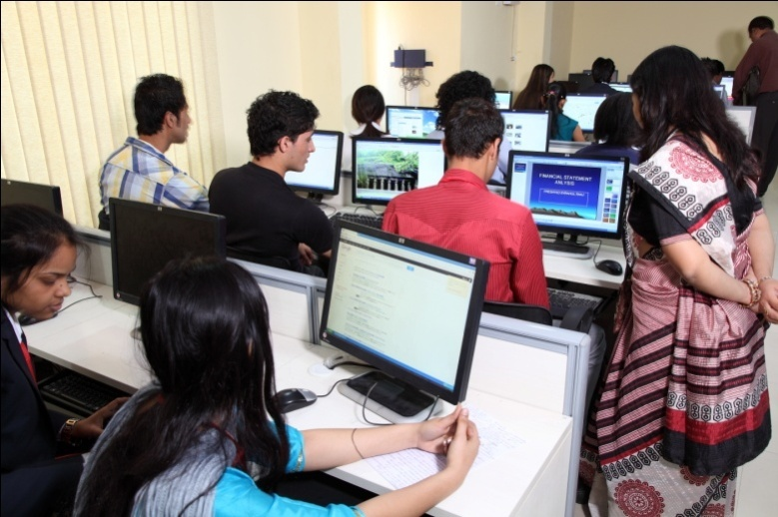

Students are grouped based on the needs that are required to enable them to effectively perform academically. To bridge the knowledge and skill gap, foundation lectures are delivered before commencement of the regular classes. Further, the students’ class performance and the internal test are assessed. On the basis of all these factors, students are categorized as advanced learners, average learners and slow learners. The slow learners are provided special coaching through remedial classes to academically rehabilitate them. Depending upon the students’ knowledge gap, add on/enrichment programs are also conducted.

2.2.4. How does the college sensitize its staffs and students on issues such as gender, inclusion, environment etc.?
The institution has initiated several actions to sensitize students on gender, inclusion and environment. This is in view of the fact that the students come from gender specific institutions and from rural areas. During the induction program, clear awareness and education is provided to the students to the rules and regulations of the college including the dress code, common timings, and students’ code of conduct, gender sensitivity, inclusive practices and environmental awareness. The HODs/Principal monitors and guides to resolve students’ problems and grievances. In order to make the class room environment comfortable, the faculty in charge takes care of the seating arrangements based on the background from which the students’ have come from. Special care is also taken in respect of students with weakness in communication skills (spoken English classes are conducted regularly) to ensure that the barrier in communication is eliminated.
2.2.5. How does the institution identify and respond to special educational/ learning needs of advanced learners?
The advanced learners are identified in the same manner by which slow learners are identified. Some of the motivations to recognize the positive performance of the advanced learners are by nominating them as class representatives, sponsoring them to the external quiz competitions, poster presentations, seminars etc. The faculties also ensure certain special efforts are made to guide these students to acquire knowledge and skills beyond the curriculum through special classes. Special tutorials are organized to enable these students to participate in national level competitive examinations and any high level research activities.
2.2.6. How does the institute collect, analyze and use the data and information on the academic performance (through the program duration) of the students at risk of drop out (students from the disadvantaged section of society, physically challenged, slow learners, economically weaker sections etc).
To bridge the knowledge and skill gap, foundation lectures are delivered before commencement of the regular classes. Further, students are categorized as advanced learners, average learners and slow learners. The slow learners are provided special coaching through remedial classes to academically rehabilitate them. Depending upon the students’ knowledge gap, add-on/enrichment programs are also conducted.
2.3.1. How does the college plan and organize the teaching learning and evaluation schedules?
Academic plan: The College has two semesters in each academic year according to Bangalore university curriculum. A fixed number of courses are taught in each semester through different teaching methods: lectures, tutorials, assignments, internal tests etc. In all departments internal assessment is conducted twice a semester. Based on the students’ performance, final marks are sent to the university. Academic calendar according to the university curriculum are planned before the commencement of each semester. It is submitted within seven days of the beginning of the first and second semester. A copy of the teaching plan is submitted to the Principal. Depending on the syllabus stipulated by the university and college academic calendar, each department frames the teaching plan, distributing the classes per paper/topic for every teacher at the beginning of the academic session. Intra-departmental meetings are held from time to time to review the progress of study in the department in order to complete the syllabus, and for proper understanding of the subject by the students.
Teaching plan: All the courses taught in the college are through lecture method. Apart from classroom interactions, tutorials, assignments, project-writing and seminars are provided to the students in most of the Departments. Some departments adopt other practices such as group discussion, laboratory work, field-work, industrial visits etc. Individual faculties from all departments have to maintain work diaries where details of all lesson plans are made and sincerely followed.
Time table (for regular lectures): Time table for regular class room sessions for the forth coming academic semester is prepared and displayed on the notice board well in advance. This helps to ensure that the lectures start on the very first day of the academic semester. If any lecturer is absent on a particular day his/her lecture is engaged by a substitute which ensures non cancellation of classes.
Portion Completion Certificate: In the beginning of the academic year itself the total number of lectures available during the semester is calculated on the basis of academic calendar and examination schedule. Accordingly teaching plans are prepared and portion completion dates are announced and intimated to the H.O.D. In case a teacher needs additional lectures, special lectures are allotted.
Examination schedules: Semester examination schedules are notified through the academic calendar issued before the beginning of the semester. Class tests topics and dates are notified through the notice board.
Evaluation of Blue print: Dates of examinations, last dates for submission of project reports, commencement dates for new academic year, dates of revaluation of papers, etc are announced well in advance.
2.3.2. How does IQAC contribute to improve teaching-learning process?
IQAC help to improve the overall teaching – learning process by introducing self appraisal of faculty, student assessment of faculty performance getting continuous feedback, in turn the particular faculty can work out on the respective feedbacks in order to improve his or her teaching as a whole. Moreover, the faculties evince interest to introduce and adopt best practices in the college that would improve the teaching learning system.
The IQAC has been regularly organizing several quality enrichment programs. Especially from the previous academic years many programs are focusing on learning, teaching-learning enhancement. Even for current academic year 2013-14, a detailed annual IQAC plan has been formulated and programs are organized as per the plan.
2.3.3. How is learning more student centric?
In the class room lecture sessions, the faculties generally conduct buzz sessions. The students are divided into small groups and the topic to be covered for the day is given to all the groups. The groups are required to independently discuss among themselves for fifteen minutes. A representative from each group shall make a presentation of the group discussions. Thereafter the faculty shall handle the lecture session and provide the required knowledge on the topic. The exercise generates interest among the students as to which group has rightly identified the contents of the topic.
Further, over a period of time a healthy competition is created among the students to contribute effectively in each session. It has also motivated the students to prepare and attend the class room sessions to excel in the buzz sessions. A few advanced learners take it as a challenge to express their own thoughts regarding the topic to be taught.
In a few seminars, group discussions on topics are allotted to the students which make them to interact positively, involve frequently in reference work and in turn increase their interest in that particular subject or topic. Some current topics are given to students to discuss in the Journal Club conducted from time to time in most of science departments. They are encouraged to participate in external seminars and quiz programs. Advanced students are given responsibility to undertake a class seminar or any particular case study in which all of the students are benefited through collaborative learning. Topics for project work are given to the students which are beyond curriculum.
2.3.4. How does the college nurture critical thinking, creativity and scientific temper among the students to transform them into lifelong learners and innovators?
Students are encouraged to participate in some debate competitions or they are asked to take some recent topics in popular science as seminars. The college arranges for field trips to good institutions to enable them to inculcate the finer aspects of higher studies and research activities. Orientation visits are undertaken to expose them to understand the actual working conditions, work culture and various other vocation related norms, procedures etc,. They are encouraged to take hands- on projects at some industries where they can have the glimpse of the future of the particular subject they are interested for. They participate in lectures of eminent scientists or resource person in house or outside to have a glimpse of the current research topics on all fields. Students are given ideas of research methodologies to develop the scientific temper among them.
Apart from their curriculum, they are encouraged to participate in debates, group discussions, seminars, workshops, competitions in arts and crafts of various types. These help them to cultivate talents and skills beyond their curricular requirements, thus facilitating an all-round personality development. Students are encouraged to participate actively in the College NSS unit to inculcate a sense of civic responsibility and community orientation
2.3.5. What are the technologies and facilities available and used by the faculty for effective teaching?
For effective teaching by the faculty, the following facilities are provided:
Sufficient numbers of class rooms are provided with multimedia projectors with internet facility.
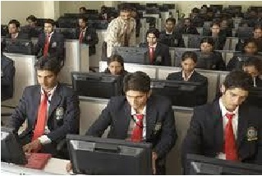 | 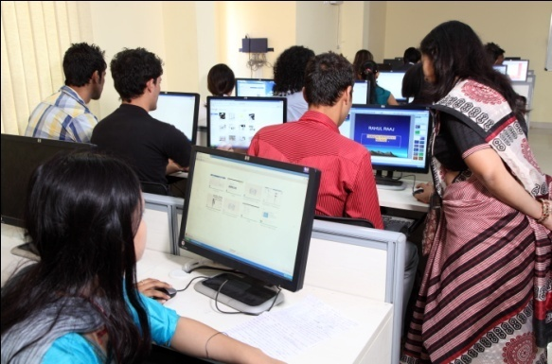
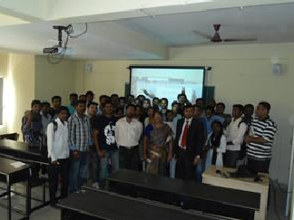 | 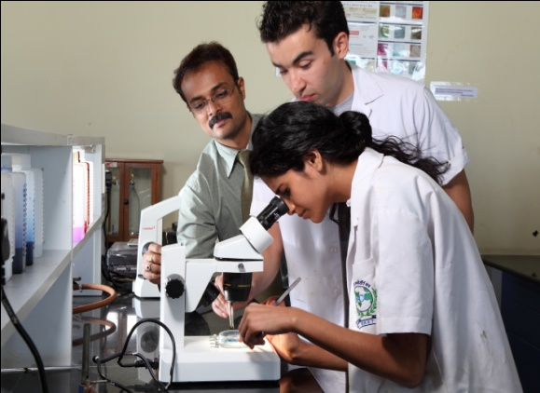

Sufficient number of desktops with internet facility is provided to all the faculties.
The objective of providing the desktops with internet are to facilitate the faculties to prepare lesson plans, power point presentations , web assignments, etc. further it also facilitates the faculties to regularly browse the various important websites to keep themselves aware of the emerging trends and recent technologies in the respective fields to enable them to effectively perform the teaching-learning process.
The institution has subscribed for online access to Journals through INFLIBNET as a part of library. Faculties can utilize the e-resource. Each faculty member has a unique login ID and password for INFLIBNET access.
The institute has a large computer lab with latest licensed software’s and hardware’s with Wi-Fi and internet facilities. The lab is extensively used by the faculties and students. Computers are upgraded from time to time
2.3.6. How are the students and faculty exposed to advanced level of knowledge and skills?
Students are exposed to innovative learning through ICT that power point presentations. Students’ are encouraged to participate in seminars or workshops conducted by the institution or external colleges. The teachers adopt interactive and participatory approach in creating a feeling of responsibility in learning to make learning a process of construction of knowledge and to continuously develop knowledge. The College provides internet facilities to the teachers and students through Wi-Fi connectivity which is free of cost. Students and teachers acquire knowledge through internet surfing.
2.3.7. Detail on the academic, personal and psycho-social support and guidance services provided to the students.
Academic support
Students are free to approach the faculty to clarify their doubts even after teaching hours. They are encouraged to solve the previous years question papers and unsolved questions are discussed in the class room. Teachers extend help to the students for detailed references and websites in the respective subjects. During study holidays prior to the semester examinations, teachers encourage the students to seek guidance on the subjects and to clear the doubts. Academic advices are provided to advanced learners which suits their standard. Counseling is provided to the needy students’.
Personal and Psycho-Social support
The mentor-mentee system is to identify and provide support to the slow learners. Students are grouped in small numbers to the individual faculties who under take case work on students and counsel them to provide personal and psycho social support to enable the slow learners to improve their academic performance.
2.3.8. Provide details of the innovative teaching approaches adopted by the faculty in the last four years.
As mentioned under 2.3.3 above, various methods are adopted by faculties to make learning effective as well as interesting to the students of all courses. The management of the college always encourages teachers to practice innovative methods.

2.3.9. How are library resources used to augment teaching-learning process?
The college has a well-equipped computerized library with adequate books including text books, reference books, advanced books, journals and periodicals on various subjects. On an average 40 teachers and one hundred students visit the library every day.
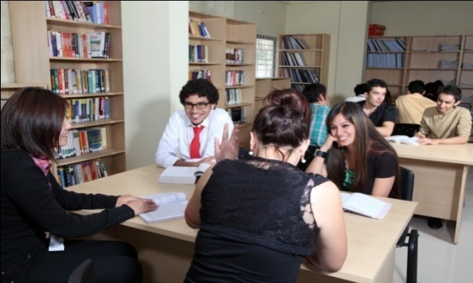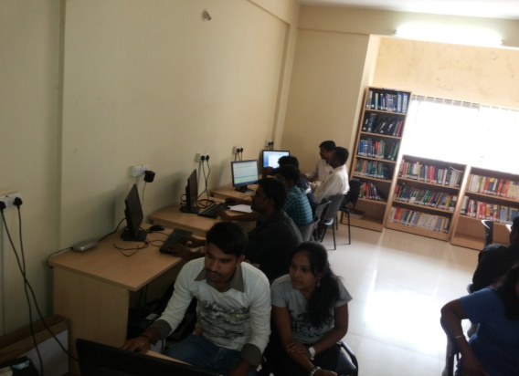
The details of support services available in the library are:
- Computer facility
- Online access to Journals is provided through INFLIBNET. Each faculty member has a login ID and password for INFLIBNET access.
- The library provides supportive services to assist the faculty and students who information on selected topics.
- Information on new arrivals
- Display of interesting articles
- Question papers of previous years are maintained for students’ reference and to prepare for the examinations.

2.3.10. Does the institution face any challenges in completing the curriculum within the planned time frame and calendar? If ‘yes’, elaborate on the challenges countered and the institutional approaches to overcome these.
The present University norm envisages semester schemes for both UG and PG programs. The academic calendar has provided target dates for completing the curriculum. The academic calendar is developed by the institution for different programs plans month wise and date wise activities for the co-curricular and extra-curricular programs. The faculties prepare lesson plans to ensure the curriculum is completed well in advance. The faculty work diary ensures a disciplined and systematic teaching learning practice. The faculties are required to guide and assist the slow learners to progress through counseling and remedial classes. The faculties are required to ensure motivational programs for the advanced learners.
All the above academic activities are fairly challenging. The institution and faculty are able to overcome the challenges through the systematic academic practices such as annual academic plan, lesson plans, work diaries, mentor-mentee program etc.,
2.3.11 How does the institute monitor and evaluate the quality of teaching learning?
All the faculties are required to prepare the lesson plans which are approved by the HODs. Every faculty member regularly completes the work diaries which are perused by the HODs.
Students provide feedback on the faculties which are analyzed and necessary action is initiated for improvement in quality of teaching. The institution also practices the procedure of members of the senior faculty observing the teaching performance of the faculty in the class rooms and providing guidance and tips to the faculty for improvement and development.
The recharging facility further augments the faculty to further improve their teaching skills.
2.4 Teacher Quality
2.4.1 Provide the following details and elaborate on the strategies adopted by the college in planning and management (recruitment and retention) of its human resource (qualified and competent teachers) to meet the changing requirements of the curriculum

Highest qualification | Professor |  | Associate Professor |  | Assistant Professor |  | Total
Highest qualification | *M | *F | *M | *F | *M | *F | Total
Permanent teachers: 86
D.Sc./D.Litt. | - | - | - | - | - | - | -
Ph.D. | 07 | 07 | 00 | 00 | 00 | 03 | 17
M.Phil. | 01 | 01 | 01 | 02 | 02 | 06 | 13
PG | 02 | 02 | 05 | 02 | 11 | 34 | 56
Part-time teachers: 01
Ph.D. | 1 | - | - | - | - | - | 01
M.Phil. | - | - | - | - | - | - | -
PG | - | - | - | - | - | - | -

    - How does the institution cope with the growing demand/ scarcity of qualified senior faculty to teach new programs/ modern areas (emerging areas) of study being introduced (Biotechnology, IT, Bioinformatics etc.)? Provide details on the efforts made by the institution in this direction and the outcome during the last three years.

The institution is situated in a renowned city of Bangalore which is known for qualified and experienced academicians and professional industry leaders. Hence the institution has not faced any serious difficulties in sourcing good academicians. Besides, the institution has developed a good retention policy where by the employee’s turnover is very marginal.

    - Providing details on staff development programs during the last four years elaborate on the strategies adopted by the institution in enhancing the teacher quality.

a) Nomination to staff development programs
Academic Staff Development Programs | Number of faculty  nominated
Refresher courses | 05
HRD programs | 02
Orientation programs | 05
Staff training conducted by the university | 02
Staff training conducted by other institutions | 10
Summer / winter schools, workshops, etc. | Nil

b) Faculty Training programs organized by the institution to empower and enable the use of various tools and technology for improved teaching-learning
Teaching learning methods/approaches
- Handling new curriculum : yes
- Content/knowledge management : yes
- Assessment : yes
- Cross cutting issues : yes
- Audio Visual Aids/multimedia : yes
- Teaching learning material development, selection and use : yes

c) Percentage of faculty
- Invited as resource persons in Workshops / Seminars / Conferences organized by external professional agencies : 20%

- Participated in external Workshops / Seminars / Conferences recognized by national/ international professional bodies : 20%

- Presented papers in Workshops / Seminars / Conferences conducted or recognized by professional agencies : 40%.

    - What policies/systems are in place to recharge teachers? (eg: providing research grants, study leave, support for research and academic publications teaching experience in other national institutions and specialized programs industrial engagement etc.)

- Teachers are given the opportunity to attend seminars and workshop conducted by other colleges
- Faculties are granted leave to carry out their research works
- Provides OOD for participating in seminars and conferences

    - Give the number of faculty who received awards / recognition at the state, national and international level for excellence in teaching during the last four years. Enunciate how the institutional culture and environment contributed to such performance/achievement of the faculty.

Faculties who have given 100% result in the subject handled are facilitated by the management.

Sl No | Name of the faculty | Details of award | Date/  year
1 | Dr. Sreekanth P.M  ( Dept. of Biotechnology) | Dr. K.M Bhat endowment gold medal for the best emerging Scientist of Kerala Forest Research Institute, Peechi, Thrissur, Kerala | 2013
2 | Prof. Umamaheswari. V.  ( Dept. of Social Work) | Golden Interviewer by MIOL study, Aravind Eye Hospital, Madurai. HR Specialist by Fastrack, Madurai. Best Lecturer by Sathya jothi College, Bangalore. Best Social Worker by Madurai Institute of Social Sciences, Madurai. | 2010
3 | Mrs. Devi  ( Dept. of Microbiology) | Best Poster (National conference-yogurt production and its anticandidal effect)-Bharathidasan University, Trichirapalli | 2009

    - Has the institution introduced evaluation of teachers by the students and external Peers? If yes, how is the evaluation used for improving the quality of the teaching-learning process?
The institution has implemented the feedback system through which the students provide feedback on the faculty teaching once in a semester. The feedbacks are analyzed and the HOD individually meets the faculty concerned and shares the details of the analysis. The appreciation received from the students and improvements required to be taken up by the faculties are also discussed.
The feedback from the senior faculties also further provides an opportunity to the faculty to improve the quality of teaching learning process.
  - Evaluation Process and Reforms

2.5.1 How does the institution ensure that the stakeholders of the institution especially students and faculty are aware of the evaluation processes?
The comprehensive information and details of the evaluation process is printed in the prospectus which is provided to the students.
The details are available on the institution’s website also.
During the induction program an exclusive session is held to explain the details of the evaluation process,
The above activities ensure that the students and faculties are aware of the evaluation process.
2.5.2 What are the major evaluation reforms of the university that the institution has adopted and what are the reforms initiated by the institution on its own?
The major evaluation reforms introduced by the University have been adopted by the institute. The details are:-
- The patterns of question papers are changed. In line with the university question papers, the college has suitably revised the question papers set for internal assessments.
- The answer scripts are modified and OMR patterns are introduced for certain papers.
- The university has introduced completion and evaluation of research dissertation projects to be mandatory for a few programs which was exempted in the past.
- The grading system for internal assessment has been introduced for all UG programs from the academic year 2011-12.

2.5.3 How does the institution ensure effective implementation of the evaluation reforms of the university and those initiated by the institution on its own?
The implementations of evaluative reforms are ensured by adopting the following process:
- The academic committee at the beginning of the academic year receives communication from the parent university in respect of reforms to the evaluation if any.
- In case of reforms evaluation, the procedure to be adopted is discussed and circulars, notices and communications are sending to all the stake holders about the change in the procedure.
- The principal with the able support of HODs and nonteaching staff ensures that a quality systems which are operational for evaluation process is suitably amended for effective implementation.
- Constant monitoring and follow up results in successful implementation of the evaluation reforms.

    - Provide details on the formative and summative evaluation approaches adapted to measure student achievement. Cite a few examples which have positively impacted the system.

The institution has been practicing both formative and summative process of assessment and evaluation.
In the formative assessment the goal is to monitor the students learning and provide feedback to the students. Parallely the students’ feedback on faculty is obtained on the teaching learning methodology. Appropriate changes and amendment are made in the teaching learning practice by the faculty suiting to their requirements of the students.
The process helps students to identify their strengths and weaknesses and target areas that need additional efforts.
The goal of the summative assessment is to evaluate student learning at the end of an instructional unit and comparing the same with the standard practice or practices which are bench marked. Some of the summative assessments includes midterm examination, the final project etc.

2.5.5 Enumerate on how the institution monitors and communicates the progress and performance of students through the duration of the course/program? Provide an analysis of the students results/achievements (Program/course wise for last four years) and explain the differences if any and patterns of achievement across the programs/courses offered.
Department | Pass percentage for Each Year
Department | 2009 | 2010 | 2011 | 2012 | 2013
Biotechnology UG Dept. | 100% | 100% | 100% | 95% | 95%
Biotechnology PG Dept. | 100% | 100% | 97% | 97% | 97%
Chemistry PG Dept | 75% | 80% | 85% | 85% | 70%
Biochemistry PG Dept | 72% | 64% | 60% | 46% | 80%
Computer Science BCA | 56% | 74% | 46% | 80 % | 50%
Computer Science B.Sc., | No Adm | No Adm | No Adm | 60% | No Adm
Computer Science M.Sc., | - | - | - | 84% | 94%
Microbiology PG Dept | 82% | 100% | 100% | 100% | 87.5%
Microbiology UG Dept | ------ | ------ | ------- | ------ | ----
Electronics PG Dept | ------ | ------ | ------- | 14% | 50%
Physics PG Dept | 75% | 53% | 36% | 25% | 27%
FAD Dept | ------- | ------ | 33% | 44% | 64%
BA | ------- | 33% | 40% | 100% | 100%
BBM | 52% | 72% | 62% | 44% | 60%
B.Com | 39% | 65% | 55% | 50% | 61%
MIB | 58% | 91% | 50% | ------- | -----
MFA | 100% | 100% | 89% | ------ | ------

2.5.6 Detail on the significant improvements made in ensuring rigor and transparency in the internal assessment during the last four years and weightages assigned for the overall development of students (weightage for behavioral aspects, independent learning, communication skills etc.
In order to ensure transparency, corrected answer booklets for all the internal examinations organized by the college / departments are made available to the students to understand the evaluation made by the faculty. Further this procedure facilitates the students to fully understand the evaluation process and to effectively perform in the future evaluations.
Although the college formally cannot assign any weightage for behavioral aspects, independent learning etc. students are encouraged to participate in various extra-curricular activities within and outside the college for their overall development. As a token of encouragement certificates and mementos are given to the students for their achievements in various activities. Internal marks will be decided based on all the criteria mentioned above.
    - Does the institution and individual teachers use assessment/evaluation as an indicator for evaluating student performance, achievement of learning objectives and planning? If ‘yes’ provide details on the process and cite a few examples.

The College holds two internal examinations in each semester. Results of these examinations are published on notice boards. Answer scripts are shown to the students and the scheme of evaluation is explained. Model answers are prepared and discussed for the benefit of the students. Class tests and tutorial classes are held regularly by the departments in order to assess students’ knowledge and skills.

    - What are the mechanisms for redressal of grievances with reference to evaluation both at the college and University level?

The college has established a grievance redressal procedure and a grievance redressal committee with senior faculty members. The committee regularly meets to deliberate on the grievances received and initiate action to redress.
  - Student performance and Learning Outcomes.

2.6.1 Does the college have clearly stated learning outcomes? If ‘yes’ give details on how the students and staff are made aware of these?
The institution has defined the program objectives and learning outcomes for each program. The whole processof teaching learning evaluation process are although as per the norms of the parent university, the co-curricular activities are planned to specifically address on program objectives.
The outgoing students on completion of each program are required to undergo a test which clearly indicates the level of the learning outcomes achieved. In case of major mismatch between the program objectives and learning outcomes the reasons for such a scenario is studied in detail and corrective action are initiated.
2.6.2 How are the teaching, learning and assessment strategies of the institution structured to facilitate the achievement of the intended learning outcomes?
- Our institutional mission and goal is to impart liberal education, to produce intellectually developed, morally upright, socially conscious and spiritually oriented young people who will serve society and the nation
- To facilitate the students to achieve intended learning outcomes, students are provided sufficient opportunities for Industrial visits, Environmental Studies, provide training in ecology and environment related issues. Educational excursions in science subjects help to promote awareness among students about present day scenario.

2.6.3 What are the measures/initiatives taken up by the institution to enhance the social and economic relevance (quality Jobs, entrepreneurship, innovation and research aptitude) of the courses offered?
In the introductory classes of any course teachers make the newcomer students aware of the social and economic relevance of the courses. Teachers focus on how the study of the courses can be economically and socially significant by explaining the job opportunities and scope in further studies and research work in the subjects. During the courses departments organize seminars / invite lectures to discuss the issues relating to impact of studying the subjects on the society.
2.6.4 How does the institution collect and analyse data on student learning outcomes and use it for planning and overcoming barriers of learning?
The academic progresses of the students are analyzed in the head of the departments’ meetings and in the departmental meetings. The outgoing students learning outcomes are assessed to ensure that the learning outcomes are comprehensively meeting the program objectives.
2.6.5 How does the institution monitor and ensure the achievement of learning outcomes?
The College holds two internal examinations in each semester. Results of these examinations are published on notice boards. Answer scripts are shown to the students and the scheme of evaluation is explained. Model answers are prepared and discussed for the benefit of the students. Class tests and tutorial classes are held regularly by the departments in order to assess students’ knowledge and skills.
2.6.6 What are the graduates attributes specified by the college/affiliating university? How does the college ensure the attainment of these by the students?
The college ensures that the graduate attributes are systematically achieved.
The various areas which are focused in different semesters are as follows:
- Basic written and spoken English so as to be successful in formal writing and communication task. Possess basic computer literacy skills to fluently operate computers.
- All the UG programs’ curriculum includes a paper on English and Computer fundamentals for which theory and practical classes are held.
- Future Students also achieve these skills through the orientation programs, bridge program and through special session for English speaking and written classes and through basic computer classes.
- General essay writing skills and specific technical writing skills. Posses the ability to use the computer and internet search option facilities to access the required information.
- In addition to the English language and computer fundamental classes, special programs are organized to develop the students in technical writing skills.
- Develop writing skills to communicate technical for scientific findings and to make presentation to a small group.

Refine on line search from a range of sources to evaluate the merit of materials on the web and to obtain important and valuable points for a study.
While guiding the students to complete research dissertation projects the students develop these attributes.
CRITERION III: RESEARCH, CONSULTANCY AND EXTENSION
3.1 Promotion of Research
3.1.1 Research Facilities
Does the institution have recognized research center/s of the affiliating University or any other agency/ organization?
The college has a R&D lab equipped with basic and essential apparatus like hot air oven, Microscopes, electronic balance, vacuum pump, Reflux condensers and glass apparatus. It aims to promote research activities. The institution has a long term plan to explore possibilities of establishing a research center.
3.1.2 Does the Institution have a research committee to monitor and address the issues of research? If so, what is its composition? Mention a few recommendations made by the committee for implementation and their impact.
A research committee has been formed in the college with the following academicians:-
Sl.No | Name | Designation | Department
1 | Dr. S.N. Rai | Prof & HOD | Physics
2 | Dr. I F Mudagall | Prof & HOD | Physics
3 | Dr. C. Nagmani | Prof & Vice-Principal | Chemistry
4 | Dr.S.Shreemathi Giri | Professor | Physics
5 | Dr. Sreekumar | Professor | English
6 | Dr. Sreekanth | Prof &HOD | Bio Technology
7 | Dr. Vimala | Prof &HOD | Microbiology
8 | Dr. Somali Ghosh | Prof &HOD | Biochemistry
9 | Dr. Chandrama Basu | Prof &HOD | Chemistry
10 | Dr. Francis Kalavathi | Professor | Chemistry
11 | Dr. Mariyada Dixith | Professor | Biotechnology
12 | Dr. Parshati Majumder | Professor | Chemistry
13 | Dr. Shipra Raj | Asst. Professor | Bio Technology
14 | Dr. Anand Shankar | Prof &HOD | Computer science
15 | Dr. Kalpana Sharma | Assistant Professor | Physics

The main objectives of the Research Committee are:-
- To plan and design the annual research activities
- To conduct science related symposiums for post graduates.
- Developing the research projects (Internal and External) to give exposure to the new areas of research.
- To promote faculty to attend national and international conferences.
- To encourage faculty and students to publish their research work.
Recommendations to the Management by the Research committee
- To provide a computer with internet facility to the teachers
- To provide the facility of official leave to attend national and international conferences.
- To encourage staff to help to publish the research work carried out in the labs.
- To conduct inter college science fest in the college.
- To expose students to current developments by inviting experts.
- The committee has initiated staff and students to publish research papers in national and international journals
Impact of recommendations:
  - An orientation program was conducted to all the eligible faculties on “Research Methodology and Career Prospects- Post Ph.D” .
  - The response from the faculties has been fairly good and a few faculties have been enrolled for M.Phil and Ph.D.
  - Students and teachers are encouraged to present papers in conferences and intercollegiate scientific fests.
  - Faculties and students motivated in publication in the various journals.
  - Exploring the possibilities to establish collaborative research projects with industries. Action has been initiated for preliminary discussions with Siri life sciences, Bangalore.
3.1.3 What are the measures taken by the institution to facilitate smooth progress and implementation of research schemes/projects?
    - autonomy to the principal investigator
    - timely availability or release of resources
    - adequate infrastructure and human resources
    - time-off, reduced teaching load, special leave etc. to teachers
    - support in terms of technology and information needs
    - facilitate timely auditing and submission of utilization certificate to the funding authorities
    - any other

The institution has not established a research center currently. Hence no research projects are currently undertaken. Whenever the institute plans to establish a research center the research guidelines will be in place for the smooth conduct of research projects.
However, currently the Principal and management are encouraging and motivating the faculty members to pursue Ph.D. programs on part-time basis. The following facilities are provided:
Faculty members are provided with internet facility and scientific journals have been subscribed.
Adequate infrastructural facilities are provided to promote and develop research activities.
3.1.4 What are the efforts made by the institution in developing scientific temper and research culture and aptitude among students?
Students are exposed to carry out projects in their respective industries and research organization.
Ex: Bio –Con,GE health care
Students are provided with current development in the global significance field information.
To initiate the interest towards science the given below program is conducted for UG and PG science students.
A Science talent day contest was celebrated on 3rd March 2014 .The topic given was “Role of Science in the Transformation of Indian Society”

3.1. 5 Give details of the faculty involvement in active research (Guiding student research, leading Research Projects, engaged in individual/collaborative research activity, etc.
The institution has established an exclusive committee for research with highly qualified and experienced faculties. The committee has been planning to promote research Activities in the campus by forming several clusters for the faculties, UG and PG Students’. One cluster is totally devoted to take up minor and major research projects either individually or through collaboration.
Currently faculties are guiding the PG students and few UG students to complete the research dissertation projects.
3.1.6 Give details of workshops/ training programmes/ sensitization programmes conducted/organized by the institution with focus on capacity building in terms of research and imbibing research culture among the staff and students.
The institute has been organizing training programs and sensitization programs regularly for the students to imbibe research culture. The details are:
- An orientation training program on research dissertation work is organized during the third semester for the PG students to enable them to take up the research work which is a part fulfillment of the PG program.
- A program providing detailed information on career opportunities in research and development is conducted for the benefit of the PG students during the fourth semester.

3.1.7 Provide details of prioritised research areas and the expertise availablewith the institution.
The college with experienced and qualified faculty in Research Committee is planning for collaborative research projects.
Sl.No | Name | Department | Area of Research
1 | Dr. S.N. Rai | Physics | Quantum Mechanics
2 | Dr. C. Nagmani | Chemistry | Polymer blend chemistry
3 | Dr.S.Shreemathi Giri | Physiscs | Nano technology
4 | Dr. Sreekumar | Management | Business Management
5 | Dr. Sreekanth | BioTechnology | Population Genetics
6 | Dr. Vimala | Microbiology | Agricultural Micro bilogy
7 | Dr. Somali Ghosh | Biochemistry | Enzymology
8 | Dr. Chandrama Basu | Chemistry | Bioinorganic and environmental
9 | Dr. Mariyada Dixit | Biotechnology | Plant Biotechnology
 | Dr. Kalavathi | Microbiology | Environmental Science
10 | Dr. Parshati Majumder | Chemistry | Analytical chemistry
11 | Dr. Shipra Raj | Bio Technology | Plant breeding and genetics
12 | Dr. Arsheeb | Bio Technology | Medical bio chemistry
13 | Dr. Kalpana Sharma | Physics | Nuclear physics
14 | Dr. Anand Shankar | Computer Science | Data Mining

3.1.8 Enumerate the efforts of the institution in attracting researchers of eminence to visit the campus and interact with teachers and students?
The college has been inviting professors with vast research experience to the programs organized for the faculty and the students. For the career development program (Career in research) eminent research scholars are invited.
3.1.9 What percentage of the faculty has utilized Sabbatical Leave for research activities? How has the provision contributed to improve the quality of research and imbibe research culture on the campus?
As the institution has not yet initiated action to register a research center, currently the faculties are not undertaken fulltime and funded projects. However the faculties have been motivated to carry out research projects in their department laboratories which have adequate infrastructure.
3.1.10 Provide details of the initiatives taken up by the institution in creating awareness/advocating/transfer of relative findings of research of the institution and elsewhere to students and community (lab to land)
Sufficient initiatives are taken by the research committee to create awareness and on transferring the research funding to the student community. However the institution and the research committee have in place a structured plan to develop and optimize the activities on formation of the research center
3.2 Resource Mobilization for Research

3.2.1 What percentage of the total budget is earmarked for research? Give details of major heads of expenditure, financial allocation and actual utilization.
As the institution is currently exploring the possibilities of establishing a research center, admissions to students to take up research work to pursue Ph.D is yet to be initiated.
However the research committee of the intuition has initiated action to take up the research project. The College has allotted a nominal amount for the promotion of research work which is approximately about 5% for purchasing Journals (National and International) , chemicals and glass ware and for providing INFLIBNET Facility
The institute has sanctioned funds to procure certain special infrastructure.
3.2.2 Is there a provision in the institution to provide seed money to the faculty for research? If so, specify the amount disbursed and the percentage of the faculty that has availed the facility in the last four years?
As the college programs are self financing, there is no provision for providing seed money to the faculty to carry out research projects. However from the current academic year, the institution is planning to provide a nominal fund to carry out a community need based project as a pilot project for research. It is hope that this initiative will be a harbinger for the research committee to plan and take up major research work in forth coming years.
3.2.3 What are the financial provisions made available to support student research projects by students?
All students’ research projects (PG) are self-financed. The students receive a marginal financial support/aid from the organizations wherein they are pursuing their live projects.
3.2.4 How does the various departments/units/staff of the institute interact in undertaking inter-disciplinary research? Cite examples of successful endeavors and challenges faced in organizing interdisciplinary research.
The institution has certain departments which are academically inter-connected. The PG students who are required to undertake research dissertation projects interact with the faculty and students to successfully complete the inter-disciplinary activities.
Institution also offers MFA and MSC in Computer Science programs. The faculty and students from inter-disciplinary research projects seek help from faculty of concerned specialization area.
3.2.5 How does the institution ensure optimal use of various equipment and research facilities of the institution by its staff and students?
The institute infrastructural committee while periodically planning for the budget ensures that the infrastructure is carefully planned for the optimum utilization. The committee’s efforts are to balance the infrastructure in the institution for the effective utilization.
Each faculty member is provided with separate work place with a locking facility for the safe keeping of individual’s research journals/ papers/ reference books.
3.2.6 Has the institution received any special grants or finances from the industry or other beneficiary agency for developing research facility? If ‘yes’ give details.
Currently not available.
3.2.7 Enumerate the support provided to the faculty in securing research funds from various funding agencies, industry and other organisations. Provide details of ongoing and completed projects and grants received during the last four years.
Currently not applicable.
Nature of the Project | Duration Year  From To | Title of the project | Name of the funding agency | Total grant |  | Total grant received till date
 |  |  |  | Sanctioned | Received | Total grant received till date
Minor projects

Major projects

Interdisciplinary projects
Industry sponsored
Students’ research projects
Any other (specify)

The institution does not have a registered research center. However, faculties are encouraged to take up collaborative projects with other academic and industry to pursue research projects for which funding may be received. So far such grants have not been received by faculty.
3.3 Research Facilities
3.3.1 What are the research facilities available to the students and research scholars within the campus?
The college has well equipped laboratories with adequate infrastructure for the benefit of PG/UG students. The Labs are equipped with the following facilities.

SL.NO. | ITEM DETAIL
01. | Electro centrifuge
02. | Potentiometer
03. | Conductivity meter
04. | Melting point apparatus
05. | Steamer
06. | Digital pH meter
07. | Photoelectric colorimeter
08. | Water bath with thermostat
09. | Distillation plant
10. | Hot air oven
11. | Flame photometer
12. | Cooling centrifuge
13. | Spectrophotometer
14. | BOD Incubator
15. | Chromatographic chamber
16. | Hot plate
17. | Autoclave
18. | Agarose gel electrophoresis
19. | Slab gel electrophoresis
20. | Orbital shaker
21. | Membrane filtration unit
22. | Trans illuminator
23. | Compound microscope
24. | Dissection microscope
25. | Magnetic stirrer
26. | Electronic balance
27. | Laminar air flow chamber
28. | Light microscope

The college has hi tech computer, internet facilities and INFLIBNET facility for providing information on recent development of all over the world.
Both teacher and students have access to all the books, journals both national and international and internet facilities within the college without any cost.
The college has Conference room to organize seminars and conferences which is well equipped with multimedia projectors and other more facilities to organize successful events.
3.3.2 What are the institutional strategies for planning, upgrading and creating infrastructural facilities to meet the needs of researchers especially in the new and emerging areas of research?
The institution has established a research committee guided by senior faculty members from each department. One of the core activities of the committee is to monitor the infrastructural facilities which are required to conduct research projects. As part of the activities the committee regularly plans the requirement, identifies the up gradation required and advice the management on maintenance.
3.3.3 Has the institution received any special grants or finances from the industry or other beneficiary agency for developing research facilities?? If ‘yes’, what are the instruments/ facilities created during the last four years.
Currently not available.
3.3.4 What are the research facilities made available to the students and research scholars outside the campus/ other research laboratories?
Yes UG and PG students avails various facilities outside the campus and laboratories.
3.3.5 Provide details on the library/ information resources centre or any other facilities available specially for the researchers?
The College has one well-equipped fully computerized Central Library containing about 7,000 books including text books, reference books, advanced books, both national and international journals, online journals and periodicals on various subjects to act as an information resource centre, which remains open from 10 am to 5 pm on every working day.
Online access to Journals is provided by the library through INFLIBNET by which researchers can review the literature Teachers can utilize these resources also. To access the INFLIBNET each faculty member has a login ID and password.
3.3.6 What are the collaborative research facilities developed/ created by the research institutes in the college. For ex. Laboratories, library, instruments, computers, new technology etc.
The college has provided facilities like computers, Wi-Fi internet and Library to the students for undertaking research projects.
The institute is exploring the possibilities of providing new age instruments to carry out research easily.(Ex: Micro wave oven) which is recommended by research committee.
3.4 Research Publications and Awards
3.4.1 Highlight the major research achievements of the staff and students in terms of Patents obtained and filed (process and product)Original research contributing to product improvementResearch studies or surveys benefiting the community or improving the services Research inputs contributing to new initiatives and social development.
As there are no major research achievements of staff and students, the research committee member secretary has taken a initiation this year to carry out research studies on different drinking water samples in urban and rural areas which in turn benefiting the community and contributing some services to the society.
3.4.2 Does the Institute publish or partner in publication of research journal(s)? If ‘yes’, indicate the composition of the editorial board, publication policies and whether such publication is listed in any international database?
NO
3.4.3 Give details of publications by the faculty and students:
BIOTECHNOLOGY- Publications:
a) Publication per faculty

Dr. Sreekanth P. M: - 3
1) Sreekanth,P.M., Balasundaran M., Nazeem P.A and Suma T.B. Genetic diversity of nine natural Tectona grandis L.f. populations of the Western Ghats in Southern India. 2012.Conservation Genetics 13:1409–1419 Springer Publication;DOI: 10.1007/s10592-012-0383-5.(Impact factor 2.183)
2) Sreekanth,P.M., Balasundaran, M., 2012. AFLP diversity of teak in Clonal seed Orchard.Indian Journal of Genetics andPlant Breeding.72 (4) 484 - 487 (Impact factor 7.2). ISSN:-0975-6906.
3) Sreekanth, P.M and Balasundaran, M, 2013. Clonal Seed Orchard of Teak (Tectona grandis L.f.): Genetic Diversity Measures Primary Basis for Future Environmental Uncertainty, Tree Genetics and Molecular Breeding Vol.3, No.24-10, 7- 11 Biopublishers Publication, Canada;
(DOI: 10.5376/tgmb.2013.03.0002) (Peer Reviewed)
Number of papers published in peer reviewed journals (national / international) by faculty and students :- 1
1) Sreekanth, P.M and Balasundaran, M, 2013. Clonal Seed Orchard of Teak (Tectona grandis L.f.): Genetic Diversity Measures Primary Basis for Future Environmental Uncertainty, Tree Genetics and Molecular Breeding Vol.3, No.24-10, 7- 11 Biopublishers Publication, Canada;
(DOI: 10.5376/tgmb.2013.03.0002) (Peer Reviewed
Number of publications listed in International Database (For Eg: Web of Science, Scopus, Humanities International Complete, Dare Database - International Social Sciences Directory, EBSCO host, etc.):- NIL
Monographs:- NIL
Chapter in Books:- 3
1. Sreekanth, P.M, Balasundaran, M., Nazeem, P.A. and Suma T. B 2010. Nilambur Teak: A Phenotypically and Genotypically Distinct Provenance. In: Proceedings of International Workshop, Production and Marketing of Teakwood: Future Scenarios, 23-25, Peechi, India. C. Mohanan, M. P. Sujatha, Mammen Chundamannil (Eds), pp. 83-89
2. Balasundaran M, Suma T.B and Sreekanth P.M, A peep into the genetic diversity of trees of the Western Gats In: National Biodiversity Conference 27- 30 December 2012, Thiruvananthapuram. (In Press)
3. Sreekanth P. M, 2013. Identification of mislabeling errors in teak clonal seed orchard of Kerala using AFLP markers. In Proceedings of Tree Biotechnology National Seminar, pp 134-136
Books Edited:- NIL
Books with ISBN/ISSN numbers with details of publishers:- NIL
Citation Index:- NIL
SNIP:- NIL
SJR:- NIL
Impact factor:- 2

  - Sreekanth,P.M., Balasundaran M., Nazeem P.A and Suma T.B. Genetic diversity of nine natural Tectona grandis L.f. populations of the Western Ghats in Southern India. 2012. Conservation Genetics 13:1409–1419 Springer Publication; DOI: 10.1007/s10592-012-0383-5.(Impact factor 2.183).

  - Sreekanth,P.M., Balasundaran, M., 2012. AFLP diversity of teak in Clonal seed Orchard. Indian Journal of Genetics andPlant Breeding. 72 (4) 484 - 487 (Impact factor 7.2). ISSN:-0975-6906.

H-index:- NIL
Areas of consultancy and income generated: - NIL
Faculty as members in
National committees:- 1

Dr. Sreekanth P M | Indian Society of Genetics and Plant Breeding | 2010 | Till Today

b) International Committees: - NIL
Editorial Boards….:-1

Dr. Sreekanth P. M | Management Science and Engineering, Canadian Research and Development Centre for Science and Culture | 2012 | 2015

Awards/ Recognitions received by faculty and students

AWARDS RECEIVED BY FACULTY

- Dr. Sreekanth P. M awarded Dr. K.M Bhat endowment gold medal 2013 for the best emerging Scientist of Kerala Forest Research Institute, Peechi, Thrissur, Kerala.

- Dr. Sreekanth awarded best oral paper presentation award in the National Seminar on Tree Biotechnology 2013, September 23-24, organized at the Institute of Forest Genetics and Tree Breeding, Coimbatore sponsored by Department of Biotechnology and Department of Science and Technology.
MICROBIOLOGY DEPARTMENT

Dr. Francisca Kalavathi
    - Jeza M. Abdul Aziz & Francisca Kalavathi. Antibiotic Resistance Pattern and Phylogenetic Analysis of Staphylococcus Aureus.Asian Journal of Experimental Biological Science Vol 4(3), 2013:450-454.
    - Francisca Kalavathi and G. Subramanian.Hydrogen Peroxide Photoproduction By A Marine Cyanobacterium Oscillatoria boryana BDU 92181 With Potential use in Bioremediation Biosciences, Biotechnology Research Asia Vol 10, No.2, 2013-09-28.
3. D. Francisca Kalavathi , L.Uma & G.Subramanian. Degradation and metabolization of the pigment - Melanoidin in distillery effluent by the marine cyanobacterium Oscillatoria boryana BDU 92181. Enzyme and microbial technology, 2001.29:246-251
4. D. Francisca Kalavathi , L.Uma & G.Subramanian. Ossein wastes - A Potential source of biofuel. Indian Journal of Microbiology, 2002.41:319-320.
II.Dr.S. Vimala Gandhi
- S.Vimala Gandhi and S.Ahmed John. Effect of Physicochemical factors on growth of Rhizobium species and influence on Vigna mungo. J. Ecobiology.2010, 27(1):27-32.
- Vimala Gandhi and S.Ahmed John.Rhizobium leguminosarum and their nodulation ability on Arachishypogea under salt stress. Eco.Env. &Cons.2009, 15(2):77-79.
- Thiyagarajan and Vimala Gandhi.Incidence of Methicillin Resistant Staphylococcus aureus in wounded patients at Perambalur. Microb. World .2001, 3(2):63-66.
- Thiyagarajan and Vimala Gandhi. Bacteriological Analysis of Municipal Water in Perambalur Town, Tamil Nadu .J. Microb. World .2000, 2(1):59-61.
MEMBERSHIP: (Dr.S. Vimala Gandhi)
- Research Adviser - M.Phil Microbiology in Bharathidasan University,Tiruchirappalli.
- Question Paper Setter in SRM University, Chennai, Karpagam University, Coimbatore and Dr.G.R.Damadharan Science College (Autonomous), Coimbatore.
- Doctoral committee member for PhD in Bharathidasan University, Tiruchirappalli.
CHEMISTRY DEPARTMENT -1.
Dr. C. Nagamani
- S. Nagaraju, C. Nagamani, M.C.S. Subha, and K. Chowdoji Rao, Apparent molar volumes and viscosity studies of amino acids in aqueous tertiary butyl alcohol at 303.15 K., Bulletin of pure and applied sciences, vol.31C-Chemistry (No.1) 2012: P.18
  - I.F-3,386
- C. Nagamani, M.C.S. Subha, and K. Chowdoji Rao, Densities and viscosity of propionates of Na &K in aqueous prop ionic acid at different temperatures ( Acta Ciencia Indica : Vol.XVI,c,2,125,1990.).
  - I.F-2,016
- C. Nagamani, M.C.S. Subha, M. Prasad, H.M.P. Naveen Kumar and K. Chowdoji Rao, Miscibility and Interaction studies on Polymer blends of Poly (acrylic acid) and Poly (Vinyl acetate) poly blend in N,N Dimethyl formamide, by ultrasonic velocity, viscosity and Refractometric methods. Acoustical Society of India, 30 No.3&4 (2002) 31.
I.F-1,310
- MCS. Subha, C. Nagamani, N. Surendra Babu K. Chowdoji Rao, A. Sadasiva Rao and B. Vijay Kumar Naidu, Miscibility and Interaction studies on polymer blends of poly (methacrylic acid)/ poly (vinyl pyrrolidone) by ultrasonic, viscosity and Refractometric methods, J. Acoustical society of India, XXVII, Nos. 1-4 (1999) 367.
I.F-1,310
- C. Nagamani,K. Chowdojirao, T. Shobha Rani and MCS Subha, Charecteristic studies of Ligno-cellulosic Fabric Grewia tenax. J. of natural fibers,7(2010),194
I.F-1,855
- C. Nagamani, Meghana Dravida Seetharam Dr.C.saraswathi devi Miscibility and Interaction studies on polymer blends of poly (methacrylic acid)/ poly (vinyl pyrrolidone) by ultrasonic studies -2201-2204 vol 3 December, International Journal of Scientific and Engineering research 2013
- C. Nagamani, densities and viscosities studies on Polymer blends of Poly ( acrylic acid) and Poly (Vinyl acetate) poly blend in N,N Dimethyl formamide, by viscosity Method 2401-2404 Vol.5,issue 2,Feb.2014
- Reducing the burden on indian Judiciary:Turning to alternative dispute resolution
Dr.C.Nagamani, Ms.Trishna Rao and Mr.Ojas gole:International Journal of Scientific Research (2014),Volume3,Issue 3,21-23
Conferences:
- C.Nagamani ,M.C.S.Subha and K.ChowdojiRao apparent molar volume of propionic acid in sodium propionate solutions (presented at 76th INDIAN SCIENCE CONGRESS,Madhurai ,1989)

- C.Nagamani , M.C.S.Subha and K.ChowdojiRao Ultrasonic studies of interacting poly blend solution of PAA and PVA in DMSO at different temperatures (Presented on National symposium on radioactive materials at BARC,Bombay,1998)

- C.Nagamani,M. C. S. Subha and K.ChowdojiRao Miscibility and interaction study on poly blend solution of PAA and PEG in methanol by Ultrasonic ,Viscosity and refractometric methods presented at “Polymers 99” (International symposium on polymers beyond AD 2000,IIT,Delhi,12-15,Jan 1999).

- C.Nagamani , M.C.S.Subha and K.M.Prasad,H.M.P.Naveen Kumar and K.ChowdojiRao ,Ultrasonic studies of interacting poly blend solution of PAA and PVAcetate in DMF ,Procedings of MACRO -2002, International seminar on “Frontiers of Polymer Science and engineering, Dec,2002,9)

- C. Nagamani, presented a paper on Compatability studies on PAA and PVAcetate in DMF in National seminar on role of chemistry in Emerging areas of Biology and Industries, at SKU, Anantapur, March 24-25,2006.

- C.Nagamani, M.C.S.Subha and K.ChowdojiRao Ultrasonic studies of interacting poly blend solution of PAA and PVP in DMSO at different temperatures (Abstract sent to 52nd Annual meeting of the APS Division of Plasma Physics, CHICAGO on september 2010).

- C.Nagamani, M. C. S. Subha ,S.Nagaraj and K.ChowdojiRao Ultrasonic studies of intermoleculor interactions of some amino acids in aqueous ter.Butyl alcohol solution at303.15K( sent for a symposium at Jhansi,India on Nov.2011,16-17).

- C.Nagamani , M.C.S.Subha Prabhakar,M.N ,Venkata Prasad and K.ChowdojiRao Thermal and mechanical properties of Epoxy composites reinforced with peanut shell powder as bio filler ,presented at National seminar on recent trends in polymer science and technology, on 29-30th june ,2013 at S KU,Anantapur.

- C.Nagamani ,atteneded an International conference on Graduate research at University of New Hampshire,USA (April 18th 2014)

2. Dr. Chandrama Basu
1. Synthesis, Characterization, Spectroscopic and Electrochemical Studies of New Thioether Ligated Octahedral Low-Spin Cobalt(II) Complex: Oxidative Cleavage of C-S Bond
Chandrama Basu, Santanu Chowdhury and Soma Mukherjee
Indian J. Chem. (2006) 45A, 1126

2. A Novel Blue Luminescent High – Spin Iron (III) Complex With Interlayer O – H --- Cl Bridging : Synthesis, Structure and Spectroscopic Studies
Chandrama Basu, Santanu Chowdhury, Helen Stoeckli-Evans and Soma Mukherjee
Polyhedron (2007) 3617 (IF – 1.813)

3. Production Behavior of Tobacco in Major SAARC Countries and a Case Study on Pollution and Health Hazards in Tobacco Industry
Chandrama Basu, Rakhee Banerjee, Prangya Paramita Sarkar and Soma Mukherjee
Science and Culture (2008) 281

4. Sulphate Bridged Dimeric Copper(II) Complexes with Three Dimensional Network: Synthesis, Structure and DFT Studies
Chandrama Basu, Saptashati Biswas, Asoke P. Chattopadhyay, Helen Stoeckli Evans and Soma Mukherjee
European Journal of Inorg. Chem (2008) 4927 (I.f 2.810)

5. A New Luminescent Sulfate Bridged Dimeric Copper (II) Complex with DNA Binding and SO₂ Fixation Ability: Synthesis and Structure
Santanu Chowdhury, Palash Mal, Chandrama Basu, Helen Stoeckli–Evans, Soma Mukherjee
Polyhedron 28 (2009) 3863 (IF – 1.813)

6. A New Chromogenic Agent for Iron (III): Synthesis, Structure and Spectroscopic Studies
Chandrama Basu, Santanu Chowdhury, Helen Stoeckli-Evans and Soma Mukherjee
Journal of Chemical Sciences (2010) 122(2), 217

7. A New Blue Luminescent Dichlorido-bridged Dinuclear Copper (II) Complex with DNA Binding and Cytotoxic Activities: Synthesis, Structure and DFT Studies
Soma Mukherjee, Chandrama Basu, Santanu Chowdhury, Asoke P. Chattopadhyay, Atanu Ghorai, Utpal Ghosh, Helen Stoeckli-Evans
Inorganica Chimica Acta (2010) 363(12), 2752(I. F. 1.833)
    - Dr. Parshati Majumdar

- M. Sarkar, P. Majumdar, A green technology of two phase micellar extraction of Cu(II) via Schiff base complex formation , J. Indian Chem. Soc. , 88, 2011, 537 (I F 0.36).

- M. Sarkar, P. Majumdar, Application of response surface methodology for optimization of heavy metal biosorption using surfactant modified chitosan bead, Chem. Eng. J. 175, 2011, 376 ( I. F – 3.4)

Faculty as members in National committees:

1. Dr. Chandrama Basu: Life Member of Indian Association for the Cultivation of Science, Jadavpur, Kolkata.
2. Dr. C. Nagamani, Member of Indian Science Congress Association

Faculty as members in International committees:

Dr.C.Nagamani - Member in Society for Canadian women in science and Technology –SCWIST (2013-2014)

Name of Faculty | Awards received
Dr. Chandrama Basu | UGC NET qualified in December 2003, Award for Eligibility for Lectureship, stood second position in M. Sc. Final Examination , June 2004
Dr.C.Nagamani | Invited Speaker on Nano technology and applications at National Seminar on ROLE OF CHEMISTRY ON EMERGING AREAS OF BIOLOGY AND INDUSTRIES March 2006 Sri krishnadevaraya University Anantapur,AP,India
Dr. Parshati Majumdar | Certificate of Merit from Indian Chemical Society in 2008
M. Sc. IV Semister student  Mr. Raghavendra K. S. | Got Second Highest Marks in BU exam Organic Chemistry IV semister in 2012

PHYSICS DEPARTMENT
Publication per faculty:

Dr. S. N Rai
1. Y.Wu, P.C.Stancil, H.P.Leibermann, P.Funke, S.N.Rai, R.J.Buenker, D.R.Schultz, Y.Hui, I.N.Draganic and C.C.Havener
Theoretical investigation of Charge transfer between N6+ and atomic Hydrogen Phys. Rev. A84, 022711:1-8 (2011).
2 F.B.Hazarika, S.N.Rai, G.D.Baruah
An analysis of lasing without inversion in a three level system in terms of vector representation, OPTIK 85-89(2011)
International papers Journals / Conferences
Dr. S.Shreemathi Giri
1. Application of Drug Analysis. (10th international Conference on FTIR, Budapest, Hungary)
2. Diet and Cancer – UV Spectral analysis ASIAN JOURNAL OF PHYSICS Vol 5,no3.
3. Trace of elemental concentration of Leukemia blood- ASIAN JOURNAL OF PHYSICS, vol 5,No3.
4. Vibrational Spectra and Normal Coordinate analysis of 2,4,6 Tri Nitrophenol (NCONS 2000)
5. Vibrational Spectra and role of Tri NitroToluene in Cancer Growth, (ICONS 2003)
6. Atomic absorption and spectroscopic study in cytotoxic effect cyclophosphamide (International conference on spectrophysics 2003)
7. FTIR, 13C NMR and UV visible study of blend behavior of sodium polyacrylate Nano silver composite World Journal of Science and Technology 2011,
1(7): 54-1 ISSN: 2231 – 2587.
- 13C NMR and FTIR spectroscopic study of blend behavior of PVP and Nano silver particles, Scholars research library Archives of Applied Science Research, 2011,
3 (5):624-630.
- UV –Vis spectroscopic study of PVP - Nano silver complex and antibacterial properties of its fibrous membranes” World Journal of Science and Technology 2011,
1(7): 49-53 ISSN: 2231 – 2587.
10. Synthesis and characterisation of nano silver by infrared, photon correlation and UV-Visible spectroscopy, communicated International Journal of Chem Tech Research
Dr.Kalpana Sharma
List of Publications
International Journals
- Neetu, K. Sharma, Pratibha, P.K. Diwan and S. Kumar, “Energy loss straggling of 5.486 MeV α-particles in PP, PET and KAPTON polymeric foils”, Applied Radiation and Isotopes, 68 (2010) 2252-2254

- Kalpana Sharma, P.K. Diwan and Shyam Kumar, “Study of isotropic etching behavior of CR-39(DOP) polymer through ion tracks”, Nuclear Instruments and Methods in Physics Research,B268 (2010) 3523-3525.

- Kalpana Sharma, Rishi Pal Chahal, SumanMahendia, Anil Kumar Tomar and Shyam Kumar, “Optical behaviour of swift heavy ions irradiated poly(vinyl alcohol) films”,Radiation effects and defects in solids, 168 (2013) 378-384.

- Neetu,Kalpana Sharma, P.K. Diwan,, S. Kumar and D.K. Avasthi, “Higher order moments associated with energy loss distribution of swift heavy ions in thick polyethylene napthalate polymeric foils”, Radiation effects and defects in solids, 168 (2013) 601-606.

- Kalpana Sharma, Neetu, Anupam, P.K. Diwan and S. Kumar “Energy loss for swift heavy ions in polymers: A new approach for effective charge parameterization”, Defects and Diffusion Forum Journal,341(2013) 129-141.

Conferences/ Workshops Attended
- National Conference and workshop on Recent Advances in Condensed Matter Physics, held at N.I.T. Hamirpur (HP) from May 23 -24, 2009.
- 16thNational Symposiumon SSNTD and Their Applications held at G.N.D.U. Amritsar, Indiafrom November 9-11, 2009.
- Science Conference to celebrate Dr. Homi J. Bhabha Birth Century held at KU, Kurukshetra, Haryana from Jan 23-24, 2010.
- 17th National Symposium on Thermal analysis held at K.U. Kurukshetra, Haryana from March 9-11, 2010.
- Workshop on Thermal Analysis held at K.U. Kurukshetra, Haryana, India from March 12-13, 2010.
- Conference on Swift Heavy ions in Materials Engineering and Characterization held at Inter- University Accelerator Centr, New Delhi from Oct 6-9, 2010.
- National Conference on Recent Advances in Material Science held at Dyal Singh College, Karnal, Haryana from Feb 25-26,2012.
- National Workshop on Advanced Characterization and Simulation Techniques held at K.U. Kurukshetra, Haryana from March 12-17, 2012.
- International Conference on Material Science and Technology held at St. Thomas College, Pala, Kerala from June 10-14, 2012.
- Conference on Swift Heavy ions in Materials Engineering and Characterization held at Inter- University Accelerator Centr, New Delhi from Oct 9-12, 2012.
Abstract in Conferences
- Neetu, Kalpana Sharma, Pratibha, P.K. Diwan and S. Kumar “Energy loss and straggling for alpha particles in polypropylene” presented in National Conference on Recent Advances in Condensed Matter Physics (RACMP-09), National Institute of Technology, Hamirpur,H.P.
- Pratibha, Neetu, Kalpana Sharma, P.K. Diwan and S. Kumar, “Statistical variations in energy loss for light ions in thick polymeric foils” presented in 16th National Symposium on Solid State Nuclear Track Detectors and their Applications (SSNTD-16), Guru Nanak Dev University, Amritsar.
- Renu Gupta, Vijay Kumar, ParveenGoyal, Neetu, Kalpana Sharma, Shyam Kumar,"100 keV N+ ion implantation induced Thermal stability of CR-39 polymer”, NCRAMS-2012,Dyal Singh College, Karnal, Haryana.
- Kalpana Sharma, Neetu, Vijay Kumar, Rishi Pal and Shyam Kumar,"Energy Loss foe heavy ions in polymers:A possible correlation with the induced changes in optical and electrical properties", ICMST-12, St Thomas College, Pala, Kerala.
- Kalpana Sharma, Neetu, Anupam, P.K. Diwan and S. Kumar, “Stopping Power of elemental targets for swift heavy ions (Z=3-29) in the energy range ~ 0.5-5.0 MeV/n”, SHIMEC-2012, IUAC, New Delhi.
Areas of consultancy and income generated -Nil

Faculty as members in
National committees :-

    - Dr. S.N Rai, Executive Council and Finance Committee for Mahatma Gandhi International Hindi University.
    - Dr. S.Shreemathi Giri, Life membership Indian Spectrophysics Association.

International Committees

      - Dr. S.Shreemathi Giri, Member of ASIAN JOURNAL OF PHYSICS
      - Dr. S.Shreemathi Giri, Organizing Committee - member NCONS 97,

c) Editorial Boards…. Nil

3.4.4 Provide details (if any) of
- research awards received by the faculty
- recognition received by the faculty from reputed professional bodies and agencies, nationally and internationally
- incentives given to faculty for receiving state, national and international recognitions for research contributions.
Nil

3.5 Consultancy
3.5.1 Give details of the systems and strategies for establishing institute-industry interface?
Nil
3.5.2 What is the stated policy of the institution to promote consultancy? How is the available expertise advocated and publicized?
The college is in the process of preparing a policy on consultancy services.
3.5.3 How does the institution encourage the staff to utilize their expertise and available facilities for consultancy services?
Not yet started
3.5.4 List the broad areas and major consultancy services provided by the institution and the revenue generated during the last four years.
Nil
3.5.5 What is the policy of the institution in sharing the income generated through consultancy (staff involved: Institution) and its use for institutional development?
As and when the institution follows a structured consultancy policy, the procedure for sharing income generated etc., will be incorporated.

3.6 Extension Activities and Institutional Social Responsibility (ISR)
College organizes extension activities through NSS programme and through MSW department field works.

3.6.1 How does the institution promote institution-neighborhood-community network and student engagement, contributing to good citizenship, service orientation and holistic development of students?
Our institution is committed to develop quality students as well as responsible citizens of the nation. Our faculty from various departments organizes programs in association with NSS in various inspiring activities which includes the following:
- Conducted awareness programs on Alcohol abuse, Drugs abuse,etc
- The college has established a woman empowerment cell to provide awareness about women rights and their protection, comprehensively handling violence against women.
- The students have come forward to donate their blood and organs to ensure that the needy patients are saved.
- The students create awareness among the members of the community to come forward and register for blood and organ donation by organizing regular camps.
- Our students are involved in program of Green environment.
- Students are involved in positive activities to provide community service by taking up projects as per the details given for 3.6.2.
    - What is the Institutional mechanism to track students’ involvement in various social movements / activities which promote citizenship roles?

Our Institution encourages students for their involvements in the following activities
- Visit and counseling at orphanages
- Literacy development program
- Pulse polio campaign
- Developing HIV awareness
- Shramadan- Awareness to a healthy life by maintaining cleanliness.
3.6.3 How does the institution solicit stakeholder perception on the overall performance and quality of the institution?
The institution has established feedback system from all the stake holders including the peer faculties who visit the institution as external examiner and for participating in the seminars,workshops, etc
The analysis of this feed backs provides valuable information for the Institution’s continuous development.
3.6.4 How does the institution plan and organize its extension and outreach programmes? Providing the budgetary details for last four years, list the major extension and outreach programmes and their impact on the overall development of students.
The major extension and outreach programmes of the institution are;
College provides free transportation and minimum amount to carry out community development programmes and involving students to make them to understand the problems faced by the rural people.
3.6.5 How does the institution promote the participation of students and faculty in extension activities including participation in NSS, NCC, YRC and other National/ International agencies?
Institution is conducting many extension activities for students and faculty.We encourages the students to take part in various extension activities including NSS in several ways. Formulated an exclusive committee to organize extention activities with the student’s representation.Organizing the committee meetings with the students and plan activities providing certificates on achievements the institution has a well established NSS program for the last five years. The NSS program Officer is well experienced and highly dedicated in his duties. Over 50 students are enrolled every year. The total strength of NSS students is 100 in each academic year. Students participate in various outreach activities which includes:
- Orphanage visit
- Literacy program
- Pulse polio campaign
- HIV awareness
- Shramadan
- Visiting to villages

Students attend the camp organized by Bangalore University in NSS Bhavan. During the camp they get exposure to various social awareness programs. Students are provided with certificate for attending camp.
NCC: Institution has initiated the process for getting recognition for NCC under 7th KarnatakaBattalion.Students are encouraged to take part in various activities which are conducted round the year in our institution.
Our college has initiated to establish woman empowerment shell to provide awareness about women rights and their protection, violence against women.
The institution has established an exclusive committee with student’s representation for anti- ragging activities. The committees are very active and ensure that the campus is totally free from ragging menace.
The MSW students are involved in various social work campaigns which includes Health and hygiene, Social evils like dowry and child marriage, Adult literacy and Blood donation camp.

3.6.6 Give details on social surveys, research or extension work (if any) undertaken by the college to ensure social justice and empower students from under-privileged and vulnerable sections of society?
College encourages and makes students as a responsible citizens to participate in all college activities as volunteers.
College provides equal rights to all students to share their problems (personal or official) with their teachers either interacting with them personally or in writing to the grievance committee and college ensures the safety and security to all students and also empower students from under-privileged and vulnerable sections of society to meet the principal and share their grievances.
Economically weak and meritorious students are given concession in college fees and also extending the payment date.
3.6.7 Reflecting on objectives and expected outcomes of the extension activities organized by the institution, comment on how they complement students’ academic learning experience and specify the values and skills inculcated.
The extension programs conducted by college like Vision 2020, Student enrichment program Co- Curricular & extracurricular activities , field studies and industrial reports have enabled the students to think beyond classroom and to develop a global approach and develop valuable life skills .
3.6.8 How does the institution ensure the involvement of the community in its reach out activities and contribute to the community development? Detail on the initiatives of the institution that encourage community participation in its activities?
Our institution conducts many activities round the year which includes Organizing NSS Camp, Orphanage visit, Literacy program, Pulse polio campaign, HIV awareness, Shramadan, Tree plantation, etc .Most of this activities are tri-partite programs consisting of the institution, students and the members of the community/social organizations. The institute has built a strong relationship and a healthy rapport with the members of the community and the social organizations which is one of the major strengths of the institution to continuously organize extension activities all through the year.
3.6.9 Give details on the constructive relationships forged (if any) with other institutions of the locality for working on various outreach and extension activities.
The Institution conducting UG and PG courses has got constructive relationship with other local schools by inviting students to visit laboratories .
3.6.10 Give details of awards received by the institution for extension activities and/contributions to the social/community development during the last four years.
Students of MSW received letters of appreciation by the NGOs for their active participation to transform the lives of under privileged, economically weak and uneducated.

3.7 Collaboration
3.7.1 How does the institution collaborate and interact with research laboratories, institutes and industry for research activities. Cite examples and benefits accrued of the initiatives - collaborative research, staff exchange, sharing facilities and equipment, research scholarships etc.
The Institution do not have any collaborative activities or interactions with any industry. However the UG/PG students who undertake research dissertation work have established collaboration and interact with Industries (Gov/Semi Gov/Private) to get permission for students to take up projects and carry out the work. These organizations provide stipend to students as per their policies and practices for taking up the projects and bringing the desired results.
Some of our teachers collaborate with other teachers (who are working in different colleges in Bangalore.) in exchanging and sharing the research work and discussions about current topics.
3.7.2 Provide details on the MoUs/collaborative arrangements (if any) with institutions of national importance/other universities/ industries/Corporate (Corporate entities) etc. and how they have contributed to the development of the institution.
The Institute is in the process of establishing collaborations with other universities.

    - Give details (if any) on the industry-institution-community interactions that have contributed to the establishment / creation/up-gradation of academic facilities, student and staff support, infrastructure facilities of the institution viz. laboratories / library/ new technology /placement services etc.
Eminent persons from academic and industry are invited to have interactions with the students and faculty. This helps in upgrading academic standards of the Institution and having better placements for the students.
    - Highlighting the names of eminent scientists/participants who contributed to the events, provide details of national and international conferences organized by the college during the last four years.

The college has not yet organized national and international conferences.
    - How many of the linkages/collaborations have actually resulted in formal MoUs and agreements? List out the activities and beneficiaries and cite examples (if any) of the established linkages that enhanced and/or facilitated –

- Curriculum development/enrichment

Our institution utilized the expert staff from English department to conduct Soft skill training, general ethics and also curriculum development programs for all UG and PG students once in a year.
b) Internship/ On-the-job training
All students from Organic chemistry, Biotechnology and Micro biology post graduate courses carry out their projects as internships in the college under experts and also in scientific /research centers.
For Eg:
I. BT students carried out projects in
1. Credora life sciences, Bangalore
2. Grand medical foundation, Pune
3. Sangenomic research labs Pvt., Ltd, Bangalore
II. M.Sc Organic chemistry students carried out in “MEDO PHARMA PHARMACEUTICAL”, MALUR, Bangalore.
Few students from 2014 batch have completed their projects at BIOCON, SIRILIFE SCIENCES, Bangalore.
III. M.Sc Electronics students carried out in BHEL, ISTRAC/ISRO, SYSTEM AIDS.
IV. B.Sc Fashion & apparel design students carried out WOOLSPUNS LTD., BANGALORE.
- Pink boutique, Manipur, Impphal.
- Ramesh dembla’s boutique, Bangalore
- Riayaz fashion studio, Bangalore
- Fiza boutique, Bangalore
- S2 boutique, Bangalore
V. M.Sc Micro biology students carried out
1. GKVK, Bangalore
2. CREDORA LIFE SCIENCES, Bangalore
c) Summer placement
Not encouraged because of curriculum
d) Faculty exchange and professional development
Faculty members are encouraged to attend professional development conferences
- Dr.Vimala has attended an international conference at Jamal Mohamed College, Trichy,Tamilnadu (2014)

- Mrs. Arti Mohapatro has attended a national conference at New Horizon College, Bangalore.(2013)

- Dr.Somali Ghosh has attended a faculty development programme at Oxford College, Bangalore .(2014)

- Arti Mohapatro has attended a faculty development programme at Oxford College, Bangalore.(2014)

- Dr.C.Nagamani has attended an international conference at University of New Hampeshire,USA.( 2014)
e) Research
M.Sc final year students carry out simple research projects in the college under the supervision of experienced teachers.
f) Consultancy
Not available
g) Extension
The major extension and outreach programmes of the institution are;
- Orphanage visit
- Literacy program
- Pulse polio campaign
- HIV awareness
- Shramadan
- Visiting to villages
Our institution is conducting many extension activities for students and faculty. We encourage the students to take part in various extension activities including NSS in several ways formulating an exclusive committee to organize extension activities with the representation of students and provide certificates to participants on achievements. The institution has a well established NSS program for the last five years. The NSS program Officer is well experienced and highly dedicated in his duties.
Students attend the camp organized by Bangalore University in NSS Bhavan. During the camp they get exposure to various social awareness programs.
The MSW students are involved in various social work campaigns which includes Health and hygiene, Social evils like dowry and child marriage, Adult literacy and Blood donation camp.

h) PUBLICATION
DEPARTMENT OF BIOTECHNOLOGY:

a) Publication per faculty

Dr. Sreekanth P. M: - 3
- Sreekanth,P.M., Balasundaran M., Nazeem P.A and Suma T.B. Genetic diversity of nine natural Tectona grandis L.f. populations of the Western Ghats in Southern India. 2012.Conservation Genetics 13:1409–1419 Springer Publication;DOI: 10.1007/s10592-012-0383-5.(Impact factor 2.183)

- Sreekanth,P.M., Balasundaran, M., 2012. AFLP diversity of teak in Clonal seed Orchard. Indian Journal of Genetics andPlant Breeding. 72 (4) 484 - 487 (Impact factor 7.2). ISSN:-0975-6906.

- Sreekanth, P.M and Balasundaran, M, 2013. Clonal Seed Orchard of Teak (Tectona grandis L.f.): Genetic Diversity Measures Primary Basis for Future Environmental Uncertainty, Tree Genetics and Molecular Breeding Vol.3, No.24-10, 7- 11 Biopublishers Publication, Canada; (DOI: 10.5376/tgmb.2013.03.0002) (Peer Reviewed)
Number of papers published in peer reviewed journals (national / international) by faculty and students: 1
- Sreekanth, P.M and Balasundaran, M, 2013. Clonal Seed Orchard of Teak (Tectona grandis L.f.): Genetic Diversity Measures Primary Basis for Future Environmental Uncertainty, Tree Genetics and Molecular Breeding Vol.3, No.24-10, 7- 11 Biopublishers Publication, Canada; (DOI: 10.5376/tgmb.2013.03.0002) (Peer Reviewed)
Number of publications listed in International Database (For Eg: Web of Science, Scopus, Humanities International Complete, Dare Database - International Social Sciences Directory, EBSCO host, etc.):- NIL
Monographs: - NIL
Chapter in Books: - 3
  - Sreekanth, P.M, Balasundaran, M., Nazeem, P.A. and Suma T. B 2010. Nilambur Teak: A Phenotypically and Genotypically Distinct Provenance. In: Proceedings of International Workshop, Production and Marketing of Teakwood: Future Scenarios, 23-25, Peechi, India. C. Mohanan, M. P. Sujatha, Mammen Chundamannil (Eds), pp. 83-89

  - Balasundaran M, Suma T.B and Sreekanth P.M, A peep into the genetic diversity of trees of the Western Gats In: National Biodiversity Conference 27- 30 December 2012, Thiruvananthapuram. (In Press)

  - Sreekanth P. M, 2013. Identification of mislabeling errors in teak clonal seed orchard of Kerala using AFLP markers. In Proceedings of Tree Biotechnology National Seminar, pp 134-136
Impact factor: - 2

    - Sreekanth,P.M., Balasundaran M., Nazeem P.A and Suma T.B. Genetic diversity of nine natural Tectona grandis L.f. populations of the Western Ghats in Southern India. 2012.Conservation Genetics 13:1409–1419Springer Publication;DOI: 10.1007/s10592-012-0383-5.(Impact factor 2.183)

    - Sreekanth,P.M., Balasundaran, M., 2012. AFLP diversity of teak in Clonal seed Orchard. Indian Journal of Genetics andPlant Breeding. 72 (4) 484 - 487 (Impact factor 7.2). ISSN:-0975-6906.

DEPARTMENT OF MICROBIOLOGY
I. Dr. Francisca Kalavathi
1.Jeza M. Abdul Aziz & Francisca Kalavathi. Antibiotic Resistance Pattern and Phylogenetic Analysis ofStaphylococcus Aureus.Asian Journal of Experimental Biological Science Vol 4(3), 2013 :450-454.
2. Francisca Kalavathi and G. Subramanian.Hydrogen Peroxide Photoproduction By A Marine Cyanobacterium Oscillatoria boryana BDU 92181 With Potential use in Bioremediation Biosciences, Biotechnology Research Asia Vol 10, No.2, 2013-09-28.
3. D. Francisca Kalavathi , L.Uma & G.Subramanian. Degradation and metabolization of the pigment - melanoidin in distillery effluent by the marine cyanobacterium Oscillatoria boryana BDU 92181. Enzyme and microbial technology, 2001.29:246-251
4. D. Francisca Kalavathi, L.Uma & G.Subramanian. Ossein wastes - A Potential source of biofuel. Indian Journal of Microbiology, 2002.41:319-320.
II. Dr.S. Vimala Gandhi
1. S.Vimala Gandhi and S.Ahmed John. Effect of Physicochemical factors on growth of Rhizobium species and influence on Vigna mungo. J. Ecobiology.2010, 27(1):27-32.
2. S.Vimala Gandhi and S.Ahmed John.Rhizobium leguminosarum and their nodulation ability on Arachishypogea under salt stress. Eco. Env. &Cons.2009, 15(2):77-79.
3. Thiyagarajan and Vimala Gandhi.Incidence of Methicillin Resistant Staphylococcus aureus in wounded patients at Perambalur .Microb. World .2001, 3(2):63-66.
4. Thiyagarajan and Vimala Gandhi. Bacteriological Analysis of Municipal Water in Perambalur Town, Tamilnadu. J. Microb. World .2000, 2(1):59-61.
DEPARTMENT OF CHEMISTRY:
Dr. C. Nagamani
1. S. Nagaraju, C. Nagamani, M.C.S. Subha, and K. Chowdoji Rao, Apparent molar volumes and viscosity studies of amino acids in aqueous tertiary butyl alcohol at 303.15 K., Bulletin of pure and applied sciences, vol.31C-Chemistry (No.1) 2012: P.1, I.F-3,386
2. C. Nagamani, M.C.S. Subha, and K. Chowdoji Rao, Densities and viscosity of propionates of Na &K in aqueous prop ionic acid at different temperatures ( Acta Ciencia Indica : Vol.XVI,c,2,125,1990.). I.F-2,016
3. C. Nagamani, M.C.S. Subha, M. Prasad, H.M.P. Naveen Kumar and K. Chowdoji Rao, Miscibility and Interaction studies on Polymer blends of Poly (acrylic acid) and Poly (Vinyl acetate) poly blend in N,N Dimethyl formamide, by ultrasonic velocity, viscosity and Refractometric methods. Acoustical Society of India, 30 No.3 & 4 (2002) 31. I.F-1,310
4. MCS. Subha, C. Nagamani, N. Surendra Babu K. Chowdoji Rao, A. Sadasiva Rao and B. Vijay Kumar Naidu, Miscibility and Interaction studies on polymer blends of poly (methacrylic acid)/ poly (vinyl pyrrolidone) by ultrasonic, viscosity and Refractometric methods, J. Acoustical society of India, XXVII, Nos. 1-4 (1999) 367. I.F-1,310
5. C.Nagamani,K. Chowdojirao,T.ShobhaRani and MCS Subha,Charecteristic studies of Ligno-cellulosic Fabric Grewia tenax.J.of natural fibers,7(2010),194. I.F-1,855
06. C. Nagamani, Meghana Dravida Seetharam Dr.C.saraswathi devi Miscibility and Interaction studies on polymer blends of poly (methacrylic acid)/ poly (vinyl pyrrolidone) by ultrasonic studies -2201-2204 vol 3 December, International Journal of Scientific and Engineering research 2013
07. C. Nagamani, densities and viscosities studies on Polymer blends of Poly (acrylic acid) and Poly (Vinyl acetate) poly blend in N,N Dimethyl formamide, by viscosity Method 2401-2404 Vol.5,issue 2,Feb.2014.

Department of Orginic Chemistry

2. Dr. Chandrama Basu
1. Synthesis, Characterization, Spectroscopic and Electrochemical Studies of New Thioether Ligated Octahedral Low-Spin Cobalt(II) Complex: Oxidative Cleavage of C-S Bond
Chandrama Basu, Santanu Chowdhury and Soma Mukherjee
Indian J. Chem. (2006) 45A, 1126
2. A Novel Blue Luminescent High – Spin Iron (III) Complex With Interlayer O – H --- Cl Bridging : Synthesis, Structure and Spectroscopic Studies
Chandrama Basu, Santanu Chowdhury, Helen Stoeckli-Evans and Soma Mukherjee
Polyhedron (2007) 3617 (IF – 1.813)
3. Production Behavior of Tobacco in Major SAARC Countries and a Case Study on Pollution and Health Hazards in Tobacco Industry
Chandrama Basu, Rakhee Banerjee, Prangya Paramita Sarkar and Soma Mukherjee
Science and Culture (2008) 281
4. Sulphate Bridged Dimeric Copper (II) Complexes with Three Dimensional Network: Synthesis, Structure and DFT Studies
Chandrama Basu, Saptashati Biswas, Asoke P. Chattopadhyay, Helen Stoeckli Evans and Soma Mukherjee
European Journal of Inorg. Chem (2008) 4927 (I.f 2.810)
5. A New Luminescent Sulfate Bridged Dimeric Copper (II) Complex with DNA Binding and SO₂ Fixation Ability: Synthesis and Structure
Santanu Chowdhury, Palash Mal, Chandrama Basu, Helen Stoeckli–Evans, Soma Mukherjee
Polyhedron 28 (2009) 3863 (IF – 1.813)
6. A New Chromogenic Agent for Iron (III): Synthesis, Structure and Spectroscopic Studies
Chandrama Basu, Santanu Chowdhury, Helen Stoeckli-Evans and Soma Mukherjee
Journal of Chemical Sciences (2010) 122(2), 217
7. A New Blue Luminescent Dichlorido-bridged Dinuclear Copper (II) Complex with DNA Binding and Cytotoxic Activities: Synthesis, Structure and DFT Studies
Soma Mukherjee, Chandrama Basu, Santanu Chowdhury, Asoke P. Chattopadhyay, Atanu Ghorai, Utpal Ghosh, Helen Stoeckli-Evans
Inorganica Chimica Acta (2010) 363(12), 2752(I. F. 1.833)
3. Dr. Parshati Majumdar
1. M. Sarkar, P. Majumdar, A green technology of two phase micellar extraction of Cu(II) via Schiff base complex formation , J. Indian Chem. Soc. , 88, 2011, 537 (I F 0.36).
2. M. Sarkar, P. Majumdar, Application of response surface methodology for optimization of heavy metal biosorption using surfactant modified chitosan bead, Chem. Eng. J. 175, 2011, 376 ( I. F – 3.4).

DEPARTMENT OF PHYSICS
Publication per faculty:

Dr. S. N Rai

1. Y.Wu, P.C.Stancil, H.P.Leibermann, P.Funke, S.N.Rai, R.J.Buenker, D.R.Schultz, Y.Hui, I.N.Draganic and C.C.Havener
Theoretical investigation of Charge transfer between N6+ and atomic Hydrogen Phys. Rev. A84, 022711:1-8 (2011).
F.B.Hazarika, S.N.Rai, G.D.Baruah
2. An analysis of lasing without inversion in a three level system in terms of vector representation, OPTIK 85-89(2011)
International papers Journals / Conferences

Dr. Kalpana Sharma
International Journals
1. .Neetu, K. Sharma, Pratibha, P.K. Diwan and S. Kumar, “Energy loss straggling of 5.486 MeV α-particles in PP, PET and KAPTON polymeric foils”, Applied Radiation and Isotopes, 68 (2010) 2252-2254

- Kalpana Sharma, P.K. Diwan and Shyam Kumar, “Study of isotropic etching behavior of CR-39(DOP) polymer through ion tracks”, Nuclear Instruments and Methods in Physics Research,B268 (2010) 3523-3525.

3 Kalpana Sharma, Rishi Pal Chahal, SumanMahendia, Anil Kumar Tomar and Shyam Kumar, “Optical behaviour of swift heavy ions irradiated poly(vinyl alcohol) films”,Radiation effects and defects in solids, 168 (2013) 378-384.

4 Neetu,Kalpana Sharma, P.K. Diwan,, S. Kumar and D.K. Avasthi, “Higher order moments associated with energy loss distribution of swift heavy ions in thick polyethylene napthalate polymeric foils”, Radiation effects and defects in solids, 168 (2013) 601-606.

5 Kalpana Sharma, Neetu, Anupam, P.K. Diwan and S. Kumar “Energy loss for swift heavy ions in polymers: A new approach for effective charge parameterization”, Defects and Diffusion Forum Journal,341(2013) 129-141.

DEPARTMENT OF ELECTRONICS
Dr. S.Shreemathi Giri
1. Application of Drug Analysis. (10th international Conference on FTIR, Budapest, Hungary)
2. Diet and Cancer – UV Spectral analysis ASIAN JOURNAL OF PHYSICS Vol 5, no3.
3. Trace of elemental concentration of Leukemia blood- ASIAN JOURNAL OF PHYSICS, vol 5, No 3.
4. Vibrational Spectra and Normal Coordinate analysis of 2, 4, 6 Tri Nitrophenol (NCONS 2000)
5. Vibrational Spectra and role of Tri NitroToluene in Cancer Growth, (ICONS 2003)
6. Atomic absorption and spectroscopic study in cytotoxic effect cyclophosphamide (International conference on spectrophysics 2003)
7. FTIR, 13C NMR and UV visible study of blend behavior of sodium polyacrylate Nano silver composite World Journal of Science and Technology 2011, 1(7): 54-1 ISSN: 2231 – 2587.
8. 13C NMR and FTIR spectroscopic study of blend behavior of PVP and Nano silver particles, Scholars research library Archives of Applied Science Research, 2011, 3 (5):624-630.
9. UV –Vis spectroscopic study of PVP - Nano silver complex and antibacterial properties of its fibrous membranes” World Journal of Science and Technology 2011, 1(7): 49-53 ISSN: 2231 – 2587.
10. Synthesis and characterisation of nano silver by infrared, photon correlation and UV-Visible spectroscopy, communicated International Journal of Chem Tech Research

DEPARTMENT OF COMPUTER SCIENCE

Anand Shankar:

1. A study on datamining using visualization techniques in the national conference on computational intelligence in computer application(NCCI 09) organized by the department of computer science and engineering VMKV Engineering College, Salem on 27th April 2009.

2. A study on XML mining using association rules techniques in the national conference on computational intelligence in computer application(NCCI 09) organized by the department of computer science and engineering VMKV Engineering College, Salem on 27th April 2009.

3. A study on data mining for Gene in protein prediction using Neural Network Techique in the national conference on current trends in advanced computing (CTAC 10) computational intelligence in compute Apllication(NCCI 09) organized by the department of management and technology by Krishtu Jayanthi College, Bangalore on 19th and 20th of april 2010.

4.. A study on data mining using data visualization technique in the national conference on convergence in operational and computational technology(COCT 14) organized by the department of computer Science , Garden City College, Bangalore on 28th March 2014

Mrs. R.R.Aparna

  - Enhanced Automatic Offline Character Image Pre–Processing & Recognition Using Single Layer Network “by Mrs. R.R.Aparna.

Mrs. Jinsha. K

    - Genetic algorithm approach for network intrusion detection by Mrs. Jinsha. K

Mrs. Subashini. S

      - Validated Nearest Neighbour Search to Minimize The Transmission Overhead by. Mrs. Subashini.S

  - Web Mining: Prominent Applications and FutureDirectionsby. Mrs. Subashini.S

  - Web usage mining techniques for user browsing pattern analysis Mrs. Subashini. S

i) Student Placement
Placement committee is coordinating with students and companies. Recently companies like SIRILIFE SCIENCES AND MUTHOOT FINANCE and other have visited and recruited students.
j) Twinning programmes
The institute is affiliated to Bangalore University; Bangalore University does not offer the twinning program.
k) Introduction of new courses
The institute introduced M.Sc Maths and M.A English in the academic year 2013-2014.
l) Student exchange
Nil
m) Any other
Nil

3.7.6 Detail on the systemic efforts of the institution in planning, establishing and implementing the initiatives of the linkages/collaborations.
The institution is in the process of establishing links with external agencies for collaborative and linkage programs.

Criterion IV: Infrastructure and Learning Resources

4.1 Physical Facilities

4.1.1 What is the policy of the Institution for creation and enhancement of infrastructure that facilitate effective teaching and learning?
As per the Vision of the institution the curriculum is transformed through systematic teaching, learning and evaluation process. Endeavour is to ensure establishing state of the art and exemplary infrastructural facility which shall ensure that all the students are provided the optimum infrastructural facilities to enrich teaching and learning process.

4.1.2 Provide details of the facilities available for:
a) Curricular and co-curricular activities –
Common Facilities | Campus1: | Campus2
Class rooms | 30 | 25
Staff rooms | 02 | 04
Principal room | 01 | 01
Technology Enabled learning spaces | 01 | 01
Seminar halls | 01 | 01
Tutorial spaces | 01 | 01
Laboratories | 05 | 15
Botanical house | NA | NA
Animal house | NA | NA

- Campus 1-UG Block Campus 2- PG Block

    - The institute has established most modern and user friendly teaching Equipments and aids such as LCD Projectors, WiFi facility etc, in class rooms.

    - Both the campuses are Wi-Fi friendly and staff\students can access the internet facility.

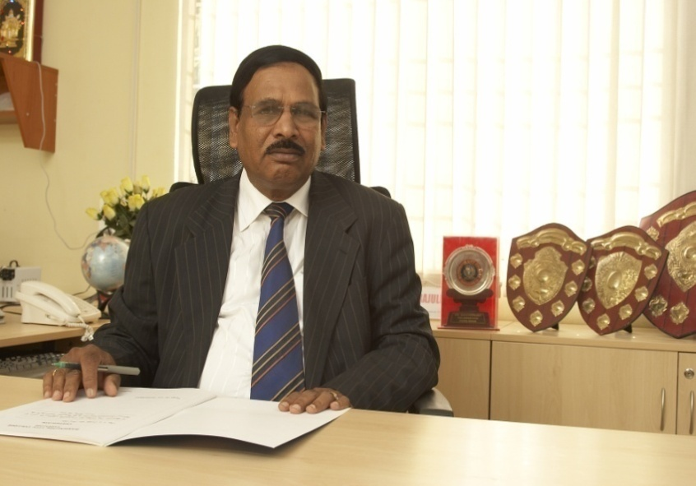 | 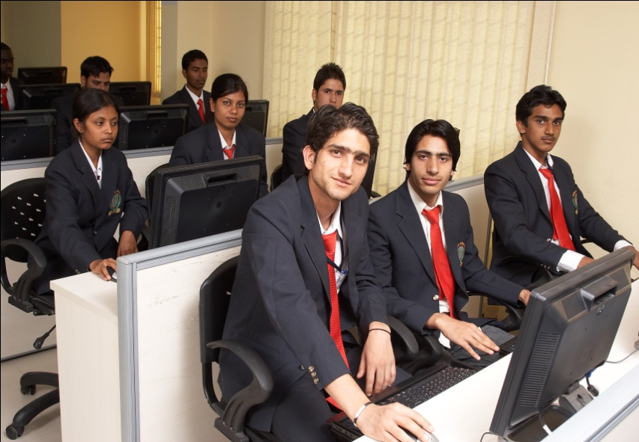
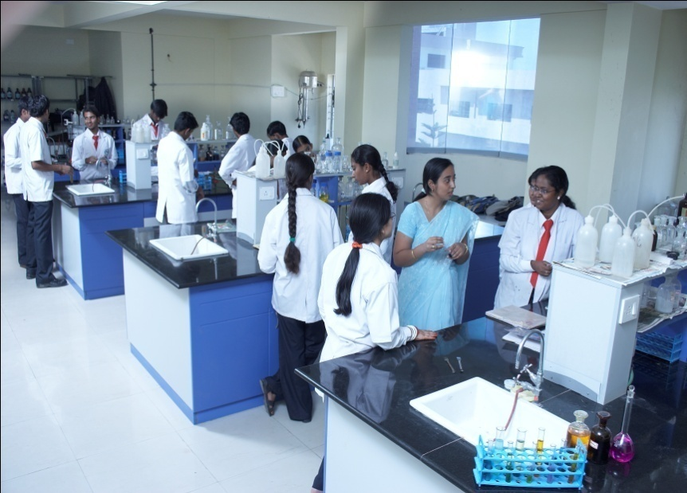 | 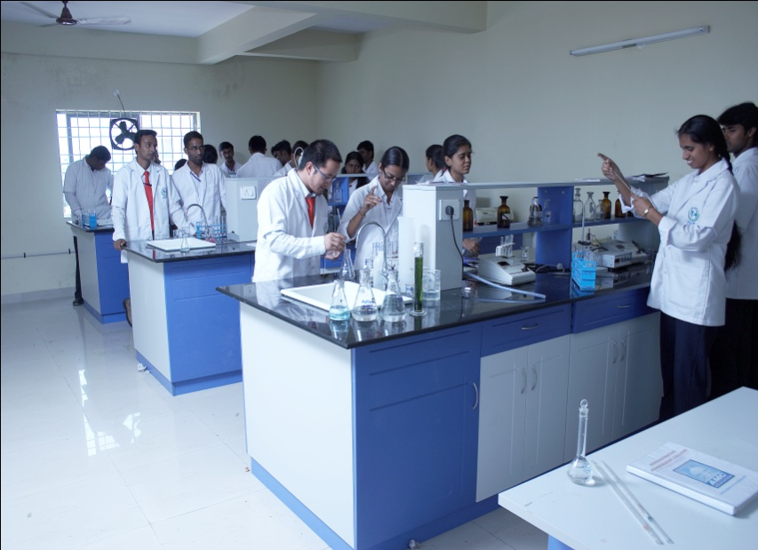
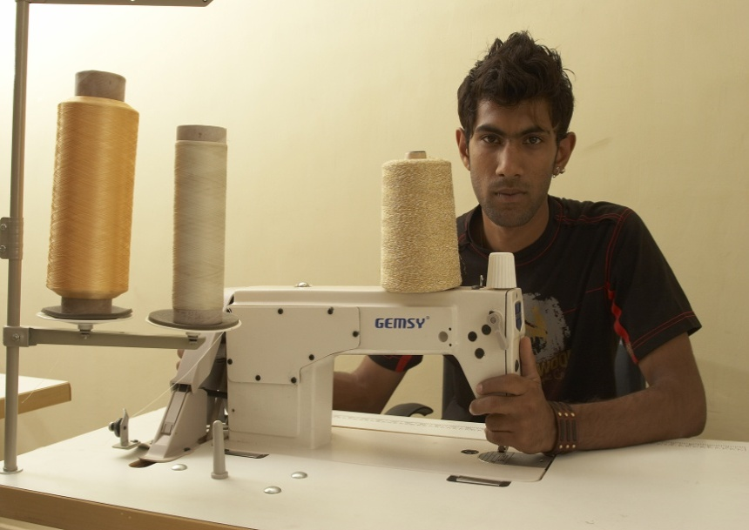 | 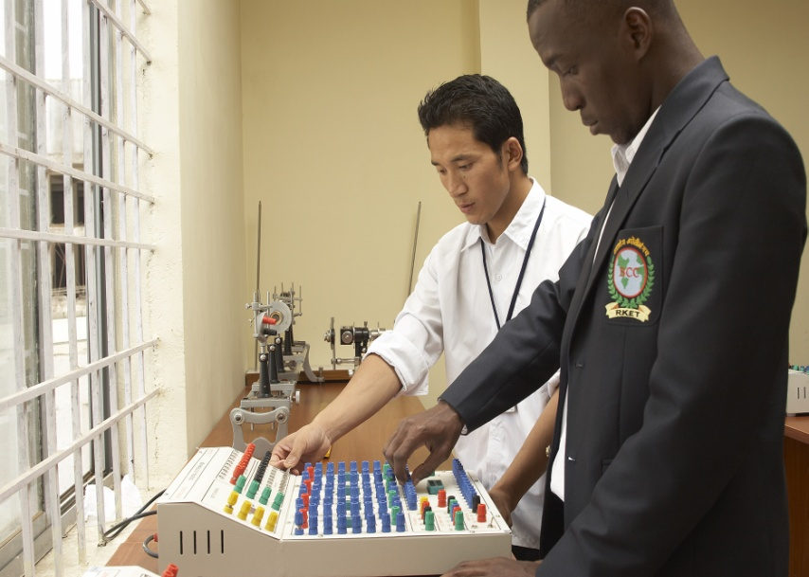
b) Extra –curricular activities:
Sports: | Athletics, Kabbadi, Kho-Kho, Basket Ball
Outdoor and indoor games: | Cricket, Volley-ball, Chess, Carom
NSS | Available
NCC | Applied(Awaiting for approval to implement)
Cultural activities: | A cultural committee consisting of students representations actively plans annual cultural activities and organizes various competitions in which students participate in large numbers.
Public speaking & Communication Skills development | A structured personality development sessions are systematically organized with an aim that all the students develop the various skills by the end of the program.
Health and Hygiene | Continuous education to practice good health and hygiene is promoted through continuous notices and displays at the vantage points.

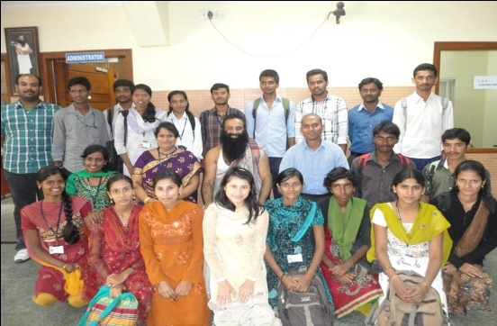 | 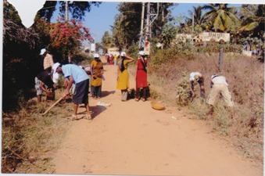
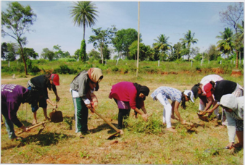 | 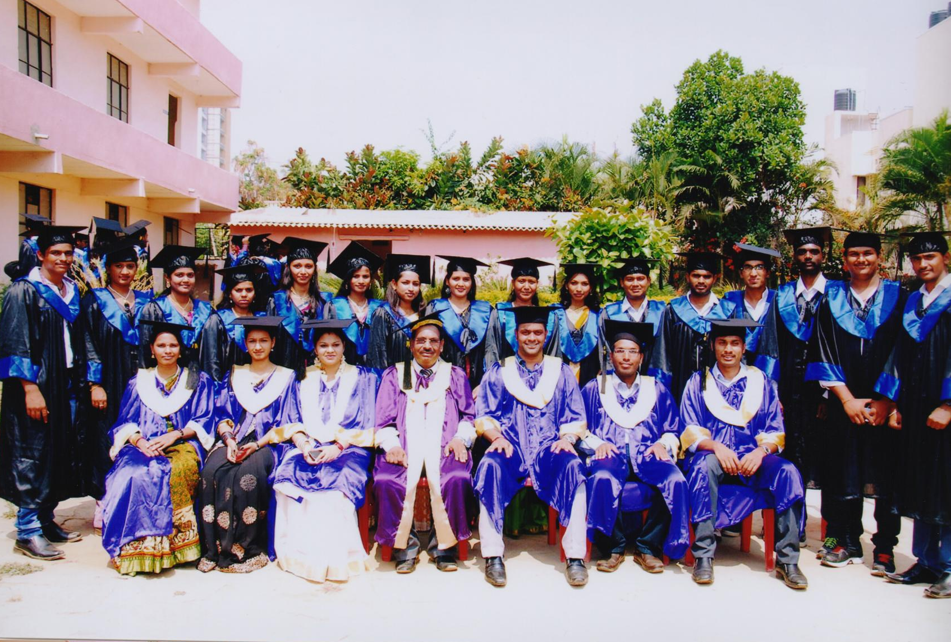
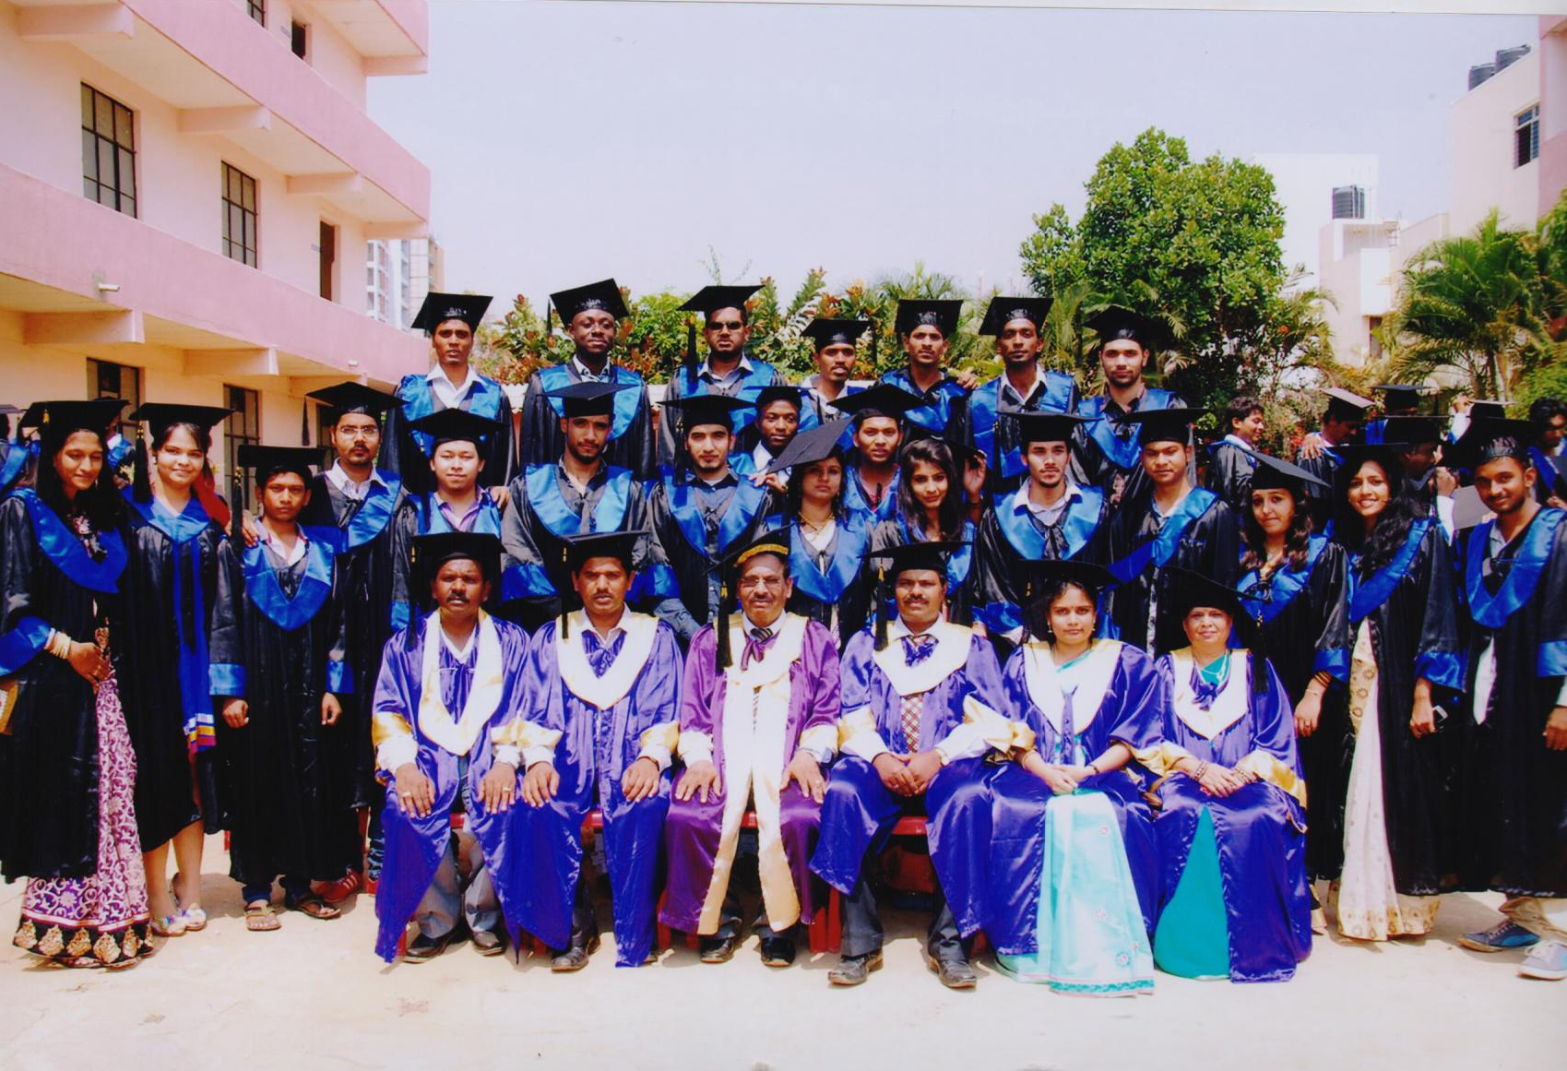 | 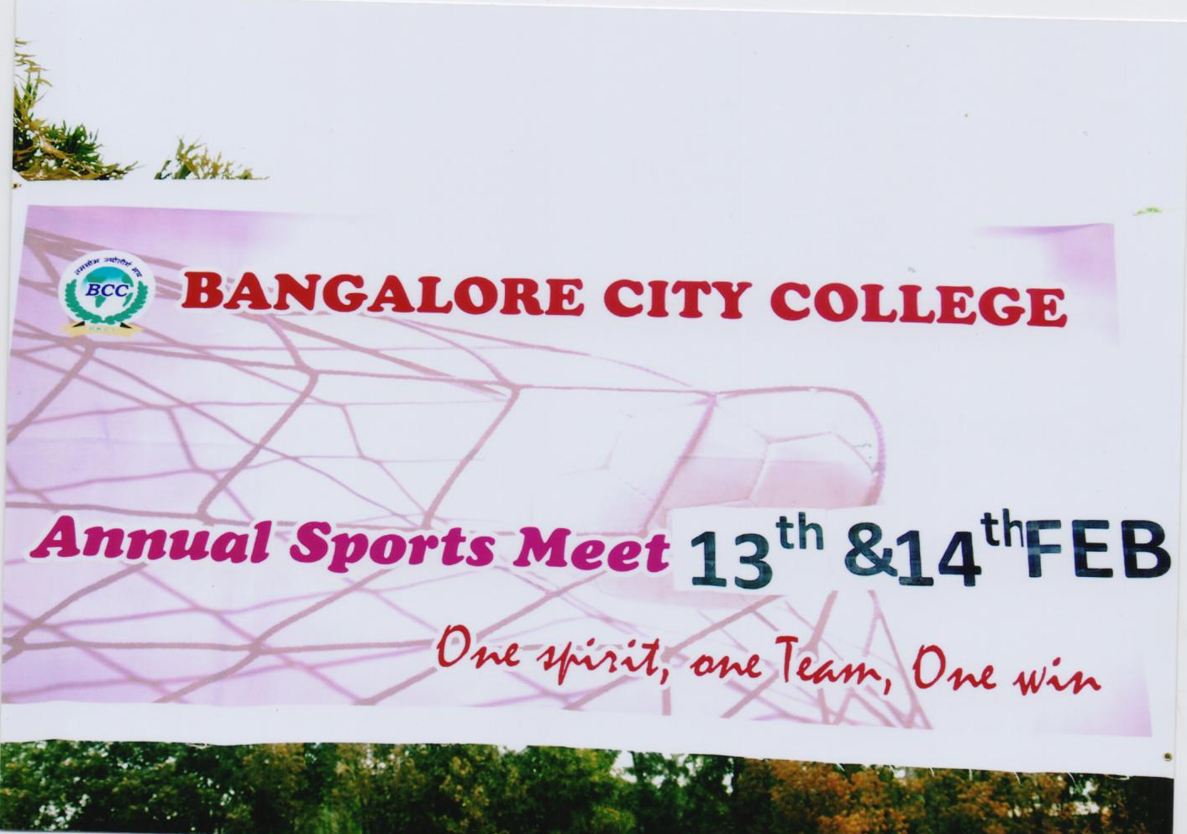
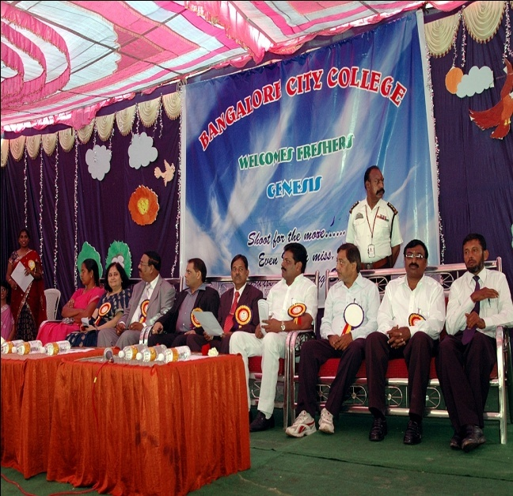 | 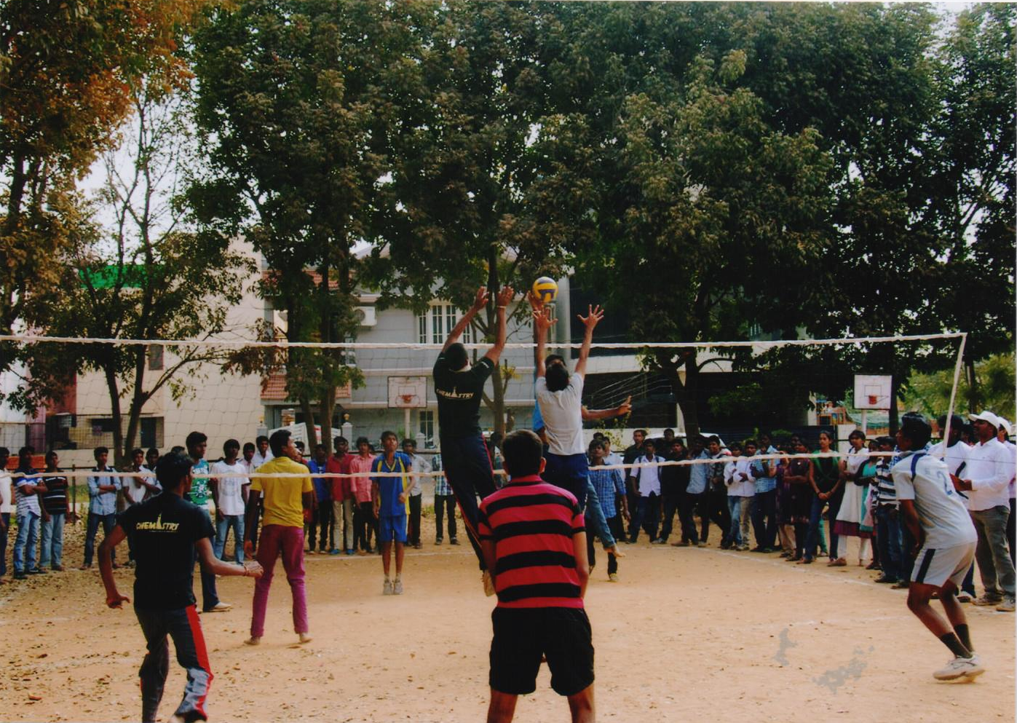

    - How does the institution plan and ensure that the available infrastructure is in line with its academic growth and is optimally utilized? Give specific examples of the facilities developed/augmented and the amount spent during the last four years (Enclose the Master Plan of the Institution/ campus and indicate the existing physical infrastructure and the future planned.
Sl no | Departments | 2009-2010 |  | 2010-2011
1 | Physics | Micro Processor Kits,  CRO, Thermal Conductivity by Probes Method, Traveling Microscopes,  Sources Kits,  Stefan’s law setup | 2,30,000 | Fermi Energy kit,  Semiconductor energy kit,  Two Phase diagram setup,  Rheostat stand,  Muffex furnance,  Micro balance,  Metalogical microscope,  Magnetic stirrer,  Chemicals,  Babinet’s compansation | 2,40,000
2 | Electronics | Digital trainer kits and basic requirement for the electronic lab | 1,50,000/- | Power Electronics lab  C++ computer lab (7 Nos) | 2,10,000/-
3 | Organic Chemisty | 1.Digital pH Meter (2nos)  2.Conductivity Meter (3nos)  3.Potentiometer(3nos)  4.Digital Potentiometer (1nos) | 81,200/- | 1.Digital Flame Photometer(1nos)  2.Hot Air Oven(1nos)  3.Melting Point Apparatus(1 nos)  4.Digital Water bath(1nos) | 86,100/-
4 | BioChemistry | Physical Balance  Cooling Centrifuge  Spectrophotometer |  | Chromatographic chamber  Agarose gel Electrophoresis unit
5 | Biotechnology | Centrifuge | - | Light Microscope(8 Nos) | 18,000/-
6 | Microbiology | Cooling centrifuge | 27,700/- | Compound Microscope  2.molecular microscope  3.Hot water bath heater  4.Digital colonycounter | 48,903/-
7 | FAD | Sewing machines Ind  Sewing Machine Dom | 80,000  25,000 | - | -
8. | Computer Science | -- | 1,00,000  2,87,088 | Computers  Hp computers(3 Nos) | 1,14,000  82,500

Sl no | Departments | 2011-2012 |  | 2012-2013
1 | Physics | Gouy balance, Electron balance, electromagnetic power supply,  Guass meter,  Electric burner, four probe setup,  Digital conductivity meter,  Batioz setup,  Ferromagnetic wire temp setup,  G.M counter soure,  Talium & Cesium,  Stefans law setup, chemicals, visometer, micro balance ,  Thermometers, | 4,20,000/- | Electromagnetic Power Supply,  Batiioz set up, chemicals, samplesAl,CU, potentio meter bench, G.M counter, Eye Pies, curietemp setup,end window GM Detector, Digital Thermometer, Radio active source kit, aluminum absorber, head absorber | 1,61,000/-
2 | Electronics | Microwave testbench (1 set )  VHDL LAB (5 kits)  Communication kits (8 kits) | 4,00,000/- | - | -
3 | Organic Chemisty | Remi ElectroCentrifuge(2 nos)  Rocker vacuum pump(1nos)  Denver Analytical Balance(1nos)  Shimadzu Weighing balance(1nos)  Shimadzu Weighing balance(1nos) | 1,53,640/- | - | -
4 | BioChemistry | Fridge |  | Colorimeter
5 | Biotechnology | Steoreomicroscope  Calorimeter  Electronic Balance | 50,000/- | Incubator | -
6 | Microbiology | Colorimeter  Incubater  Hot air oven  Distillation Unit  Laminar air flow | 1,37,000/- | Agarose Gel Electrophoresis unit- | 14000/-
7 | FAD | Launderometer  Tensile testing machine  Crockmeter  Wrap reel | 51,000/- | Drapemeter  Perspirometer | 30,000/-
8. | Computer Science | - | - | Computers(50 Nos),  Flat bed scanner,  Printer | 6,40,000/-

Bangalore City College has 2 blocks.
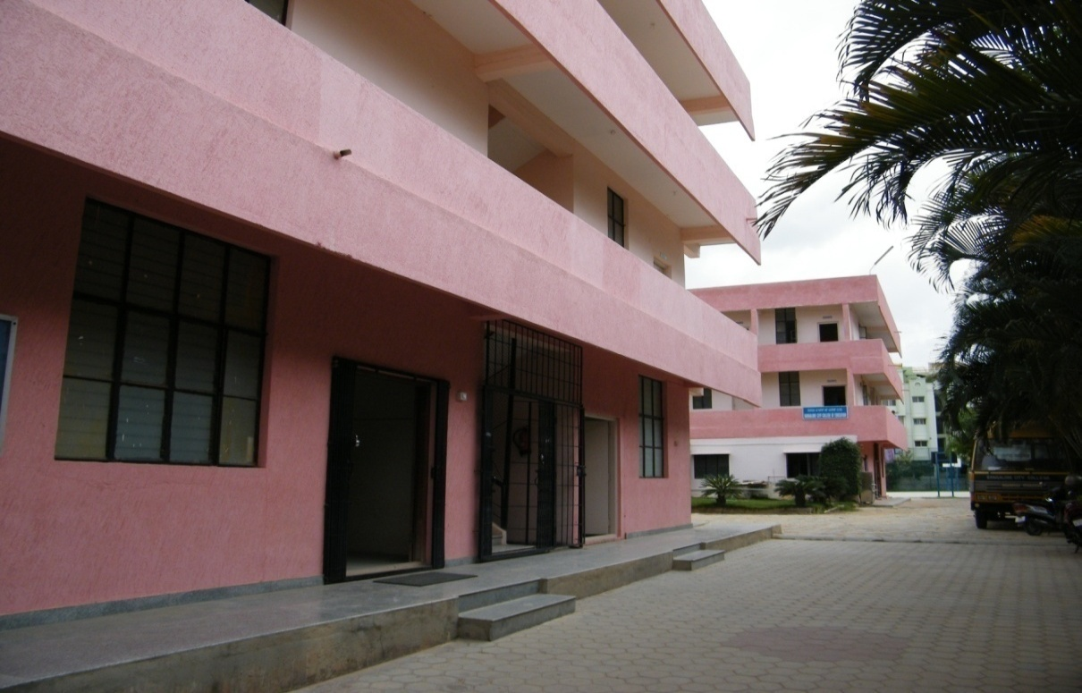
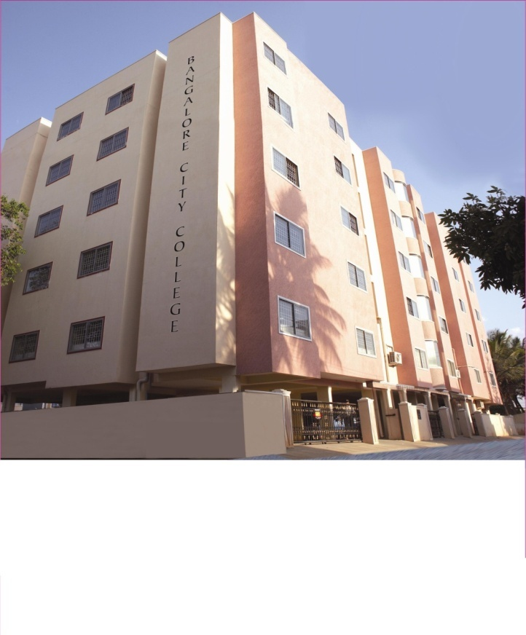
UG Block-Campus 1
PG Block –Campus 2
Generator facility provided in the campuses. The college has fully furnished class rooms with ICT Facilities. UG and PG blocks provided with libraries. The sophisticated labs are available in both the blocks and students are provided with good hostel facility separately for girls and boys. UG and PG block is provided with canteen facility.
    - How does the institution ensure that the infrastructure facilities meet the requirements of students with physical disabilities?

The institution has initiated the following proactive arrangements to ensure that the campus is differently abled friendly some of the initiatives are:
- The most critical laboratories are housed in the ground floor.
- The central library and the class rooms are located in the first, second, third, and fifth floor which has the elevator facility.

    - Give details on the residential facility and various provisions available within them:

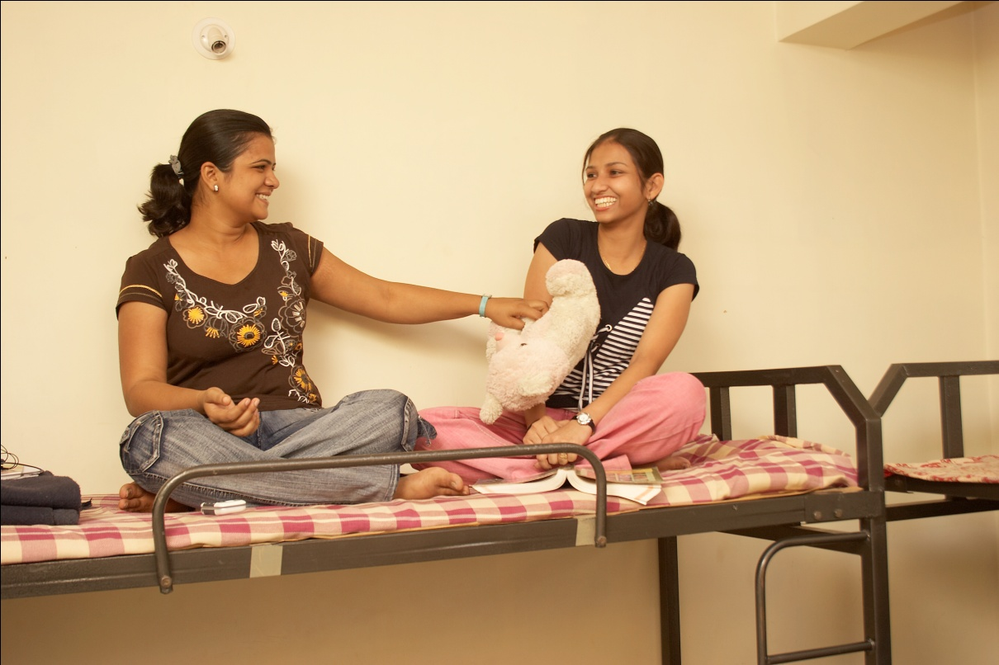
- Hostel Facility – Boys Hostel- 1 No (80 inmates)
-Girls Hostel- 1 No (60 inmates)
- Wi-Fi access at the hostels.
- Recreational facilities- Facility for indoor games at the hostels.
- Medical facilities for emergencies – Medical room with necessary equipments to provide treatment in case of emergency. Qualified medical officer visits the hostels and doctor on call in case of emergencies.
- Recreational facility-common room with audio-visual equipments-are available.
- Available residential facility for the staff and occupancy Constant supply of safe drinking water : No
- Security: The security is available in the college and hostel through out the day and night and students and staff has to get the pass to go out of the college and hostel. The visitors entry and exit time are monitored.
For Additional security to the female faculty and students and as a general security measure, the campus is installed with closed circuit camera which is monitored by the Director of the institution.
    - What are the provisions made available to students and staff in terms of health care on the campus and off the campus?

General medical check-up is conducted twice in a year for all the students including blood test and identification of the blood group.

4.1.7 Give details of the Common Facilities available on the campus –spaces for special units like IQAC, Grievance Redress unit, Women’s Cell, Counseling and Career Guidance, Placement Unit, Health Centre, Canteen, recreational spaces for staff and students, safe drinking water facility, auditorium, etc.
IQAC : Office with the necessary infrastructure
Grievance Redress unit : Office with required facilities
Anti-Sexual Harassment Cell : Exclusive room with necessary furniture
Counseling and Career Guidance : Office with required facilities
Placement Unit : Exclusive room with necessary furniture
Health Centre : Yes
Canteen : 2 Canteens
Recreational spaces for staff and students: Yes
Safe drinking water facility : Available in both the campuses
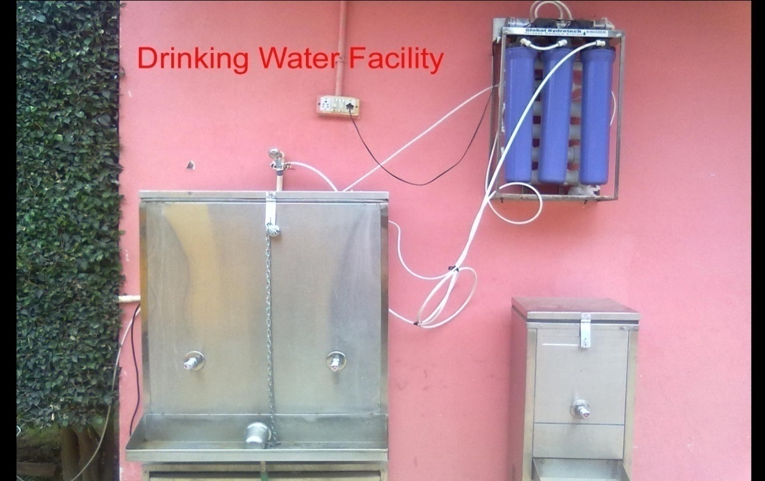

Library as a Learning Resource:

4.2.1 Does the library have an Advisory Committee? Specify the composition of such a committee. What significant initiatives have been implemented by the committee to render the library, student/user friendly?
Yes, The Committee consists of the following members for both PG and UG campus

Chairman : Dr. Devaraujulu, S, Principal.
Member : Dr. Sreekanth, P. M., HOD, Biotechnology Dept.
Member : Mrs. Arti Mahopotra, HOD, Computer ScienceDept.
Member : Mr. Govind Joshi, Librarian, BCC, Coordinator
Member : Ms.Savitha, S., Librarian, BCC, Coordinator

The facilities available in the campus:
- Internet facility.
- Journals and newspapers and reports of previous year’s projects.
- Department wise previous year question papers.
- E Resources of the INFLIBNET N-LIST to access the text books.

    - Provide details of the following:

 |  | Campus 1 | Campus 2
Total area of the library |  | 84 Sq. Mts. | 180 Sq. Mts.
Total seating capacity in Reading Room |  | 50 | 84
Total seating capacity in Reference Section |  | 20 | 80
Working hours | Monday to Friday | 8:30 AM to 3:30 PM | 9:30 AM to 4:30 PM
Working hours | Saturday | 8:30 AM to 12:30 PM | 9:30 AM to 12:30 PM
Working hours | During examination days | 7:00 AM to 9:00 PM | 7:00 AM to 9:00 PM
Working hours | During vacation | 8:30AM to 4:30 PM | 9:30 AM to 4:30PM
Layout of the library |  | Annexure-4.2.2(1) | Annexure-4.2.2(2)

Students and Faculties are using the E Resources of the INFLIBNET N-LIST.
Two Systems are exclusively provided for the Library Staff for library administration and four system for students usage to access internet.

    - How does the library ensure purchase and use of current titles, print and e-journals and other reading materials? Specify the amount spent on procuring new books, journals and e-resources during the last four years.
The college has a procurement policy for purchase of textbooks, journals, magazines, newspapers, etc for the central library. The details of the procedure are:
  - A suggestion box is kept in the library inviting suggestion from the stake holders for the development of the library in general and additions to be added to the library facilities.
  - The library advisory committee meets regularly and deals with the meeting peruse the suggestions and makes proposal to the management to procure/add additional books, journals, etc.
  - Upon approval by the management the necessary library materials are procured by the concerned departments and delivered to the central library.
  - The central library ensures that the new arrivals are documented and proper docket numbers are entered in the inventory registers and on the books, journals, etc. and there after they are made available for the faculty and students to borrow/use for reference purpose.

Campus 1
Library holdings | 2009-2010 | 2010-2011 | 2011-2012 | 2012-2013
Text books | 3890 | 280 | 630 | 360
Reference Books | - | - | - | -
Journals/ Periodicals | 25 | 18 | 15 | 15
e-resources | - | - | - | Inflibnet
Total cost (Rs) | 72634 | 62540 | 54231 | 65490

Campus 2
Library holdings | 2009-2010 | 2010-2011 | 2011-2012 | 2012-2013
Text books | 4949 | 451 | 448 | 442
Reference Books | 800 | 100 | 100 | 90
Journals/ Periodicals | 22 | 22 | 11 | 11
e-resources | - | - | - | Inflibnet
Total cost (Rs) | 1,38,324 | 5,57,178 | 1,79,118 | 1,13,516

    - Provide details on the ICT and other tools deployed to provide maximum Access to the library collection?

Campus 1
- OPAC - Yes
- Electronic Resource Management package for e-journals - Member of INFLIBNET L-LIST.
- Federated searching tools to search articles in multiple databases : Yes
- Library Website :Not Available
- In-house/remote access to e-publications: Member of INFLIBNET N-LIST
- Library automation: library Automated.
- Total number of computers for public access: 1
- Total numbers of printers for public access: None
- Total no. of photocopy machine: 1
- Internet band width/ speed: 15Mbps
- Institutional Repository: 162 Nos. Hard Copies of project reports available in the library. 240 CDs available in the library.
- Content management system for e-learning: The college is in the process of exploring the possibilities of introducing the system shortly.
- Participation in Resource sharing networks/consortia (like Inflibnet) :Member of INFLIBNET.

Campus 2
- OPAC -Yes
- Electronic Resource Management package for e-journals - Member of INFLIBNET L-LIST
- Federated searching tools to search articles in multiple databases: Yes
- Library Website : Not Available
- In-house/remote access to e-publications: Member of INFLIBNET N-LIST
- Library automation:Library Automated.
- Total number of computers for public access : 4
- Total numbers of printers for public access : 1
- Internet band width/ speed: 15 Mbps
- Institutional Repository:470 Nos. Hard Copies of project reports available in the library. 300 CDs available in the library.
- Content management system for e-learning:Proposal for Creation of Virtual Library/Class Room in Bangalore City College put up.
- Participation in Resource sharing networks/consortia (like Inflibnet): Already become Member of INFLIBNET.

    - Provide details on the following items:

 | Campus 1 | Campus 2
Average number of walk-ins | 60-70 | 150-200
Average number of books issued/returned | 20-30 | 35-40
Ratio of library books to students enrolled | 1:7 | 1:7
Average number of books added during last three years | 220 | 447
Average number of login to opac (OPAC): | Not exist | Not exist
Average number of login to e-resources | N/A | 50 per day
Average number of e-resources downloaded/printed | - | 10 per day
Number of information literacy trainings organized | - | N/A
Details of “weeding out” of books and other materials | Nil | Nil

4.2.6 Give details of the specialized services provided by the library
- Manuscripts : N/A

- Reference: 30%. Of total collection available. Books , special collections of Medical microbiology and Berrgey‟s manual of systematic Bacteriology.

- Reprography : 1 Machine available

- ILL (Inter Library Loan Service) : Yes
Information deployment and notification (Information Deployment and Notification)

- Download : 4 Systems to download

- Printing :1 printer available

- Reading list/ Bibliography compilation: Available

- In-house/remote access to e-resources :Yes

- User Orientation and awareness – Yes

  - Employment News.
  - Sports journals.(Sports Star)
  - Economic Times.
  - Science and technology.

- Assistance in searching Databases: LIBASOFT - Software Database Searching For Books.

- INFLIBNET/IUC facilities: INFLIBNET N-LIST Resources are accessed by Faculty and students.

    - Enumerate on the support provided by the Library staff to the students and teachers of the college.

Library Staff are very friendly and co-operative with the Students and the Faculty. They assist the students and faculty in searching of books, journals, magazines and other documents. All the accessed books data have been stored in the Library. Various websites can be easily searched with the assistance of the library personnel by the faculty and the students.

    - What are the special facilities offered by the library to the visually/physically challenged persons? Give details.

The following facilities are offered for the differently abled persons:
- Special assistance to identify the books/ Journals and providing them.
- Designated place at the reference section.
- Accessibility and special provision for the wheel chair in the library.
- Assistance for web browsing.

    - Does the library get the feedback from its users? If yes, how is it analysed and used for improving the library services. (What strategies are deployed by the Library to collect feedback from users? How is the feedback analysed and used for further improvement of the library services?)

A feedback forms is introduced for the stake holders to provide feedback in respect of library facilities .The library advisory committee reviews the feedback analysis and initiates correct actions.

4.3 IT Infrastructure:
4.3.1 Give details on the computing facility available (hardware and software) at the institution.

SL.NO | Common facilities | Number (In UG) | Number (In PG)
1 | Number of Computers in Computer Lab | 50 | 60
2. | Number of Computers in other offices | 10 | 8
3 | The Total Number of Computers in Library | - | 4
4 | The Total Number of Computers in Electronics Lab | - | 7
5 | Total No of Printers | 4 | 3
6 | Reprography | 1 | 1
7 | LCD Projectors | 1 | 2
8 | OH Projector | - | 1
9 | Scanner | 1 | 2
10 | Computer-student ratio in computer science dept. | 1:1 | 1:1
11 | Total Computers | 60 | 80
12 | Internet Connection | ISP:BSNL  (Broad Band)  Speed : 15 Mbps | ISP:BSNL  (Broad Band)  speed :15 Mbps
13 | LAN connection | provided to all system | provided to all system
14 | Wi-Fi facility | Yes- 15 Mbps | Yes- 15 Mbps

Hardware and Software
SL.NO | Devices | Number (In UG) | Number (In PG)
1 | Processor | 60 (Intel Core2Duo 2.66,Core i3 3.06 GHz and Intel P4 2.07 GHz) | 80 (Intel Core2Duo 2.66,Core i3 3.06 GHz and Intel P4 2.07 GHz)
2 | Ram | 60 (1 GB, 2GB, 512Mb) | 80(1 GB, 2GB, 512Mb)
3 | Hard Disk | 60(80GB, 160GB, 500GB). | 80(80GB, 160GB, 500GB).
4 | USB Drive | USB DRIVE | USB DRIVE
5 | DVD Drive | Inbuilt | Inbuilt (External DVD Drive R/W (BUFFALO ) and separate DVD -1
6 | Monitor | 60(HP L1908w , LV1911) | 80(HP L1908w , LV1911)
7 | Key Board | 60 (HP ,Logitech ,I boll) | 80 (HP ,Logitech ,I ball)
8 | Mouse | 60(HP Optical Mouse) | 80 (HP Optical Mouse)
9 | VGA Card | Inbuilt | Inbuilt
10 | Sound Card | Inbuilt | Inbuilt
11 | Total Computer | 60 | 80
12 | Company | HP, Zebronic, Mercury | HP
13 | Printers | 4 | 3

Software:-

Sl.No | Software (In UG) | Software (IN PG)
1 | Windows XP Service Pack 2 | Windows XP Service Pack 2
2 | MS-office 2003, 2007 | VB 6.0
3 | Adobe reader 9, 10 | Oracle 9i
4 | WinZip 4.01 | MS-office 2003,2007,2010
5 | Turbo C | Turbo-C
6 | Nero 7 | Java
7 | Tally-9.2 | Unix
8 | eSIS-9.402 | Matlab
9 | eSSL 6.5 | Linux
10 | Kaspersky Internet Security 2014 | Xlink

4.3.2 Detail on the computer and internet facility made available to the faculty and students on the campus and off-campus?
- Internet is accessible to all the students and staff from 9:30 Am– 4:30pm
- The internet facility speed up to 15 Mbps with Wi-Fi in campus1 Seminar Halls with multimedia (LCD, OHP, power-point facilities) Support for teaching.
- An excellent computerized open- access library with a collection of C.D’s, D.V.D’s, Internet connections.

4.3.3 What are the institutional plans and strategies for deploying and upgrading the IT infrastructure and associated facilities?
The institute plans to initiate certain actions to upgrade IT infrastructure and related facilities in the near future.
The details are:
- Systematic usage of the high speed broadband in the campus.
- To monitor the growth of faculty/Students and correspondingly increase the IT infrastructure.
- To constantly monitor the global development and introduction of new products in ICT and to introduce appropriately at the campus.
- To establish ICT facilities in-line with the emerging changes academically/ in the curriculum.

4.3.4 Provide details on the provision made in the annual budget for procurement, up gradation, deployment and maintenance of the computers and their accessories in the institution (Year wise for last four years)
1. College allocates a separate fund for the maintenance.
2. The labs are maintained by the full time technician to repair the equipment if needed and handle it with care.

Year | Amount in Rs
2009 | 3,87,088
2010 | 1,96,000
2011 | 80000
2012 | 700000

4.3.5 How does the institution facilitate extensive use of ICT resources including development and use of computer-aided teaching/ learning materials by its staff and students?
- Well-equipped Class rooms with ICT facilities for conducting regular classes, seminars and workshops..
- Periodical web assignments.
- Motivating Students to contribute presentations on emerging technology.

4.3.6 Elaborate giving suitable examples on how the learning activities and technologies deployed (access to on-line teaching - learning resources, independent learning, ICT enabled classrooms/learning spaces etc.) by the institution place the student at the centre of teaching-learning process and render the role of a facilitator for the teacher.
The Teaching techniques adopted to improve the students learning are:-

- The students are initially helped in teaching learning process through PPT’s.

- All the students are given a brief summary of the chapter by PPT and then the detailed study of each topic is done.

- Every student is assigned a new topic every week, which he/she is required to prepare presentation in the class room under the close supervision of the faculty. The students are required to make extensive study at different web sites to collect presentation material for the seminar. The second part of the seminar is focused on the interaction of the participants with the students who presents the paper. The faculty carefully undertakes the role of the facilitator, a coordinator and as a mentor.

- After the completion of every unit, the teachers conduct a group discussion for the respective unit.

- The students are regularly required to submit assignments.

- To develop creativity and to generate interest in the specified topic, quiz programs are conducted every fortnight which help the students in learning process.

4.3.7 Does the Institution avail of the National Knowledge Network connectivity directly or through the affiliating university? If so, what are the services availed of?
The national knowledge network has been requested to send the complete details to avail the various facilities. The institute is in the process of establishing a network facility to avail their services.

4.4 Maintenance of Campus Facilities

4.4.1 How does the institution ensure optimal allocation and utilization of the available financial resources for maintenance and upkeep of the following facilities (substantiate your statements by providing details of budget allocated during last four years)?

*Figures entered in Lakhs. |  | 2012-2013 | 2011-2012 | 2010-2011 | 2009-2010
a. | Building | 6.59 | 7.98 | 5.25 | 3.71
b. | Furniture | 8.62 | 4.67 | 88.54 | 85.29
c. | Equipment | 8.35 | 17.27 | 7.18 | 7.06
d. | Computers | 1.27 | 1.73 | 10.76 | 7.68
e. | Vehicles | Nil | Nil | 16.22 | 16.20
f. | Chemicals | 5.54 | 9.40 | 54.68 | 40.63

4.4.2 What are the institutional mechanisms for maintenance and upkeep of the infrastructure, facilities and equipment of the college?
Stock registers are maintained in departments and maintenance of the computers is done by the technician and other instruments are given best care to maintain it by the lab attenders and chemicals and others lab equipments are also checked and carefully handled.
Stock verification is done in all the departments twice a year and every year the instruments and devices in labs are checked and serviced and missing or damaged items are noted. The campus manager over sees all the repair work before the college starts.
The college principle submits the annual budget every year; the chairman allows the funds for the servicing and the repair of the instruments.

4.4.3 How and with what frequency does the institute take up calibration and other precision measures for the equipment/instruments?
Subjects | Suppliers
Electronic Science | Digit track ALs , Scietic, Maha electronics
Computer Science | Kruti Computers India Pvt Ltd.  Tarvo Technologies Ltd  Maha Electronics Pvt. Ltd,
Physics | Kamaljith
Organic Chemistry | The Industrial and Laboratory Co.  Scientific and Allied Co.  Sri Krishna Scientific Equipments
Bio-Chemistry | Remi, Alpha co, Shimadzu, Suswox Optik/MV TEX
Biotechnology | Remi, Alpha co, Labomed,Shimadzu
Microbiology | Elico, Cystronics, Shimadzu, Bangalore Gelei
FAD | Launderometer  Tensile testing machine  Crockmeter  Wrap reel

4.4.4 What are the major steps taken for location, upkeep and maintenance of sensitive equipment (voltage fluctuations, constant supply of water etc.)?
The institution has made the following arrangements:
- Special and sensitive equipments are stored in separate enclosures as directed by the manufacturer.
- All the equipments are under AMC’s with renowned organizations who properly take care of the maintenance and upkeep of the equipments.
- Periodical calibration work is entrusted to renowned agencies to carry out the activities.

Any other relevant information regarding Infrastructure and Learning Resources which the college would like to include.
Nil

Criterion V: Student Support and Progression
  - Student Mentoring and Support

    - Does the institution publish its updated prospectus/handbook annually? If ‘yes’, what is the information provided to students through these documents and how does the institution ensure its commitment and accountability?

Yes, the Institute publishes its prospectus and it is updated every year. In the prospectus the college provides the complete information required for the students related to the college and the various courses.
The prospectus contains the information regarding the affiliations, courses offered by the institution, it’s duration, eligibility criteria, syllabus and the faculty details. It contains the college rules and regulations for the students and also the academic details.
It also provides the information regarding the facilities provided by the college like library, laboratory, hostel, transport facility etc. The details of extra-curricular activities like cultural, sports, college magazine, study tour etc are also mentioned. Along with all the information, the Placement details are also provided. To make it more approachable the similar details are mentioned in the college web site:www.bangalorecitycollege.org

    - Specify the type, number and amount of institutional scholarships / freeships given to the students during the last four years and whether the financial aid was available and disbursed on time?

Year | Number of Beneficiaries | Amount
2009 | 15 | 85,000
2010 | 10 | 95,000
2011 | 16 | 80,000
2012 | 18 | 1,15,000
2013 | 20 | 1,80,000

    - What percentages of students receive financial assistance from state government, central government and other national agencies?

We give the financial assistance to the students from state government through Bangalore University. The students coming from SC,ST,OBC quota will get back some percentage of all four semester fees at the end of semester. For this the student should have lived in Karnataka from SSLC onwards .Social work and other department send the required information to the university.
Yes. The institution coordinates with the state government and provides necessary guidance and assistance to the eligible students to obtain scholarship. The details of the beneficiaries of the last four years are as under
Year | C-I No. | Amount  (Rs) | C-II A No. | Amount  (Rs) | C- III A No | Amount  (Rs)
2009-10 | 04 | 6400 | --- | --------- | ---- | ----------
2010-11 | 04 | 5200 | --- | --------- | --- | ----------
2011-12 | --- | --------- | --- | --------- | --- | ---------
2012-13 | --- | --------- | -- | --------- | --- | ---------
2013-14 | 05 | 46,250 | 17 | 1,26,500 | 40 | 3,62,750

C- III B No | Amount  (Rs) | SC No | Amount  (Rs) | ST No | Amount  (Rs) | GM No | Amount  (Rs)
--- | -------- | 15 | 246360 | 02 | 7920 | 02 | 3200
--- | -------- | 25 | 366441 | 04 | 40750 | --- | ---------
--- | -------- | 04 | 69530 | 01 | 28000 | --- | ---------
--- | -------- | 13 | 207040 | --- | -------- | ---- | --------
05 | 67,000 | 16 | 3,42,084 | 01 | 23,395 | ---- | -------

    - What are the specific support services/facilities available for

- Students from SC/ST, OBC and economically weaker sections.
The SC/ST, OBC and economically weaker sections are provided assistance and guidance to receive scholarship from the State Government.
- Students with physical disabilities
The institution has installed an electric elevator which can be used by the differently challenged students to commute the various floors in the campus. The institute has established user friendly infrastructure including seating arrangements, etc.
- Overseas students
A special cell is created in the campus to guide and assist the overseas students in complying with the various statutory and regulatory requirements such as registration with the concerned embassy, compliance with commissioner of police, etc. A special induction program is conducted to help these students to familiarize with the prevailing culture, work-life, etc. the needy candidates are provided with special coaching on English speaking and adoptability programs.
- Students to participate in various competitions/National and International.
The students interested in sports and cultural activities, register with the corresponding committee. This committee will help them and extend support to participate in various competitions. Students who participate in such competitions shall be considered for relaxation in attendance, etc.
- Medical assistance to students: health centre, health insurance etc.
The college has a nursing branch which provides the first Aid Facility and for further medical assistance college has a tie up with Seventh Day Hospital, Frazer Town, Bangalore.
- Organizing coaching classes for competitive exams.
The institute is contemplating to commence coaching classes for the students to appear in PG-CET, NET, SLET, CAT, MAT. Currently relevant books in multiple copies are available in the library.
- Skill development (spoken English, computer literacy, etc.,)
Personality development classes are conducted to improve the students’ presentation skills and communication skills. Basic computer training classes are also provided to all students to improve their computer knowledge.
- Support for “slow learners”
Slow learners are recognized by the concerned lecturers through class performance and internal assessments. The lecturers counsel such students to identify the reason for the academic weak performance and then arrange remedial classes for those students who require.
Exposure of students to other institution of higher learning/ corporate/business house etc.
Students are exposed to corporate/business houses through industrial visits and project work.
- Publication of students’ magazines
Yes the college has a students’ magazine which is published every academic year .The complete responsibility of bringing the magazine is handled by the Magazine Committee consisting of a group of students and teachers.
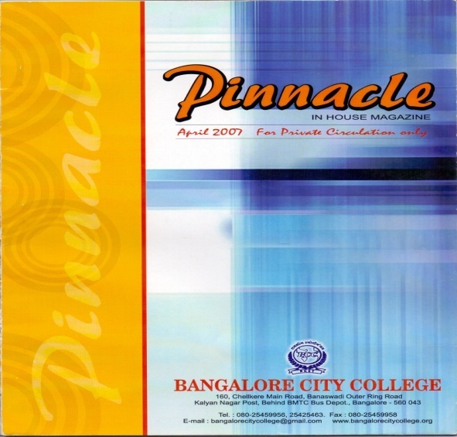 | 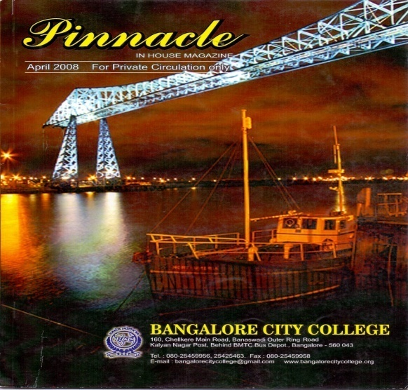
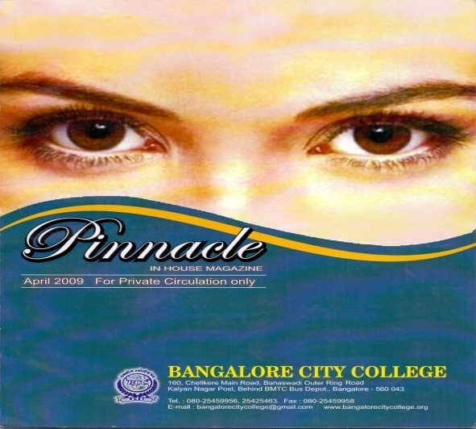 | 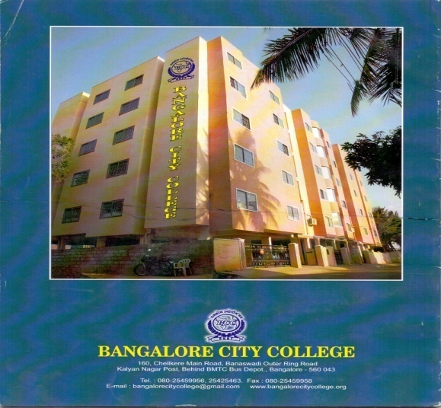

OBJECTIVES:
  - To bring out the talents and skills of the students.
  - To make known to the stakeholders the activities and other important events that takes place in the college every year.
  - The photographs published in the magazine are one of the records of the events that had taken place in the course of the academic year.
  - It’s a form of motivation not only to the student community but also to the staff for exhibiting their writing skills in the form of poems, articles, and their experiences in the institution.
  - It forms as a platform for the business community to advertise their products and to enhance their business.
  - The magazine is an avenue to make known to the students, the staff and the stakeholders the strides they are making every year in the form of development in academic excellence, infra-structure, curricular activities, sports and games etc.
  - The magazine is an excellent platform to update information of the institution to the past students who may be interested in the growth and development of their alma mater.
  - It’s a great medium in the memory lane of the students to recapture the nostalgic events of their days in the institution.

CONTENTS
- Mission and Vision
- Messages
- Name of the board of Trustees
- From the Editor’s Desk
- About us
- Department Reports
- Placement Report
- Toppers List
- Cultural and Sports activities
- Group Photographs
- Technical articles
- General Articles

    - Describe the efforts made by the institution to facilitate entrepreneurial skills, among the students and the impact of the efforts.
Seminars are arranged for the students to develop the entrepreneurial skills by experts. It also improves their inter-personal skills. The details of seminars conducted during the last four years are:

DATE | TOPIC | Resource Persons
12/09/2009 | How to find a Job – Job tips | Dr. V.S. Natarajan
24/10/2009 | Organization structure and management plan | Prof. Dhanaraj
09/10/2010 | Biggest mistakes people make on their resumes | Mr. Beshara Syed
30/10/2010 | How to improve entrepreneurship skills | Mr. Kailash
22/10/2011 | Effective discussion tips for students | Mr. Rajarajan
19/11/2011 | How to plan and start a Business | Mr. Rajarajan
20/10/2012 | Career success and mentoring | Dr. S. N. Rai
10/11/2012 | Marketing and sales strategies | Dr. Siddharth Panda
26/10/2013 | Starting a small business – The formula for success | Prof. Dhanaraj
23/11/2013 | Leadership during time of complexity and change | Ms. Blessy

As a part of the curriculum the Management students work in a company for one month duration to understand the working of the organization during the 3rd semester and they learn about how an organization and its departments function.

Add-on programs are conducted for the students to enrich their skills.

    - Enumerate the policies and strategies of the institution which promote participation of students in extracurricular and co-curricular activities such as sports, games, Quiz competitions, debate and discussions, cultural activities etc.

*Additional academic support, flexibility in examinations
* Special dietary requirements, sports uniform and materials
* Any other
The institution considers that encouraging students to participate in extracurricular and co-curricular activities to be equally important for the overall development of the students. All the departments prepare an annual academic plan at the beginning of the academic year which provides tentative dates for individual departments’ academic activities and co-curricular activities.
The co-curricular activities such as seminars, workshops, quiz competitions, debate, etc are generally held on a designated date spread throughout the semesters. The extra-curricular activities such as cultural dates (including individual competitions) and the annual sports day are commonly conducted to facilitate the students from all the departments to participate and compete in the various competitions.
Exemplary students who have outstanding capabilities and talents are encouraged to participate in external competitions- state level and university tournaments. Such students are considered for certain special facilities such as time off etc.
Students who are unable to appear for the internal examination as a result of cultural/sports competitions, are provided an opportunity to participate in the internal tests subsequently.

    - Enumerating on the support and guidance provided to the students in preparing for the competitive exams, give details on the number of students appeared and qualified in various competitive exams such as UGC-CSIR- NET, UGC-NET, SLET, ATE / CAT / GRE / TOFEL / GMAT / Central /State services, Defense, Civil Services, etc.

The institution has taken the initiative to identify qualified, trained and experienced faculties who can train the students to successfully appear for the various competitive examinations. The entire process is a very nascent effort of the institution with the objective of enhancing and enriching student support activities.

    - What type of counseling services are made available to the students (academic, personal, career, psycho-social etc.)

The MSW department has qualified psychological counselors and each student is assigned a mentor who keeps a watch over the progress of the student. In case of any problem the student can approach his/her mentor, whose responsibility is to help the students. The students have a mentor who gives the guidance for all the various fields like his academics, project, further studies and job placement.
    - Does the institution have a structured mechanism for career guidance and placement of its students?If ‘yes’, detail on theservices provided to help students identify job opportunities and prepare themselves for interview and the percentage of students selected during campus interviews by different employers (list the employers and the programmers).

The institution has a Placement and Training Centre which offers a wealth of experience and advice which the students can tap into anytime during their course of study in Bangalore City College. The Placement and Training Centre helps the students to realize their potential to find a career which will match their skill interest. The Placement and Training Centre runs comprehensive career programs with seminars and workshops to help the students to identify their skills, understand the employer requirement, how to apply for jobs and anticipate interview situations.

Year | Company Name | Total No. of students got appeared | Total No. of students got recruited | Percentage
2013-14 | Binary  Core IT Corporation Pvt. Ltd | 54 | 38 | 70
2013-14 | Digicall Tele Services Pvt Ltd. | 72 | 64 | 88
2013-14 | Muthoot Finance | 80 | 47 | 60
2013-14 | Step-In Management and financial services India(P) Ltd. | 10 | 04 | 40
2013-14 | Teeim Universa | 30 | 05 | 17
2013-14 | United cultural and educational Services Pvt. Ltd | 32 | 13 | 40
2013-14 | Siri Life Sciences Pvt. Ltd | 28 | 10 | 35
2013-14 | Sushruta Nursing Home | 18 | 07 | 38
2013-14 | Good Sheferd Hospital | 15 | 09 | 60
2013-14 | Different Schools in Bangalore | 40 | 28 | 70
2013-14 | Anthen Bio-Sciences Pvt. Ltd, Hosur | 19 | 12 | 64
2013-14 | Others | 60 | 36 | 60

    - Does the institution have a student grievance redressal cell? If yes, list (if any) the grievances reported and redressed during the last four years.

The college has a Grievance Handling Committee consisting of four members. The students can either directly approach the committee members or drop their grievances in the box meant for grievances’. The cell actively responds to the students grievances and takes required action after discussing the issues in the Grievance Handling Committee.
Grievances addressed:
Internet was upgraded to a higher speed. New water purifier was re-installed. Generators have been installed in addition to UPS to avoid power shut down.
    - What are the institutional provisions for resolving issues pertaining to sexual harassment?

The college has constituted an Anti-sexual harassment Committee to resolve issues pertaining to sexual harassment. The committee consists of five faculty members to address these issues. To ensure the campus is totally free from sexual harassment, the college is equipped with CCTV cameras. Till date no cases of sexual harassment has neither happened nor reported in the institute.
    - Is there an anti-ragging committee? How many instances (if any) have been reported during the last four years and what action has been taken on these?

Ragging is strictly banned in Bangalore City College. The students receive sufficient awareness of the evils of raging and the punitive measures which are initiated. This has ensured that the student do not indulge in raging.
As per the college rules if any student is found indulging in such kind of activities, strict action will be taken as per the college norms. An Anti-ragging committee has been formed and brought into operation which consists of five faculty members.
Punitive Measures for Ragging:-
Depending upon the nature and gravity of the offence as established by the Anti-Ragging Committee of the College, the possible punishments for those found guilty of ragging shall be one or any combination of the following:
- Cancellation of admission.
- Suspension from attending classes.
- Debarring from any test/examination or any other evaluation process
- Collective punishment when the individuals committing or abetting ragging are not identified.
- In-case of major activities which are punishable under IPC\CrPC, necessary complaints will be lodged with the police authorities..

    - Enumerate the welfare schemes made available to students by the institution.
The institute has introduced certain welfare measures which addresses the core requirements of the students. The details are
- Bus facility to various points in the city,
- Uniforms to all the students,
- Canteen facility.
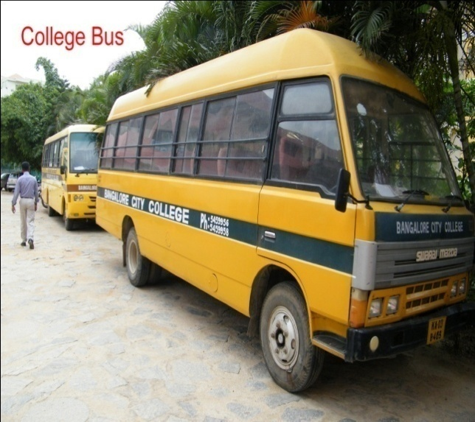 | 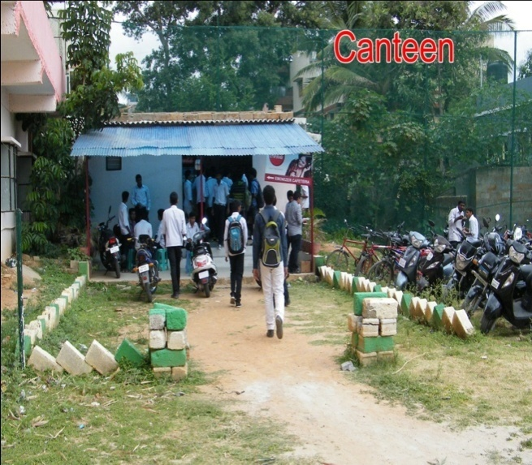

    - Does the institution have a registered Alumni Association? If ‘yes’, what are its activities and major contributions for institutional, academic and infrastructure development?

Yes, College has registered for the Alumni Association. Every year college conducts an Annual meet which is scheduled in the last week of December. Also some Alumni members are requested to come and share their experience and give guidance to students which benefit them.

5.2 Student Progression
5.2.1 Providing the percentage of students progressing to higher education or employment (for the last four batches) highlight the trends observed.

Department | Acedemic Year | Student Progression (%)
Department | Acedemic Year | U.G to P.G | P.G to M.Phil. | P.G to Ph.D. | Employed
 |  |  |  |  | Employed | Self Employed
Biotechnology UG Dept . | 2009-2010 | 25% | - | - | 50 % | 25%
Biotechnology UG Dept . | 2010-2011 | 25% | - | - | 50% | 25%
Biotechnology UG Dept . | 2011-2012 | 25% | - | - | 50% | 25%
Biotechnology UG Dept . | 2012-2013 | 50 | - | - | 30% | 20%
Biotechnology PG Dept. | 2009-2010 | - | - | 5 % | 80 % | 15 %
Biotechnology PG Dept. | 2010-2011 | - | - | 10% | 75% | 15%
Biotechnology PG Dept. | 2011-2012 | - | - | 5% | 80% | 15%
Biotechnology PG Dept. | 2012-2013 | - | - | - | 90% | 10%
Chemistry PG Dept | 2009-2010 | - | 10% | - | 75 % | 15 %
Chemistry PG Dept | 2010-2011 | - | - | 10% | 80% | 10%
Chemistry PG Dept | 2011-2012 | - | - | - | 90% | 10%
Chemistry PG Dept | 2012-2013 | - | - | - | 95% | 5%
Biochemistry PG Dept | 2009-2010 | - | - | - | 80% | 20%
Biochemistry PG Dept | 2010-2011 | - | - | - | 76% | 24%
Biochemistry PG Dept | 2011-2012 | - | - | - | 70% | 30%
Biochemistry PG Dept | 2012-2013 | - | - | 4% | 80% | 16%
Computer Science UG Dept | 2009-2010 | 20% | - | - | 80 % | -
Computer Science UG Dept | 2010-2011 | 10% | - | - | 90% | -
Computer Science UG Dept | 2011-2012 | 30% | - | - | 70% | -
Computer Science UG Dept | 2012-2013 | 15% | - | - | 85% | -
Computer Science PG Dept | 2011-2012 | - | - | 10% | 70% | 20%
Computer Science PG Dept | 2012-2013 | - | - | 20% | 50% | 30%
Microbiology PG Dept | 2009-2010 | - | - |  | 50 %
Microbiology PG Dept | 2010-2011 | - | - | 10% | 80% | 10%
Microbiology PG Dept | 2011-2012 | - | - | - | 90% | 10%
Microbiology PG Dept | 2012-2013 | - | - | - | 75% | 25%
Electronics PG Dept | 2011-2012 | - | - | - | 80 % | 20%
Electronics PG Dept | 2012-2013 | - | - | - | 60% | 40%
Physics PG Dept | 2009-2010 | - | - | - | 80% | 20%
Physics PG Dept | 2010-2011 | - | - | - | 75% | 25%
Physics PG Dept | 2011-2012 | - | - | - | 60% | 40%
Physics PG Dept | 2012-2013 | - | - | - | 90% | 10%
Social work | 2009-2010 | - | - | - | 80% | 20%
Social work | 2010-2011 | - | 4% | - | 62% | 38%
Social work | 2011-2012 | - | - | - | 56% | 44%
Social work | 2012-2013 | - | 3% | - | 50% | 47%
FAD Dept | 2009-2010 | - | - | - | 25% | 15%
FAD Dept | 2010-2011 | 65% | - | - | 20% | 15%
FAD Dept | 2011-2012 | 70% | - | - | 20% | 10%
FAD Dept | 2012-2013 | 60% | - | - | 30% | 10%
BBM | 2009-2010 | 64% | - | - | 30% | 6%
BBM | 2010-2011 | 58% | - | - | 37% | 5%
BBM | 2011-2012 | 65% | - | - | 30% | 5%
BBM | 2012-2013 | 50% | - | - | 38% | 12%
B.Com | 2009-2010 | 62% | - | - | 32% | 6%
B.Com | 2010-2011 | 58% | - | - | 32% | 10%
B.Com | 2011-2012 | 63% | - | - | 32% | 5%
B.Com | 2012-2013 | 58% | - | - | 38% | 4%
 | 2009-2010 | 60% |  |  | 40% | -
B.A | 2010-2011 | 48% |  |  | 52% | -
 | 2011-2012 | 55% |  |  | 45% | -
 | 2012-2013 | 80% |  |  | 20% | -

5.2.2 Provide details of the programme wise pass percentage and completion rate for the last four years (Course wise/batch wise as stipulated by the university)? Furnish programme-wise details in comparison with that of the previous performance of the same institution and that of the Colleges of the affiliating university within the city/district.

Department | Pass percentage for Each Year
Department | 2009 | 2010 | 2011 | 2012 | 2013
Biotechnology UG Dept. | 100% | 100% | 100% | 95% | 95%
Biotechnology PG Dept. | 100% | 100% | 97% | 97% | 97%
Chemistry PG Dept | 75% | 80% | 85% | 85% | 70%
Biochemistry PG Dept | 72% | 64% | 60% | 46% | NA
Computer Science UG Dept |  | 60 % | 25 % | 45 % | 36%
Computer Science PG Dept | - | - | - | 84% | 94%
Microbiology PG Dept | 82% | 100% | 100% | 100% | 87.5%
Electronics PG Dept | ------ | ------ | ------- | 13.47% | 50%
Physics PG Dept | 75% | 53% | 36% | 17% | 27%
FAD Dept | ------- | ------ | 33.3% | 44.4% | 64%
BA | ------- | 33.33% | 40% | 100% | 100%
BBM | 52% | 72% | 50% | 9.6%
B.Com | 39% | 65% | 45% | 9.6%
MIB | 58% | 91% | 50% | ------- | -----
MFA | 100% | 100% | 89% | ------ | ------

5.2.3 How does the institution facilitate student progression to higher level of education and/or towards employment?

The institute strongly believes that every UG student before the completion of 4th semester will have sufficient inputs to formally decide on the career that he/she may opt on completion of the program (6 semesters) or the value addition to his/her UG education which shall facilitate him/her to a superior career option. Almost all the departments of the institution regularly organize sessions where in students are provided the details of the various options available on completion of the UG program.

5.2.4 Enumerate the special support provided to students who are at risk of failure and drop out?

The college takes keen interest in helping the students who are finding it difficult to handle the academic pressure. The institution has successfully implemented the mentorship program through which slow learners who are at the risk of failure or drop out are provided sufficient academic and other needy facilities to be academically successful.

5.3 Student Participation and Activities
    - List the range of sports, games, cultural and other extracurricular activities available to students. Provide details of participation and program calendar.

Various outdoor and indoor games are made available to students such as Badminton, Basket ball, Volley ball and indoor games such as Chess, Carom and Table-Tennis. We have tie up with another organization and we are using their playground, where our students play Cricket and Football.
The college organizes Fresher’s Day and Graduation Day every year .Various cultural activities are performed by students such as dance, singing, skit etc.
The college also organizes annual sports day every year.
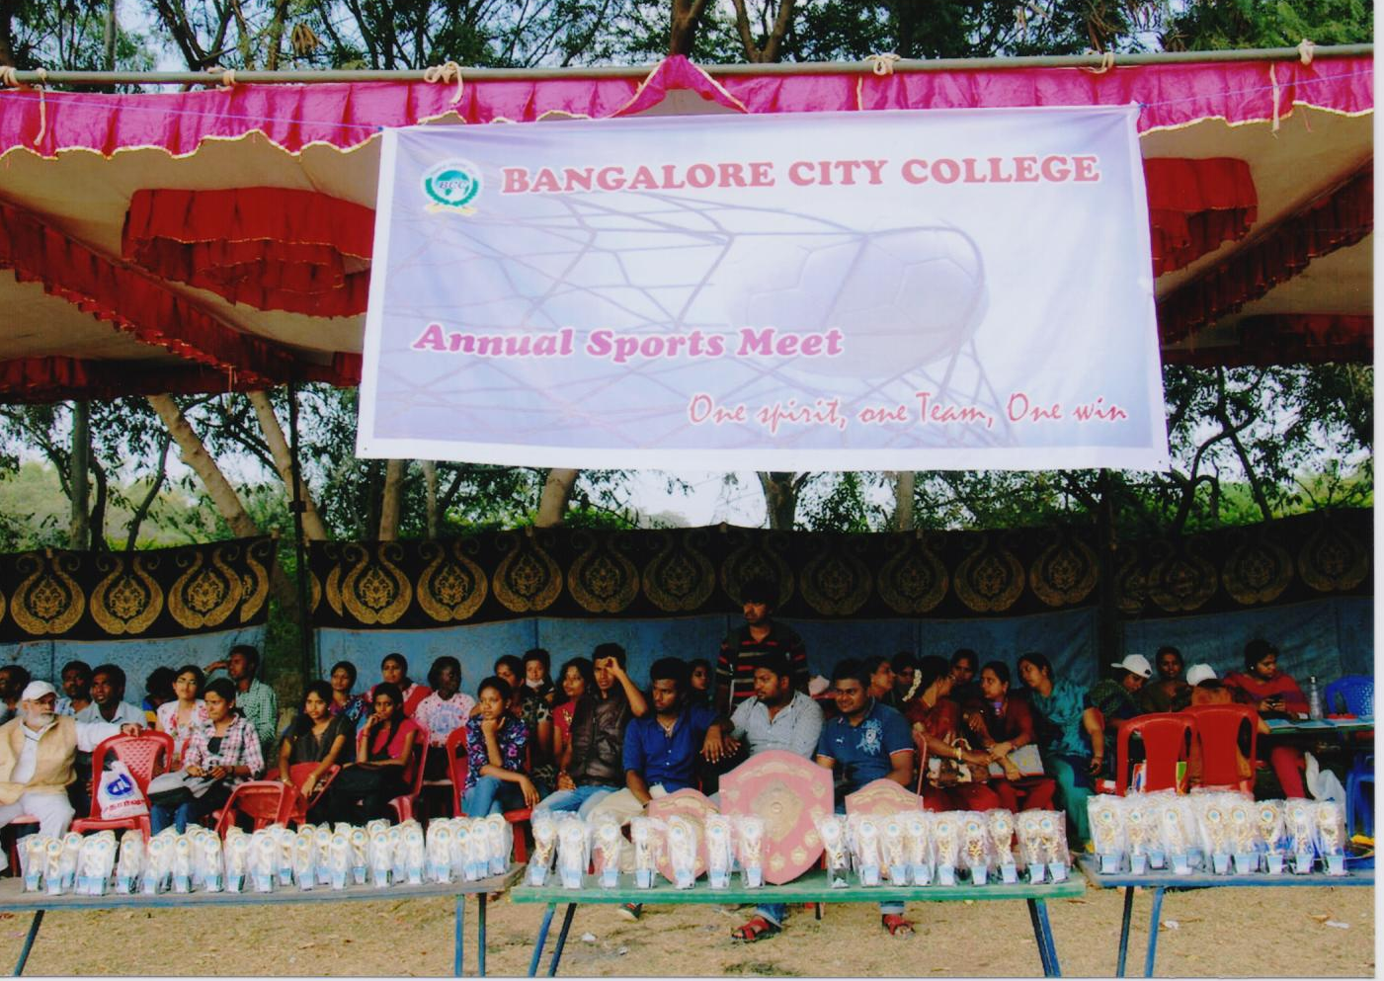 | 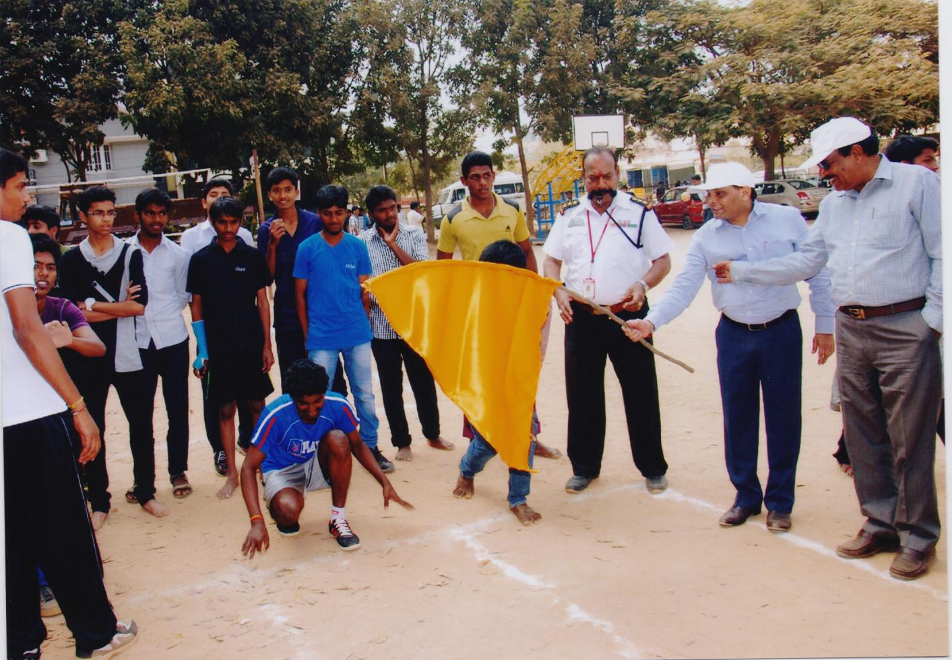
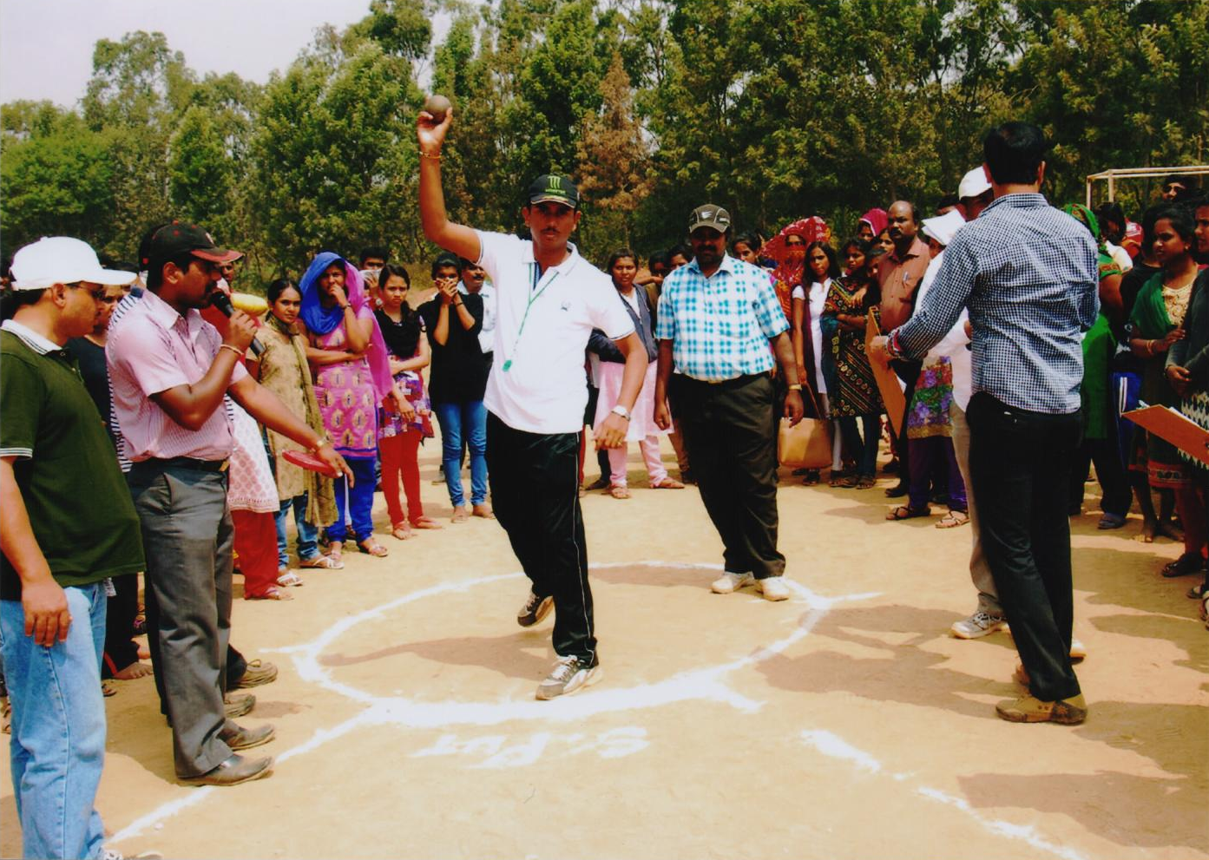 | 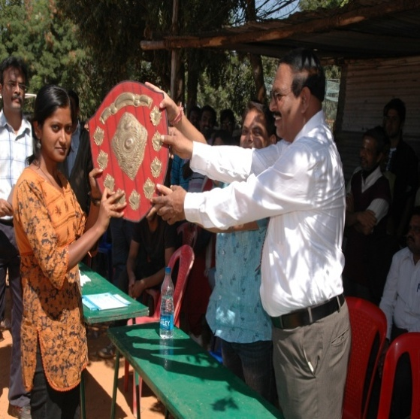
Program calendar
Sl no | Sports | Date | Level of participation
1 | cricket | 18.03.12 | College level
2 | badminton | 18.03.12 | College level
3. | Volley ball | 19.03.12 | College level
4 | chess | 19.03.12 | College level
5 | carrom | 19.03.12 | College level

Sl no | Name of the activity | Date | Level of participation
1 | Pot painting | 20.03.12 | College level
2 | Face painting | 20.03.12 | College level
3 | Quiz competition | 21.03.12 | College level
4 | Rangoli | 21.03.12 | College level

    - Furnish the details of major student achievements in co-curricular, extracurricular and cultural activities at different levels: University / State / Zonal / National / International, etc. for the previous four years.

Year | Activity | Participants | Prize | Venue
2013 | Play with Mathematics Quiz | Amreen & Navatha | II Prize, III Prize | Presidency College
2013 | Movie maker | Dilshan & Hunaif | I Prize | Presidency College
2013 | Quiz | Franklin & Navatha | II Prize | Presidency College
2013 | Paper Presentation | Mukund | III Prize | Presidency College
2013 | Gaming | Rahul Hari Narayan | I Prize | Presidency College
2013 | Project Leader | Divya A | I Prize | Presidency College

    - How does the college seek and use data and feedback from its graduates and employers, to improve the performance and quality of the institutional provisions?

The college has defined mechanism for obtaining feedback from outgoing students on the institution. HODs are responsible to take feedback from students. The Feedback obtained and analyzed. The institution considers the feedback and analysis to be valuable as it helps the college to initiate action for continuous development.
5.3.4 How does the college involve and encourage students to publish materials like catalogues, wall magazines, college magazine, and other material? List the publications/ materials brought out by the students during the previous four academic sessions.
The college teaching staff encourages students to publish in college magazine. The magazine committee will first decide the layout plan in the beginning of the session and then they inform all HODS to collect the articles from the student’s .Students are motivated to exhibit their talents by contributing good articles. They are encouraged to submit relevant material in any form which can enrich knowledge and develop individual’s skills to excel.
    - Does the college have a Student Council or any similar body? Give details on its selection, constitution, activities and funding.

It is proposed to constitute a full-fledged and a official student council which can plan and execute the entire activities pertaining to Academic, sports , cultural , discipline , etc .
    - Give details of various academic and administrative bodies that have student representatives on them.

The details of academic and administrative bodies that have student representatives-:
Committees | Student Representatives Names
Co-Curricular and Extra Curricular Committee | Hussan(BCA), Sonali (BT) ,Junaid (B.com)
Women’s cell and Anti –Sexual harassment committee | Anjana(BCA) , Krithi (BT) , Rashmi ( Msc Chemistry)
Anti – Ragging Committee | Kavitha(MFA), Niveditha( Msc Physics) ,Hunaif( BCA)
Magazine Committee | Nimisha(BCA), Guruprasad( Msc computer science), Pooja (BBM),Amit( B.com),Swetha (Msc Physics)
Sports Committee | Sharath(BCA), Srinath( Msc Maths) , Sridhar( MSW) ,Sowmya (BscFAD)
Alumini Committee | Ajay (BCA), Arun ( MFA),Surendhar( B.com),Ishaq( BT),Priya (MB)

5.3.7 How does the institution network and collaborate with the Alumni and former faculty of the Institution.
The Institute has an Alumni association to have a network with the Passed out batch students. Also with the currently studying students , Department maintains a Yahoo groups where all the students are connected to .This group help the students to get all the important information even if they are not in the college ( means out of station ) .
List of office bearers for the year 2013-14 are as under:
Sl.No | Name | Position | Parent Department
1 | Wasim Yousuf | President | Management
2 | Ms. Nandita Kanwar | Vice-President-1 | Biotechnology
3 | Mr. Guru Prasad | Vice President-2 | Computer science
4 | Ms. Preethi.M | Gen. Secretary | Computer science
5 | Mr. Manjuanath. N | Treasurer | Computer science
6 | Mr. Mukhtar Ahmad Khan | EC Member | Computer science
7 | Mr. K. Karthik | EC Member | Management
8 | Mr. Sampath Raj | EC Member
9 | Mr. Sajeevan. K | EC Member | Computer science
10 | Mr. Sridhar B. Enne | EC Member
11 | Mr. Ajay | EC Member | Computer science
12 | Ms. Rastumashree | EC Member | Physics
13 | Mr. Junaid | EC Member | Management
14 | Ms. Nupur | EC Member | Management
15 | Ms. Shabari Das | EC Member | Biotechnology
16 | Ms. Deena | EC Member | Chemistry
17 | Mr. Ria Khan | EC Member | Biochemistry
18 | Ms. Priya Ghosh | EC Member | Microbiology
19 | Ms. Puja Sharma | EC Member | Microbiology
20 | Ms. Aditi | EC Member | Computer Science
21 | Mr. Zoya Hassan | EC Member | FAD
22 | Mr. Manjunath | EC Member | Electronics
23 | Ms. Shree Lakshmi | EC Member | Electronics
24 | Mr. Rajendra Prasad | Mentor & Convener | Faculty of Languages Department

Note: The Alumini has enrolled 150numbers of members from all the departments.

Criterion VI: Governance, Leadership and Management

6.1 Institutional Vision and Leadership
6.1.1 State the vision and mission of the Institution and enumerate on how the mission statement defines the institution’s distinctive characteristics in terms of addressing the needs of the society, the students it seeks to serve, institution’s traditions and value orientations, vision for the future, etc.?
Vision:
To set high standards in imparting knowledge in higher education and inculcating superior value systems among students for the nation development to comprehensively meet the global competencies and challenges with a quest for excellence ably guided by technology.
Mission:
The college transforms the curriculum through systematic teaching, learning and evaluation process to create valuable citizens. Our endeavor is to ensure exemplary infrastructural facility with optimum student support activities coupled with good governance, leadership and innovation.
Bangalore City College [BCC] has been started with the vision of enabling the youth of this country to have a purposeful mission and to secure a niche in higher education for job oriented courses approved by the Bangalore University. The college aims at giving the students a free hand to meet their goals and desires.
Institutions Distinctive Characteristics
- Imparting good education to students
- Providing inputs to opt for suitable career
- Education for all
- Education for a bright future of the youth and the Country

1. The college focuses on promotion of quality teaching, learning to acquire knowledge, skills and attitude. It also promotes research and self evaluation. This is achieved through:
- More than ninety Qualified and experienced faculties.
- Enhancement of skill is achieved through practical sessions and co-curricular activities etc.
- Students are guided to adopt the right attitude and life skills through personality development programs and extension activities.

2. The campus has created an atmosphere for excellence in education by utilizing the latest technology to enable the students’ friendly teaching-learning process.
3. Remedial classes are conducted for the slow learners and conducts various co-curricular activities such as workshops, seminars, etc are organized to motivate students to take up research projects to improve their scholarly activities.
4. The college concentrates on all round development of the youth of today to make them powerful and respectable citizens of tomorrow. Creative writing contests, career oriented trainings,, analytical thinking test, extempore speech etc are conducted to prepare the students for their future endeavors and special activities which are beyond the syllabus.
5. As the students of this college are from diverse background (both rural and urban) and many are from foreign countries, the college fosters the global competencies among students and also encourages the spirit of extension service for developing a better nation. Community orientation projects such as social counseling, blood donation and organ donation camps, visit and service to orphanages and blind schools, organizing camps in rural areas for creating public awareness on social, ethical, medical and marital issues etc. provides a holistic development of the students. The NSS camp helps to integrate issues like human rights, environmental Education etc., to provide awareness to students and to the community.
6. All important festivals are celebrated in the college for generating cultural and traditional awareness and to create moral and ethical values among all the students and especially among the foreign students. The importance of celebrating these special days and its ethical values are shared by conducting speech, competition, essay writing, skit, cultural activities etc.

6.1.2 What is the role of top management, Principal and Faculty in design and implementation of its quality policy and plans?
The Institution is committed to provide quality education to the students enabling them to excel in the fields of Science, Arts and Management to cater to the changing and challenging needs of society and industry by
- Development and application of quality benchmarks/parameters for the various academic and administrative activities;
- Facilitating the creation of a learner-centric environment conducive for quality education and faculty maturation to adopt the required knowledge and technology for participatory teaching and learning process;
- Arrangement for feedback responses from students, parents and other stakeholders on quality-related institutional processes;
- Dissemination of information on the various quality parameters;
- Organization of inter and intra institutional workshops, seminars on quality related themes and promotion of quality circles;
- Documentation of the various programs/activities, leading to quality improvement;
- Development of Quality Culture in HEI;
The Governing council meets at the beginning of the each semester to discuss the plans and policies for the forth coming year and to resolute any issues that came up during the previous years. The Principal of the college conveys the council decisions and the action plans to be initiated by the HODs of the respective departments. The HODs are responsible for accurate execution of the action plan. Thereafter the Faculty members of each department are informed about their duties and responsibilities. They follow the instructions given by the Principal of the college and interact with him or HODs for any clarification or feedback.
  - The Management regularly interacts with the Principal and staff at formal and informal meetings and obtains feedback from the staff irrespective of transactions of teaching – learning process. Whenever there are any bottlenecks, the management discusses the same at length with the Principal and necessary corrective measures like arranging meetings with senior faculty members for guidance of junior members.
  - Management has purchased additional computer system during the previous year so that information communication technology as part of teaching-learning process is strengthened.
  - Latest ICT facilities are provided at the class rooms for efficient teaching learning process. Internet facility/Wi-Fi connectivity is provided without any interruption. Purchase of more number of standard text books and reference books, help the teaching staff to adopt more number of innovative teaching-learning methods.
  - The management organizes guest lecturers from other colleges, Universities and industries who are subject specialists. These lectures provide specialized knowledge especially from the industry representatives who are exposed to emerging technologies.
  - The institute has established good laboratory and library facilities with valuable operators and instruments at the laboratory and a good collection of national and international publications at the library.
  - An excellent infrastructure is provided to make the teaching, learning process more effective.
  - The institute has established a good feedback system to receive inputs from the staff and students. The management with the help of the Principal initiates necessary corrective measures so that the transaction of teaching learning process goes on smoothly and effectively.
6.1.3 What is the involvement of the leadership in ensuring?
- The policy statements and action plans for fulfillment of the stated mission
- Formulation of action plans for all operations and incorporation of the same into the institutional strategic plan
- Interaction with stakeholders
- Proper support for policy and planning through need analysis ,research inputs and consultations with the stakeholders
- Reinforcing the culture of excellence
- Champion organizational change

The Institution’s leadership is totally involved in the entire academic and administrative activities. The details of involvement are:
- The policy statements and action plans for fulfillment of the stated mission
- The Chairman and the Trustees reviews whether the academic activities are in line with the mission of the Institution. The Institution’s activities are reviewed regularly in the meetings
- Formulation of action plans for all operations and incorporation of the same into the institutional strategic plan
- The academic plan of the entire institution prepared by the Faculties/HODs/Principals are discussed in detail in the Trust meeting every year and amended if necessary and approved to enable the departments to implement.
- Interaction with stakeholders
- All the applicants individually meet the Trustees at the time of admissions, at the Fresher’s Day and during Annual day. All the senior members of the Management participate at the Alumni annual meet. Interactions are regularly held with the Faculties on a day-to-day basis. During the various extension activities Chairman and the Director meet the Community representatives and the members of the various organizations and agencies.
- Proper support for policy and planning through need analysis, research inputs and consultations with the stakeholders
- The Management strongly believes in involving all the stakeholders in all the policy decisions through formal meetings and informal discussions.
- Reinforcing the culture of excellence
- Every activities of the Institution is aimed at achieving excellence through proper planning and timely execution.
- Champion organizational change
- Timely changes are regularly implemented to ensure that the Institution keeps pace with the global changes and organizational requirements.

6.1.4 What are the procedures adopted by the institution to monitor and evaluate policies and plans of the institution for effective implementation and improvement from time to time?
These are the few procedures that are followed by the institution:
- Communication from BOS Bangalore University: Any curriculum change is informed to the Principal by the BOS and the Principal of the college in turn informs the respective department heads and the faculty members. At the end of the semester a feed back is collected from the faculty members to know how the change in syllabus is affecting the whole curriculum. The analysis is sent to the BOS. Also, whenever the faculty members feel that there is a need to change any portion of the syllabus which is not keeping up with the emerging trends and the needs of the current society or to add a portion to improve the syllabus, it is notified to the BOS.
- Regular academic meetings of the department: Each department faculty members meet at the beginning of the semester to allocate the subjects to the respective teachers, finalizing timetable and preparation of departmental academic calendar. A review meeting is held at the middle of the semester to discuss the status of the completion of syllabus, Academic progress of the students, and review of students’ attendance. Another meeting is organized during the end of the semester to review syllabus completion report , class test , students attendance record and materials or other requirements for the forth coming exams.
- Academic plan: The College has two semesters in each academic year according to Bangalore university curriculum. Curricular, co curricular and extracurricular activities are identified and dates are fixed in the academic calendar. The academic plan is according to the university curriculum and prepared before the commencement of each semester. It is submitted seven days before the beginning of the first and second semester to the principal. Depending on the syllabus stipulated by the university and college academic calendar, each department frames the teaching plan, distributing the classes per paper/topic for every teacher at the beginning of the academic session. A copy of the teaching plan is submitted to the Principal. Principal-H.O.D meetings are held periodically to review the academic progress in the department in order to complete the syllabus and for proper understanding of the subject by the students.
- Time table (for regular lectures): Time table for regular lectures for the coming academic semester is prepared and displayed on the notice board well in advance. This helps to ensure that the lectures start on the very first day of the academic semester. If any lecturer is absent on a particular day his/her lecture is engaged by a substitute which ensures non cancellation of classes.
- Teaching plan/work diaries: According to the academic plans, faculties will prepare lesson plans. The lesson plans are implemented and documented in work diaries. Every faculty is provided with work diaries at the beginning of academic year. The work diaries provide the details of time table, syllabus plan. The month wise/date wise progressare recorded in the work diaries. All the faculties are required to maintain work diaries where details of all lesson plans are made and sincerely followed.
- Teaching Method: Apart from classroom interaction, tutorials, assignments, project-writing and seminars are given to the students in most of the Departments. Some departments adopt other practices also such as group discussion, laboratory work, field-work, industrial visits etc. To ensure that the stated objectives of curriculum are achieved, the head of the department monitors that the faculties follow the lesson plans and complete the syllabus in time and well in advance. At the end of the session in each semester, revision classes are adequately conducted.
- Portion Completion Certificate: In the beginning of the academic year itself the total number of lectures available during the semester is calculated on the basis of academic calendar and examination schedule. Accordingly teaching plans are prepared and portion completion dates are announced and intimated to the H.O.D. In case a teacher needs additional lectures, special lectures are allotted.
- Evaluation: Dates of examinations, last dates of project submissions, announcement of results, commencement dates for new academic year, dates of revaluation of paper, etc are announced well in advance. In all departments internal assessment is conducted twice a semester, according to the students performance final marks are sent to the university. Apart from that class tests, assignments seminars and attendance percentage are also taken into consideration for the correct evaluation of the students. By closely monitoring the student’s performance in the above manner, the objectives of the programs are fairly achieved and the outcomes match with the objectives.
- Monitoring Student Attendance: As per the college requirement every student is expected to attend a minimum of seventy five percent of the classes conducted. Students whose academic performance and attendance percentage are below the average are identified and corrective actions are initiated.

6.1.5 Give details of the academic leadership provided to the faculty by the top management?
The Managing Committee delegates certain powers and functions to the Principal and the Committees so as to enable them to work efficiently. The Principal refers every matter to the concerned Committee(s). The decision taken by the Committee is communicated to the Principal and then to the Managing Committee. And any decision taken by the Managing Committee is communicated to the Committee(s) through the Principal. Although the major administrative decision is taken by the Managing Committee, full academic freedom is given by the Managing Committee to the Principal and the Committees.
Grievances and feedbacks from all quarters are gathered from the Complaint Box and also through personal contacts and reviewed by the Committees.
- Management and heads of the institution ensures that responsibilities are defined and communicated to the staff of the institution. Responsibilities of every staff are communicated to them through notices thatclearly define their role in the implementation of any given assignments. Besidesthey are also informally counseled so as to make them aware of their duties.
- Management encourages all the staff to take up research, do higher studies and thereby improve their professional abilities.
- A system of participative management is followed which helps our staff to voice their opinions and give suggestions which are valued and considered.
- Outstanding faculties of the institution are encouraged by giving the Best Teacher Award.
- Staff Rooms are provide to the faculties which are well lighted, well ventilated and having all basic amenities like lockers, cupboards, computers etc.

IQAC plays a vital role in the functioning of both curricular and co-curricular activities involving planning, organizing and evaluation of every aspect of the institution. It acts as the think tank of the institution. Decision on new committees to be floated and effective co-ordination of these committees are overseen by IQAC.

6.1.6 How does the college groom leadership at various levels?
- Organizations succeed by identifying, developing, and retaining talented leaders. Talent provides organizations a key competitive advantage, but there must be leaders and a process in place to identify and nurture next-generation leaders.
- What separates true leaders from the merely capable is flexibility in leadership styles in order to meet challenges of the global economy, rapid commoditization, and hyper-competitive environments and use the right approach at the right time and change as the situation demands is going to be tough. Not everybody can do it. That's going to distinguish the true leaders from people who are capable but not leaders."
- An individual who can think beyond their job, can think bigger, and has the potential to make a bigger impact. A leader has vision; a leader has reason and a leader has concerns.
- In order to groom leadership in our college H.O.Ds train new faculties and in turn vice principal and senior HODs train new HODs. HODs and other prospective faculties are often given a task such as organizing the Annual sports meet or graduation day etc. to judge their abilities as a leader. Whoever comes out with flying colours are recognized by the Principal and management.

6.1.7 How does the college delegate authority and provide operational autonomy to the departments / units of the institution and work towards decentralized governance system?
Autonomy is given to the faculty to decide various polices for the Teaching-Learning process. These are then monitored during the Principal- Faculty and Principal to H.O.D meetings during the semester.

Bangalore City College follows semester wise plan. At the beginning of the semester, an academic calendar is planned department wise. Secondly the curriculum is allotted to various department faculties based on individual’s specialization by HOD. The implementation of entire process is regularly monitored by the HOD and Principal and timely collective actions are initiated to ensure proper implementation of curriculum for all programs.

The H.O.D.s of the concerned departments guides the faculties and the faculties guide the students with regard to the books or websites to be referred, online journals for reference, scientific journals, current articles etc.
Departments are given the freedom to invite academic experts of their choice for their specific subjects.

The equipment and books to be purchased are decided by the respective departments though the college allots money for these. Every department does a frequent updating of both when there is a syllabus change and every year new updated publication of books are recommended to be purchased and maintained in the library.

The teacher is given the freedom to evaluate the students for giving the internal marks which constitutes 20% of the total marks. For proper evaluation of the students class tests, seminar, assignments and internal tests are regularly conducted. Evaluation is completely done by the course teacher for college exams but it is monitored by the Head of the department. Students are given the opportunity to review their evaluated answer scripts and seek clarifications on if any.

Student and the faculty feedback mechanism ensure accountability. Heads of Departments are given the twofold responsibility of monitoring faculty performance and attending to communications sent from various offices of the college.
6.1.8 Does the college promote a culture of participative management? If ‘yes’, indicate the levels of participative management.
The participatory management approach is practiced at different levels in the college and stakeholders are involved in the process of decision making based on shared insight.

The IQAC is constituted as per the norms of UGC. This ensures the involvement of Teaching and Non-teaching staff, students, Industrialist and the Management Board member in the decision making process.

The heads of all departments and the senior faculty are actively involved in the decision making process ensuring a role for each of the departments.

For college functions on campus, members of the nonteaching staff and students are included in different working committees with the faculty members.

Parent teacher meeting are conducted every semester to allow the parents to know about their wards performance as well as to get any feedback on the institution.

Student representatives (one girl and one boy for each department) are selected from all departments, both UG and PG to represent the whole class. They communicate the decision taken by the management and the opinion of the Principal to the entire student body. The representatives are also included in several committees of the institution who are able to present student problems to the particular committees and also can give suggestions to resolve a particular problem. They function in close association with the students and the management.
The NSS student representatives are a part of the student disciplinary committee as invitees.
Feedback from alumni and present students are also collected on a regular basis, all the feedbacks suggestions are analyzed and any corrective action is incorporated in the next semester planning or policy making.

Strategy Development and Deployment
6.2.1 Does the Institution have a formally stated quality policy? How is it developed, driven, deployed and reviewed?
Yes, BCC has a formally stated quality policy. In line with the quality policy of the institution the entire academic plan which includes curricular, co-curricular and extra- curricular activities are planned every year.
The IQAC which is constantly monitoring the entire activities of the institution ensures that the quality policy is properly deployed in all the spheres of the academic activities.
The feedback received from the stake holders on the various academic aspects and on the institution provides a clear picture of the institutional adherence to the quality policies. In case of any deviations, immediate corrective actions are initiated.

6.2.2 Does the Institute have a perspective plan for development? If so, give the aspects considered for inclusion in the plan.
Yes, the institute has a perspective plan for development. The institution takes effort in developing plans for continuous improvement. The details are:
  - The institute interacts with the stake-holders; other similar educational institutions etc. and indentify the various best practices in different aspects of academics. In addition to the above, it monitors the changing scenario and the global development which requires toenhance the institutions systems and procedure and the need for introducing better practices. The inputs received through these sources are analyzed and refined systems are developed.
  - The institute maintains a harmonious relationship with the industry and business representatives who are involved in the institutes’ co-curricular activities. Theses representatives provides valuable inputs about the current changing scenario and forth coming professional and technological changes and the different needs which are required to cope with the developments.
  - The data received are analyzed and the changes required to carry out are analyzed and classified as systems required to be implemented immediately and to be implemented in the next five years.
  - A suitable and an effective action plan is drawn for smooth implementation of the plan and to effectively introduce revised and best practices.

    - Describe the internal organizational structure and decision making processes.
The organization structure of the institution is:

Board of Trustees

Principal

Vice-Principal

Head of Departments’

Academic Committees

Non-Teaching Staff

Faculties

Technical Staff

Non- Technical Staff

The board of trustees initiates the various actions and approves all the policy decisions recommended by the principal/ HODs. All the activities of the institution are required to be approved by the board of trustees/chairman/Director.
The implementations of recommendations approved are carried out by the Principal/Vice-Principal. The principal/Vice-Principal delegates certain powers to the HODs to ensure smooth functioning of the departments and academic activities.

The various academic committees regularly meet to follow up on the actions which were recommended and approved in the previous meeting. And to discuss to recommend future improvements and developments which are in line with the quality policy and for the development of the institute. The principal forwards the committee’s recommendations to the board of trustees for approval and implementation thereafter.

6.2.4 Give a broad description of the quality improvement strategies of the institution for each of the following
- Teaching & Learning
- Research & Development
- Community engagement
- Human resource management
- Industry interaction

The institute has evolved certain quality improvement activities in the last few years. The details are:
• Teaching & Learning
- The institute prepares departmental academic plan and an academic plan for the entire institute every year. The academic plan provides date wise details of curricular, co-curricular and extra-curricular activities. The academic plan is prepared after preparation of curriculum allotment to the faculties, preparation of time-table etc.
- Based on the academic plan, the individual faculties prepare the lesson plan, question paper bank for internals etc.
- Students’ performance is assessed by conducting continuous assessment tests, assignments, projects etc. And are encouraged to give presentations in their own domain to enhance learning and presentation skills as well.
- The Principal and the HODs monitors that the curriculum is completed as per the academic plan well in advance to conduct revision classes and to enable the students to prepare for the examination. During this period, additional remedial classes are conducted for the benefit of slow learners.
- These improvements have resulted in improvement in the students’ academic performance.

• Research & Development
- The institute has added additional infrastructural facilities like well equipped laboratory for student learning as well as for faculty research are made available.
- Relevant books, e-journals, computer hardware and software are added to the library to facilitate the students and faculties to take up research activities.
- Students and faculty are sponsored for presentations in conferences hosted by other institutions.
- Under graduation students are provided guidance and support to complete the research dissertation work.

• Community engagement
- The institution actively participates in NSS activities which mainly provide service to the community to the down trodden people.
- The institution in collaboration with various club of Bangalore participates in blood donation camp every year.
- The students actively coordinate with the community by taking up several extension activities.

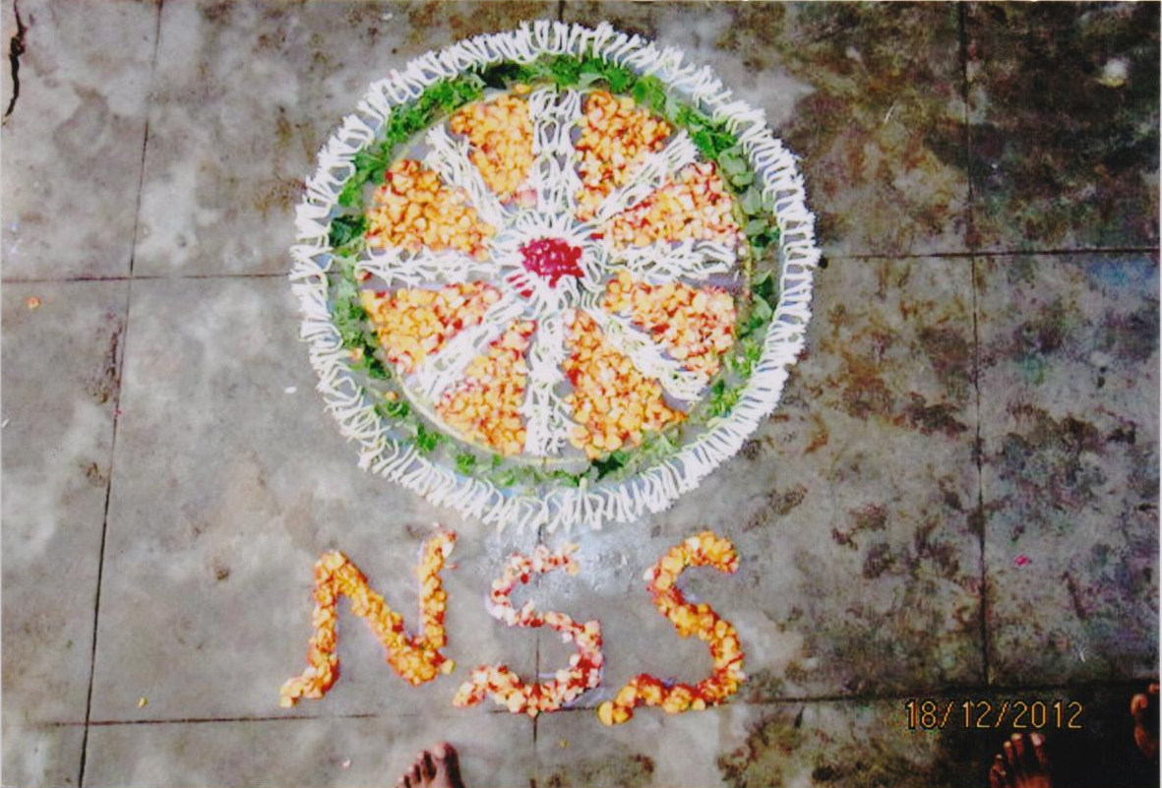 | 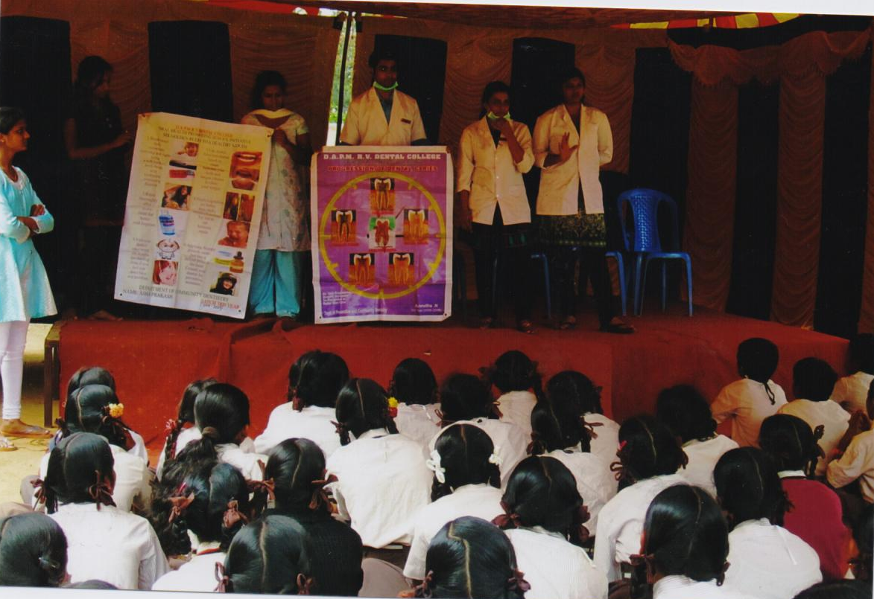

• Human Resource Management
- The institute has adopted a good human resource policy through which it administers manpower planning, development and recruitment, employee’s well being, salary and wage administration and training and development activities.
- Employees are given utmost importance and their needs are recognized well. The service rules for the employees are transparent. The employees are provided various benefits such as Leave facilities, adequate vacation every year, medical facilities etc.
- The institution frequently arranges for training programmes in-house and also deputes to other organization for acquiring balanced skills (technical skills, teaching skills, soft skills etc.) from all dimensions. Every time equipment is purchased and installed, software is purchased and installed, the department arranges for a demo session by the supplier.
- The institution encourages quality improvement programmes and deputes faculty on sabbatical leave for higher education. Their progress is monitored and based on their achievements incentives are paid, accounted during their appraisal based on which promotions are implemented.

• Industry interaction
- The institution organizes orientation visit to industries regularly and for short term training for the students.
- The institution facilitates students for the internship programs at the industry.
- The students are assisted to take up research dissertation work at the industry.
- The institution actively coordinates with the placement committee for student placement to the various industries and business houses.

    - How does the Head of the institution ensure that adequate information (from feedback and personal contacts etc.) is available for the top management and the stakeholders, to review the activities of the institution?

The institute has evolved a proper feedback system on various factors/activities of the institution such as feedback on curriculum, faculties, students, library, institution etc. The feedbacks are systematically analyzed and appropriate corrective actions are initiated as approved by the Principal.
Actions which involve policy decisions are referred to the board of trustees for approval. Upon approval actions are initiated for continuous improvement.
Summary of analyses of all the feedback are sent to the Board of Trustees for information and advice.
    - How does the management encourage and support involvement of the staff in improving the effectiveness and efficiency of the institutional processes?

All the members of the staff are serving in the various academic committees and have been very effectively functioning and contributing for the efficacy of the individual committee.
The faculty members irrespective of being in a particular committee communicates to the Chairman/Coordinator of another committee his/her suggestions.
The committees deliberate on the agenda and suggestions by the faculties. The minutes are made thereafter and forwarded to the principal for further action who initiates appropriate action as per rules.

    - Enumerate the resolutions made by the Management Council in the last year and the status of implementation of such resolutions.

For improving the performance of students the following resolutions were passed in the governing council meeting.
• Special attention and coaching for students with poor performance.
• Extra class tests for weak students.
• Continuous classes from 8.30 AM to 1.30 PM to increase the attendance percentage of students.
• For improving the discipline of students, late comers were not allowed to attend classes.

    - Does the affiliating university make a provision for according the status of autonomy to an affiliated institution? If ‘yes’, what are the efforts made by the institution in obtaining autonomy?

The University allows autonomy status. However the college is presently concentrating on academic development through good teaching- learning practices, research activities, student support activities and governance & leadership.

    - How does the Institution ensure that grievances / complaints are promptly attended to and resolved effectively? Is there a mechanism to analyze the nature of grievances for promoting better stakeholder relationship?

There is a grievance handling cell in the college which comprises of efficient members. They attend to the grievances and queries raised by the stake holders which are solved effectively. A record is maintained for the grievances which are handled by the cell. The frequently raised problems are analyzed and remedial actions are taken for preventing it in the future.

    - During the last four years, had there been any instances of court cases filed by and against the institute? Provide details on the issues and decisions of the courts on these?
Nil
    - Does the Institution have a mechanism for analyzing student feedback on institutional performance? If ‘yes’, what was the outcome and response of the institution to such an effort?

Feedback forms are distributed to the outgoing students/ alumni at the end of the program. The IQAC prepares the analysis of the feedback given by the alumni’s on the institution, infrastructure, academic procedures and support. The analysis is forwarded to the principal for further necessary action.
6.3 Faculty Empowerment Strategies
6.3.1 What are the efforts made by the institution to enhance the professional development of its teaching and non teaching staff?
- The institute initiates actions to enhance and enrich the teaching and non-teaching staff for their professional development. The details are:
- The members of the faculty are deputed/nominated to attend training programs (FDP) organized either in-house or by other external institutions.
- Faculties are deputed to attend conferences/ seminars/workshops, paper presentation.
- The institute has subscribed for online journals which are made available to each stream of program.
- The library is regularly improving the collection of books in various streams and has been subscribing to reputed journals and magazines which are effectively used by the faculty.
- Non teaching staff is provided both basic and advanced training in computers and related areas for improving computer skills, training programs on the emerging academic trends and programs to update and enhance their soft skills.

    - What are the strategies adopted by the institution for faculty empowerment through training, retraining and motivating the employees for the roles and responsibility they perform?

Faculty development programs are regularly conducted to train and refresh the teachers in the emerging scenario and steps to be initiated to face the challenges confidently and comprehensively. The faculties are placed in high ambience in terms of sharing both administrative and academic responsibilities. This is achieved through delegation of powers and through the participation/contribution to the academic committees.
The academic contribution given to the whole faculty makes them appreciative of the academic environment. Motivational activities such as recognition monetarily are through other substantial schemes encourages the faculties to contribute effectively.
Irrespective of their years of teaching experience, permission is granted for them to pursue their Ph.D. as part-time researchers and they can opt for a six month leave without pay. Service rules are employee friendly and the faculty feels comfortable with them.
Management considers comprehensive faculty development, which is more important today than ever before. It empowers faculty members to excel as educators and to create vibrant academic communities that value teaching and learning. A comprehensive faculty development program is built upon
- Professional development (new faculty members should be oriented to the university and to their various faculty roles).
- Instructional development (all faculty members should have access to teaching-improvement workshops, peer coaching, mentoring etc).
- Leadership development (academic programs depend upon effective leaders and well-designed curricula; these leaders should develop the skills of scholarship to effectively evaluate and advance education)
- Organizational development (empowering faculty members to excel in their roles as educators.) Organizational policies and procedures encourage and reward teaching and continual learning.

    - Provide details on the performance appraisal system of the staff to evaluate and ensure that information on multiple activities is appropriately captured and considered for better appraisal.

Based on standard performance appraisal forms available in the UGC web and sources from internet, the institute has created its own form. Students fill up a feedback form on faculty every semester and these feedbacks are analyzed by the IQAC. The analysis o f the feedback provides certain inputs on the individual faculties’ strength and weaknesses.
The faculties’ qualities such as communication skill, presentation skill, teaching ability, subject knowledge and usage of innovative teaching practices etc. are assessed by the HODs/Principal in the annual appraisal form. The principal finally assesses an individual faculty based on the feedback form and annual appraisal form.

6.3.4 What is the outcome of the review of the performance appraisal reports by the management and the major decisions taken? How are they communicated to the appropriate stakeholders?
The faculties’ qualities such as communication skill, presentation skill, teaching ability, subject knowledge and usage of innovative teaching practices etc. are assessed by the HODs/Principal in the annual appraisal form. The principal finally assesses an individual faculty based on the feedback form and annual appraisal form.
The decision on monitory increase etc. is taken thereafter. The principal/HOD communicates to the faculty the outcome of the assessment. While good performers are appreciated and motivated to continue to perform effectively, faculties with weaknesses are suitably counseled and action is extended to help them for total rehabilitation.

    - What are the welfare schemes available for teaching and non teaching staff? What percentage of staff have availed the benefit of such schemes in the last four years?
The management has a pro employee policy and has introduced several welfare schemes for the benavalance of the employees. To name a few:
                - Sabatical leave for pusuing higher studies.
                - Educational and personal loans for employee’s family.
                - Annual medical checkup and medical assistance.

    - What are the measures taken by the Institution for attracting and retaining eminent faculty?

The institute has in place a good man power planning and recruitment policy. Advertisements are displayed in prominent dailies/magazines inviting eminent faculties and suitable candidates are selected. As the institute has a record of healthy salary policy, efficient and well qualified faculties come forward to associate themselves with the institution.
As the institute follows healthy policy in employee relations and management with very high academics systems and practices, the faculties continue to identify themselves with the institute.
The strategy of empowering the faculties and motivating them to professional and to meaningfully contribute for the academic and management development is yet another important factor which binds the faculties with institution.

  - Financial Management and Resource Mobilization

6.4.1 What is the institutional mechanism to monitor effective and efficient use of available financial resources?
To ensure effective and efficient use of financial resources, the institute initiates the following action:
- The institute ensures that all the HODs submit the departmental budget to the principal well in-advance.
- The budget provides details quarter wise for all the four quarters of the year.
- The budget for the institute is finalized by the principal and forwarded to the trust for approval.
- The approved budget is maintained by the finance department who monitors purchase and expenses incurred by the various departments.
- Any deviation in the budget approvals is required to be approved by the trustees before purchasing/incurring expenditure.
- On completion of the accounting year, a qualified accounting organization conducts an external audit and provides the audited balance sheet to the trustees which is deliberated in the trust meeting and approved.

6.4.2 What are the institutional mechanisms for internal and external audit? When was the last audit done and what are the major audit objections? Provide the details on compliance.
The institution has appointed a company Chinappa and Associates headed by a qualified Charted Accountant- Mr. Chinappa. He along with his team of qualified accountants conducts the external audit of the entire institutes’ accounts. On completion of the audit the Charted Accountant Company issues the receipts and payments statements along with the audited account for every financial year.
The last statuary audit was conducted on 28th September 2013 and the audit report dated 20-12-2013 for the year 2012-13 is available with the institute.
The audit reports have not noticed any types of anomalies in the audit so far and the reports have certified that the books of accounts are maintained by the institute in the proper manner.
6.4.3 What are the major sources of institutional receipts/funding and how is the deficit managed? Provide audited income and expenditure statement of academic and administrative activities of the previous four years and the reserve fund/corpus available with Institutions, if any.
The institute source of receipts is by way of fees payable by the students. The institute has the budgetary system in place and ensures that the income and expenditure is as per the budgetary plans. Hence the needs for deficit management do not rise. The audited income and expenditure statement of academic and administrative activities of the previous four years and the reserve fund/corpus available with Institutions are annexed (6.4.3(1)).

6.4.4 Give details on the efforts made by the institution in securing additional funding and the utilization of the same (if any).
The institute has been effectively managing the funds by the trustees as per the budget. A group of philantrapist and well-wishers have setup a corpus to extend financial support to educational institutions in need. As and when need arises for securing additional funds, the institute approaches the said organisations for financial assistance. The sechuduled banks are also apporoched depending on fund requirements. Timely action is initiated to refund to the banks.

6.5 .1 Internal Quality Assurance System (IQAS)
a. Has the institution established an Internal Quality Assurance Cell (IQAC)? If ‘yes’, what is the institutional policy with regard to quality assurance and how has it contributed in institutionalizing the quality assurance processes?
Yes. Institution has established an IQAC on 22/05/2009.
The aim of the institution is to provide quality education for the empowerment of youth from all strata of society by promoting academic brilliance, employability and leadership with social obligation. The quality policy has been formulated based on the vision and mission of the college and is the guiding force that help departments to plan their activities.
The chairman and the IQAC team members ensure that this policy is embodied in the quality objectives are well communicated to all the departments of the College for better enrichment and accomplishment in academic excellence. The IQAC ensures that all its programs and activities are in-line with the quality policy which are reviewed by the IQAC team at its regular meeting.
The IQAC cell analyses the feedback forms on faculty/curriculum/academic by the stakeholders, analyses the feedbacks and necessary recommendations are made by the committee to improve the quality of education.
b. How many decisions of the IQAC’s have been approved by the management/ authorities for implementation and how many of them were actually implemented?
The major recommendations have been approved by the management. And many of them were implemented and are in practice like:-
- Implementation of ICT facilities.
- Wi-Fi facility in the college which can be accessed by both faculty and students
- Digital Library
- Organizing guest lectures , seminars, bridge courses, etc.,
- To form committees like women’s cell and anti-sexual harassment committee, library advisory committee, etc.,
- Organizing cultural events like ethnic day, and celebration of national festivals.
- Blood donation camps.

c. Does the IQAC have external members on its committee? If so, mention any significant contribution made by them.
The Institution has involved Mr. Channakeshavulu, Principal, BET College, Bangalore, as an external member in IQAC committee. His significant contribution has helped us in adopting best practices in teaching learning methods and innovating library.
d. How do students and alumni contribute to the effective functioning of
IQAC?

The IQAC cell invites the alumni’s to participate in meetings organized for aluminates’ annually. Alumni’s provide various views and thoughts on advancements in quality of education.
Alumni’s help to place students’ in various jobs’ in MNC’s and organizations by notifying the vacancies and referring our students for project internships and vacant positions.
e. How does the IQAC communicate and engage staff from different constituents of the institution?
The institution has formed IQAC cell with senior most and expertise personalities which is responsible for quality sustenance. It monitors the functioning of various committees and departmental activities by conducting meetings on regular intervals and circulates the minutes of the meeting to all the departments.
IQAC can plan and design new activities and enforce all the departments to comply with. Further the departments are required to communicate to the IQAC on the action taken process.
All communications from the IQAC are through E-Mails, inter-department communications and through the notice boards.
6.5.2 Does the institution have an integrated framework for Quality assurance of the academic and administrative activities? If ‘yes’, give details on its operationalization.
The institution has formed IQAC with members who are senior faculties with high academic expertise. All the HODs are the constituent members of the IQAC in addition to principal as the chairman with the vice-principal and a coordinator. The IQAC constituting such senior members of the faculty decide and formulate methodologies, systems and procedures for the growth and development of the institution and to provide the best educational services to the stakeholders.
6.5.3 Does the institution provide training to its staff for effective implementation of the Quality assurance procedures? If ‘yes’, give details enumerating its impact.
The institution motivates the faculty members to periodically attend programs on new and emerging technologies. The institution organizes in-house training programs to maintain quality of education system.
All the activities are organized and monitored by the IQAC.
6.5.4 Does the institution undertake Academic Audit or other external review of the academic provisions? If ‘yes’, how are the outcomes used to improve the institutional activities?
The IQAC is planning to conduct an academic audit during the year 2014-15. Based on the outcome of the audit necessary action will be initiated for the improvement of the institutional activities.
6.5.5 How are the internal quality assurance mechanisms aligned with the requirements of the relevant external quality assurance agencies/regulatory authorities?
The Internal Quality Assurance looks into the various activities of the institute like:
IQAC has to define which are the internal audit factors and areas that they are going to cover and monitor. Example: if the checklist has included all the factors required for academic progress, the internal audit committee instructs all departments to make corrective actions from the LIC inspection report.
6.5.6 What institutional mechanisms are in place to continuously review the teaching learning process? Give details of its structure, methodologies of operations and outcome?
Each department prepares an annual academic plan before the commencement of the next academic year. The progress of teaching learning process is regularly monitored by the HODs at the departmental level and the principal at the institutional level. The troubleshooting activities are initiated in-time to ensure the teaching learning process is smooth and effective.
The detail structure, methodologies of operations etc, is provided in criteria-I and criteria-II.
6.5.7 How does the institution communicate its quality assurance policies, mechanisms and outcomes to the various internal and external stakeholders?
Most of the internal stakeholders are part of the IQAC and in addition to attending the meetings, they receive all official communications.
The external stakeholders are given proper communication on a need base process to reach the objectives and for the effective functioning of the IQAC.

6.5.8 Any other relevant information regarding Governance Leadership and Management which the college would like to include.
Nil
Criteria VII: Innovations and Best Practices

7.1 Environment Consciousness
7.1.1 Does the Institute conduct a Green Audit of its campus and facilities?
The IQAC is planning to conduct a Green Audit of its campus and facilities in the year 2014-15. The audit report will be submitted to the Principal and the outcome of the report will be discussed in a meeting of the HODs and necessary action to be initiated to preserve the campus and to ensure an healthy environment.

It is also proposed to create awareness among the stakeholders and to establish eco-friendly atmosphere on the Environmental conditions regular programs are organized with the help of NSS in the campus and hostel.
The campus has sufficient greenery and various kinds of trees are grown. To ensure that the campus is a plastic free zone, the students and staff are educated on the hazards caused by abusing plastic materials and minimize the use of plastic.
A number of awareness programs are conducted for the benefit of stakeholders for preservation and conservation of natural resources such as power, water and air. Display boards are kept seeking stakeholders participation in conserving electricity and water when it is not used.

7.1.2 What are the initiatives taken by the college to make the campus eco-friendly?
- Energy conservation

  - The ordinary bulbs and tube lights are replaced with CFL bulbs throughout the campus.
  - The faculty members are advised to consume energy economically in the Staff rooms, class rooms and the laboratories by maximizing the use of natural light and turning off all non – essential lights, turning off exterior lighting during daytimes, minimizing the usage of fans and air conditioners.
  - Turning off the powered equipments when not in use like computers and other electronic devices at the end of the day.
  - Normal CRT monitors are upgraded to LCD monitors in the labs to consume less energy.
  - Elevator is used only for essential purpose and for persons who are differently abled.
  - The overflow of water is checked and the leaking points are identified and repaired immediately. Suitable measures are undertaken to prevent wastage of water

- Minimizing wastage:

  - Plastics Bottles, cans and papers are sent for recycling.
  - Waste fabric from Fashion & Apparel Design are used for making accessories for children and other fabrics.
  - The water heaters in the hostels are operated with solar power.

- Water harvesting

  - The college has proposed to set up Rainwater Harvesting System in campus –I.

- Check dam construction
Not Applicable
- Efforts for Carbon neutrality
  - Students are motivated to use public transportation rather than individual transportation.
  - Awareness programs on global warming are conducted by NSS.
  - Plantation of trees in campus has been increased to absorb carbon-di-oxide emitted.
- Plantation
NSS Volunteers and members of the institution take keen interest in tree plantation and organizing special programs for plantation of trees within the campus.
- Hazardous waste management

  - The college avoids the usage of severe corrosive and toxic chemicals in the practical classes and sees that minimum quantity of chemicals is purchased to save expiry and disposal.
  - Adequate number of exhaust fans and fume hoods are also provided to make sure that all unwanted fumes generated during organic or in-organic synthetic procedures are got rid off while conducting practical classes. Solid waste in the chemistry lab is collected separately and disposed off carefully without causing any harm to the students.
  - Special drainages are constructed to dispose off the chemical waste from the labs.

- e-waste management

The electronic components are maintained to the extent possible and on expiry date the components are disposed to the authorized vendors as per the central government rules.

7.2 Innovations
7.2.1 Give details of innovations introduced during the last four years which have created a positive impact on the functioning of the college.
Innovations in teaching and learning:
  - Innovative teaching, web assignments, seminars organized by the students, innovative quiz programs etc.
  - Add-on courses are conducted to fulfill the demands of the current job market.
  - Faculty Development programs are conducted on regular basis where in a special session are held to analyze and discuss on innovation in teaching around the world.
  - To improve the performance of the faculty, the feedbacks from the students are analyzed and the faculties are appropriately counseled by the HODs/Principal to overcome their short coming and weakness. The good performers are recognized with several honors as a part of motivation.
  - Remedial coaching for slow-learners
  - Students are taken to Industrial visits for real time experience to related companies and places.
  - ICT-enabled teaching and learning are in practice
  - Motivating and recommending the students for Internship training in the industries.
Innovations in student support services
  - Various committees such as Students’ Council Cell, Grievance, and Anti-ragging Committee are in existence to ensure students’ welfare.
  - Alumni association is in existence and functional to maintain the link and relationship between the college and the alumni’s.
  - The Placement Cell facilitates the students in getting placed in to their desired and dream companies.
  - Students have a wide option to select to join the Add-on courses of their choice which shall provide a better leverage for placement.
Innovative Infrastructure
- ICT, Wi-Fi and internet facility is made available to students and faculty members.
- The institution has well- stacked and maintained central library.
- A Well equipped and upgraded computer lab for the exclusively use of students and faculties.
- Automated administration.
7.3 Best Practices
7.3.1 Elaborate on any two best practices as per the annexed format (see page .. ) Which have contributed to the achievement of the Institutional Objectives and/or contributed to the Quality improvement of the core activities of the college.
I. Mentoring for slow learners
1. Goal:
Those students who have personal, financial or academic problem are provided an opportunity for counseling to help the students with their specific problems to overcome them and to bring them in to the normal stream of studies.
2. The context:
The first reason to establish a structured student mentoring initiative is to utilize the talents the institution is having. A structured mentoring initiative can save costs in talent, energy and time for students. Any information that saves their time and energy directly affects their satisfaction with their work and improves both the quality of their performance and their commitment to their studies, thus enhancing our chances for retaining and improving them.
3. The Practice:
Student mentoring is an arena for problem solving, and an opportunity for encouragement. Mentors should be as friend-philosopher – guide who are able to spend valuable time with needy students to hear their concerns, successes, and grievances and proper reasons that make them slow learners. It should be only one is to one interaction between a teacher and student.
● A mentor is a wise and trusted counselor, a guide and teacher
● A mentor coaches, teaches, advises, supports, guides and helps the students achieve their goals.
● Mentoring is a tool that organizations use to nurture and grow their people.
● Mentoring is a personal as well as a professional relationship.
Our faculty tries to identify those students who are experiencing academic, personal, financial etc. problems as early as possible. Students that have missed more than three or four classes are called personally and the concerned faculty talks with them personally to inquire why the student missed more than three or four class days. If he/she shows early signs of having problems with the classroom/home work assignments or personal problems or if the student continues to miss classes, then the Counselor attempts to contact the student and a meeting is scheduled with those students with the student counselor. Through this personalized meeting the student counselor is able to ascertain the exact nature of the problem and assist the student to resolve his problem.
If the problem is academic that is the student concerned is having trouble understanding the subject or he/she is a slow learner then special tutoring is also given to assist students in various classes.
Peer mentoring has also been initiated to focus on building a connection of junior and senior students as well. Peer mentoring also include input from senior students. The student coordinator can call on senior students who might have faced the same problem or may be resourceful in solving the particular problem.
4. Success:
This system has been followed for last few years and now students are well aware of where to go when there seems nobody else to turn to when they need help.
Being in contact with our student on a personal basis is beneficial to the fact that it creates trust in the student teacher relationship. When a student feels there is a shared trust in the relationship, the student is less likely to cheat or miss classes.
5. Problems encountered and resources required:
There is no single approach that will work for everyone. All cases are student specific and problem specific. Hence, Faculties have to identify the specific problems of the individual students. In mentoring initiatives of any kind, a wide variety of participation and impact on both mentees and mentor is expected. Individuals are variously talented as mentors, and mentees vary widely in their listening and strategic thinking skills. Some mentoring relationships bring immediate and longer term benefits others do not work at all depending on the mentality of the students
II. Title of the Practice: Stakeholders’ Relationship
    - Stakeholders are Students, Parents, Staff, Alumni and Society.
    - Objectives of the Practice: Standardization of system and infrastructure, efficient professional management, enhancing teaching quality, maintenance of discipline, attendance, performance, etc.
    - The Context: All the members of the alumni cannot be accessed.
    - The Practice: Students’ union and allied association represent student population. Students can communicate their problems to their respective faculty advisors and HOD. Parents have access to meet them with the prior permission of the Principal. Information regarding GO from DCE/RJD, any changes in the schedule given in the college calendar are informed to the students and the faculty members. Decisions are taken after consultation with the faculty. Old students’ association is active with a senior faculty in-charge. Suggestions from alumni are acknowledged. Suggestions of the parents are also considered. Career counseling is extended. Good library with internet facility and wide range of books serves as a knowledge resource. Faculty members participate in research and administrative activities. Guest lectures by eminent scholars are arranged.
    - Evidence of Success: There is always high strength in admission and low dropout rates.
    - Problems encountered and resources required: Inability to contact a large number of old students.
    - Notes: ¾ Periodic update of curriculum to be at par with national and global trends.
    - Quality promotion through IQAC
    - ¾ Introducing and updating innovative teaching-learning and evaluative methods
    - ¾ Feedback from stakeholders
    - ¾ Participatory management
Format for Presentation of Best Practices
1. Title of the Practice
This title should capture the keywords that describe the Practice.
2. Goal
Describe the aim of the practice followed by the institution. Brief the underlying principles or concepts in about 100 words.
3. The Context
Describe any particular contextual feature or challenging issues that have had to be addressed in designing and implementing the Practice in about 150 words.
4. The Practice
Describe the Practice and its implementation. Include anything about this practice that may be unique in the Indian higher education. Please also identify constraints or limitations, if any, in about 400 words.
5. Evidence of Success
Provide evidence of success such as performance against targets and benchmarks and review results. What do these results indicate? Describe in about 200 words.
6. Problems Encountered and Resources Required
Please identify the problems encountered and resources required to implement the practice in about 150 words.

Best Practice - Bio Technology Department

Title: Proficiency to become skilled on a skill
Goal: The meaning “to become skilled on a skill” is a method of increasing the knowledge and skill of a person for doing the job in their field of interest. Training helps to acquire latest skills, thus increase versatility for qualification for busting carrier. It provides better safety, remuneration and security. It also enables to drive greater satisfaction and utilize the full skills and capacity. Proper training teaches skilled operation and directs the student in a right manner. Since Biotechnology is an application oriented program, we prefer students to attend training courses in techniques related to various concepts in Molecular biology, recombinant DNA technology, Bioinformatics, Tissue culture, microbiology and gene therapy. Thus as an outgoing alumnae, our students are highly skilled enough to compete the growing technology. These innovative practices will improve the performance and morale of students and they acquire new skills, increasing their contribution to their self-esteem so, they’re unskilled to do new and different tasks, which keep them motivated and fresh.
The context: Employees join in the biotechnology sector from a diverse range of backgrounds and so have a range of prior experience with the theory and practice of biotechnological research methods. This provision has a very strong focus upon practical skills and the execution of biotechnological laboratory practice. In Contemporary society, the students are highly ignorant about the problems of the society where they live. Therefore, it is realized that the students must be sensitized about the society and skill oriented activities are made mandatory for them in our department
The Practice: The purpose of the learning environment is to support evidence-based practices that improve their skills in procedure of research and biotechnological service organizations. Best Practices in Biotechnology education is directed at faculty seeking to start or expand biotechnology education programs; policy-makers and economic developers seeking to help meet workforce needs; and, students, scientists, and business professionals looking to enter the industry or upgrade their existing skills. These best practices provide a framework upon which to understand critical issues in biotechnology business development. Experts from a wide range of disciplines will share their experiences and expertise, by giving hands on training and creating a vital toolbox covering a broad spectrum of topics. These best practices will enable to develop a better understanding of the key elements in these operations and empower to better manage their implementation. Our aim at good skills training is that all learners should enjoy their training Skills and practice course and their by the end of their course all learners should be confident trainer.
We focus on practice and implementation of following skills.
- Background to lab work; risk assessments, planning work based upon reasonable timelines
- Basic principles of the Biotechnological lab; following an introduction to appropriate use of general lab equipment including balances, pipettes, pH meters, the concept of the mole, pH, preparing solutions, buffers, dilutions
- Common basic assays; ELISA, RIA, activity assays, enzyme kinetics.
- Molecular separation; review of the tools available for molecular separation for analytical or preparative purpose - chromatography, electrophoresis
This practice is carried out in the following phases:
- Work distribution to all faculties
- Planning of the activity : At individual level
- Discussion about planning:
- Finalization of the plan: The suggestions are considered.
- Involvement of faculty members and student representatives inadministration.
- Execution of the activity / program
- Feedback
- Evidence of Success
Every young person should have the opportunity to grow up with a good education, get a job and participate in his/her community. Creating more fair and effective juvenile justice systems that support learning and growth and promote accountability can ensure that all of our young people grow up to be healthy, productive members of society. To prepare for an outcome evaluation, we analysed whether our program is doing what it set out to do. Second, we chose a research design for the evaluation and gather the appropriate information. Third, we must be ready, once the evaluation is complete, to take the next steps. Students realized the challenges faced by them in the society. They have also realized the value and importance of education for their upliftment.

- Problems Encountered and Resources Required

- Fund mobilization to organize events is the major problems for the college
- In some critical situation, it is difficult to take a decision to sort out the problem. In such a case, the decision is taken by the Principal.
Resources required
- Laboratory
- Instruments
- Chemicals
- Library
- Seminar hall

Contact Details
Name of the Principal : Dr. S. Devarajulu
Name of the Institution : Bangalore City College
City : Bangalore
Pin Code : 560043
Accredited Status : B - Grade
Work Phone : 080-25459956, 25425463
Fax : 080-25459958
Website : www.bangalorecitycollege.org
E-mail: : bangalorecitycollege2009@gmail.com
Mobile : +918088720711
Evaluative Report of the Departments
The Self-evaluation of every department may be provided separately in about 3-4 pages, avoiding the repetition of the data.

- Name of the department : BIOCHEMISTRY

- Year of Establishment : 2002-2003

- Names of Programs / Courses offered (UG, PG, M.Phil., Ph.D., Integrated Masters; Integrated Ph.D., etc.):

UG: B.Sc., (Biotechnology, Biochemistry and Genetics)
PG: M.Sc., Biochemistry

- Names of Interdisciplinary courses and the departments/units involved:

Name of the Dept | Course | Paper Name
Dept. of Microbiology | M.Sc. | Practical Microbiology(106)
Dept. of Microbiology | M.Sc. | Theory Microbiology(103)
Dept. of Biotechnology | B.Sc. | Biochemistry-VIII
Dept. of Biotechnology | M.Sc. | Biochemical Genetics
Dept. of Biotechnology | M.Sc. (6 out of 7 units) | Bioinformatics & Research methodology
Dept. of Chemistry | B.Sc. | Biochemistry- I
Dept. of Chemistry | B.Sc. | Biochemistry- II
Dept. of Chemistry | B.Sc. | Practical Biochemistry- II
Dept. of Chemistry | B.Sc. (9 units out of 15) | Biochemistry- III
Dept. of Chemistry |  | Practical Biochemistry- IV
Dept. of Chemistry | M.Sc.,(6 units out of 7) | Fundamentals of Chemistry & Environmental Biochemistry

- Annual/ semester/choice based credit system (program wise) : Semester

- Participation of the department in the courses offered by other departments:

Name of the Dept | Course | Paper Name
Dept. of Microbiology | B.Sc. | Practical Biochemistry & Biophysics
Dept. of Microbiology | B.Sc. | Theory Biochemistry & Biophysics
Dept. of Microbiology | M.Sc. (4.5 units out of 6 units) | Microbial physiology & Biochemistry
Dept. of Biotechnology | B.Sc. | Practical Biochemistry & Biophysics
Dept. of Biotechnology | B.Sc. | Theory Biochemistry & Biophysics
Dept. of Biotechnology | M.Sc. | Biochemical Techniques & Enzymology
Dept. of Chemistry | B.Sc. | Biochemistry Theory
Dept. of Chemistry | B.Sc. | Paper VIII Practical
Dept. of Chemistry | M.Sc.(1 unit out of 5) | Organic reaction mechanisms
Dept of Nursing | B.Sc. (7 units ) | Theory Nutrition & Biochemistry
Dept of Nursing | Post Basic B.Sc. (8 units out of 16) | Theory Biochemistry & Biophysics

- Courses in collaboration with other universities, industries, foreign institutions, etc. : Nil

- Details of courses/programs discontinued (if any) with reasons :
Nil

- Number of Teaching posts

Posts | sanctioned | Filled
Professors | 1 | 1
Associate Professors | Nil | Nil
Asst. Professors | 03 | 03

- Faculty profile with name, qualification, designation, specialization, (D.Sc./D.Litt. /Ph.D. / M. Phil. etc.,)

Name | Qualification | Designation | Specialization | No. of Years of Experience | No. of Ph.D. Students guided for the last 4 years
Dr. Somali Ghosh | Ph.D. | HOD, Professor | Enzymology and Protein chemistry | 9 years | -
Mrs. Olive Grace | M.Sc. | Asst. Prof | Biochemistry | 6 years | -
Mrs. R. Gomathi | M.Sc., M.Phil. | Asst. Prof | Biochemistry | 5 years | -
Ms. Anupama N. | M.Sc. | Asst. Prof | Biochemistry | 1.5 year | -

- List of senior visiting faculty: Dr. Indrani Bose, Assistant Professor, Department of Biology, Western Carolina University, USA

- Percentage of lectures delivered and practical classes handled(program wise) by temporary faculty : Nil

- Student -Teacher Ratio (program wise): 18:1

- Number of academic support staff (technical) and administrative staff; sanctioned and filled : 01

Sl. No: | Position | Sanctioned | Filled | remarks
1 | Laboratory Support Staff | 1 | 1 | Nil

- Qualifications of teaching faculty with DSc/ D.Litt/ Ph.D/ MPhil/PG.:

Ph.D – 1, M.Phil- 1, M.Sc.- 2

Name | Qualification
Dr. Somali Ghosh | Ph.D., PDF, Biochemistry
Mrs. Olive Grace | M.Sc., Biochemistry
Mrs. R. Gomathi | M.Sc., M.Phil, Biochemistry
Ms. Anupama N. | M.Sc., Biochemistry

- Number of faculty with ongoing projects from a) National b) International funding agencies and grants received: Nil

- Departmental projects funded by DST-FIST; UGC, DBT, ICSSR, etc. and total grants received: Nil

- Research Centre /facility recognized by the University: Nil

- Publications:

- a) Publication per faculty:
  - 1) Dr. Somali Ghosh: 1

- Number of papers published in peer reviewed journals (national / international) by faculty and students :

Characterization of Polyaniline/Ionic Liquid Composites using Nuclear Magnetic Resonance, Ghosh, S.; Fadeev, A.; Noris, I.; Mattes, B.R.; Espe, M.P; Polyomer Preprint, American Chemical Society Journal, 2004, 45(1), 304-305.l

- Number of publications listed in International Database (For Eg: Web of Science, Scopus, Humanities International Complete, Dare Database - International Social Sciences Directory, EBSCO host, etc.)
- Monographs
- Chapter in Books- Nil
- Books Edited - Nil
- Books with ISBN/ISSN numbers with details of publishers- Nil
- Citation Index
- SNIP
- SJR
- Impact factor
- h-index

- Areas of consultancy and income generated : Nil

- Faculty as members in
  - National committees b) International Committees c) Editorial Boards….
Dr. Somali Ghosh: Applied for membership in The Indian Science Congress Association.

- Student projects

  - Percentage of students who have done in-house projects including inter departmental/program: 30%

  - Percentage of students placed for projects in organizations outside the institution i.e. in Research laboratories/ Industry/ other agencies : Nil

- Awards/ Recognitions received by faculty and students :
Sl. No. | Name of faculty | Awards | Purpose | Year
1 | Dr. Somali Ghosh | University of Akron,USA | Tution waiver to pursue Doctoral degree | 1999-2004
2 | Dr. Somali Ghosh | Dr. Mathhew Espe, University of Akron , USA (NIH Grant for Activator of L-aspartse ) | Graduate Research Fellowship | 2001-2003
3 | Dr. Somali Ghosh | Cleveland Clinic Research Foundation, OHIO | Post doctoral fellowship | 2004-2005

- List of eminent academicians and scientists/ visitors to the department :
Dr. Indrani Bose, Assistant Professor, department of Biology, Western Carolina University, USA

- Seminars/ Conferences/Workshops organized & the source of funding
a)National b)International
Seminar on “A yeast under cover: The capsule of Cryptococcus neoformans” given by Dr. Indrani Bose, Assistant Professor, department of Biology, Western Carolina University, USA
Workshop organized by Mr. Ramana Reddy, Scientist, Natural Remedies, Bangalore.

- Student profile program/course wise:

Name of the Course/program  (refer question no. 4) | Applications received | Selected | Enrolled  *M *F |  | Pass percentage
M.Sc (2009) | 09 | 09 | 05 | 03 | IV Sem : 71%
M.Sc (2010) | 19 | 19 | 09 | 07 | IV Sem : 64%
M.Sc (2011) | 14 | 13 | 07 | 06 | IV Sem: 80%
M.Sc (2012) | 16 | 16 | 07 | 08 | NA
*M=Male F=Female

- Diversity of Students

Name of the Course | % of students from the same state | % of students from other States | % of students from abroad
M.Sc(2009) | 25% | 75% | 0
M.Sc (2010) | 19% | 69% | 12.5%
M.Sc (2011) | 7.7% | 77% | 7.7%  NRI : 7.7%
M.Sc (2012) | 20% | 47% | 33%

- How many students have cleared national and state competitive examinations such as NET, SLET, GATE, Civil services, Defense services, etc. ? :
GATE: Subhasree Swain, 2011
CCMB entrance for research : Rajalaxmi Tingu, 2012
- Student progression

Student progression | Against % enrolled
UG to PG | 16%
PG to M.Phil. | 0
PG to Ph.D. | 4%
Ph.D. to Post-Doctoral | -
Employed  - Campus selection  - Other than campus recruitment | 80%
Entrepreneurship/Self-employment | -

- Details of Infrastructural facilities
a) Library: Yes
b) Internet facilities for Staff & Students: Yes
c) Class rooms with ICT facility: One Seminar room is equipped with ICT facility which we can use as per requirement.
d) Laboratories: Yes

- Number of students receiving financial assistance from college, university, government or other agencies:

3 students in 2012-13 batch are from University Quota for whom the tuition fees are less.

- Details on student enrichment programs (Special lectures / workshops / seminar) with external experts:

Sl. No | Program | Year
1 | International Conference on Current trends in Chemistry and Biochemistry, Bangalore University | 2009
2 | Confluence 2010 , Conference arranged by Indian Academy Degree College & Bangalore University | 2010
3 | Visit to Natural remedies Pvt. Ltd., Bangalore | 2011 | Learning Analytical Techniques like HPLC etc.,
4 | Visit to IISC, Open Day symposia | 2011
5 | Visit to IISC, Open Day symposia Bangalore | 2012
6 | Visit to Sangenomics Research Lab, Bangalore | 2012 | Workshop on PCR
5 | Visit to IISC, Bangalore, Open Day Symposia | 2013
6 | Seminar on “Biodiversity, indegeneous knowledge and biotechnology) at Maharani Laxmi Ammani’s College, Bangalore | 2013

- Teaching methods adopted to improve student learning: Interactive teaching is adopted in our Department where for each subject one topic each semester each student has to give a seminar. Regular class tests, internal assessment tests are also conducted periodically. Students are always encouraged to ask any questions or doubts at any time outside or inside the classroom.

- Participation in Institutional Social Responsibility (ISR) and Extension activities: Visit to orphanage (Sacred Heart Little Indians, Hosur).

- SWOT analysis of the department and Future plans-
Please specify the Department’s:
Strength:
- Qualified experienced and dedicated faculty members. It is considered by the students that lecture and practical teaching is of high quality here.
- Diverse student background which contributes to make a healthy, competitive multicultural environment in the department.
- 80% students are placed in companies or academic institutions.
- Biochemistry syllabus provided by the Bangalore University is very comprehensive and covers all aspects of life sciences as well as critical concepts in Biochemistry which helps the students to acquire adequate knowledge and skills to perform their job on employment.
- Students are motivated to take up a project work voluntarily which is beyond the curriculum.

Weakness:
- A few students admitted for M.Sc. programs have completed their under graduation in their native language and have limitations in English working knowledge.
- Project work is not part of the curriculum for M.Sc., course.

Opportunities:
- Instrument facilities in the lab can be used for consultancy services and for generating revenue. For example, giving some practical based training courses or certificate courses or giving services to students, teachers or outside clients.
- Separate classes to train students for NET, GATE exams for which all the life Sc students can be combined together and different faculty members can teach the subject of their specialization.
- Syllabus may be reviewed by the Bangalore University to include project work which will facilitate all the students to get exposed to research work.

Threats:
- Major threat to Biochemistry the job opportunity and the current salary levels are not as attractive as compared to the other jobs.
- To attract the bright students to join the program.

Please specify the department’ Future plans
- To arrange workshops in house
- To build a research oriented program, this should be prescribed by the university.
- To encourage faculty members for starting their own research projects and to apply for small scale Govt. funding.
- To use the existing instrument facility to generate revenue and buy new instruments with that fund.
Evaluative Report of the Departments

- Name of the department :- BIOTECHNOLOGY

- Year of Establishment:- 2001-02

- Names of Programs / Courses offered (UG, PG, M.Phil., Ph.D., Integrated Masters; Integrated Ph.D., etc.) :-

UG: B.Sc., Biotechnology
PG: M.Sc., Biotechnology

- Names of Interdisciplinary courses and the departments/units involved:-
NIL

- Annual/ semester/choice based credit system (program wise):-
SEMESTER SCHEME

- Participation of the department in the courses offered by other departments:-

Microbiology and Biochemistry

- Courses in collaboration with other universities, industries, foreign institutions, etc. :-
NIL

- Details of courses/programs discontinued (if any) with reasons:-
NONE

- Number of Teaching posts

Post | sanctioned | Filled
Professors | 02 | 02
Associate Professors | 2 | 2
Asst. Professors | 3 | 3

- Faculty profile with name, qualification, designation, specialization, (D.Sc./D.Litt. /Ph.D. / M. Phil. etc.,)

Sl. No | Name | Qualification | Designation | Specialization | No. of Years of Experience | No. of Ph.D. Students guided for the last 4 years
1. | Dr. Sreekanth P. M | Ph.D.,  Post Doctoral Degree | HOD & Professor | Population Genetics | 4(Post Doctoral Experience) | Nil
2. | Dr. Marayada Dixit | Ph.D.,  Post Doctoral Degree | Professor | Plant Biotechnology | 10 | Nil
3. | Dr. Shipra Raj | M.Sc., Ph.D., | Assistant Professor | Plant breeding and Genetics | 7 | Nil
4. | Mrs. Rekha J | M.Sc., M.Phil. | Assistant Professor | Molecular Biology | 10 | Nil
5. | Ms. Mahalakshmi R | M.Sc., B.Ed., | Assistant Professor | Genetic Engineering/Plant Biotechnology | 9 | Nil
6. | Ms. Priya John | M.Sc., M.Phil. | Assistant Professor | Genetics | 7 | Nil
7 | Mrs. Abhilasha Srivastava | M.Sc | Assistant Professor | Molecular Biology | 3 months | Nil

- List of senior visiting faculty:-Dr. Chandrashekara, Retired Professor Department of Life Science, Bangalore University.

- Percentage of lectures delivered and practical classes handled(program wise) by temporary faculty:-
NIL

- Student -Teacher Ratio (program wise):

UG: 4:1
PG: 3:1

- Number of academic support staff (technical) and administrative staff; sanctioned and filled:- 1

Sl. No: | Position | Sanctioned | Filled | remarks
1 | Lab At tender | 1 | 1 | nil

- Qualifications of teaching faculty with DSc/ D.Litt/ Ph.D/ MPhil/PG.:-

Sl. NO: | Name | Qualification
1. | Dr. Sreekanth P. M | Ph.D., Post Doctoral Degree
2. | Dr. Marayada Dixit | Ph.D.,  Post Doctoral Degree
3. | Dr. Shipra Raj | M.Sc., Ph.D.,
4. | Mrs. Rekha J | M.Sc., M.phil.
5. | Ms. Mahalakshmi R | M.Sc., B.Ed.,
6. | Ms. Priya John | M.Sc., M.Phil.
7 | Mrs. Abhilasha Srivastava | M.Sc

- Number of faculty with ongoing projects from a) National b) International funding agencies and grants received:-
NIL

- Departmental projects funded by DST-FIST; UGC, DBT, ICSSR, etc. and total grants received:-
NIL

- Research Centre /facility recognized by the University:-
NIL

- Publications:

a) Publication per faculty
Dr. Sreekanth P. M: - 3

1) Sreekanth,P.M., Balasundaran M., Nazeem P.A and Suma T.B. Genetic diversity of nine natural Tectona grandis L.f. populations of the Western Ghats in Southern India. 2012. Conservation Genetics 13:1409–1419 Springer Publication;DOI: 10.1007/s10592-012-0383-5.(Impact factor 2.183)

2) Sreekanth,P.M., Balasundaran, M., 2012. AFLP diversity of teak in Clonal seed Orchard.Indian Journal of Genetics and Plant Breeding.72 (4) 484 - 487 (Impact factor 7.2). ISSN:-0975-6906.

3) Sreekanth, P.M and Balasundaran, M, 2013. Clonal Seed Orchard of Teak (Tectona grandis L.f.): Genetic Diversity Measures Primary Basis for Future Environmental Uncertainty, Tree Genetics and Molecular Breeding Vol.3, No.24-10, 7- 11 Biopublishers Publication, Canada;
(DOI: 10.5376/tgmb.2013.03.0002) (Peer Reviewed)
b). Number of papers published in peer reviewed journals (national / international) by faculty and students: - 1

1) Sreekanth, P.M and Balasundaran, M, 2013. Clonal Seed Orchard of Teak (Tectona grandis L.f.): Genetic Diversity Measures Primary Basis for Future Environmental Uncertainty, Tree Genetics and Molecular Breeding Vol.3, No.24-10, 7- 11 Biopublishers Publication, Canada;
(DOI: 10.5376/tgmb.2013.03.0002) (Peer Reviewed

c). Number of publications listed in International Database (For Eg: Web of Science, Scopus, Humanities International Complete, Dare Database - International Social Sciences Directory, EBSCO host, etc.):- 02
- Monographs:- NIL
- Chapter in Books:- 3
1)Sreekanth, P.M, Balasundaran, M., Nazeem, P.A. and Suma T. B 2010. Nilambur Teak: A Phenotypically and Genotypically Distinct Provenance. In: Proceedings of International Workshop, Production and Marketing of Teakwood: Future Scenarios, 23-25, Peechi, India. C. Mohanan, M. P. Sujatha, Mammen Chundamannil (Eds), pp. 83-89
2)Suma T.B., Sreekanth P.M., Renee M Borges Balasundaran M 2013. A peep into thegenetic diversity of trees of the Western Ghats.Evergreen (71) 6-8
3)Sreekanth P. M, 2013. Identification of mislabeling errors in teak clonal seed orchard of Kerala using AFLP markers. In Proceedings of Tree Biotechnology National Seminar, pp 134-136

d). Books Edited:-NIL
e). Books with ISBN/ISSN numbers with details of publishers:-NIL
f). Citation Index:-NIL
g). SNIP:-NIL
h). SJR:-NIL
i). Impact factor:- 2
  - Sreekanth,P.M., Balasundaran M., Nazeem P.A and Suma T.B. Genetic diversity of nine natural Tectona grandis L.f. populations of the Western Ghats in Southern India. 2012.Conservation Genetics 13:1409–1419 Springer Publication;DOI: 10.1007/s10592-012-0383-5.(Impact factor 2.183)
  - Sreekanth,P.M., Balasundaran, M., 2012. AFLP diversity of teak in Clonal seed Orchard. Indian Journal of Genetics and Plant Breeding. 72 (4) 484 - 487 (Impact factor 7.2). ISSN:-0975-6906.
- h-index:- NIL

- Areas of consultancy and income generated :- NIL

- Faculty as members in
- National committees:- 1

Dr. Sreekanth P M | Indian Society of Genetics and Plant Breeding | 2010 | Till Today

- International Committees: - NIL

c) Editorial Boards….:-02

Dr. Sreekanth P. M | Management Science and Engineering, Canadian Research and Development Centre for Science and Culture | 2012 | 2015
Dr. Sreekanth P. M | Journal of Forest Research | 2014

- Student projects
- Percentage of students who have done in-house projects including inter departmental/program:-
UG: -100% PG: - NIL

b) Percentage of students placed for projects in organizations outside the institution i.e.in Research laboratories/ Industry/ other agencies:
UG: - NIL; PG: - 100%

- Awards/ Recognitions received by faculty and students
AWARDS RECEIVED BY FACULTY

  - Dr. Sreekanth P. M awarded Dr. K.M Bhat endowment gold medal 2013 for the best emerging Scientist of Kerala Forest Research Institute, Peechi, Thrissur, Kerala.
  - Dr. Sreekanth awarded best oral paper presentation award in the National Seminar on Tree Biotechnology 2013, September 23-24, organized at the Institute of Forest Genetics and Tree Breeding, Coimbatore sponsored by Department of Biotechnology and Department of Science and Technology.

- List of eminent academicians and scientists/ visitors to the department

Dr. Chandrasekara previous principal, Bangalore City College, Bangalore, an eminent visitor to the department who specialized in teaching professionals in Enzymology and Genetics

- Seminars/ Conferences/Workshops organized & the source of funding
a) National: - NIL
b) International: - NIL

- Student profile programme/course wise:
PG Programme
Name of the Course/programme  (refer question no. 3) | Applications received | Selected | Enrolled  *M *F | Pass percentage
Biotechnology 2009 | 29 | 26 | 17 09 | 100%
Biotechnology 2010 | 53 | 51 | 26 25 | 100%
Biotechnology 2011 | 39 | 35 | 18 17 | 100%
Biotechnology 2012 | 12 | 11 | 04 07 | 97%
Biotechnology 2013 | 20 | 18 | 05 13 | 97%
*M=Male F=Female

UG Programme
Name of the Course/programme  (refer question no. 3) | Applications received | Selected | Enrolled  *M *F | Pass percentage
Biotechnology 2009 | 15 | 10 | 04 06 | 100%
Biotechnology 2010 | 11 | 11 | 08 03 | 100%
Biotechnology 2011 | 25 | 17 | 15 04 | 100%
Biotechnology 2012 | 23 | 23 | 06 17 | 95%
Biotechnology 2013 | 16 | 15 | 08 07 | 95%
*M=Male F=Female

- Diversity of Students
PG Program
Name of the Course | % of students from the same state | % of students from other States | % of students from abroad
Biotechnology 2009 | 3.85% | 96.15% | -
Biotechnology 2010 | - | 78.43% | 19.6%
Biotechnology 2011 | 2.86% | 94.3% | 2.86%
Biotechnology 2012 | - | 72.73% | 27.27%
Biotechnology 2013 | 5.50% | 94.5% | -
UG Program

Name of the Course | % of students from the same state | % of students from other States | % of students from abroad
Biotechnology 2009 | 10% | 80% | 10%
Biotechnology 2010 | 9.09% | 72.72% | 18.18%
Biotechnology 2011 | 20% | 53.34% | 26.66%
Biotechnology 2012 | 30.4% | 0.08% | 56.5%
Biotechnology 2013 | 46.6% | 20% | 33.4%

- How many students have cleared national and state competitive examinations such as NET, SLET, GATE, Civil services, Defense services, etc? :- 3 Students cleared NET

- Student progression
Student progression | Against % enrolled  UG PG
UG to PG | 50% | NA
PG to M.Phil. | NA | Nil
PG to Ph.D. | NA | Nil
Ph.D. to Post-Doctoral | NA | Nil
Employed  - Campus selection  - Other than campus recruitment | 50% | 80%
Entrepreneurship/Self-employment | Nil | 20%

- Details of Infrastructural facilities
- Library:-
The Department has Special Collections of specimen copies which acquires, preserves, and makes accessible rare, valuable, or unique materials which support students, faculty, and scholarly community. The department's holdings are non-circulating but are available for reference.

- Internet facilities for Staff & Students: -
Internet facility is available which is used by faculty and students.

- Class rooms with ICT facility: -
The class room with ICT facility can be exploited for teachers to create their own material and thus have more control over the material used in the classroom. We have one common class room with a projector with internet facility and those faculties willing to teach with the use of Power Point presentations and also, using web pages by providing authentic knowledge to enhance an activity demonstrates that technology can be used to complement other aspects of good teaching.

d) Laboratories: -
A biotechnology laboratory is a facility that provides controlled conditions in which scientific research, experiments, and measurement can be performed. The laboratory consists of:

- Sophisticated instruments like:
  - Spectrophotometer
  - UV transilluminator
  - Cooling centrifuge
  - Stereomicroscope
  - Light microscope, etc.,
The Lab is extensively used for regular practical classes for both UG and PG programmes.

Apart from the main laboratory an inoculation room and plant tissue culture room is established for conducting experiments.
Plant tissue culture laboratory is maintained to perform tissue culture experiments under controlled conditions.

- Number of students receiving financial assistance from college, university, government or other agencies:-

1) 02 students received financial assistance from college
2) Few students received scholarship from GOVT.

- Details on student enrichment programs (special lectures / workshops / seminar) with external experts:-
Seminar, Guest Lectures, Trainings & Soft Skills, Value Added Courses
- Draw inference from observations
- Ask students for responses
- Written Assignment
- Interaction for vibrant classroom climate

- Participation in Institutional Social Responsibility (ISR) and Extension activities:-

- Environmental Day
- Blood Donation Camp

- SWOT analysis of the department and Future plans

STRENGTH | WEAKNESS | OPPORTUNITIES | THREATS
1. Good facilities  2. Expertise in subjects  3. Planning  4. Execution | - Collaborative assignments  - Implementation of externally funded research projects | - Increase in demand of the subject  - Job opportunities in different organizations | Growth of Institutions offering the same Program in the region

Future plans
- Strengthening of biotechnology laboratory with sophisticated instruments.
- Training will be given for students to focus on research oriented projects.
- Participation of students and teachers in national and international seminars, conferences and workshops
- Value added programs and skill oriented programs will be improved in the department.

Evaluative Report of the Departments

- Name of the department: CHEMISTRY

- Year of Establishment: 2006-2007

- Names of Programmes / Courses offered (UG, PG, M.Phil., Ph.D., Integrated Masters; Integrated Ph.D., etc.):

- UG: B.Sc.,
- PG: M.Sc., Chemistry (Organic Specialization)

- Names of Interdisciplinary courses and the departments/units involved: Nil
- Annual/ semester/choice based credit system (program wise) :
Semester basis

- Participation of the department in the courses offered by other departments:

Name of Department | Course | Subjects taught | Theory/ Practical
Microbiology | B. Sc. Chemistry | Inorganic , Organic, Physical, Analytical | Both
Biotechnology | B. Sc. | Inorganic , Organic, Physical, Analytical | Both
Biochemistry | M. Sc. | Organic chemistry | Theory

- Courses in collaboration with other universities, industries, foreign institutions, etc. :
Nil
- Details of courses/programmes discontinued (if any) with reasons :
Nil
- Number of Teaching posts

 | Sanctioned | Filled
Professors | 02 | 02
Associate Professors | NIL | NIL
Asst. Professors | 05 | 05

- Faculty profile with name, qualification, designation, specialization, (D.Sc./D.Litt. /Ph.D. / M. Phil. etc.,)

Sl No | Name | Qualification | Designation | Sepecilization | No. of Years of Experience
1 | Dr. Chandrama Basu | M. Sc. Ph. D. | Professor | Inorganic &Environmental Chemistry | 08
2 | Dr. C Nagamani | M.Sc, M.Phil, Ph.D | Professor | Organic chemistry | 20
3 | Dr. Parshati Majumder | M. Sc. Ph. D. | Assistant Professor | Inorganic & Analytical Chemistry | 06
4 | Mrs. Priya Jhalavat | M. Sc. | Assistant Professor | Organic Chemistry | 05
5 | Mrs. Radhika Nair | M. Sc. | Assistant Professor | General Chemistry | 02
6 | Mrs. Shalini A. | M. Sc. | Assistant Professor | General Chemistry | 02
7 | Mrs. Kavita V. Sonawane | M. Sc. NET | Assistant Professor | organicChemistry | 03 months

- List of senior visiting faculty:
Dr. Ajay Kumar Sinha, Professor, RRIT, Hasserghatta, Bangalore

- Percentage of lectures delivered and practical classes handled(programme wise) by temporary faculty:
Nil

- Student -Teacher Ratio (program wise)

Programme | Course | Teacher- student ratio
B. Sc. Chemistry | UG | 1 : 12
M. Sc. Chemistry | PG | 1 :12
- Number of academic support staff (technical) and administrative staff; sanctioned and filled:

01 Technical assistant no administrative staff

- Qualifications of teaching faculty with DSc/ D.Litt/ Ph.D/ MPhil/PG.

Name | Qualification
1. Dr. ChandramaBasu | M. Sc. Ph. D.
2. Dr. C Nagamani | M.Sc, M.Phil, Ph.D
3. Dr. ParshatiMajumdar | M. Sc. Ph. D.
4. Mrs. PriyaJhalavat | M. Sc.
5. Mrs. Radhika Nair | M. Sc.
6. Mrs. Shalini A. | M. Sc.
7. Mrs. Kavita V. Sonawane | M. Sc. NET

- Number of faculty with ongoing projects from a) National b) International funding agencies and grants received:
Nil
- Departmental projects funded by DST-FIST; UGC, DBT, ICSSR, etc. and total grants received:
Nil
- Research Centre /facility recognized by the University:
Nil
- Publications:
- a) Publication per faculty
* Number of papers published in peer reviewed journals (national /
international) by faculty and students
- Number of publications listed in International Database (For Eg: Web of Science, Scopus, Humanities International Complete, Dare Database - International Social Sciences Directory, EBSCO host, etc.)
- Monographs
- Chapter in Books
- Books Edited
- Books with ISBN/ISSN numbers with details of publishers
- Citation Index
- SNIP
- SJR
- Impact factor
- h-index

Name of Faculty | Number of Publications | Publication in National journals | Publication in International journals | Chapter in Books  ISBN No | Impact factor
Dr. Chandrama Basu | 07 | 04 | 03 | N/A | 2.8
Dr. SavitaGarg | 05 | 04 | 01 | N/A | 2.5
Dr. ParshatiMajumdar | 02 | 01 | 01 | ISBN No. 978-93-80747-14-9  ISBN no 978-81-910222-4-7 | 3.4
Dr. C. Nagamani | 05 | 02 | 03 |  | 3.386

Details of Publications:

1. Dr. ChandramaBasu
1. Synthesis, Characterization, Spectroscopic and Electrochemical Studies of New Thioether Ligated Octahedral Low-Spin Cobalt(II) Complex: Oxidative Cleavage of C-S Bond
ChandramaBasu, SantanuChowdhury and Soma Mukherjee
Indian J. Chem. (2006) 45A, 1126
2. A Novel Blue Luminescent High – Spin Iron (III) Complex With Interlayer O – H --- Cl Bridging : Synthesis, Structure and Spectroscopic Studies
ChandramaBasu, SantanuChowdhury, Helen Stoeckli-Evans and Soma Mukherjee
Polyhedron (2007) 3617
3. Production Behavior of Tobacco in Major SAARC Countries and a Case Study on Pollution and Health Hazards in Tobacco Industry
ChandramaBasu, Rakhee Banerjee, PrangyaParamitaSarkar and Soma Mukherjee
Science and Culture (2008) 281

4. Sulphate Bridged DimericCopper(II) Complexes with Three Dimensional Network: Synthesis, Structure and DFT Studies
ChandramaBasu, SaptashatiBiswas, Asoke P. Chattopadhyay, Helen Stoeckli Evans and Soma Mukherjee
European Journal of Inorg.Chem (2008) 4927
5. A New Luminescent Sulfate Bridged Dimeric Copper (II) Complex with DNA Binding and SO₂ Fixation Ability: Synthesis and Structure
SantanuChowdhury, Palash Mal, ChandramaBasu, Helen Stoeckli–Evans, Soma Mukherjee
Polyhedron 28 (2009) 3863
6. A New Chromogenic Agent for Iron (III): Synthesis, Structure and Spectroscopic Studies
ChandramaBasu, SantanuChowdhury, Helen Stoeckli-Evans and Soma Mukherjee
Journal of Chemical Sciences (2010) 122(2), 217
7. A New Blue Luminescent Dichlorido-bridged Dinuclear Copper (II) Complex with DNA Binding and Cytotoxic Activities: Synthesis, Structure and DFT Studies
Soma Mukherjee, ChandramaBasu, SantanuChowdhury, Asoke P. Chattopadhyay, AtanuGhorai, UtpalGhosh, Helen Stoeckli-Evans
InorganicaChimicaActa (2010) 363(12), 2752

2. Dr. C. Nagamani
1. S. Nagaraju, C. Nagamani, M.C.S. Subha and K. ChowdojiRao, Apparent molar volumes and viscosity studies of amino acids in aqueous tertiary butyl alcohol at 303.15 K, bulletin of pure and applied sciences, Vol. 31C-Chemistry (No.1) 2012: P. 18
2. C. Nagamani, M.C.S. Subha and K. ChowdojiRao, Densities and viscosity of propionates of Na & K in aqueous prop ionic acid at different temperatures (ActaCienciaIndica: Vol. XVI, c, 2, 125, 1990)
3. C. Nagamani, M.C.S. Subha, M. Prasad, H.M.P. Naveen kumar and K. ChowdojiRao, Miscibility and Interaction studies on Polymer Blends of Poly (acrylic acid) and Poly (Vinyl Acetate) poly blend in N, N Dimethyl formamide, by ultrasonic velocity, viscosity and Refractometric methods. Acoustical Society of India, 3.No. 3& 4 (2002) 31.
4. MCS Subha, C. Nagamani, N. SurendraBabu K, ChowdojiRao, A. SadasivaRao and B. Vijay Kumar Naidu, Miscibility and Interaction studies on polymer blends of poly (methacrylic acid)/ poly (vinyl pyrrolidine) by ultrasonic, viscosity and Refractometricmwethods, J. Acoustical society of India, XXVII, Nos. 1-4 (1999) 367.
5. C. Nagamani, K. Chowdojirao, T. Shobha Rani and MCS Subha, Characteristic studies of studies of Ligno-Cellulosic Fabric Grewiatenax. J. of natural fibers, 7 (2010), 194
06. C. Nagamani, Meghana Dravida Seetharam Dr.C.saraswathi devi Miscibility and Interaction studies on polymer blends of poly (methacrylic acid)/ poly (vinyl pyrrolidone) by ultrasonic studies -2201-2204 vol 3 December International Journal of Scientific and Engineering research 2013
07. C. Nagamani, densities and viscosities studies on Polymer blends of Poly ( acrylic acid) and Poly (Vinyl acetate) poly blend in N,N Dimethyl formamide, by viscosity Method 2401-2404 Vol.5,issue 2,Feb.2014

3. Dr. ParshatiMajumdar
1. M. Sarkar, P. Majumdar, A green methodology of two phase micellar extraction of Cu(II) via Schiff base complex formation, J. Indian Chem. Soc. 88 (2011) 537-542.

2. M. Sarkar, P. Majumdar, Application of response surface methodology for optimization of heavy metal biosorption using surfactant modified chitosan bead, Chem. Eng. J. 175 (2011) 376-387.

- M. Sarkar, P. Majumdar, K. Ghosh, A green chemistry pathway to safeguard aquatic environment, Recent advances in chemical sciences application for the rural population, ISBN No. 978-93-80747-14-9, New Delhi: 2011, 28-39.

- M. Sarkar, K. Ghosh, P. Majumdar, Control and management of environmental pollution – A green approach, Environmental pollution, ecological impacts, health issue and management, ISBN No. 978-81-910222-4-7, Kolkata: 2011, 50-55.
5. M. Sarkar, P. Majumdar, K. Ghosh, Sustainable Development – promise and challenges in chemical sciences, Jalchintan, 1 (1), 2013,31-42, ISSN: 2321-5011.

- Areas of consultancy and income generated :
Nil
- Faculty as members in
National committees:
1) Dr. Chandrama Basu :Life Member of Indian Association for the Cultivation Of Science, Jadavpur , Kolkata .
2) Dr. C. Nagamani, Member of Indian Science Congress Association

International committees:

- Dr.C.Nagamani - Member in Society for Canadian women in science and Technology –SCWIST(2013-2014)

c) Editorial Boards: Nil
- Student projects

- Percentage of students who have done in-house projects including inter departmental/program:
60 %
- Percentage of students placed for projects in organizations outside the institution i.e.in Research laboratories/Industry/other agencies: 40 %

- Awards/ Recognitions received by faculty and students

Name of Faculty | Awards received
Dr. Chandrama Basu | UGC NET qualified in December 2003, Award for Eligibility for Lectureship
Dr. ParshatiMajumdar | Certificate of Merit from Indian Chemical Society in 2008
M. Sc. IV Sem student Mr. Raghavendra K. S. | Got Second Highest Marks in BU exam Organic Chemistry IV sem in 2012
Mrs. Kavitha V. Sonawane | UGC NET

- List of eminent academicians and scientists/ visitors to the department:

1. Prof. M. A. Pasha, Bangalore University
2. Prof. Ajay Kumar Sinha, RRIT Hasserghatta
3. Mr. R. Jesurajan, Biocon

- Seminars/ Conferences/Workshops organized & the source of funding

  - National :

DepartmentalSeminars and workshops are arranged in a regularbasis to inculcate in the students the interest about various topics. Students are also encouraged to participate in Seminars and Symposiums conducted by other colleges as well.
  - International: Nil

- Student profile program/course wise:M : Male, F : Female

Name of the Course/program  (refer question no. 4) | Applications received | Selected | Enrolled  *M *F | Pass percentage
Chemistry PG 2009 | 28 | 24 | 18 06 | 95
2010 | 49 | 45 | 28 17 | 88
2011 | 20 | 19 | 11 08 | 50
2012 | 71 | 66 | 34 32 | Result awaited
2013 | 50 | 37 | 21 16 | Result awaited

- Diversity of Students

Name of the Course | % of students from the same state | % of students from other States | % of students from abroad
Chemistry PG 2009 | 91.6 | 8.4 | nil
2010 | 88.8 | 6.66 | 4.0
2011 | 84.2 | 15.7 | nil
2012 | 92.4 | 7.57 | nil
2013 | 90 | 10 | nil

- How many students have cleared national and state competitive examinations such as NET, SLET, GATE, Civil services, Defense services, etc. ?

Nil

- Student progression

Student progression | Against % enrolled
UG to PG | -
PG to M.Phil. | 25
PG to Ph.D. | 10
Ph.D. to Post-Doctoral | -
Employed  - Campus selection  - Other than campus recruitment | 90  Nil  80
Entrepreneurship/Self-employment | 10

30. Details of Infrastructural facilities
a) Library: Department library is established where in reference books are available.
b) Internet facilities for Staff &Students: Library and Computer science laboratories are equipped with systems with internet facilities for staffs and students
c) Class rooms with ICT facility: A Seminar room is there for conducting classes or seminars with PPTs
d) Laboratories: Chemistry department has four laboratories: Organic, Inorganic, Physical and Analytical Labs. Details of equipments is given below
Laboratory equipments as updated till May 2014

Sl No. | Name of Equipment | Quantity
1. | Electro centrifuge | 03
2. | Potentiometer | 07
3. | Conductivity meter | 06
4. | Melting point apparatus | 02
5. | Steamer | 03
6. | Heating Mantle | 01
7. | pH meter | 02
8. | Photoelectric colorimeter | 06
9. | Suction pump | 02
10. | Water Bath with Thermostat | 04
11. | Weighing balance (4 digit) | 01
12. | Weighing balance (3 digit) | 01
13. | Distillation plant | 02
14. | Hot air oven | 02
15. | Flame photometer (Elico) | 01

31. Number of students receiving financial assistance from college, university, government or other agencies:
80% of the Current PG IV semester students are from Government Quota. Hence the fees payable by them is less than the regular students. Among those few students the SC/ST/Minorities received scholarship from GOVT.

32. Details on student enrichment programmes (special lectures / workshops / seminar) with external experts:
Class seminars are conducted once in a month that is a regular part of their curriculum. Departemental Seminars and workshops are arranged in a regular basis to inculcate students in various topics. Students are also encouraged to participate in seminars and symposiums conducted by other colleges as well.

33. Teaching methods adopted to improve student learning:
- Interaction in a friendly manner.
- To encourage them to participate in buzz sessions.
- Ask them to participate in writing reports from some current issues and to encourage them by displaying their names.
- To increase more writing and evaluation processes.

34. Participation in Institutional Social Responsibility (ISR) and Extension activities:
Students participated in Blood donation camps and Environment day activities.

35. SWOT analysis of the department and Future plans
STRENGTH | WEAKNESS | OPPORTUNITIES | THREATS
1. Good facilities.  Faculties with expertise in subjects.  2. Proper planning and execution of academic and research activities. | 1. Collaborative research works.  2. Implementation of funded research projects.  3. Separate research lab. | 1. Increase in demand of the subject in companies, R & Ds.  2. Job opportunities in different organizations.  3. Demand for the subject in academics because it is a mother subject. | 1. Growth of Institutions offering the same Program in the neighborhood.  2.Decrease in trends of students to opt for general science and research.

Future Plans:

1) To start proper research activities in the department and to get some funded projects.
2) We are also planning to organize a national level seminar or workshop in a regular basis where eminent personalities from different academic field or Industry can enlighten the students as well as the teachers and we all will be benefitted to run this department.
3) Faculties should be motivated to bring in house projects.
4) To inculcate proper value based education to future generations.

Evaluative Report of the Departments

- Name of the department :COMMERCE & MANAGEMENT

- Year of Establishment :1999-2000

- Names of Programmes / Courses offered (UG, PG, M.Phil., Ph.D., Integrated Masters; Integrated Ph.D., etc.):

UG : B.Com & BBM
PG : MFA & MIB

- Names of Interdisciplinary courses and the departments/units involved:

B.C.A., Dept. is associated to cover a paper on Computer Fundamentals, EVS

- Annual/ semester/choice based credit system (programme wise)
: Semester

- Participation of the department in the courses offered by other departments:-

Two papers on Indian Constitution and Banking and Insurance is handled for BCA DEPT.

- Courses in collaboration with other universities, industries, foreign institutions, etc.
: NIL

- Details of courses/programmes discontinued (if any) with reasons:
:Nil

- Number of Teaching posts

Posts | sanctioned | Filled
Professors | 03 | 03
Associate Professors | 00 | 00
Asst. Professors | 07 | 07

- Faculty profile with name, qualification, designation, specialization, (D.Sc./D.Litt. /Ph.D. / M. Phil. etc.,)

Sl N0 | Name | Qualification | Designation | Specialization | No. of Years of Experience | No. of Ph.D. Students guided for the last 4 years
1 | Prof. V.C. Dhanraj | M.A.,MBA | Professor & HOD | HR & Marketing | Industry-35, Teaching-15 | NA
2 | Mr. Ganeshan | M.A, B.L | Professor | Finance | 03 years | NA
3 | Mr. Balasubramanyam | M.Com, PGDCA | Professor | Finance | 03 years | NA
4 | Mrs. Sudha Ashok | M.Com, MBA, M.Phil | Assistant Professor | Finance | 05 | NA
5 | Mr. Nikhil Chandra | PGDSM, MBA | Assistant Professor | Marketing & system | Industry-12, Teaching-02 | NA
6 | Ms. Mary Anu Veena | MFA | Assistant Professor | Finance | 01 | NA
7 | Mr. Shiv Kumar | M.Com | Assistant Professor | Finance | 01 | NA
8 | Ms. Joice. B | MFA | Assistant Professor | Finance | 01 | NA
9 | Mr. Umar Ali Khan | MFA | Assistant Professor | Finance | 01 | NA
10 | Mrs. Sharmila Suresh | MA(Economics) | Assistant Professor | Finance | 02 | NA

- List of senior visiting faculty:-

- Mr. Shivakumar Tikko, Rtd. Deputy General Manager, ITI Ltd, Bangalore.
- Dr. Venugopal, Professor, Oxford College, Bangalore

- Percentage of lectures delivered and practical classes handled(programme wise) by temporary faculty

: Nil

- Student -Teacher Ratio (programme wise) : 20 : 1

- Number of academic support staff (technical) and administrative staff; sanctioned and filled

Sl. No: | Position | Sanctioned | Filled
1 | Office Assistant | nil | nil
2 | Office Attender | 1 | 1

- Qualifications of teaching faculty with DSc/ D.Litt/ Ph.D/ MPhil/PG.---

Sl N0 | Name | Qualification
1 | Prof. V.C. Dhanraj | M.A.,MBA
2 | Mr. Ganeshan | M.A, B.L
3 | Mr. Balasubramanyam | M.Com, PGDCA
4 | Mrs. Sudha Ashok | M.Com, MBA, M.Phil
5 | Mr. Nikhil Chandra | PGDSM, MBA
6 | Ms. Mary Anu Veena | MFA
7 | Mr. Shiv Kumar | M.Com
8 | Ms. Joice. B | MFA
9 | Mr. Umar Ali Khan | MFA
10 | Mrs. Sharmila Suresh | MA(Economics)

- Number of faculty with ongoing projects from a) National b) International funding agencies and grants received :-Nil

- Departmental projects funded by DST-FIST; UGC, DBT, ICSSR, etc. and total grants received :-Nil

- Research Centre /facility recognized by the University :- Nil

- Publications

- a) Publication per faculty :- Nil
- Number of papers published in peer reviewed journals (national / international) by faculty and students :- Nil
- Number of publications listed in International Database (For Eg: Web of Science, Scopus, Humanities International Complete, Dare Database - International Social Sciences Directory, EBSCO host, etc.) :- Nil
- Monographs :- Nil
- Chapter in Books :- Nil
- Books Edited----NIL
- Books with ISBN/ISSN numbers with details of publishers:- Nil
- Citation Index :- Nil
- SNIP :- Nil
- SJR :- Nil
- Impact factor :- Nil
- h-index :- Nil

- Areas of consultancy and income generated :- Nil

- Faculty as members in :- Nil

  - National committees b) International Committees c) Editorial Boards….

- Student projects

a) Percentage of students who have done in-house projects including inter departmental/program :-Nil

- Percentage of students placed for projects in organizations outside the institution i.e.in Research laboratories/Industry/other agencies –

- 100% of MFA Students.
- 100% of MIB students.
- 100% of BBM students.

- Awards/ Recognitions received by faculty and students :- Nil

- List of eminent academicians and scientists/ visitors to the department---

Dr. K. Venugopal, Director of management studies, Oxford College of Management Studies, Bangalore

- Seminars/ Conferences/Workshops organized & the source of funding:

- National-

A Seminar on“ Awareness of Finance and stock market” by Mr. Gandhimathi Nathan, Sr. Finance and Accounts Manager, ITI Ltd, Bangalore. The seminar was funded by the institution.

b) International :-Nil

- Student profile program/course wise:

Name of the Course/programme  (refer question no. 4) | Applications received | Selected | Enrolled  *M *F | Pass percentage
BBM – 2009-10 | 30 | 20 | 14 06 | 51.72
BBM 2010 - 11 | 35 | 30 | 17 13 | 71.42
BBM 2011-12 | 20 | 11 | 03 08 | 62.75
BBM 2012-13 | 35 | 28 | 20 08 | 44.2
BBM 2013-14 | 30 | 22 | 16 06 | Results Awaited
BCOM – 2009 - 10 | 35 | 32 | 17 15 | 39.58
B.COM., 2010-11 | 50 | 41 | 24 17 | 65
B.COM., 2011-12 | 15 | 11 | 03 08 | 55
B.COM., 2012-13 | 35 | 32 | 26 06 | 50
B.COM., 2013-14 | 35 | 33 | 17 06 | Results Awaited

*M=Male *F=Female

- Diversity of Students

Name of the Course | Karnataka |  | Non-Karnataka |  | Foreign |  | N.R.I |  | Total |  | Total
Name of the Course | B | G | B | G | B | G | B | G | B | G | Total
B.com | 5 | 3 | 6 | 2 | 4 | 1 | 1 | 1 | 16 | 7 | 23
BBM | 16 | 14 | 1 | 0 | 0 | 1 | 0 | 1 | 17 | 16 | 33

- How many students have cleared national and state competitive examinations such as NET, SLET, GATE, Civil services, Defense services, etc. ? --- NIL

- Student progression

Student progression | Against % enrolled
UG to PG | 52
PG to M.Phil. | Nil
PG to Ph.D. | Nil
Ph.D. to Post-Doctoral | Nil
Employed  - Campus selection  - Other than campus recruitment | 38%  5%
Entrepreneurship/Self-employment | 5%

- Details of Infrastructural facilities
a) Library --- Well maintained library available
b) Internet facilities for Staff & Students : Yes
c) Class rooms with ICT facility : Yes
d) Laboratories : No

31. Number of students receiving financial assistance from college, university, government or other agencies---

1) 02 students received financial assistance from college
2) 02 students received scholarship from GOVT.

IV Sem BBM
- Syeda Sumiya
- Suriya Khanum

32. Details on student enrichment programmes (special lectures / workshops / seminar) with external experts
1. 3 special lectures
2. 2 workshops conducted

33. Teaching methods adopted to improve student learning:
- Use of PPT for teaching as and when required
- Regular Class tests
- Debate and Quiz competitions

34. Participation in Institutional Social Responsibility (ISR) and Extension activities
- NSS Activities
- Participation in Blood Donation camps organized by different clubs in Bangalore,
- Contribution to orphanages and old ages homes.

35. SWOT analysis of the department and Future plans

Strength:
- Qualified and adequate number of faculties
- Faculties with hands-on industry experience
- Good and positive network with industries.
- The department has the capacity and capability to handle higher batch size of students.

Weakness: 1. Lack of general awareness and prospects.

Opportunities: 1. Good placements opportunities
2. To introduce PG Programs in management
Threats:
1. Multiplicity of Management institutions.

Please specify the department’ Future plans

      - Industry visits to include industry and business houses engaged in emerging technology and concepts.
      - To organize the regional seminar/conference by inviting industry and business Luminaries.

Evaluative Report of the Department
- Name of the department: COMPUTER SCIENCE

- Year of Establishment:
- Under GraduateProgram: BCA & B.Sc. (C. Sc) :2000-01

- Post Graduate Program: M.Sc., (Computer. Science) :2010-11

- Names of Programs / Courses offered (UG, PG, M.Phil., Ph.D., Integrated Masters; Integrated Ph.D., etc.):

BCA, B.Sc., & M.Sc., (Computer Science)

- Names of Interdisciplinary courses and the departments/units involved :

MSW, Language, Mathematics.

- Annual/ semester/choice based credit system (program wise):

Semester

- Participation of the department in the courses offered by other departments –

BBM, B.Com, B.Sc., (Biotechnology, Microbiology, Fashion and apparel designing), MIB, MFA, MSW, M.Sc.,(Biotechnology, Biochemistry).

- Courses in collaboration with other universities, industries, foreign institutions, etc.,:
Nil

- Details of courses/programs discontinued (if any) with reasons:
Nil

- Number of Teaching posts:

Post | sanctioned | Filled
Professors | 01 | 01
Associate Professors | 03 | 03
Asst. Professors | 06 | 06

- Faculty profile with name, qualification, designation, specialization, (D.Sc./D.Litt. /Ph.D. / M. Phil. etc.,)

Sl. No | Name | Qualification | Designation | Specialization | No. of Years of Experience | No.of Ph.D. students guided for the last 4 years
1 | Dr. Anand Shankar | MCA, M.Phil, Ph.D | Associate Professor | Data mining | 5 Years | -
2 | Mr. K. Adisesha | B.E(CES), M.Sc.,(IT) , (M.Tech), NET | Associate Professor & HOD | Systems & Networking | 14Years | -
3 | Mrs. Arati Mohapatro | M.Sc., M.TECH | Associate Professor | Computer | 8 Years | --
4 | Mrs. Nutan Mangwani | MCA | Associate Professor | Computer | 13 years
5 | Mr. Manjunath | MCA | Assistant Professor | Computer | 4 Years | --
6 | Mrs. InnahaiAnugraham | MCA | Assistant Professor | Computer | 5Years | --
7 | Mrs. Jinsha .K | M.TECH | Assistant Professor | Computer | 4 Years | --
8 | Mrs. Subhashini Anandan | MS(IT) , (Ph.D) | Assistant Professor | Computer | 3 Years | --
9 | Mrs. Lekshmi P Nair | MCA | Assistant Professor | Computer | 1 Year | --
10 | Mr. S.M.S. Asgar | BE, M.Tech | Assistant Professor | Computer | 5 Years

- List of senior visiting faculty -

Dr. Panda, Professional Counselor, Bangalore on the topics “Importance of Good Communication skills in Life, personality development, how to face interview, body language”.

- Percentage of lectures delivered and practical classes handled(program wise) by temporary faculty:

Nil

- Student -Teacher Ratio (program wise):

UG: 20:1
PG: 10:1
- Number of academic support staff (technical) and administrative staff; sanctioned and filled:

Sl. No: | Position | Sanctioned | Filled | remarks
1 | Tech Assistant | 2 | 2 | Nil
2 | Lab Attender | 2 | 2 | Nil

- Qualifications of teaching faculty with DSc/ D.Litt/ Ph.D/ MPhil/PG.:

Name | Qualification
Dr. Anand Shankar | MCA, M.Phil, Ph.D
Mr. K. Adisesha | B.E(CES), M.Sc.,(IT) , ( M.Tech), UGC NET
Mrs. AratiMohapatro | M.Sc., M.TECH
Mrs. Nutan Mangwani | MCA
Mr. Manjunath | MCA
Mrs. InnahaiAnugraham | MCA
Mrs. Jinsha .K | M.TECH
Dr. SubhashiniAnandan | MS(IT) , (Ph.D)
Mrs. Lekshmi P Nair | MCA
Mr. S.M.S. Asgar | BE, M.Tech

- Number of faculty with ongoing projects from a) National b) International funding agencies and grants received: Nil

- Departmental projects funded by DST-FIST; UGC, DBT, ICSSR, etc. and total grants received: Nil

- Research Centre /facility recognized by the University–No

- Publications:

Publication per faculty –04

1.Anand Shankar :
1. A study on datamining using visualization techniques in the national conference on computational intelligence in computer application(NCCI 09) organized by the department of computer science and engineering VMKV Engineering College, Salem on 27th April 2009.

2. A study on XML mining using association rules techniques in the national conference on computational intelligence in computer application(NCCI 09) organized by the department of computer science and engineering VMKV Engineering College, Salem on 27th April 2009.

3. A study on data mining for Gene in protein prediction using Neural Network Techique in the national conference on current trends in advanced computing (CTAC 10) computational intelligence in compute Apllication(NCCI 09) organized by the department of management and technology by Krishtu Jayanthi College, Bangalore on 19th and 20th of april 2010.

4.. A study on data mining using data visualization technique in the national conference on convergence in operational and computational technology(COCT 14) organized by the department of computer Science , Garden City College, Bangalore on 28th March 2014

- Publication per faculty –03

- Enhanced Automatic Offline Character Image Pre–Processing & Recognition Using Single Layer Network “by Mrs. R.R.Aparna .
- Genetic algorithm approach for network intrusion detection by Mrs. Jinsha. K
- Validated Nearest Neighbour Search to Minimize The Transmission Overhead by. Mrs. Subashini.S
- Web Mining: Prominent Applications and FutureDirectionsby. Mrs. Subashini.S
- Web usage mining techniques for user browsing pattern analysis Mrs. Subashini.S

- Number of papers published in peer reviewed journals (national / international) by faculty and students–1(Genetic algorithm approach for network intrusion detection)International journal for technological science and management:
Nil
- Number of publications listed in International Database (For Eg: Web of Science, Scopus, Humanities International Complete, Dare Database - International Social Sciences Directory, EBSCO host, etc.): Nil
- Monographs: Nil
- Chapter in Books: Nil
- Books Edited: Nil
- Books with ISBN/ISSN numbers with details of publishers – Nil
- Citation Index: Nil
- SNIP: Nil
- SJR: Nil
- Impact factor: Nil
- h-index: Nil

- Areas of consultancy and income generated: -
Nil

- Faculty as members in

- National committees b) International Committees c) Editorial Boards…. : Nil

- Student projects

- Percentage of students who have done in-house projects including inter departmental/program:
40%

- Percentage of students placed for projects in organizations outside the institution i.e.in Research laboratories/Industry/other agencies:
60%

- Awards/ Recognitions received by faculty and students –

In the Inter Collegiate Meet, the students participated for various events and won many awards. The details are mentioned below

- Bishop Cotton college :-

Sl.No | Activity | Participants | Prize
1 | Presidency College  Play with MathsQuiz | Amreen&Navatha | II Prize  III Prize
2 | Movie maker | Dilshan&Hunaif | I Prize
3 | Quiz | Franklin &Navatha | II Prize
4 | Paper Presentation | Mukund | III Prize
5 | Gaming | Rahul Hari Narayan | I Prize
6 | Project Leader | Divya A | I Prize

- List of eminent academicians and scientists/ visitors to the department –

Mr. Anumanthappa, Associate Professor, Bangalore University

- Seminars/ Conferences/Workshops organized & the source of funding:

a) National: Seminar on Advance Java and Dot Net by Harinath Reddy

b)International: Nil

- Student profile program/course wise:

Under Graduate: *M=Male F=Female

Name of the Course/program  (refer question no. 4) | Applications received | Selected | Enrolled  *M *F | Pass percentage
BCA 2009 | 23 | 23 | 20 03 | 40%
BCA 2010 | 37 | 37 | 18 19 | 53%
BCA 2011 | 65 | 42 | 52 07 | Results  Awaited
BCA2012 | 70 | 63 | 42 19 | Results  Awaited
BCA 2013 | 50 | 43 | 25 18 | Results  Awaited
B.Sc 2009 | 7 | 07 | 05 02 | 28%
B.Sc 2010 | 4 | 04 | 03 01 | 50%
B.Sc 2012 | 12 | 09 | 07 02 | Results  Awaited
B.Sc 2013 | 04 | 04 | 03 01 | Results  Awaited

Post Graduate: *M=Male F=Female

Name of the Course/program  (refer question no. 4) | Year | Applications received | Selected | Enrolled  *M *F | Pass percentage
M.SC(CS) | 2012-14 | 20 | 20 | 14 06 | Result not declared
M.SC(CS) | 2011-13 | 25 | 18 | 08 10 | 80%
M.SC(CS) | 2010-12 | 25 | 13 | 05 08 | 80%

- Diversity of Students : July 2013

Under Graduate
Name of the Course | % of students from the same state | % of students from other States | % of students from abroad
BCA 2009 | 35% | 26% | 39%
BCA 2010 | 68% | 21% | 11%
BCA 2011 | 24% | 38% | 38%
BCA2012 | 22% | 37% | 41%
BCA 2013 | 63% | 24% | 17%
B.Sc 2009 | 28 % | 14% | 58%
B.Sc 2010 | 25% | 50% | 25%
B.Sc 2012 | 11% | 66% | 23%
B.Sc 2013 | 00 | 100% | 00

Post Graduate

Name of the Course | Year | % of students from the same state | % of students from other States | % of students from abroad
M.SC(CS) | 2012-14 | 30 | 15 | 55
M.SC(CS) | 2011-13 | 27 | 67 | 7
M.SC(CS) | 2010-12 | 0.07 | 39 | 60

- How many students have cleared national and state competitive examinations such as NET, SLET, GATE, Civil services, Defense services, etc. ? -Nil-

- Student progression –

Since BCA and B.Sc (CS ) being a UG course , students after finishing the Course either go for the PG or for JOB . The details are given below
Student progression | Against % enrolled  UG | PG
UG to PG | 20%
PG to M.Phil. |  | Nil
PG to Ph.D. |  | Nil
Ph.D. to Post-Doctoral |  | Nil
Employed  - Campus selection  - Other than campus recruitment | 70% | 100 %
Entrepreneurship/Self-employment | 10%

- Details of Infrastructural facilities
- Library:
A well equipped library with a collection of books on Indian and Foreign writers.
The Department maintains its own Library with good stock of textbooks and references. It also maintains a stock of previous years Question Papers of the University Examinations as well as Class Tests which were conducted in the past. The department takes the responsibility of the maintenance, issue and return of books.
The Department has Special Collections of specimen copies which support students, faculty, and scholarly community. The department's holdings are non-circulating but are available only for reference.

- Internet facilities for Staff & Students :
Internet is accessible to all the students and staff from 9:30 AM to4:30 PM.

- Class rooms with ICT facility:
Well equipped room with Projector which is used by the staff for presentation and seminars.

d) Laboratories –
Lab Details:- Our Computer Science department is designed to keep pace with the latest development in the subject. This department has a computer lab with 61 latest configured computers consisting of Intel Dual Core Processor with 1GB RAM. All Computers are connected to a 2 Mbps LAN and supported by accessories such as:
- CD & DVD writer
- Scanner
- Laser Printer
- 8085 Microprocessor Trainer Kits.

- Number of students receiving financial assistance from college, university, government or other agencies:

1) 03 students received financial assistance from college
2) Few students received scholarship from government.

- Details on student enrichment program (special lectures/ workshops/ seminar) with external experts:

Nil.

- Teaching methods adopted to improve student learning.

The teaching method used is Interactive teaching. The teaching techniques adopted to improve the students learning are:-
- The students are taught by PPT’s.
- All the students are given a brief summary of the chapter by PPT and then the detailed study of each topic is done.
- Each and every student is allotted a new topic regularly,which he needs to present for the seminar in the seminar hour every week.
- After the completion of every unit, the teachers conduct a group discussion for the respective unit.
- The students have to submit assignments regularly.
- The subject related quiz is conducted every fortnight to help them in improvement in learning.

- Participation in Institutional Social Responsibility (ISR) and Extension activities.

Department actively participates in all NSS Activities, Visits to Orphanages and old Ages

- SWOT analysis of the department and Future plans
Please specify the Department’s:
Strength:
- Qualified experienced and dedicated faculty members. It is considered by the students that lecture and practical teaching is of high quality here.
- Diverse student background which contributes to make a healthy, competitive multicultural environment in the department.
- 80% students are placed in IT companies or other institutions.
- Syllabus provided by the University is very comprehensive and covers all basic knowledge and skills to perform their job on employment.
- Students are motivated to take up a project work voluntarily which is beyond the curriculum.

Weakness:
- A few students admitted for M.Sc. programs have completed their under graduation in their native language and have limitations in English working knowledge.
- Project work is not part of the curriculum for M.Sc., course.

Opportunities:
- Computer lab can be used for consultancy services and for generating revenue. For example, giving some practical based training courses or certificate courses or giving services to students, teachers or outside clients.
- Separate classes to train students for NET, GATE exams for which all the students can be combined together and different faculty members can teach the subject of their specialization.

Threats:
- Multiplicity of educational institutions.

Please specify the department’ Future plans

- To arrange workshops in house
- Frequent Industrial visits should be organizedfor the students to get the practical exposure.
- Visits to various organizations & institutes like IISC, C-DAC, etc.
Evaluative Report of the Department

- Name of the department : ELECTRONIC SCIENCE

- Year of Establishment : 2010-11

- Names of Programs / Courses offered (UG, PG, M.Phil., Ph.D., Integrated Masters; Integrated Ph.D., etc.)

: PG:- M.Sc., Electronic Science

- Names of Interdisciplinary courses and the departments/units involved.

: Nil

- Annual/ semester/choice based credit system (program wise)

: Semester Scheme

- Participation of the department in the courses offered by other departments.

The Electronics lecturers are involved in teaching Digital Electronics Paper for B.C.A and Electronic specialization paper for M.Sc., Physics Department.

- Courses in collaboration with other universities, industries, foreign institutions, etc.
Nil
8. Details of courses/programs discontinued (if any) with reasons
Nil

- Number of Teaching posts
 | sanctioned | Filled
Professors | 01 | 01
Associate Professors | 00 | 00
Asst. Professors | 06 | 06

- Faculty profile with name, qualification, designation, specialization, (D.Sc./D.Litt. /Ph.D. / M. Phil. etc.,)

Name | Qualification | Designation | Specialization | No. of Years of Experience | No. of Ph.D. Students guided for the last 4 years
Dr. Sreemati Giri | M.Sc., Ph.D | Professor & HOD | Spectroscopy | 37 | 01
Mr.Ananth H.A | M.Sc Electronics Science, Mysore University | Assistant Professor | Communication & Power Electronics | 04 | NA
Mr. Barkathulla | M.Sc Electronics Science(Bangalore University),  UGC NET Qualified Dec-2012 | Assistant Professor | Embedded Systems & Network Analysis | 03 | NA
Mrs.Durga Madhavan | M.Sc Electronics Science | Assistant Professor | Physics of Semi Conductor Devices & Instrumentation and Microcontrollers | 05 | NA
Ms.Vamshi BK | M.Sc Electronics Science((Bangalore University))  UGC NET Qualified June-2012 | Assistant Professor | Digital Signal Processing and VLSI | 04 | NA
Ms.Archana V | M.Sc Electronics Science(Bangalore University) | Assistant Professor | Microwave Devices and C++ Programming | 02 | NA
Mr. Raghu | M.Sc Electronics Science(Bangalore University) | Assistant Professor | Microprocessor,  Linear Circuits | 02 | NA

- List of senior visiting faculty

Name of the Visiting Faculty | Topic dealt | Address
Dr.J.T Devaraju | Interrupts in 8086 | Associate Professor, Department of Electronics science JB campus, BUB, Bangalore
Dr.H.M Mahesh | 1.Multiplexing techniques  2. Optical Fiber Communication | Associate Professor, Department of Electronics science JB campus, BUB, Bangalore
Dr. Manjesh | 1.Noise in digital circuits  2.D.C and A.C Motors | Assistant Professor, Department of Electronics science JB campus, BUB, Bangalore

- Percentage of lectures delivered and practical classes handled(programme wise) by temporary faculty.
Nil

13. Student -Teacher Ratio (program wise)

Name of the Program | Student –Teacher ratio
M.Sc Electronics Science | 4:1

14. Number of academic support staff (technical) and administrative staff; sanctioned and filled.
Staff | Sanctioned | Filled
Academic support staff (technical) | 01 | 01
Administrative Staff | Nil | Nil

15. Qualifications of teaching faculty with DSc / D.Litt / Ph.D / MPhil/ PG.

Name of the Faculty | Qualification
Dr. Sreemati Giri | M.Sc., Ph.D
Mr. Ananth H.A | M.Sc(Electronics Science)
Mr.Barkathulla | M.Sc(Electronics Science)  UGC NET Dec-2012
Mrs.Durga Madhavan | M.Sc(Electronics Science),
Ms.Vamshi B.K | M.Sc(Electronics Science)  U.G.C NET June-2012
Ms.Archana v | M.Sc(Electronics Science)
Mr. Raghu | M.Sc Electronics Science(Bangalore University)

16. Number of faculty with ongoing projects from
a) National b) International funding agencies and grants received.
Nil
17. Departmental projects funded by DST-FIST; UGC, DBT, ICSSR, etc. and total grants received -
Nil

18. Research Centre /facility recognized by the University
Nil

19. Publications:
a) Publication per faculty

Dr. S.Shreemathi Giri
  - National seminar on “NANO MATERIAL”, R. V. College of Engineering, Bangalore. (2006)
  - National Conference on “NANO TECHNOLOGY”, Donboscow Instituteof Technology, Bangalore. (2008)
  - National Conference on SPECTROPHYSICS, Chennai (NCONS 2012).

- Number of papers published in peer reviewed journals (national / international) by faculty and students

Dr. S.Shreemathi Giri
    - Application of Drug Analysis. (10th international Conference on FTIR,Budapest,Hungary)
- Diet and Cancer – UV Spectral analysis ASIAN JOURNAL OF PHYSICS.
- Trace of elemental concentration of Leukemiablood- ASIAN JOURNAL OF PHYSICS.
- Vibrational Spectra and Normal Coordinate analysis of 2,4,6 Tri Nitrophenol (NCONS 2000)
- Vibrational Spectra and role of Tri NitroToluenein Cancer Growth, ASIAN JOURNAL OF PHYSICS
- Atomic absorption and spectroscopic study in cytotoxic effect cyclophosphamide (International conference on spectrophysics)
- UGC (project) part time Associate ship Advanced Spectroscopic Investigations of the Micro –nutrients levels in Cancer subjects treated with cytotoxic drugs (Applied) Papers Published / Communicated in Journals
- FTIR, 13C NMR and UV visible study of blend behavior of sodium polyacrylateNano silver composite World Journal of Science and Technology 2011, 1(7): 54-1 ISSN: 2231 – 2587.
- 13C NMR and FTIR spectroscopic study of blend behavior of PVP and Nano silver particles, Scholars research library Archives of Applied Science Research, 2011, 3 (5):624-630.
- UV –Vis spectroscopic study of PVP - Nano silvercomplex and antibacterial properties of its fibrous membranes” World Journal of Science and Technology 2011, 1(7): 49-53 ISSN: 2231 – 2587.
- Synthesis and characterisation of nano silver by infrared,photon correlation and UV-Visible spectroscopy, International Journal ofChemTech Research

- Number of publications listed in International Database (For Eg: Web of Science, Scopus, Humanities International Complete, Dare Database - International Social Sciences Directory, EBSCO host, etc.)
Nil
- Monographs
Nil
- Chapter in Books
Nil
- Books Edited
Nil
- Books with ISBN/ISSN numbers with details of publishers
Nil
- Citation Index
Nil
- SNIP
Nil
- SJR
Nil
- Impact factor
Nil
- h-index
Nil

20. Areas of consultancy and income generated.
Nil
21. Faculty as members in
a) National committees b) International Committees c) Editorial Boards….
Nil
22. Student projects
a) Percentage of students who have done in-house projects including inter departmental/program:

20%

b) Percentage of students placed for projects in organizations outside the institution i.e.in Research laboratories/Industry/other agencies:
80%
23. Awards/ Recognitions received by faculty and students:
Nil

24List of eminent academicians and scientists/ visitors to the department
Name | Academician/Scientist | Address
Dr.J.T Devaraju | Academician | Department of Electronics science JB campus, BUB, Bangalore
Dr.H.M Mahesh | Scientist cum  Academician | Department of Electronics science JB campus, BUB, Bangalore
Dr. Manjesh | Academician | Department of Electronics science JB campus, BUB, Bangalore

25. Seminars/ Conferences/Workshops organized & the source of funding
a) National : Nil

- International : Nil

26. Student profile programme/course wise:
Name of the Course/programme  (refer question no. 4) | Applications received | Selected | Enrolled  *M *F | Pass percentage
M.Sc Electronics Science(2010) | 40 | 26 | 14 12 | 20
M.Sc Electronics Science(2011) | 50 | 21 | 13 8 | 65
M.Sc Electronics Science(2012) | 40 | 23 | 12 11 | Results  Awaited
M.Sc Electronics Science(2013) | 40 | 08 | 02 06 | Results  Awaited

*M=Male *F=Female
27. Diversity of Students
Name of the Course/  program | Year | % of the students from same state | % of the students from other states | % of the students from  abroad
M.Sc Electronics Science | 2010-11 | 83% | 1% | 16%
M.Sc Electronics Science | 2011-12 | 90% | 10% | 0%
M.Sc Electronics Science | 2012-13 | 95% | 5% | 0%

28. How many students have cleared national and state competitive examinations such as NET, SLET, GATE, Civil services, Defense services, etc?
Nil
29. Student progression
Type of Progress | % of Enrolled
U.G to P.G | NA
P.G to M.Phil/Ph.D/Post Doctoral | Nil
Employed
Campus Selection | Nil
Other than campus recruitment | 80

30. Details of Infrastructural facilities
a) Library - The Department has a library, Books are available for reference for both students and faculty. The library consists of Experimental manuals utilized by the students and faculty.

b) Internet facilities for Staff & Students – The department has separate computer lab with wireless internet connection utilized by the students to do their Projects in the final academic year.

c) Class rooms with ICT facility -The department class rooms are equipped with Projectors utilized by the teachers to deliver lectures and by the student community to deliver their project presentation.

d) Laboratories- The Department has two separate Laboratories,
i. Computer Lab- C++ programming, Assembly level programming and interfacing, VHDL implementation on FPGA, MAT lab experiments/programming are carried out here.
ii. Electronic Hardware assembly and design- The lab is equipped with apparatus, equipments, components, Demonstration Kits, Bench setup to conduct experiments in Power electronics, Microwaves, Communication etc.
- Number of students receiving financial assistance from College, University, Government or Other agencies

Year | No of students receiving financial assistance | College | States government or other agencies
2010-11 | NIL | NIL | NIL
2011-12 | 03 | 01 | 02
2012-13 | 02 | NIL | 02
2013-14 | NIL | NIL | NIL

32. Details on student enrichment programs (special lectures / workshops / seminar) with external experts
- External and in- house seminar on career growth.
- Personality development programs.

33. Teaching methods adopted to improve student learning
- Interactive teaching.
- Power point presentations.
- Black Board teaching.
- Presentation with animations.

34 Participation in Institutional Social Responsibility (ISR) and Extension activities
Active participation in NSS events and other extension activities organized by the college.

35. SWOT analysis of the department and Future plans
Strengths
- Qualified and experienced teaching and non teaching staff.
- Convenient transportation.
- Good infrastructure, well equipped Laboratories and Library facilities.

Weakness
- Research Activities.
- Funded research projects.

Opportunities

- Bright opportunities for the students to enter industry and education
- Job openings at Hardware & software sectors.

Threats
- High cost of infrastructural maintenance.
- Competition from other higher education entities.
- Declination in affinity towards science courses.

Future plans
- Strengthening the laboratory with sophisticated instruments.
- Training to be given for students to focus on research oriented projects.
- Participation of students and teachers in national and international seminars, conferences and workshops
- More emphasis to be given on research activities
- Value added programs and skill oriented programs to be improved.
Evaluative Report of the Departments
- Name of the department : ENGLISH

- Year of Establishment : 2013-2014

- Names of Programmes / Courses offered (UG, PG, M.Phil., Ph.D., Integrated Masters; Integrated Ph.D., etc.) –

PG : M.A in English

- Names of Interdisciplinary courses and the departments/units involved

: Nil

- Annual/ semester/choice based credit system (program wise):

: Semester

- Participation of the department in the courses offered by other departments:

B.Sc., BCA, B.Com. B.A., BBM and FAD (General English, Additional English and Optional English)

- Courses in collaboration with other universities, industries, foreign institutions, etc.:
: Nil.

- Details of courses/programs discontinued (if any) with reasons:
: Nil.

- Number of Teaching posts

Post | sanctioned | Filled
Professors | 02 | 02
Associate Professors | 0 | 0
Asst. Professors | 02 | 02

- Faculty profile with name, qualification, designation, specialization, (D.Sc./D.Litt. /Ph.D. / M. Phil. etc.,)

Sl No | Name | Qualification | Designation | Specialization | No. of Years of Experience | No. of Ph.D. Students guided for the last 4 years
1 | H. Ravilochanan | M.A., PGDBIM | Professor | Literacy, Criticism & Critical Reading and HR | 20 years | NA
2 | Dr. G.Sree Kumar | M.A., M.Phil., Ph.D | Professor | Grammar & Gender Studies | 20 years | Nil
3 | Mrs. Regina Jaykumar | M.A, M.Phil, MBA | Associate Professor | British Literature, | 10 years | NA
4 | Ms. Sharmistha Paul | M.A., B.Ed | Assistant Professor | Communication English | 12Years | NA

- List of senior visiting faculty: Mr. Emmanuel Dawson M.A., M.Phil.

- Percentage of lectures delivered and practical classes handled(programme wise) by temporary faculty : Nil

- Student -Teacher Ratio : 1 :1

- Number of academic support staff (technical) and administrative staff; sanctioned and filled : Nil

- Qualifications of teaching faculty with DSc/ D.Litt/ Ph.D/ MPhil/PG.:

Name | Qualification
H. Ravilochanan | M.A., PGDBIM
Dr. G.Sree Kumar | M.A., M.Phil., Ph.D
Mrs. Regina Jaykumar | M.A, M.Phil, MBA
Ms. Sharmistha Paul | M.A., B.Ed

- Number of faculty with ongoing projects from a) National b) International funding agencies and grants received: Nil

- Departmental projects funded by DST-FIST; UGC, DBT, ICSSR, etc. and total grants received : Nil

- Research Centre /facility recognized by the University: Nil.

- Publications: Nil
- a) Publication per faculty
- Number of papers published in peer reviewed journals (national / international) by faculty and students
- Number of publications listed in International Database (For Eg: Web of Science, Scopus, Humanities International Complete, Dare Database - International Social Sciences Directory, EBSCO host, etc.)
- Monographs
- Chapter in Books
- Books Edited
- Books with ISBN/ISSN numbers with details of publishers
- Citation Index
- SNIP
- SJR
- Impact factor
- h-index

- Areas of consultancy and income generated : Nil

- Faculty as members in
  - National committees b) International Committees c) Editorial Boards…. : Nil.

- Student projects
- Percentage of students who have done in-house projects including inter departmental/program:
Not applicable since course newly started.
- Percentage of students placed for projects in organizations outside the institution i.e.in Research laboratories/Industry/other agencies:
: Nil

- Awards/ Recognitions received by faculty and students: Nil.

- List of eminent academicians and scientists/ visitors to the department: Not applicable since course just started.

- Seminars/ Conferences/Workshops organized & the source of funding

a) National : Nil
b) International : Nil

- Student profile program/course wise:

Name of the Course/program  (refer question no. 4) | Applications received | Selected | Enrolled  *M *F | Pass percentage
MA., English Literature | 11 | 6 | 3 3 | NA

*M=Male F=Female

- Diversity of Students

Name of the Course | % of students from the same state | % of students from other States | % of students from abroad
MA English | 100 | - | -

- How many students have cleared national and state competitive examinations such as NET, SLET, GATE, Civil services, Defense services, etc?
: Nil

- Student progression

Student progression | Against % enrolled
UG to PG | N A
PG to M.Phil. | NA
PG to Ph.D. | NA
Ph.D. to Post-Doctoral | NA
Employed  - Campus selection  - Other than campus recruitment | NA
Entrepreneurship/Self-employment | NA

NA: Not Applicable

- Details of Infrastructural facilities
a) Library: Department library is established where in reference books are available.
b) Internet facilities for Staff &Students: Library and Computer science laboratories are equipped with systems with internet facilities for staffs and students
c) Class rooms with ICT facility: A Seminar room is there for conducting classes or seminars with PPTs
- Number of students receiving financial assistance from college, university, government or other agencies:
One student receiving financial assistance from government.

- Details on student enrichment programmes (special lectures / workshops / seminar) with external experts
Special Lectures
- Teaching methods adopted to improve student learning
  - Interaction in a friendly manner
  - Asking them to participate in writing reports from some current issues.
  - Asking them to explain a topic after it is taught.

- Participation in Institutional Social Responsibility (ISR) and Extension activities:

Students participated in Blood donation camps, NSS activities and Environment day activities.
- SWOT analysis of the department and Future plans:

Strength: Experienced faculty and a good library.

Weakness: Since the course is just started in the academic year 2013, it does not arise.

Opportunities: New department is having ample scope for development.

Threats: Since just started, threats are not envisaged.

Department’s Future Plans:

- To set up a language laboratory.
- To conduct workshops on Effective Communication.
- To invite guest speakers.
- To organize seminars.
- To conduct inter college quiz programmes.
Evaluative Report of the Departments

- Name of the department : FASHION AND APPAREL DESIGN

- Year of Establishment: : 2008-09

- Names of Programs / Courses offered (UG, PG, M.Phil., Ph.D., Integrated Masters; Integrated Ph.D., etc.):

Under Graduatation: B.Sc., (Fashion and Apparel Design)

- Names of Interdisciplinary courses and the departments/units involved:
: Nil

- Annual/ semester/choice based credit system (program wise) :
: Semester basis

- Participation of the department in the courses offered by other departments:
: Computer Science Department.

- Courses in collaboration with other universities, industries, foreign institutions, etc:
: Nil

- Details of courses/programmes discontinued (if any) with reasons:
: Nil

- Number of Teaching posts

 | Sanctioned | Filled
Professors | 01 | 01
Associate Professors | 02 | 02
Asst. Professors | 02 | 02

- Faculty profile with name, qualification, designation, specialization, (D.Sc./D.Litt. /Ph.D. / M. Phil. etc.,)

Sl.No | Name | Qualification | Designation | Specialization | No. of Years of Experience | No. of Ph.D. Students guided for the last 4 years
1 | Mrs. Madhu Arora | M.Sc, B.Ed | Professor & HOD | Textile technology | 30Years | NA
2 | Mrs. Hadiya Zaineb | M.Sc | Assistant Professor | Pattern making and surface ornamentation | 5 yrs | NA
3 | Mrs. Divya Chandran | M.Sc., MS | Assistant Professor | Textile Chemistry, Apparel Business admin | 6 yrs | NA
4 | Mrs. Manisha Singh | B.Tech | Assistant Professor | Textile technology | 4 yrs | NA
5 | Mrs. Sylvia Toress | M.Sc, MA, | Assistant Professor | Designing | 9 yrs | NA

- List of senior visiting faculty:

- Ms. Shwetha Pai, Assistant Professor, Garden City College, Bangalore.
- Mrs. Jyothi Laxmi, Director, Neo Zone Institute, Bangalore.

- Percentage of lectures delivered and practical classes handled(programme wise) by temporary faculty: Nil

- Student -Teacher Ratio (programme wise) : 9:1

- Number of academic support staff (technical) and administrative staff sanctioned and filled:

Sl. No: | Position | Sanctioned | Filled | remarks
1 | Attender | 1 | 1 | nil

- Qualifications of teaching faculty with DSc/ D.Litt/ Ph.D/ MPhil/PG: PG

Name | Qualification
Mrs. Madhu Arora | M.Sc
Mrs.Hadiya Zaineb | M.Sc
Mrs. Divya Chandran | M.Sc., MS
Mrs Manisha Singh | B.Tech
Mrs Sylvia Toress | M.Sc, MA,

- Number of faculty with ongoing projects from a) National b) International funding agencies and grants received: Nil

- Departmental projects funded by DST-FIST; UGC, DBT, ICSSR, etc. and total grants received: Nil

- Research Centre /facility recognized by the University: Nil

- Publications : Nil
- a) Publication per faculty : Nil
- Number of papers published in peer reviewed journals (national / international) by faculty and students :
- Number of publications listed in International Database (For Eg: Web of Science, Scopus, Humanities International Complete, Dare Database - International Social Sciences Directory, EBSCO host, etc.) : Nil
- Monographs : Nil
- Chapter in Books : Nil
- Books Edited: : Nil
- Books with ISBN/ISSN numbers with details of publishers
: Nil
- Citation Index : Nil
- SNIP
- SJR
- Impact factor
- h-index
- Areas of consultancy and income generated:

An exhibition was conducted at college level where the students were given an opportunity to display their skills, impressed by their creations (accessories, mobile pouches, sling bags, pen stands, bands, etc) staff from the college gave orders to these students.

- Faculty as members in

- National committees b) International Committees c) Editorial Boards : Nil

- Student projects

- Percentage of students who have done in-house projects including inter departmental/program : Nil

- Percentage of students placed for projects in organizations outside the institution i.e.in Research laboratories/Industry/other agencies : 100%

- Awards/ Recognitions received by faculty and students:
Each year students are awarded best outgoing student, top scorer and best designer of the department.

- List of eminent academicians and scientists/ visitors to the department:

- Ms. Shwetha Pai, Assistant Professor, Garden City College, Bangalore.
- Mrs. Jyothi Laxmi, Director, Neo Zone Institute, Bangalore.

- Seminars/ Conferences/Workshops organized & the source of funding
a) National : Nil
b) International : Nil

- Student profile program/course wise:

Name of the Course/programme  (refer question no. 4) Department of Fashion and Design | Applications received | Selected | Enrolled  *M *F | Pass percentage
2008-2009 | 8 | 3 | 0 3 | 67
2009-2010 | 13 | 10 | 4 6 | 70
2010-2011 | 15 | 12 | 4 8 | Not Applicable
2011-2012 | 12 | 10 | 1 9 | Not Applicable
2012-2013 | 10 | 08 | 1 7 | Not Applicable
*M=Male F=Female

- Diversity of Students

Name of the Course  Fashion and apparel design | % of students from the same state | % of students from other States | % of students from abroad
2009-10  No. of students 11 | 46 | 36 | 18
2010-11  No. of students 10 | 20 | 80 | --
2011-12  No. of students 06 | 33 | -- | 67
2012-13  No. of students 09 | 44 | 56 | --

- How many students have cleared national and state competitive examinations such as NET, SLET, GATE, Civil services, Defense services, etc?

2 students have cleared NIFT entrance exam (National level)

- Student progression:

Student progression | Against % enrolled
UG to PG | 60
PG to M.Phil. | nil
PG to Ph.D. | nil
Ph.D. to Post-Doctoral | nil
Employed  - Campus selection  - Other than campus recruitment | 25  00
Entrepreneurship/Self-employment | 15

- Details of Infrastructural facilities:

a) Library : Yes
b) Internet facilities for Staff & Students : Yes
c) Class rooms with ICT facility : Yes
d) Laboratories : Yes

- Number of students receiving financial assistance from college, university, government or other agencies
: 05 Students

- Details on student enrichment programmes (special lectures/ workshops/ seminar) with external experts: Work shop on:

- Personality development
- Fashion accessories, Mrs. Jothi Laxmi

- Teaching methods adopted to improve student learning:

  - Group discussion after the completion of every unit.
  - The students have to submit assignments regularly unit wise.
  - The subject related quiz is conducted regularly.
  - Seminars are conducted by both faculty and students.

- Participation in Institutional Social Responsibility (ISR) and Extension activities: NSS, Blood Donation.

- SWOT analysis of the department and Future plans:
Please specify the Department’s:
Strength:
  - Good infrastructure, Laboratories and Library facilities.
  - Well Experienced faculties.
  - Curriculum provides good job exposure for the students.
  - Positive attitude by the students to take part in the departmental activities.

Weakness:
  - Lack of general awareness about the course and prospects.

Opportunities:
- Students: competitions, paper presentations (State and National)

Threats:
- Diminishing interest among students to seek admission due to lack of employment opportunities at blue chipped companies.

Please specify the department’ Future plans
- Planning to start M.Sc., Fashion and Apparel Design
- To organize more industry visits, exhibitions, etc., which will provide practical exposure to work situations.

Evaluative Report of the Departments

- Name of the department : JOURNALISM

- Year of Establishment : 2007-2008

- Names of Programmes / Courses offered (UG, PG, M.Phil., Ph.D., Integrated Masters; Integrated Ph.D., etc.): UG: BA JOURNALISM

- Names of Interdisciplinary courses and the departments/units involved: Languages:- Kannada, Hindi, English

- Annual/ semester/choice based credit system (program wise): Semester

- Participation of the department in the courses offered by other departments : Nil

- Courses in collaboration with other universities, industries, foreign institutions, etc. : Nil

- Details of courses/programmes discontinued (if any) with reasons: Nil

- Number of Teaching posts:

Positions | Sanctioned | Filled
Professors | 00 | 00
Associate Professors | 01 | 01
Asst. Professors | 02 | 02

- Faculty profile with name, qualification, designation, specialization, (D.Sc./D.Litt. /Ph.D. / M. Phil. etc.,)

Name | Qualification | Designation | Specialization | No. of Years of Experience | No. of Ph.D. Students guided for the last 4 years
Mr. W.G. Monis | MA | Associate Professor | English | 15Years | Nil
Mrs. Revathi. C | MA | Assistant Professor | Film Analysis | 2 years | Nil
Mr. Madhuchandra | MA | Assistant Professor | Clinical Psychology | 7 years | Nil

- List of senior visiting faculty: D.S. Shivarudrappa, Associate Professor, Bangalore

- Percentage of lectures delivered and practical classes handled (program wise) by temporary faculty : Nil

- Student -Teacher Ratio (program wise):3:1

- Number of academic support staff (technical) and administrative staff; sanctioned and filled : Nil

- Qualifications of teaching faculty with D.Sc.,/ D.Litt/ Ph.D/ MPhil/PG.

Sl No: | Name | Qualification
1 | Mr. W.G. Monis | MA
2 | Mr. Madhuchandra | MA
3 | Mrs. Revathi. C | MA

- Number of faculty with ongoing projects from a) National b) International funding agencies and grants received: Nil

- Departmental projects funded by DST-FIST; UGC, DBT, ICSSR, etc. and total grants received: Nil

- Research Centre /facility recognized by the University: Nil

- Publications: Nil

- a) Publication per faculty
- Number of papers published in peer reviewed journals (national / international) by faculty and students : Nil
- Number of publications listed in International Database (For Eg: Web of Science, Scopus, Humanities International Complete, Dare Database - International Social Sciences Directory, EBSCO host, etc.): Nil
- Monographs
- Chapter in Books
- Books Edited
- Books with ISBN/ISSN numbers with details of publishers
- Citation Index
- SNIP
- SJR
- Impact factor
- h-index

- Areas of consultancy and income generated: Nil

- Faculty as members in : Nil

- National committees
- b) International Committees
- c) Editorial Boards…

- Student projects : Not Applicable

- Percentage of students who have done in-house projects including inter departmental/program: Nil

- Percentage of students placed for projects in organizations outside the institution i.e.in Research laboratories/Industry/other agencies: 100%

- Awards/ Recognitions received by faculty and students:
Best Student award By Nidhi for 2013-14.

- List of eminent academicians and scientists/ visitors to the department: Nil

- Seminars/ Conferences/Workshops organized & the source of funding:
- National: 3
- “Introduction to Mass communication” seminar by Mr. Devadas Menon, Bangalore University, Karnataka

- “Scope and nature of Journalism” by .R.S. Lakshmi Prasad ( Chief-Reporter of Journalism)

- “Responsibilities of Journalist” by D. S. Shivarudrappa (Crime reporter of Vijayavaani daily)

B) International: Nil

- Student profile program/course wise:

Name of the Course/program  (refer question no. 3) | Applications received | Selected | Enrolled  *M *F | Pass percentage
2009-10 | 10 | 05 | 03 02 | 100%
2010-11 | 10 | 08 | 03 05 | 100%
2011-12 | 08 | 04 | 01 03 | 100%
2012-13 | 10 | 05 | 03 02 | 100%
2013-14 | 07 | 04 | 02 02 | Results Awaited

- Diversity of Students

Year | % of students from the same state | % of students from other States | % of students from abroad
2009-10 | 40 | 60 | 0
2010-11 | 0 | 100 | 0
2011-12 | 0 | 75 | 25
2012-13 | 20 | 80 | 0
2013-14 | 0 | 75 | 25

- How many students have cleared national and state competitive examinations such as NET, SLET, GATE, Civil services, Defense services, etc? Nil

- Student progression

Student progression | Against % enrolled
UG to PG | 80%
PG to M.Phil. | NA
PG to Ph.D. | NA
Ph.D. to Post-Doctoral | NA
Employed  - Campus selection  - Other than campus recruitment | 20%
Entrepreneurship/Self-employment | Nil

- Details of Infrastructural facilities
a) Library : Yes
b) Internet facilities for Staff & Students : Yes
c) Class rooms with ICT facility : Yes

- Number of students receiving financial assistance from college, university, government or other agencies :

- 01students received financial assistance from college
- Few students received scholarship from GOVT.

- Details on student enrichment programmes (special lectures / workshops / seminar) with external experts

- Department attended press conference in press club, Bangalore
- Visit to Samyuktha Karnataka, Bangalore
- Teaching methods adopted to improve student learning

- Giving Assignment for “self and study” – by referring books from library.
- Organizing Seminars by Students for Students.
- Developing Presentation skills - using PPT.

- Participation in Institutional Social Responsibility (ISR) and Extension activities

- NSS, Blood donation camps, visit to Orphanage in Banaswadi.

- SWOT analysis of the department and Future plans

Strengths: -
- Qualified faculties.
- Well arranged Class rooms.
- Visit to Television Station for real time experience.
- Visit to press club to witness press meets
- Visit to news paper printing press

Weakness:-
- Admissions can be improved
- Lack of bright employment opportunities.

Future plans:

- To explore the positivity of starting a journal club
- To organize students field work with professional organization
Evaluative Report of the Departments

- Name of the department : MATHEMATICS

- Year of Establishment : 2013-2014

- Names of Programs / Courses offered (UG, PG, M.Phil, Ph.D, Integrated Masters, Integrated Ph.D, etc..) :

: M.Sc., Mathematics

- Names of Interdisciplinary courses and the departments/units involved:

: Nil

- Annual/ semester/choice based credit system (program wise)
: Semester Scheme

- Participation of the department in the courses offered by other departments:

Chemistry, Computer Science (BCA & B.Sc.,), Management and Commerce.

- Courses in collaboration with other universities, industries, foreign institutions, etc.
: Nil

- Details of courses/programs discontinued (if any) with reasons :
: Nil

- Number of Teaching posts

Position | sanctioned | Filled
Professors | 01 | 01
Associate Professors | 01 | 01
Asst. Professors | 03 | 03

- Faculty profile with name, qualification, designation, specialization, (D.Sc. /D.Litt. /Ph.D. / M. Phil. etc.)

Sl.No | Name | Qualification | Designation | Specialization | No. of Years of Experience | No. of Ph.D. Students guided for the last 4 years
1 | Dr. P.M. Balagondar | M.Sc, MS, Ph.D | Professor & HOD | Fluid Mechanics | 30 | 10
2 | Mrs. Iyer Santha Ganesh | M.Sc M.Phil | Associate Professor | Statistics | 7 | Nil
3 | Mr. Jose Christopher.S | M.Sc M.Phil | Assistant Professor | Graph Theory | 3 | Nil
4 | Ms. Smitha.S | M.Sc B.Ed | Assistant Professor | Algebra | 3 | Nil
5 | Ms. Monisha . S | M.Sc | Assistant professor | Continuum Mechanics | 1 | Nil

- List of senior visiting faculty : Nil

- Percentage of lectures delivered and practical classes handled(program wise) by temporary faculty : Nil

- Student -Teacher Ratio (program wise): 4 : 1

- Number of academic support staff (technical) and administrative staff; sanctioned and filled : Nil

- Qualifications of teaching faculty with DSc/ D.Litt/ Ph.D/ M.Phil/ PG :

Name | Qualification
Mrs. Iyer Santha Ganesh | M.Sc M.Phil
Mr. Jose Christopher.S | M.Sc M.Phil
Ms. Smitha.S | M.Sc B.Ed
Ms. Monisha . S | M.Sc

- Number of faculty with ongoing projects from a) National b) International funding agencies and grants received : Nil

- Departmental projects funded by DST-FIST; UGC, DBT, ICSSR, etc. and total grants received : Nil

- Research Centre /facility recognized by the University : Nil

- Publications: Nil
- a) Publication per faculty
- Number of papers published in peer reviewed journals (national / international) by faculty and students
- Number of publications listed in International Database (For Eg: Web of Science, Scopus, Humanities International Complete, Dare Database - International Social Sciences Directory, EBSCO host, etc.)
- Monographs
- Chapter in Books
- Books Edited
- Books with ISBN/ISSN numbers with details of publishers
- Citation Index
- SNIP
- SJR
- Impact factor
- h-index

- Areas of consultancy and income generated : Nil

- Faculty as members in
- National committees
- b) International Committees
- c) Editorial Board : Nil
- Student projects
- Percentage of students who have done in-house projects including inter departmental/program : Not applicable

- Percentage of students placed for projects in organizations outside the institution i.e.in Research laboratories/Industry/other agencies : Not applicable

- Awards/ Recognitions received by faculty and students : Nil

- List of eminent academicians and scientists/ visitors to the department : Nil

- Seminars/ Conferences/Workshops organized & the source of funding:Nil

a) National : Nil
b) International : Nil

- Student profile program/ course wise:

Name of the Course/program  (refer question no. 4) | Applications received | Selected | Enrolled  *M *F | Pass percentage
M.Sc., Mathematics | 20 | 12 | 6 6 | NA

*M=Male, *F=Female

- Diversity of Students
Name of the Course | % of students from the same state | % of students from other States | % of students from abroad
M.Sc (2013-14) | 100 | Nil | Nil

- How many students have cleared national and state competitive examinations such as NET, SLET, GATE, Civil services, Defense services, etc?
: Nil

- Student progression :

Student progression | Against % enrolled
UG to PG | NA
PG to M.Phil. | NA
PG to Ph.D. | NA
Ph.D. to Post-Doctoral | NA
Employed  - Campus selection  - Other than campus recruitment | NA
Entrepreneurship/Self-employment | NA

- Details of Infrastructural facilities

a) Library : yes
b) Internet facilities for Staff & Students : yes
c) Class rooms with ICT facility : yes

- Number of students receiving financial assistance from college, university, government or other agencies : Nil

- Details on student enrichment programs (special lectures / workshops / seminar) with external experts : Nil

- Teaching methods adopted to improve student learning :
- Industrial Trip
- Classroom Interaction

- Participation in Institutional Social Responsibility (ISR) and Extension activities:

Activities from NSS, Participated in Blood Donation Camp and Eye Check up Camps.

- SWOT analysis of the department and Future plans :

Strength:

The staff takes special and personal interest in the academic growth of the students. The classrooms environment ensures that students to concentrate effectively and make the teaching-learning process interesting.
Students will be sent to various institutions to participate in Mathematical activities so that they can gain the knowledge of advanced mathematical contents. They will be given a chance to present papers in national conferences. Students will be practiced to learn Mathematics application oriented.

Weakness:

The course has commenced during the current academic year. Hence the student’s strength is marginal. A few students are from non-English background. More efforts are required by the teachers to appropriately train them in mathematical concepts.

Opportunities:

Students have the opportunity to seek employment in IT sector as well as research. A few students take up teaching profession to enlighten the upcoming generation.

Threats:

The job opportunities for the PG students at corporate are fairly low.
Future Plans:
- To identify job oriented short term programs in the field.
- To recommend to the BOS Bangalore University to include in the curriculum commercial aspects which will provide employment opportunities in the corporate sector?
- We have planned to conduct effective workshops on the latest topics in Mathematics by inviting experts in the subject.
Evaluative Report of the Departments

- Name of the department : MICROBIOLOGY

- Year of Establishment : UG: 2011-12
PG: 2006- 07

- Names of Programs / Courses offered (UG, PG, M.Phil., Ph.D., Integrated Masters; Integrated Ph.D., etc.)

: B. Sc., Microbiology & M. Sc., Microbiology

- Names of Interdisciplinary courses and the departments/units involved

: Biotechnology, Chemistry

- Annual/ semester/choice based credit system (program wise)

: Semester basis

- Participation of the department in the courses offered by other departments
: Microbiology for UG-Biotechnology and Microbiology for PG-Biochemistry

7. Courses in collaboration with other universities, industries, foreign institutions, etc. : Nil

8. Details of courses/programs discontinued (if any) with reasons
-Nil

9. Number of teaching posts

Position | sanctioned | Filled
Professors | 02 | 02
Associate Professors | Nil | Nil
Asst. Professors | 03 | 03

- Faculty profile with name, qualification, designation, specialization, (D.Sc./D.Litt. /Ph.D. / M. Phil. etc.,)

Sl.No | Name | Qualification | Designation | Specilization | No. of Years of Experience | No. of Ph.D. Students guided for the last 4 years
1 | Dr. Vimala Gandhi | M.Sc, M.Phil, Ph.D | HOD & Professor | Agriculture Microbiology | 14 | 15-M.Phil
2 | Dr. Francis Kalaavti | M.Sc, Ph.D, B.Ed | Professor | Environmental Science | 10 | 04-M.Phil
3 | Mrs. Devika | M.ScM.Phil | Assistant Professor | Immunology | 4 | NA
4 | Ms. Jennifer | M.Sc | Assistant Professor | Food Microbiology | 1 | NA
5 | Mrs. Muktamala | M.Sc | Assistant Professor | Medical | 2 | NA

- List of senior visiting faculty

Dr. Chandrasekar (Rtd Professor) Head, School of Life Science -Bangalore University

- Percentage of lectures delivered and practical classes handled(program wise) by temporary faculty
: Nil

- Student -Teacher Ratio (program wise)
10:1

- Number of academic support staff (technical) and administrative staff; sanctioned and filled
: 1-Lab attendar

- Qualifications of teaching faculty with D.Sc/ D.Litt/ Ph.D/ MPhil/PG.

Name | Qualification
Dr. Vimala Gandhi | M.Sc,M.Phil,Ph.D
Dr. Francis Kalavati | M.Sc, Ph.D, B.Ed
Mrs. Devika | M.ScM.Phil
Ms. Jennifer | M.Sc
Mrs. Mukta | M.Sc

- Number of faculty with ongoing projects from a) National b) International funding agencies and grants received
-Nil

- Departmental projects funded by DST-FIST; UGC, DBT, ICSSR, etc. and total grants received
-Nil

- Research Centre /facility recognized by the University
On Exclusive research centre for the departments of Biotechnology, Microbiology and Biochemistry

- Publications:

- a) Publication per faculty

Dr. Francisca Kalavathi -4

1. Asian Journal of Experimental Biological Science Vol 4(3), 2013 :450-454
Jeza M. Abdul Aziz &Francisca Kalavathi
Publisher-Society of applied Science
ISSN Number-0975-5845
- Biosciences, Biotechnology Research Asia Vol 10, No.2, 2013-09-28
Francisca Kalavathi and G. Subramanian
Publisher-Oriental Scientific Publishing Co
ISSN Number-0973-1245
3. Enzyme and microbial technology, 2001.29:246-251
D. Francisca Kalavathi ,L.Uma&G.Subramanian
Publisher- Elsevier Science
Impact Factor-3.05
ISSN Number- 0141- 0229
4. Indian Journal of Microbiology,2002.41:319-320
D. Francisca Kalavathi ,L.Uma&G.Subramanian
Publisher- Springer
Impact Factor- 0.5
ISSN number-0046 -8991
Dr. Vimala Gandhi- 4
PUBLICATIONS:
S.No | Year | Journal Name
1 | 2010 | J. Ecobiology.2010,27(1):27-32
2 | 2008 | Eco.Env. & Cons.2009,15(2):77-79
3 | 2001 | J. Microb. World .2001,3(2):63-66
4 | 2000 | J. Microb. World .2000,2(1):59-61

- Number of papers published in peer reviewed journals (national / international) by faculty and students
National -5
International-3
- Number of publications listed in International Database (For Eg: Web of Science, Scopus, And Humanities International Complete, Dare Database - International Social Sciences Directory, EBSCO host, etc.)
- Monographs -Nil
- Chapter in Books -Nil
- Books Edited -Nil

- Areas of consultancy and income generated
-Nil
- Faculty as members in
  - National committees b) International Committees c) Editorial Boards…

Dr. Francisca Kalavathi-Association of Microbiologist of India
Dr.Vimala Gandhi –Doctoral committee member in BharathidasanUniversity ,Tamilnadu.

- Student projects
a) Percentage of students who have done in-house projects including inter departmental/program : Nil

- Percentage of students placed for projects in organizations outside the institution i.e.in Research laboratories/Industry/other agencies
: Research Laboratories-10%

- Awards/ Recognitions received by faculty and students
- Mrs. Devi-Best Poster (National conference-yogurt production and its anticandidal effect)-Bharathidasan University, Trichirapalli 2008

2. Dr. Vimala Gandhi –awarded for 100% result PG Microbiology, Hans Rover College,Tamil Nadu (2008-2010)

- List of eminent academicians and scientists/ visitors to the department:
a) Dr. UpendraShetty, Metahelix Life Sciences Pvt., Ltd, Bangalore, India
b) Dr.Vasundhara, Professor in Horticulture, GKVK, Bangalorec) Dr. S.N Gowda, Genetic Seeds Pvt. Ltd. M.0 Layout, Vijayanagar, Bangalore.-40

- Seminars/ Conferences/Workshops organized & the source of funding
a) National -Nil
b) International -Nil

- Student profile programme/course wise:

Name of the Course/programme  (refer question no. 4) | Applications received | Selected | Enrolled  *M *F | Pass percentage
M.Sc(2009-2011) | 05 | 05 | 04 01 | 100
M.Sc(2010-2012) | 24 | 24 | 16 08 | 88
M.Sc(2011-2013) | 08 | 08 | 01 07 | 100
M.Sc(2012-2014) | 14 | 13 | 05 08 | -
M.Sc(2013-2015) | 15 | 1 | 10 05 | -
B.Sc(2011-2014) | 04 | 04 | 02 02 | -
B.Sc(2012-2015) | 20 | 02 | 02 00 | -

*M=Male F=Female

- Diversity of Students

Name of the Course | % of students from the same state | % of students from other States | % of students from abroad
M.Sc(2012) | 7 | 62 | 31
M.Sc(2011) | 12 | 88 | 0
M.Sc(2010) | 8 | 55 | 37
M.Sc(2009) | 20 | 80 | 0
B.Sc(2011) | 25 | 75 | 0
B.Sc(2012) | 0 | 5 | 95
- How many students have cleared national and state competitive examinations such as NET, SLET, GATE, Civil services, Defense services, etc. ?
: Nil

- Student progression

Student progression | Against % enrolled
UG to PG | NA
PG to M.Phil. | NIL
PG to Ph.D. | 1
Ph.D. to Post-Doctoral | -
Employed  - Campus selection  - Other than campus recruitment | 50
Entrepreneurship/Self-employment | 49

- Details of Infrastructural facilities

a) Library : Very good collections of microbiology books and net articles, Journal articles, CD, and Lab Manual with respect to the syllabus

b) Internet facilities for Staff & Students : Yes

c) Class rooms with ICT facility : Yes

- Laboratories :

Microbiology Lab, Inoculation room (Microscope, Autoclave, Laminar Airflow, Hot air oven, Colorimeter, PH meter, Incubator, Water bath, Refrigerator, Remi centrifuge)

- Number of students receiving financial assistance from college, university, government or other agencies

Ms. Smitha (M.Sc., Student- 2013)-Merit Scholarship from Arunachal state Govt, pursuing higher education.

- Details on student enrichment programmes (special lectures / workshops / seminar) with external experts

S.No | Date | Seminar Topic | Presented By
1 | 14.9.09 | Role of Genomics; Pharmaco Genomics-Current Scenario | Dr. Upendra Shetty, Metahelix Life Sciences Pvt., Ltd, Bangalore, India
2 | 20.11.09 | Biological Nitrogen fixation | Mr. P. Rajarajan, HOD of Microbiology, BCC
3 | 8.2.10 | Impact of Genetic Engineered Crops | Dr. S.N Gowda, Genetic Seeds Pvt. Ltd. M.0 Layout, Vijayanagar, Bangalore.-40
4 | 25.3.10 | Gene Therapy | Mr. P. Rajarajan HOD of Microbiology, BCC
5 | 16.9.10 | Nitrogen cycle | Mrs. Julia Rani, Asst. Prof, Dept. of Microbiology, BCC
6 | 18.11.10 | Ribonucleic acid | Mr. Prasanna, HOD of Microbiology, Indian Academy Degree college, Bangalore
7 | 10.2.11 | Monoclonal Antibody | Mr. P. Rajarajan HOD of Microbiology, BCC
8 | 3.3.11 | Control of microbial contamination | Mrs.Uma Devi, Asst. Prof, Dept. of Microbiology, Brindhavan college, Bangalore
9 | 25.8.11 | Vaccine Production | Mr. P. Rajarajan HOD of Microbiology, BCC
10 | 24.10.11 | Gene cloning and gene expression | Dr.Sreekanth. PM, HOD of Biotechnology, BCC
11 | 17.2.12 | Production of Biofertilizer | Dr.Vasundhara, Professor in Horticulture, GKVK, Bangalore
12 | 14.3.12 | Molecular Techniques in Clinical Microbiology | Dr.SomaliGhosh, HOD of Biochemistry, BCC
13 | 20.9.12 | PCR Amplification | Dr.Sreekanth. PM, HOD of Biotechnology, BCC
14 | 28.11.12 | Biomedical application | Dr.Anil Paul Karaith,Biogene, Bangalore
15 | 12.2.13 | Bioleaching | Dr.FraniscaKalavathi, HOD of Microbiology,BCC
16 | 7.3.13 | Real Time PCR | Dr.Sreekanth. PM, HOD of Biotechnology, BCC
17 | 23.10.13 | Micro Array | Dr.MG .Raja, Genotypic Technology, Bangalore
18 | 30.12.13 | Symbiotic Nitrogen Fixation | Dr. S. Vimala Gandhi, HOD of Microbiology, BCC

- Teaching methods adopted to improve student learning :
Innovative teaching using Dale Carnegie methods, Power-point, OHP, Discussions.

- Participation in Institutional Social Responsibility (ISR) and Extension activities:
NSS- B.Sc., Microbiology students conducted AIDS-Awareness, Environmental pollution control programs in some of the villages.

- SWOT analysis of the department and Future plans

Strength | Weakness | Opportunity | Threat
Qualified and experienced faculties with various specialization of microbiology  Good feed back from the students | To facilitate co-curricular activities Conference and workshop are being planned in the coming months | Development of Pharmacy industries at Bangalore  Job opportunities in new fields such as: Quality control analyst  Research Assistants in and Development lab | Decline in Students admission
Academic Planning and execution | Planning to organize more guest lecture | Job opportunities in Food industries | Multiplicity of colleges
Students’ Counseling |  | Job opportunities as Microbiologist in hospitals

Future Plan-
- Planning to organize National conference and workshop.
- Planning to arrange Guest Lectures by eminent scientist and industry experts.

Evaluative Report of the Departments

- Name of the department : PHYSICS

- Year of Establishment : 2006 – 07

- Names of Programmes / Courses offered (UG, PG, M.Phil., Ph.D., Integrated Masters; Integrated Ph.D., etc.)
: PG M. Sc., Physics
- Names of Interdisciplinary courses and the departments/units involved : Nil

- Annual/ semester/choice based credit system (program wise)
: Semester
- Participation of the department in the courses offered by other departments : Nil

- Courses in collaboration with other universities, industries, foreign institutions, etc. : Nil

- Details of courses/programmes discontinued (if any) with reasons
: Nil
- Number of Teaching posts : 08

Post | sanctioned | Filled
Professors | 01 | 01
Associate Professor | 00 | 00
Asst. Professor | 03 | 03

- Faculty profile with name, qualification, designation, specialization, (D.Sc./D.Litt. /Ph.D. / M. Phil. etc.,)

Sl.No | Name | Qualification | Designation | Specialization | No. of Years of Experience | No. of Ph.D. Students guided for the last 4 years
1 | Dr.I.F.Mudagall | M.Sc., Ph.D., | Professor & HOD | Spectroscopy | 37 | 01
2 | Dr. S. N. Rai | M.Sc., Ph.D., | Professor | Astrophysics | 40 | 04
3 | Mrs. Farhana Aziz | M.Sc., M.Phil. | Assistant Professor | Nuclear Physics | 08 | Not Applicable
4 | Dr. Kalpana Sharma | M.Sc., Ph.D | Assistant Professor | Nuclear Physics  Material science | 01 | Nil
5 | Mr. Guru Prasad | M.Sc., | Assistant Professor | Material science | 02 | Not Applicable
6 | Mr. Desuraj Shanawaz | M.Sc., | Assistant Professor | Nuclear Physics | 01 | Not Applicable

- List of senior visiting faculty-

- Dr. Eraiah, Professor in Department of Physics, Bangalore University, Bangalore
- Dr. S. Shreemathi Giri, Professor & HOD, Department of Electronics, Bangalore City College.

- Percentage of lectures delivered and practical classes handled (program wise) by temporary faculty : Nil

- Student -Teacher Ratio (program wise) : 15:1

- Number of academic support staff (technical) and administrative staff; sanctioned and filled : 02

Sl. No: | Position | Sanctioned | Filled | remarks
01 | Lab technician | 01 | 01
02 | Lab Attender | 01 | 01

- Qualifications of teaching faculty with DSc/ D.Litt/ Ph.D/ MPhil/PG

Sl.No | Name | Qualification
1 | Dr.I.F.Mudagall | M.Sc., Ph.D.,
2 | Dr. S. N. Rai | M.Sc., Ph.D.,
3 | Mrs. Farhana Aziz | M.Sc., M.Phil.
4 | Dr. Kalpana Sharma | M.Sc., Ph.D
5 | Mr. Guru Prasad | M.Sc.,
6 | Mr. Desuraj shanawaz | M.Sc.,

- Number of faculty with ongoing projects from a) National b) International funding agencies and grants received
: Nil

- Departmental projects funded by DST-FIST; UGC, DBT, ICSSR, etc. and total grants received : Nil

- Research Centre /facility recognized by the University
: Nil
- Publications:

- Publication per faculty:

Dr. S. N Rai

- Y.Wu, P.C.Stancil, H.P.Leibermann, P.Funke, S.N.Rai, R.J.Buenker, D.R.Schultz, Y.Hui, I.N.Draganic and C.C.Havener
Theoretical investigation of Charge transfer between N6+ and atomic Hydrogen Phys. Rev. A84, 022711:1-8 (2011).

- F.B.Hazarika, S.N.Rai, G.D.Baruah
An analysis of lasing without inversion in a three level system in terms of vector representation, OPTIK 85-89(2011)

Dr. I.F. Mudagall
- Double Diffusive Convection Induced by Surface-Tension. VijnanaBharathi- a Bangalore university publication vol 8 1982 Co-authored by C.R.Murthy ( National Water Research Institute Canada Centre for Island Waters), N.Rudraiah.

- Effect of Magnetic field on onset of convection driven by temperature and concentration dependant surface tension. ICPIG XIX Belgrade, Yugoslovia 10-14, July 1989, co authored with N.Rudraiah

- Marangoni magneto convection with second sound. Proceedings of International Symposium on Aero space and Fluid Science, Japa n. Nov,14-16,1993, co authored with PradeepSiddeshwar.

- Effect of Non- Uniform temperature Gradient on Double Diffusive Marangoni Convection. Presented in international conference on Advances in Applied Mathematics. Feb 24-26.2005 organized by Gulbarga University.

- Effect of oblique magnetic field on temperature and dependant surface tension driven Convection in the absence of gravity. Presented at 2nd international conference on Asian Simulation and Modelling 2007 held in Chiang-Mai Thailand, January,9-11, 2007

- Two component Benard-Marangoni convection with third type boundary condition on Temperature and concentration. Indian Journal of Mathematics and Mathematical Science, vol 6.No1,June 2010,123-Effect of non-linear temperature profiles on temperature-concentration dependent surface tension driven convection. Presented in International Conference on Fluid Mechanics and its applications, held at B.N.M.Institute of Engineering and Technology, July 21-22,2011

- Organized two days conference on “Role of mathematics in Physical Science” as mark of International Year of Physics (IYP) 2005 sponsored by Bangalore University and Hutti Gold mines.

- Organized two days national conference on “Student Support Services and Progression –an Institutional Commitment” 6-7, January 2006. Project submitted by me was approved and sanctioned Rs 70000/-by NAAC

- Undertook UGC sponsored research project on “ Study of Temperature and Concentration dependant Surface Tension driven Convection under zero gravity with different suppressing agents” 2007-09, UGC sanctioned Rs 70000/-
Dr. Kalpana Sharma:-
International Journals
- Neetu, K. Sharma, Pratibha, P.K. Diwan and S. Kumar, “Energy loss straggling of 5.486 MeV α-particles in PP, PET and KAPTON polymeric foils”, Applied Radiation and Isotopes, 68 (2010) 2252-2254

- Kalpana Sharma, P.K. Diwan and Shyam Kumar, “Study of isotropic etching behavior of CR-39(DOP) polymer through ion tracks”, Nuclear Instruments and Methods in Physics Research,B268 (2010) 3523-3525.

- Kalpana Sharma, Rishi Pal Chahal, SumanMahendia, Anil Kumar Tomar and Shyam Kumar, “Optical behaviour of swift heavy ions irradiated poly(vinyl alcohol) films”,Radiation effects and defects in solids, 168 (2013) 378-384.

- Neetu,Kalpana Sharma, P.K. Diwan,, S. Kumar and D.K. Avasthi, “Higher order moments associated with energy loss distribution of swift heavy ions in thick polyethylene napthalate polymeric foils”, Radiation effects and defects in solids, 168 (2013) 601-606.

- Kalpana Sharma, Neetu, Anupam, P.K. Diwan and S. Kumar “Energy loss for swift heavy ions in polymers: A new approach for effective charge parameterization”, Defects and Diffusion Forum Journal,341(2013) 129-141.

Conferences/ Workshops Attended
- National Conference and workshop on Recent Advances in Condensed Matter Physics, held at N.I.T. Hamirpur (HP) from May 23 -24, 2009.
- 16thNational Symposiumon SSNTD and Their Applications held at G.N.D.U. Amritsar, Indiafrom November 9-11, 2009.
- Science Conference to celebrate Dr. Homi J. Bhabha Birth Century held at KU, Kurukshetra, Haryana from Jan 23-24, 2010.
- 17th National Symposium on Thermal analysis held at K.U. Kurukshetra, Haryana from March 9-11, 2010.
- Workshop on Thermal Analysis held at K.U. Kurukshetra, Haryana, India from March 12-13, 2010.
- Conference on Swift Heavy ions in Materials Engineering and Characterization held at Inter- University Accelerator Centr, New Delhi from Oct 6-9, 2010.
- National Conference on Recent Advances in Material Science held at Dyal Singh College, Karnal, Haryana from Feb 25-26,2012.
- National Workshop on Advanced Characterization and Simulation Techniques held at K.U. Kurukshetra, Haryana from March 12-17, 2012.
- International Conference on Material Science and Technology held at St. Thomas College, Pala, Kerala from June 10-14, 2012.
- Conference on Swift Heavy ions in Materials Engineering and Characterization held at Inter- University Accelerator Centr, New Delhi from Oct 9-12, 2012.
Abstract in Conferences
- Neetu, Kalpana Sharma, Pratibha, P.K. Diwan and S. Kumar “Energy loss and straggling for alpha particles in polypropylene” presented in National Conference on Recent Advances in Condensed Matter Physics (RACMP-09), National Institute of Technology, Hamirpur,H.P.
- Pratibha, Neetu, Kalpana Sharma, P.K. Diwan and S. Kumar, “Statistical variations in energy loss for light ions in thick polymeric foils” presented in 16th National Symposium on Solid State Nuclear Track Detectors and their Applications (SSNTD-16), Guru Nanak Dev University, Amritsar.
- Renu Gupta, Vijay Kumar, ParveenGoyal, Neetu, Kalpana Sharma, Shyam Kumar,"100 keV N+ ion implantation induced Thermal stability of CR-39 polymer”, NCRAMS-2012, Dyal Singh College, Karnal, Haryana.
- Kalpana Sharma, Neetu, Vijay Kumar, Rishi Pal and Shyam Kumar,"Energy Loss foe heavy ions in polymers: A possible correlation with the induced changes in optical and electrical properties", ICMST-12, St Thomas College, Pala, Kerala.
- Kalpana Sharma, Neetu, Anupam, P.K. Diwan and S. Kumar, “Stopping Power of elemental targets for swift heavy ions (Z=3-29) in the energy range ~ 0.5-5.0 MeV/n”, SHIMEC-2012, IUAC, New Delhi.
- International papers Journals / Conferences: Nil

- Papers / Poster presented in Conferences:

1. National seminar on “NANO MATERIAL”, R. V. College of Engineering, Bangalore. (2006)
2. National Conference on “NANO TECHNOLOGY”, Donboscow Instituteof Technology, Bangalore. (2008)
3. National Conference on SPECTROPHYSICS, Chennai (NCONS 2012).
- Areas of consultancy and income generated : Nil

- Faculty as members in
- National committees :-

- Dr.S.N Rai, Executive Council and Finance Committee for Mahatma Gandhi International Hindi University.

2. Dr. S.Shreemathi Giri, Life membership Indian Spectrophysics
Association.

- Dr. I.F. Mudagall, Life member,
  - Indian Physics Association
  - Indian Physics Teachers Association
  - Indian Society of Theoretical and Applied Mechanics.

- International Committees

1. Dr. S.Shreemathi Giri, Member of ASIAN JOURNAL OF PHYSICS
2. Dr. S.Shreemathi Giri, Organizing Committee - member NCONS 97
3. President, Bangalore University Physics Teachers Forum 2007-2013.
4. Worked as Coordinator of the Post Graduate Studies In Physics at K.L.E, Society’s College at Bangalore, 2012-‘14

c) Editorial Boards
Revision of Syllabi of physics under graduate courses Bangalore University.

- Student projects : Not Applicable

a) Percentage of students who have done in-house projects including inter departmental/program.

b) Percentage of students placed for projects in organizations outside the institution i.e.in Research laboratories/Industry/other agencies.

- Awards/ Recognitions received by faculty and students-

- Dr. S. N. Rai was nominated by the Hon’ble President of India as Executive Council member of Mahatma Gandhi International Hindi University in 2009.

- List of eminent academicians and scientists/ visitors to the department:

Prof. Dr. B.A. Kagali, Retd. Professor, Dept. of Physics, Bangalore University

- Seminars/ Conferences/Workshops organized & the source of funding

a)National
b)International: : Nil

- Student profile program/course wise:

Year | Applications received |  | Selected |  | Total | Enrolled |  | Pass percentage
Year | BU | Man | BU | Man | Total | *M | *F | Pass percentage
2009-10 | 18 | 21 | 18 | 21 | 39 | 21 | 18 | 80
2010-11 | 07 | 51 | 07 | 51 | 58 | 29 | 29 | 70
2011-12 | 24 | 22 | 24 | 22 | 46 | 24 | 22 | 55
2012-13 | 30 | 32 | 30 | 32 | 62 | 25 | 37 | Not applicable
2013-14 | 30 | 31 | 30 | 31 | 61 | 25 | 36 | Not applicable

*M=Male, *F=Female
BU=Bangalore University quota, Man=Management quota

- Diversity of Students

Year | % of students from the same state | % of students from other States | % of students from abroad
2009-10 | 79.5% | 15.4% | 5.1%
2010-11 | 81.0% | 5.2% | 13.8%
2011-12 | 91.4% | 4.3% | 4.3%
2012-13 | 88.8% | 1.6% | 9.6%
2013-14 | 96.7% | 3.3% | 0%

- How many students have cleared national and state competitive examinations such as NET, SLET, GATE, Civil services, Defense services, etc., ?
: Nil

- Student progression

Student progression | Against % enrolled
UG to PG | N A
PG to M.Phil. | Nil
PG to Ph.D. | Nil
Ph.D. to Post-Doctoral | Nil
Employed  - Campus selection  - Other than campus recruitment | 60%
Entrepreneurship/Self-employment | 40%

- Details of Infrastructural facilities – Enclosed

a) Library : Yes
b) Internet facilities for Staff & Students : Yes
c) Class rooms with ICT facility : Projectors used.
d) Laboratories : 03

- Number of students receiving financial assistance from college, university, government or other agencies-

Year | No of students receiving financial assistance | College | States government or other agencies
2009-10 | 08 | 02 | 06
2010-11 | 05 | 01 | 04
2011-12 | 07 | 02 | 07
2012-13 | 05 | 01 | 04
2013-14 | NA | NA | NA

- Details on student enrichment programmes (special lectures / workshops / seminar) with external experts:
Students and staff member attended seminar on:

- “Nano Materials” by Prof. V. K Metha, Dept. of Physics, Oxford Group of Institution on 10th Nov 2012.
- “Soft matter Physics” by Prof. Renuka, Dept. of Physics, Bangalore University, Bangalore on 26thSept 2013.
- “Theoretical Quantum Mechanical Physics” by Dr. UrvashiSinha, Raman Research Institute, Bangalore on 27th Sept 2013.
- “General Astro Physics” by Dr. B. A. Kagali, Rtd. Professor, Bangalore University.

- Teaching methods adopted to improve student learning:

- Power point presentation used in teaching.
- Regular seminars conducted for and by the students.
- Internet facility provided.
- Industrial visits organized.

- Participation in Institutional Social Responsibility (ISR) and Extension activities:

- Visited Orphanage: Prathana, Blind home, J.P. Nagar 3rd Phase, Bangalore, and provided one day meal on 27/05/2012

- Distributed note books to poor students at Government Schools Mallanayakanahalli-27/4/2012

- SWOT analysis of the department and Future plans
Please specify the Department’s:
Strength:
- Caring, dedicated, and expert faculty and staff members.
- Well established Laboratories.
- Leadership and vision.
Weakness:
- Academic projects to be incorporated into the curriculum.

Opportunities:
- Good job opportunities for outgoing students.
- Affinity of students to basic science courses rather than appliedsciences.

Threats:
- Faculties Affinity to engineering colleges.
- Competition from other higher education entities.

- Please specify the department’ Future plans

- Extension of Laboratory resources.
- Establishment of Research center.

Evaluative Report of the Departments

- Name of the department : DEPARTMENT OF SOCIAL WORK

- Year of Establishment : 2006-2007

- Names of Programs / Courses offered (UG, PG, M.Phil., Ph.D., Integrated Masters; Integrated Ph.D., etc.)
: Post Graduation, MSW

- Names of Interdisciplinary courses and the departments/units involved : Computer Science and Statistics

- Annual/ semester/choice based credit system (program wise)
: Semester Wise

- Participation of the department in the courses offered by other departments
: B.C.A and B.A

- Courses in collaboration with other universities, industries, foreign institutions, etc.
: Nil

- Details of courses/programs discontinued (if any) with reasons
: Nil
- Number of Teaching posts

Posts | sanctioned | Filled
Professors | 01 | 01
Asst. Professors | 01 | 01
Lecturers | 04 | 04

- Faculty profile with name, qualification, designation, specialization, (D.Sc./D.Litt. /Ph.D. / M. Phil. etc.,)

Sl No | Name | Qualification | Designation | Specialization | No. of Years of Experience | No. of Ph.D. Students guided for the last 4 years
1 | Mrs.Uma Maheshwari | M.Phil in Social Work, MS in Psychotherapy | Professor & HOD | Human Resource Management | 16 years | NA
2 | Mr. Veerapathman | Master of Social Work | Associate Professor | Social Development | 12 years | NA
3 | Mr.Joel Winston | Master of Social Work | Assistant Professor | Medical & Psychiatry | 5 years | NA
4 | Mr.Vinay Ravindra | Master of Social Work | Assistant Professor | HR | 1 Year | NA
5 | Mrs. Sowmya Sunil | Master of Social Work | Assistant Professor | Human Resource Management | 5 Years | NA
6 | Mrs. Swathi Kumar | Master of Social Work | Assistant Professor | Social Development | 5 years | NA

- List of senior visiting faculty

- Dr. Trimurthy (Nimhans), Associate Professor
- Prof. Rangaswamy (Madurai Institute of Social Sciences)
- Dr. Gangadhar (GM HR, BHEL, Bangalore).
- Dr. Jannet (Social Worker, KIDWAI)
- Dr. Nagraj (Director of NGO-Vidyanikethan)

- Percentage of lectures delivered and practical classes handled(programme wise) by temporary faculty

: Nil

- Student -Teacher Ratio (program wise) : 8:1

- Number of academic support staff (technical) and administrative staff; sanctioned and filled

Sl. No: | Position | Sanctioned | Filled | remarks
1 | assistant | Nil | Nil | --

- Qualifications of teaching faculty with DSc/ D.Litt/ Ph.D/ MPhil/PG.

Mrs.Uma Maheshwari | M.Phil in Social Work, MS in Psychotherapy
Mr. VeeraPathman | Master of Social Work
Mr.Joel Winston | Master of Social Work
Mr.Vinay Ravindra | Master of Social Work
Mrs. Sowmya Sunil | Master of Social Work

- Number of faculty with ongoing projects from a) National b) International funding agencies and grants received : Nil

- Departmental projects funded by DST-FIST; UGC, DBT, ICSSR, etc. and total grants received : Nil

- Research Centre /facility recognized by the University : Nil

- Publications:
- a) Publication per faculty : Nil

- Number of papers published in peer reviewed journals (national / international) by faculty and students : Nil

- Number of publications listed in International Database (For Eg: Web of Science, Scopus, Humanities International Complete, Dare Database - International Social Sciences Directory, EBSCO host, etc.) : Nil

- Monographs : Nil
- Chapter in Books : Nil
- Books Edited : Nil
- Books with ISBN/ISSN numbers with details of publishers:
: Nil
- Citation Index : Nil
- SNIP : Nil
- SJR : Nil
- Impact factor : Nil
- h-index : Nil

- Areas of consultancy and income generated : Nil

- Faculty as members in

- National committees b) International Committees c) Editorial Boards… : Nil

- Student projects

- Percentage of students who have done in-house projects including inter departmental/program : NIL

- Percentage of students placed for projects in organizations outside the institution i.e.in Research laboratories/Industry/other agencies
: 100%

- Awards/ Recognitions received by faculty and students

Prof. Umamaheswari.V.

    - Golden Interviewer by MIOL study, Aravind Eye Hospital, Madurai.
    - HR Specialist by Fastrack, Madurai.
    - Best Lecturer by Sathya Jothi College, Bangalore.
    - Best Social Worker by Madurai Institute of Social Sciences, Madurai.
    - Released Mental Health Directory with NIMHANS Director in south India level.

- List of eminent academicians and scientists/ visitors to the department

  - Dr. Trimurthy (Nimhans), Associate Professor
  - Prof. Rangaswamy (Madurai Institute of Social Sciences)
  - Dr. Gangadhar (GM HR, BHEL, Bangalore).
  - Dr. Jannet (Social Worker, KIDWAI)
  - Dr. Nagraj (Director of NGO-Vidyanikethan)

- Seminars/ Conferences/Workshops organized & the source of funding

  - National conference on women empowerment (BIRDS)
  - International Women’s Conference (Vanitha Sahayavani)
  - International Social workers day (Karnataka Social work association)
  - Gender discrimination and adolescence sexuality (3 days Workshop, NIMHANS)

- Student profile programme/course wise:

Name of the Course/programme  (refer question no. 4) | Applications received | Selected | Enrolled  *M *F | Pass percentage
Master of Social Work (2013-14) | 32 | 25 | 15 M 10F | Results  Awaited
Master of Social Work | 26 | 21 | 10 M 11 F | 100%
Master of Social Work | 29 | 23 | 19 M 4F | 100%
Master of Social Work | 49 | 42 | 30 M 12F | 100%
Master of Social Work | 58 | 53 | 40 M 13 F | 100%
*M=Male F=Female

- Diversity of Students
Name of the Course | % of students from the same state | % of students from other States | % of students from abroad
MSW (2013-14) | 98% | Nil | 2%
MSW (2012-14) | 98% | 2% | Nil
MSW (2011-13) | 98% | 2% | Nil
MSW (2010-12) | 86% | 10% | 4%
MSW (2009-11) | 100% | Nil | Nil

- How many students have cleared national and state competitive examinations such as NET, SLET, GATE, Civil services, Defense services, etc. ?
One student….Arthur Julian Joseph….Cleared NET

- Student progression
Student progression | Against % enrolled
UG to PG | NA
PG to M.Phil. | 3 %
PG to Ph.D. | Nil
Ph.D. to Post-Doctoral | Nil
Employed  - Campus selection  - Other than campus recruitment | 50%  12%
Entrepreneurship/Self-employment | 35%

- Details of Infrastructural facilities
- Library :Yes
- Internet facilities for Staff & Students : Yes
- Class rooms with ICT facility : Yes
- Laboratories : NA

- Number of students receiving financial assistance from college, university, government or other agencies SC/ST Government Scholarships Concessions for bright students.

Years | College | University | Government | SC-ST Govt  Scholarships  SC ST
2012-14 | 03 | Nil | Nil | 07 | 03
2011-13 | 03 | Nil | Nil | 05 | 01
2010-12 | 03 | Nil | Nil | 09 | 01
2009-11 | 03 | Nil | Nil | 06 | 01

- Details on student enrichment programmes (special lectures/workshops / seminar) with external experts

- Health and social Awareness programs (supported with Photos)
- Community Programs

- Teaching methods adopted to improve student learning
- Giving Practical Training
- Conducting classroom seminars, attending workshops, Conferences,
- Participative learning and Proactive learning.

- Participation in Institutional Social Responsibility (ISR) and Extension activities
Community Programs
- Visiting NGO’s , Community camps, Rural Camps, Awareness Programs
- SWOT analysis of the department and Future plans
Please specify the Department’s:

Strength: 1.Positive Rapport between Faculty and Students.
2. Good and Positive Network with Govt Organizations, NGO’s, Industries, Hospitals and other Institutions.
3. Proficient and Professional Faculty.
Weakness:
- Lack of awareness of the program.
- Eligibility criteria by the Uiversity.

Opportunities: 1. The Program provides job Opportunity at different sectors like: Industries, Hospitals, Government, NGO’s and other Institutions.
2. Opportunities for entrepreneurship
3. Scope for Studies and vocation in the field of research.
Threats: 1. Multiplicity of institutions.
2. lack of proper awareness about the program.

Please specify the department’ Future plans.
1. To conduct National Seminars.
2. To Adopt one Community for Development.

